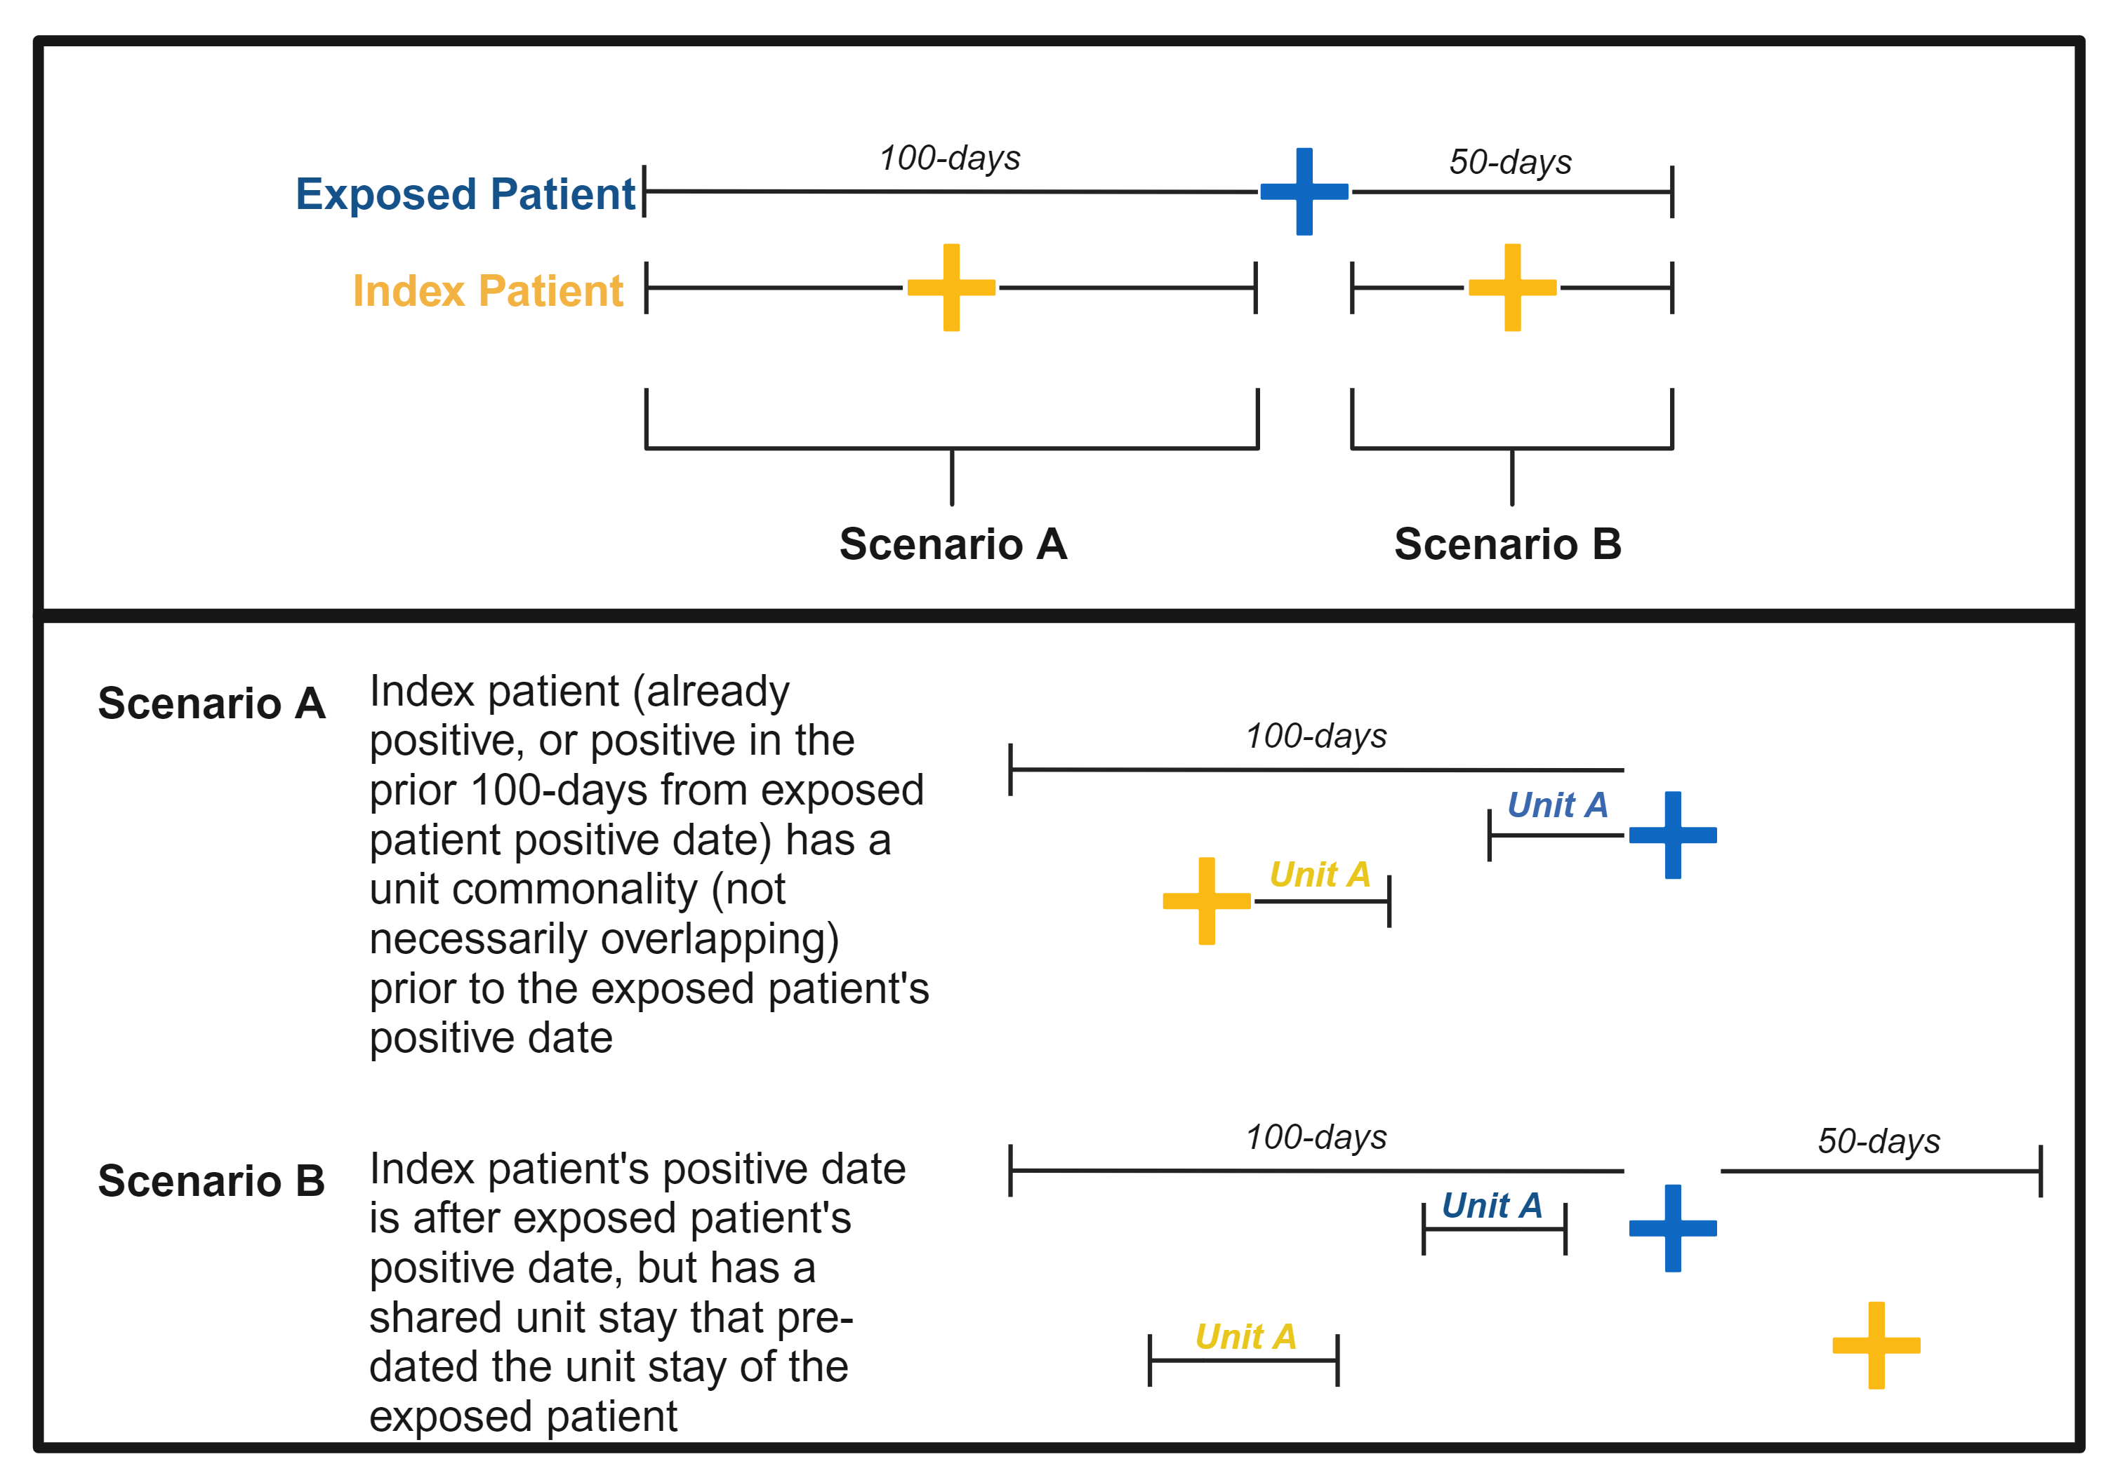
Fig S1. Geo-temporal transmission analysis approach.

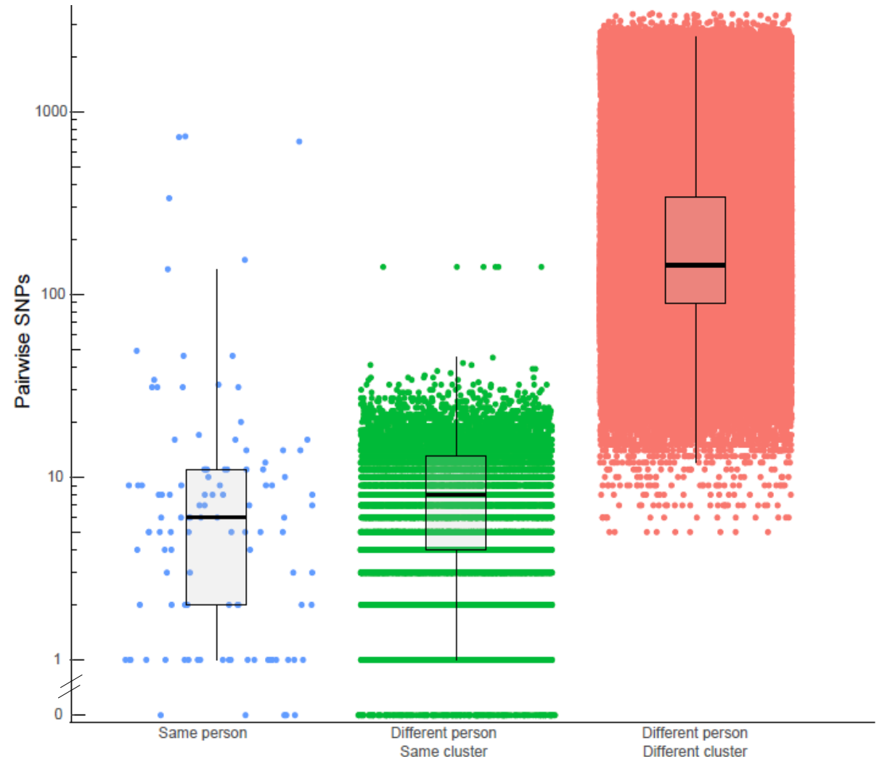
Fig S2. SNP distance comparisons. Pairwise SKA SNPs were calculated for all same-person isolates (blue), same-cluster isolates (green), and different person/different cluster isolates (red).

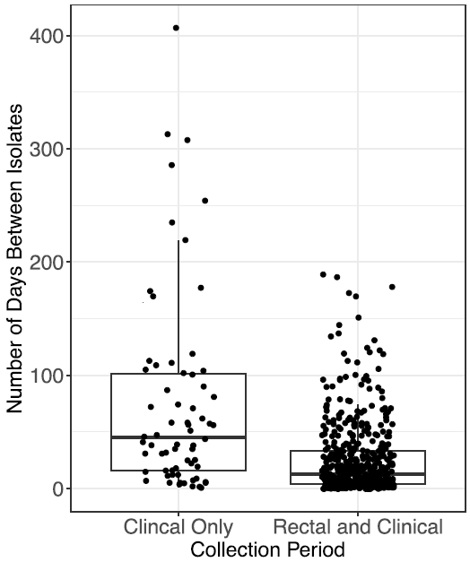

Fig S3. Transmission rates in the non-rectal screening versus clinical and rectal screening time periods. Transmission rate was defined as the number of days between collection of related isolates.

Table S2. Genome evolution rates for dominant VRE lineages.
ST | # Isolates | Divergence/root date | Mutation rate (beta)
17* | 211 | 1973.1 | 1.06E-05
736 | 173 | 1991.7 | 2.35E-06
1471 | 133 | 1959.9 | 2.65E-06
18 | 97 | 2002.4 | 2.84E-05
203 | 69 | 2016.2 | 7.24E-05
412 | 52 | 1995.8 | 1.89E-05
1478 | 36 | 2017.2 | 2.33E-06
80 | 35 | 2011.4 | 8.17E-05
375 | 29 | 2016.7 | 3.56E-06
584 | 27 | 1917.7 | 2.85E-06
* Molecular clock analysis for ST17 was performed using a deduplicated isolate set with a representative isolate from each genetically related cluster.

Table S3. Clustering of isolates at varying SNP thresholds.
SNP cut-off | Rectal swab + clinical isolates |  |  |  | Clinical isolates only
SNP cut-off | Total clusters | Number isolates clustering | Total clinical clustering (%) | Total rectal clustering (%) | Total clusters | Total clinical clustering (%)
10 | 165 | 775 | 197 (56.0) | 578 (64.9) | 54 | 140 (39.8)
15 | 163 | 843 | 227 (64.5) | 616 (68.7) | 56 | 165 (46.9)
20 | 234 | 865 | 233 (66.2) | 632 (71.0) | 61 | 186 (52.8)

Table S4. Geo-temporal links between clinical versus clinical and rectal isolates.
 | Isolates Related |  |  | Isolates with Geo-temporal Links (%)
 | Clinical Isolates | Rectal Isolates | Total Isolates | Clinical Isolates | Rectal Isolates | Total
Clinical Only | 185 | NA | 185 | 33 (17.8) | NA | 33 (17.8)
Clinical + Rectal | 233 | 632 | 865 | 47 (20.2) | 224 (35.4) | 271 (31.3)

Table S5. 30-day outcomes of 120 VRE clinical isolates that clustered with a prior rectal isolate.

Source | Isolates | Readmission (%) | ICU Admission (%) | Death (%) | NHSN HAI (%)
Blood | 19 | 1 (5.3) | 7 (36.8) | 7 (36.8) | 12 (63.2)
Body fluid/Other | 5 | 2 (40.0) | 3 (60.0) | 2 (40.0) | 2 (40.0)
Tissue/Wound | 41 | 2 (4.9) | 6 (14.6) | 6 (14.6) | 22 (53.7)
Urine | 55 | 6 (10.9) | 5 (9.1) | 1 (1.8) | 6 (10.9)
Total | 120 | 11 (9.2) | 21 (17.5) | 16 (13.3) | 42 (35.0)
ICU: Intensive-care unit; NHSN: National Healthcare Safety Network

