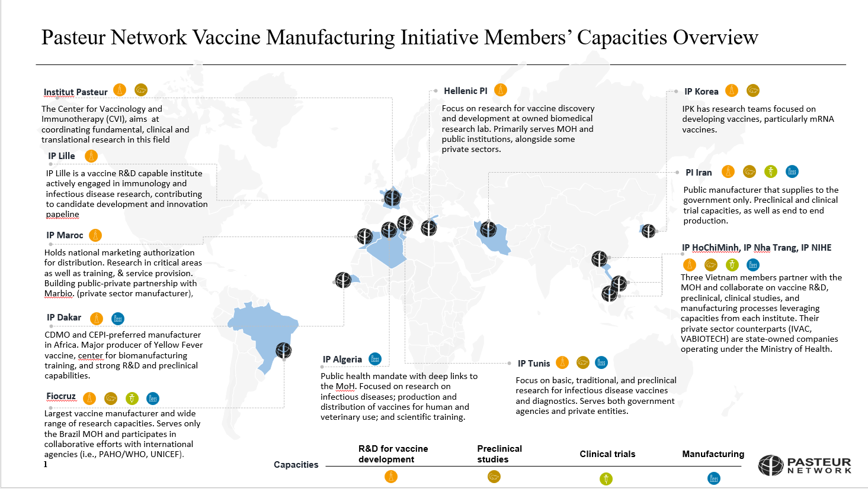
Fig S1 Pasteur Network Vaccine Manufacturing Initiative Members’ Capacity Overview
The Pasteur Network Vaccines Manufacturing Initiative’s members composition:
Fiocruz, Bio-Manguinho
Hellenic Pasteur Institute
Institute Pasteur
Institute Pasteur Algeria
institute Pasteur Dakar
institute Pasteur Ho Chi Minh City
Institute Pasteur Lille
institute Pasteur Iran
institute Pasteur Korea
institute Pasteur Morocco
institute Pasteur Nha Trang
institute Pasteur Tunis
Institute of Vaccines and Medical Biologicals (IVAC)
National institute of Hygiene and Epidemiology
Pasteur Network
VABIOTECH

Survey Questions

Capabilities &Capacity
- What types of vaccines does your institute manufacture or have the capacity to produce? (if you don't currently manufacture, please explain how you support manufacturing)
- What is your current number of staffs supporting manufacturing and what is the current composition (in terms of expertise / function) of this staff? (e.g., production, quality control, R&D)
- What is your current annual manufacturing production (by type) and potential capacity (e.g., number of vaccine doses)? Relatedly, are there potential scale-up capabilities?
- Do you have any tech transfers (TTs) underway or complete?
- Do you have DS and / or DP capacities? (please explain)
- What is the scope and scale of the facility(ies) (e.g., square meters, number of buildings)
- Do you have vaccine R&D capacities? (if yes, please explain)
- Do you have preclinical capacities? (if yes, please explain)
- Do you have the capacity / capability to run clinical trials? (if yes, please explain)
- What certifications or regulatory standards does your manufacturing process adhere to and when did these certifications occur (if any)? (e.g., WHO PQ, GMP,ISO 9001)
- Are there any other manufacturing capabilities (not mentioned above) that your institute currently possesses? (e.g., specific equipment, technology, platforms of production)
Objectives
- What are your primary objectives related to manufacturing currently?
- What are your primary objectives related to manufacturing in the next 3–5 years? (e.g., expanding type - mRNA - and / or capacity, developing new product lines, new technology, improving efficiency)
- How does your institute’s manufacturing objectives align with its overall mission and strategic goals? (e.g., focus on public health response, pandemic preparedness, or specific diseases)
- Do you have specific local or regional objectives and / or requirements for pandemic or epidemic preparedness?
Needs
- What additional resources or support would help enhance your manufacturing capabilities? (e.g., funding, technology, HR / staff, specialized staff)
- Are there specific areas in which you feel additional training or expertise is needed within your manufacturing team? (e.g., advanced manufacturing techniques, quality control, regulatory compliance)
Challenges
- What are the primary challenges your institute faces in manufacturing? (e.g., regulatory hurdles, staffing gaps, resource limitations, supply chain issues)
- How do supply chain issues impact your ability to meet manufacturing goals, and what specific constraints do you experience? (e.g., availability of raw materials, shipping delays)
- What external factors (e.g., policy, market demands, pandemic preparedness requirements) most influence your institute’s manufacturing operations?
Network Strategy
- Consider ways to leverage each institution’s strengths to create a cohesive network manufacturing strategy. What do you think is the best model for collaboration amongst the Network's Potential manufacturers? (e.g., knowledge sharing, resource pooling, joint product) development.
- Are there areas which you believe your institute could lend support to other members of the Network? (e.g., specific types of training, HR)
- Are there organizations (e.g., other local manufacturers, academic institutions) that you and or the Network should consider collaboration (locally, regionally, globally)?
Demand
- What is the local and / or regional demand for your product(s) (e.g., number of doses annually; specify where if regionally)?
- Who is the primary client or purchaser of your product(s)? (e.g., government agencies, global health organizations, private entities)
Other
- Is there anything else you would like to add?

