Supplementary material
Table of Contents
Table S1. Baseline epidemiological indicators. 2
Table S2. Effect sizes by outcome and intervention. 3
Table S3. Parameter values associated with health outcomes. 4
Table S4. Median unit costs by intervention. 8
Table S5. Assumptions on average healthcare worker time requirement per intervention. 9
Table S6. Baseline coverage of ANC contacts and ANC interventions. 10
Table S7. Cumulative DALYs for the scenarios considered. 15
Table S8. Sensitivity analysis outcomes for DALY reduction and cost per DALY averted. 16
Figure S1. Sensitivity analysis – the total costs of additional scenario. 17
Figure S2. Sensitivity analysis – the outcomes for 24-country sample of additional scenario. 18
References 19

Table S1. Baseline epidemiological indicators.
 | Maternal anaemia prevalence  (%) | Maternal mortality  (deaths per 100,000 births) | Neonatal mortality (deaths per 1,000 live births) | Preterm births (per 100 births) | Stillbirths  (per 1,000 births) | Low birth weight  (%) | Small for gestational age (%)
Source | WHO GHO  (1) | WHO GHO (1) | WHO GHO  (1) | WHO GHO  (1) | WHO GHO (1) | UNICEF-WHO (2) | LiST^ (3)
Burkina Faso | 55% | 264 | 25 | 10%* | 20 | 18% | 8%
Cambodia | 52% | 218 | 12 | 6% | 11 | 11% | 8%
Cameroon | 44% | 438 | 26 | 10%* | 19 | 13% | 8%
Cote d'Ivoire | 54% | 480 | 29 | 12% | 22 | 18% | 8%
Ethiopia | 29% | 267 | 27 | 13% | 21 | 14%* | 17%
Gabon | 53% | 227 | 18 | 7% | 14 | 15% | 8%
Gambia | 55% | 458 | 24 | 10%* | 21 | 13% | 8%
Ghana | 47% | 263 | 21 | 8% | 21 | 14% | 21%
Guinea | 53% | 553 | 31 | 10%* | 23 | 14%* | 8%
India | 50% | 103 | 18 | 13% | 12 | 27% | 42%
Kenya | 40% | 530 | 20 | 9% | 19 | 10% | 8%
Liberia | 50% | 652 | 30 | 10%* | 23 | 20% | 8%
Madagascar | 39% | 392 | 24 | 10%* | 18 | 19% | 8%
Mali | 59% | 440 | 33 | 6% | 23 | 14%* | 8%
Mauritania | 49% | 464 | 22 | 10%* | 17 | 14%* | 8%
Mozambique | 46% | 127 | 26 | 7% | 17 | 18% | 8%
Nepal | 43% | 174 | 17 | 11% | 16 | 20% | 43%
Nigeria | 56% | 1,047 | 34 | 10% | 22 | 14%* | 8%
Philippines | 26% | 78 | 14 | 8% | 10 | 21% | 8%
Rwanda | 24% | 259 | 17 | 9% | 17 | 9% | 17%
Senegal | 56% | 261 | 20 | 10%* | 19 | 17% | 8%
Sierra Leone | 54% | 443 | 31 | 10%* | 23 | 10% | 8%
Tanzania | 48% | 238 | 20 | 8% | 18 | 10% | 8%
Zambia | 39% | 135 | 24 | 8% | 14 | 11% | 17%
*Regional estimates applied.
^Modelled estimates.
GHO, Global Health Observatory; LiST, Lives Saved Tool; UNICEF, United Nations Children’s Fund; WHO, World Health Organisation.

Table S2. Effect sizes by outcome and intervention.
Intervention | Impact | Effect size (RR) | Source
Facility birth | Maternal mortality | 0.44 (0.30, 0.63)* | Chinkhumba J et al, 2014 (4)
 | Newborn mortality | 0.71 (0.54, 0.87) | Tura et al, 2013 (5)
Iron and folic acid supplementation | Maternal anemia | 0.51 (0.38, 0.7) | Hansen et al, 2023 (6)
 | Low birth weight | 0.30 (0.13, 0.68) | Hansen et al, 2023 (6)
 | Small for gestational age | 0.39 (0.17, 0.86) | Hansen et al, 2023 (6)
Balanced energy protein supplementation | Stillbirth | 0.39 (0.19, 0.80) | Lassi ZS et al, 2021 (7)
 | Low birth weight | 0.6 (0.41, 0.94) | Lassi ZS et al, 2021 (7)
 | Small for gestational age | 0.71 (0.54, 0.94) | Lassi ZS et al, 2021 (7)
Multiple micronutrient supplementation | Maternal anemia | 0.51 (0.38, 0.70) | Hansen et al, 2023 (6)
 | Stillbirth | 0.91 (0.86, 0.98) | Hofmeyr GJ et al, 2023 (8)
 | Small for gestational age | 0.93 (0.88, 0.98) | Oh C et al, 2020 (9)
Hypertensive disorder case management^ | Maternal mortality (due to hypertensive disorders) | 0.50 (0.30, 0.60) | Pollard et al, 2013 (10)
Syphilis detection and treatment^ | Newborn mortality | 0.20 (0.13, 0.32) | Blencowe H et al, 2011 (11)
 | Preterm birth | 0.36 (0.27, 0.47) | Blencowe H et al, 2011 (11)
 | Stillbirth | 0.18 (0.10, 0.33) | Blencowe H et al, 2011 (11)
Antibiotics for asymptomatic bacteriuria^ | Preterm birth | 0.27 (0.11, 0.62) | Smail FM, Vazquez JC, 2015 (12)
 | Low birth weight | 0.64 (0.45, 0.93) | Smail FM, Vazquez JC, 2015 (12)
Tetanus toxoid vaccination | Newborn mortality (due to tetanus) | 0.06 (0.02, 0.20) | Blencowe H et al, 2010 (13)
Malaria prevention (IPTp) | Maternal anemia | 0.90 (0.84, 0.95) | Moorthy et al, 2020 (14)
 | Small for gestational age | 0.65 (0.55, 0.77) | Eisele TP et al, 2012 (15)
Calcium supplementation | Preterm birth | 0.76 (0.6, 0.97) | Hofmeyr GJ et al, 2018 (16)
*Odds ratio from the study converted to country-specific relative risks using baseline facility birth coverage, then taking an unweighted average across countries.
^Effects applied to only the country-specific proportion of women/newborns experiencing the condition.
IPTp, intermittent preventive treatment in pregnancy; RR, relative risk.

Table S3. Parameter values associated with health outcomes.
Proportion of maternal deaths due to hypertensive disorders
 | Point estimate | Lower bound | Upper bound | Source
Burkina Faso | 16.0%¹ | 11.7% | 21.0% | Say L, Chou D, Gemmill A, et al 2014 (17)
Cambodia | 14.5%¹ | 8.4% | 22.7% | Say L, Chou D, Gemmill A, et al 2014 (17)
Cameroon | 16.0%¹ | 11.7% | 21.0% | Say L, Chou D, Gemmill A, et al 2014 (17)
Cote d'Ivoire | 16.0%¹ | 11.7% | 21.0% | Say L, Chou D, Gemmill A, et al 2014 (17)
Ethiopia | 16.0%¹ | 11.7% | 21.0% | Say L, Chou D, Gemmill A, et al 2014 (17)
Gabon | 16.0%¹ | 11.7% | 21.0% | Say L, Chou D, Gemmill A, et al 2014 (17)
Gambia | 16.0%¹ | 11.7% | 21.0% | Say L, Chou D, Gemmill A, et al 2014 (17)
Ghana | 16.0%¹ | 11.7% | 21.0% | Say L, Chou D, Gemmill A, et al 2014 (17)
Guinea | 16.0%¹ | 11.7% | 21.0% | Say L, Chou D, Gemmill A, et al 2014 (17)
India | 10.3%¹ | 5.8% | 16.6% | Say L, Chou D, Gemmill A, et al 2014 (17)
Kenya | 16.0%¹ | 11.7% | 21.0% | Say L, Chou D, Gemmill A, et al 2014 (17)
Liberia | 16.0%¹ | 11.7% | 21.0% | Say L, Chou D, Gemmill A, et al 2014 (17)
Madagascar | 16.0%¹ | 11.7% | 21.0% | Say L, Chou D, Gemmill A, et al 2014 (17)
Mali | 16.0%¹ | 11.7% | 21.0% | Say L, Chou D, Gemmill A, et al 2014 (17)
Mauritania | 16.0%¹ | 11.7% | 21.0% | Say L, Chou D, Gemmill A, et al 2014 (17)
Mozambique | 16.0%¹ | 11.7% | 21.0% | Say L, Chou D, Gemmill A, et al 2014 (17)
Nepal | 10.3%¹ | 5.8% | 16.6% | Say L, Chou D, Gemmill A, et al 2014 (17)
Nigeria | 16.0%¹ | 11.7% | 21.0% | Say L, Chou D, Gemmill A, et al 2014 (17)
Philippines | 14.5%¹ | 8.4% | 22.7% | Say L, Chou D, Gemmill A, et al 2014 (17)
Rwanda | 16.0%¹ | 11.7% | 21.0% | Say L, Chou D, Gemmill A, et al 2014 (17)
Senegal | 16.0%¹ | 11.7% | 21.0% | Say L, Chou D, Gemmill A, et al 2014 (17)
Sierra Leone | 16.0%¹ | 11.7% | 21.0% | Say L, Chou D, Gemmill A, et al 2014 (17)
Tanzania | 16.0%¹ | 11.7% | 21.0% | Say L, Chou D, Gemmill A, et al 2014 (17)
Zambia | 16.0%¹ | 11.7% | 21.0% | Say L, Chou D, Gemmill A, et al 2014 (17)
Prevalence of syphilis in pregnancy
 | Point estimate |  |  | Source
Burkina Faso | 1.77% |  |  | WHO GHO, 2024 (1)
Cambodia | 0.98% |  |  | WHO GHO, 2024 (1)
Cameroon | 8.49% |  |  | WHO GHO, 2024 (1)
Cote d'Ivoire | 4.87% |  |  | WHO GHO, 2024 (1)
Ethiopia | 0.83% |  |  | WHO GHO, 2024 (1)
Gabon | 2.43% |  |  | WHO GHO, 2024 (1)
Gambia | 4.53% |  |  | WHO GHO, 2024 (1)
Ghana | 1.18% |  |  | WHO GHO, 2024 (1)
Guinea | 1.04% |  |  | WHO GHO, 2024 (1)
India | 0.18% |  |  | WHO GHO, 2024 (1)
Kenya | 0.95% |  |  | WHO GHO, 2024 (1)
Liberia | 1.38% |  |  | WHO GHO, 2024 (1)
Madagascar | 1.56% |  |  | WHO GHO, 2024 (1)
Mali | 2.82% |  |  | WHO GHO, 2024 (1)
Mauritania | 3.33% |  |  | WHO GHO, 2024 (1)
Mozambique | 2.38% |  |  | WHO GHO, 2024 (1)
Nepal | 0.45% |  |  | WHO GHO, 2024 (1)
Nigeria | 0.17% |  |  | WHO GHO, 2024 (1)
Philippines | 1.04% |  |  | WHO GHO, 2024 (1)
Rwanda | 0.80% |  |  | WHO GHO, 2024 (1)
Senegal | 0.81% |  |  | WHO GHO, 2024 (1)
Sierra Leone | 0.85% |  |  | WHO GHO, 2024 (1)
Tanzania | 0.76% |  |  | WHO GHO, 2024 (1)
Zambia | 5.09% |  |  | WHO GHO, 2024 (1)
Prevalence of asymptomatic bacteriuria in pregnancy
 | Point estimate | Lower bound | Upper bound | Source
Burkina Faso | 11.1%¹ | 7.8% | 14.4% | Awoke N et al, 2021 (18)
Cambodia | 1.9%² |  |  | Sescon NC et al, 2003 (19)
Cameroon | 11.1%¹ | 7.8% | 14.4% | Awoke N et al, 2021 (18)
Cote d'Ivoire | 11.1%¹ | 7.8% | 14.4% | Awoke N et al, 2021 (18)
Ethiopia | 11.1%¹ | 7.8% | 14.4% | Awoke N et al, 2021 (18)
Gabon | 11.1%¹ | 7.8% | 14.4% | Awoke N et al, 2021 (18)
Gambia | 11.1%¹ | 7.8% | 14.4% | Awoke N et al, 2021 (18)
Ghana | 11.1%¹ | 7.8% | 14.4% | Awoke N et al, 2021 (18)
Guinea | 11.1%¹ | 7.8% | 14.4% | Awoke N et al, 2021 (18)
India | 13.5% | 11.1% | 15.8% | Khapre M et al, 2023 (20)
Kenya | 11.1%¹ | 7.8% | 14.4% | Awoke N et al, 2021 (18)
Liberia | 11.1%¹ | 7.8% | 14.4% | Awoke N et al, 2021 (18)
Madagascar | 11.1%¹ | 7.8% | 14.4% | Awoke N et al, 2021 (18)
Mali | 11.1%¹ | 7.8% | 14.4% | Awoke N et al, 2021 (18)
Mauritania | 11.1%¹ | 7.8% | 14.4% | Awoke N et al, 2021 (18)
Mozambique | 11.1%¹ | 7.8% | 14.4% | Awoke N et al, 2021 (18)
Nepal | 13.5% | 11.1% | 15.8% | Awoke N et al, 2021 (18)
Nigeria | 11.1%¹ | 7.8% | 14.4% | Awoke N et al, 2021 (18)
Philippines | 1.9%² |  |  | Sescon NC et al, 2003 (19)
Rwanda | 11.1%¹ | 7.8% | 14.4% | Awoke N et al, 2021 (18)
Senegal | 11.1%¹ | 7.8% | 14.4% | Awoke N et al, 2021 (18)
Sierra Leone | 11.1%¹ | 7.8% | 14.4% | Awoke N et al, 2021 (18)
Tanzania | 11.1%¹ | 7.8% | 14.4% | Awoke N et al, 2021 (18)
Zambia | 11.1%¹ | 7.8% | 14.4% | Awoke N et al, 2021 (18)
Proportion of newborn deaths due to tetanus
 | Point estimate |  |  | Source
Burkina Faso | 0.5% |  |  | WHO GHO, 2024 (1)
Cambodia | 0.3% |  |  | WHO GHO, 2024 (1)
Cameroon | 0.7% |  |  | WHO GHO, 2024 (1)
Cote d'Ivoire | 1.1% |  |  | WHO GHO, 2024 (1)
Ethiopia | 1.6% |  |  | WHO GHO, 2024 (1)
Gabon | 0.5% |  |  | WHO GHO, 2024 (1)
Gambia | 0.6% |  |  | WHO GHO, 2024 (1)
Ghana | 0.7% |  |  | WHO GHO, 2024 (1)
Guinea | 0.7% |  |  | WHO GHO, 2024 (1)
India | 0.8% |  |  | WHO GHO, 2024 (1)
Kenya | 0.7% |  |  | WHO GHO, 2024 (1)
Liberia | 0.5% |  |  | WHO GHO, 2024 (1)
Madagascar | 0.6% |  |  | WHO GHO, 2024 (1)
Mali | 1.2% |  |  | WHO GHO, 2024 (1)
Mauritania | 1.1% |  |  | WHO GHO, 2024 (1)
Mozambique | 0.7% |  |  | WHO GHO, 2024 (1)
Nepal | 0.6% |  |  | WHO GHO, 2024 (1)
Nigeria | 2.7% |  |  | WHO GHO, 2024 (1)
Philippines | 0.3% |  |  | WHO GHO, 2024 (1)
Rwanda | 0.3% |  |  | WHO GHO, 2024 (1)
Senegal | 0.4% |  |  | WHO GHO, 2024 (1)
Sierra Leone | 0.9% |  |  | WHO GHO, 2024 (1)
Tanzania | 0.6% |  |  | WHO GHO, 2024 (1)
Zambia | 0.7% |  |  | WHO GHO, 2024 (1)
Proportion of pregnancies at risk of malaria³
 | Point estimate | Lower bound | Upper bound | Source
Burkina Faso | 99.9% | 99.5% | 99.9% | Gore-Langton GR et al, 2022 (21)
Cambodia | 95.2% | 77.5% | 96.8% | Gore-Langton GR et al, 2022 (21)
Cameroon | 99.9% | 99.5% | 99.9% | Gore-Langton GR et al, 2022 (21)
Cote d'Ivoire | 99.9% | 99.5% | 99.9% | Gore-Langton GR et al, 2022 (21)
Ethiopia | 99.9% | 99.5% | 99.9% | Gore-Langton GR et al, 2022 (21)
Gabon | 99.9% | 99.5% | 99.9% | Gore-Langton GR et al, 2022 (21)
Gambia | 99.9% | 99.5% | 99.9% | Gore-Langton GR et al, 2022 (21)
Ghana | 99.9% | 99.5% | 99.9% | Gore-Langton GR et al, 2022 (21)
Guinea | 99.9% | 99.5% | 99.9% | Gore-Langton GR et al, 2022 (21)
India | 94.8% | 93.8% | 96.4% | Gore-Langton GR et al, 2022 (21)
Kenya | 99.9% | 99.5% | 99.9% | Gore-Langton GR et al, 2022 (21)
Liberia | 99.9% | 99.5% | 99.9% | Gore-Langton GR et al, 2022 (21)
Madagascar | 99.9% | 99.5% | 99.9% | Gore-Langton GR et al, 2022 (21)
Mali | 99.9% | 99.5% | 99.9% | Gore-Langton GR et al, 2022 (21)
Mauritania | 99.9% | 99.5% | 99.9% | Gore-Langton GR et al, 2022 (21)
Mozambique | 99.9% | 99.5% | 99.9% | Gore-Langton GR et al, 2022 (21)
Nepal | 94.8% | 93.8% | 96.4% | Gore-Langton GR et al, 2022 (21)
Nigeria | 99.9% | 99.5% | 99.9% | Gore-Langton GR et al, 2022 (21)
Philippines | 95.2% | 77.5% | 96.8% | Gore-Langton GR et al, 2022 (21)
Rwanda | 99.9% | 99.5% | 99.9% | Gore-Langton GR et al, 2022 (21)
Senegal | 99.9% | 99.5% | 99.9% | Gore-Langton GR et al, 2022 (21)
Sierra Leone | 99.9% | 99.5% | 99.9% | Gore-Langton GR et al, 2022 (21)
Tanzania | 99.9% | 99.5% | 99.9% | Gore-Langton GR et al, 2022 (21)
Zambia | 99.9% | 99.5% | 99.9% | Gore-Langton GR et al, 2022 (21)
¹Regional estimates applied.
²Assumed the same estimate in Cambodia and Philippines.
³Regional estimates of pregnancies at risk of Plasmodium falciparum in Sub-Saharan Africa and Plasmodium vivax in Asia.
GHO, Global Health Observatory; WHO, World Health Organization.

Table S4. Median unit costs by intervention.
Intervention | Median and range of unit cost across countries (US$) | Source
Antenatal care (per appointment) | $0.79 ($0.16 - $3.15) | LiST v6.36 (3)
Iron and folic acid supplementation | $1.59 ($0.34 - $3.51) | LiST v6.36 (3)
Balanced energy protein supplementation | $92.79 ($21.41 - $122.87) | LiST v6.36 (3)
Multiple micronutrient supplementation | $5.94 ($1.34 - $8.77) | LiST v6.36 (3)
Calcium supplementation | $35.26 ($31.91 – 67.09) | LiST v6.36 (3)
Hypertensive disorder case management | $0.98 ($0.31 - $4.83) | LiST v6.36 (3)
Syphilis detection and treatment | $1.99 ($0.46 - $2.64) | LiST v6.36 (3)
Tetanus toxoid vaccination | $1.54 ($0.35 - $7.16) | LiST v6.36 (3)
Malaria prevention (IPTp) | $0.49 ($0.11 - $1.68) | LiST v6.36 (3)
Bacteriuria treatment | $7.91 ($7.90 - $7.99) | Hill AM et al, 2018 (22)
LiST, Lives Saved Tool; IPTp, intermittent preventive treatment in pregnancy.

Table S5. Assumptions on average healthcare worker time requirement per intervention.
Intervention | Time requirement
ANC visit | Nurses/midwives 10 min (per contact)
Blood pressure monitoring | Part of ANC time
Blood testing | Part of ANC time
Urine testing | Part of ANC time
Management of hypertensive disorders | Midwives 50 min per case
Syphilis detection and treatment | Midwives 25 min per case (15 mins detection + 10 mins treatment)
Asymptomatic bacteriuria treatment | Midwives 3 min per case
Iron and folic acid supplementation | Midwives 8 min (per pregnancy)
Multiple micronutrient supplementation | Midwives 8 min (per pregnancy)
Balanced energy protein supplementation | Midwives 8 min (per pregnancy)
Calcium supplementation | Midwives 8 min (per pregnancy)
Tetanus toxoid vaccination | Midwives 15 min (per pregnancy)
Malaria prevention (IPTp) | Midwives 5 min (per pregnancy)
ANC, antenatal care; IPTp, intermittent preventive treatment in pregnancy.

Table S6. Baseline coverage of ANC contacts and ANC interventions.
Proportion of ANC contact
 | 0 ANC contact | 1 ANC contact | 2-3 ANC contact | 4-7 ANC contact | 8+ ANC contact
Burkina Faso | 1.13% | 2.15% | 23.87% | 71.28% | 0.83%
Cambodia | 1.23% | 1.21% | 11.69% | 58.09% | 27.66%
Cameroon | 13.04% | 2.36% | 20.15% | 56.42% | 6.42%
Cote d'Ivoire | 4.35% | 7.18% | 31.48% | 52.74% | 3.58%
Ethiopia | 26.23% | 3.63% | 26.50% | 41.02% | 2.18%
Gabon | 2.89% | 1.04% | 14.27% | 62.31% | 11.46%
Gambia | 0.32% | 1.87% | 17.91% | 74.30% | 4.54%
Ghana | 1.79% | 1.78% | 8.63% | 48.96% | 38.68%
Guinea | 12.75% | 10.59% | 37.56% | 31.42% | 3.12%
India | 5.73% | 6.66% | 27.94% | 38.89% | 18.18%
Kenya | 1.94% | 2.65% | 29.20% | 62.05% | 3.97%
Liberia | 1.53% | 1.30% | 8.29% | 59.41% | 26.12%
Madagascar | 11.75% | 3.18% | 26.55% | 55.71% | 1.94%
Mali | 18.66% | 5.54% | 29.74% | 39.25% | 3.19%
Mauritania | 10.53% | 14.41% | 27.74% | 33.47% | 3.75%
Mozambique | 12.50% | 5.90% | 26.67% | 45.51% | 1.92%
Nepal | 2.73% | 2.30% | 14.41% | 74.50% | 5.99%
Nigeria | 23.69% | 2.85% | 15.10% | 37.39% | 18.33%
Philippines | 3.48% | 1.56% | 11.80% | 53.55% | 29.18%
Rwanda | 2.53% | 4.50% | 45.63% | 47.05% | 0.26%
Senegal | 1.71% | 1.64% | 18.31% | 59.68% | 6.37%
Sierra Leone | 1.16% | 0.85% | 6.31% | 52.15% | 20.11%
Tanzania | 10.33% | 1.73% | 22.60% | 61.70% | 3.12%
Zambia | 1.15% | 1.35% | 33.30% | 61.40% | 1.26%
Proportion of facility births by ANC contact
 | 0 ANC contact | 1 ANC contact | 2-3 ANC contact | 4-7 ANC contact | 8+ ANC contact
Burkina Faso | 75.93% | 76.65% | 88.80% | 96.60% | 97.25%
Cambodia | 80.63% | 91.35% | 92.41% | 97.92% | 98.39%
Cameroon | 10.62% | 34.55% | 59.39% | 81.44% | 96.38%
Cote d'Ivoire | 28.75% | 57.36% | 74.89% | 90.17% | 96.77%
Ethiopia | 12.74% | 21.99% | 56.58% | 75.29% | 77.58%
Gabon | 51.58% | 76.00% | 90.96% | 97.27% | 99.47%
Gambia | 59.78% | 71.34% | 81.48% | 88.01% | 91.62%
Ghana | 44.42% | 52.09% | 61.96% | 86.29% | 93.91%
Guinea | 12.20% | 28.56% | 57.21% | 70.45% | 79.25%
India | 71.84% | 83.67% | 87.30% | 93.47% | 97.57%
Kenya | 31.79% | 64.61% | 78.40% | 85.46% | 86.24%
Liberia | 21.99% | 48.57% | 66.15% | 83.72% | 91.96%
Madagascar | 4.09% | 9.21% | 29.69% | 51.73% | 66.00%
Mali | 28.37% | 65.27% | 71.79% | 85.74% | 95.11%
Mauritania | 30.16% | 71.38% | 75.15% | 82.48% | 89.25%
Mozambique | 19.67% | 41.34% | 63.52% | 78.67% | 83.52%
Nepal | 48.75% | 36.05% | 65.20% | 82.29% | 95.94%
Nigeria | 6.09% | 22.65% | 30.07% | 48.41% | 76.72%
Philippines | 24.57% | 62.21% | 76.93% | 91.79% | 97.11%
Rwanda | 38.61% | 85.43% | 93.78% | 98.06% | 100.00%
Senegal | 50.22% | 78.13% | 86.61% | 94.33% | 94.16%
Sierra Leone | 78.21% | 63.21% | 71.07% | 86.95% | 85.54%
Tanzania | 72.81% | 46.95% | 67.44% | 81.12% | 92.24%
Zambia | 14.60% | 64.37% | 83.49% | 89.45% | 100.00%
Proportion of iron and folic acid supplementation by ANC contact
 | 0 ANC contact | 1 ANC contact | 2-3 ANC contact | 4-7 ANC contact | 8+ ANC contact
Burkina Faso | 27.98% | 20.64% | 39.02% | 60.58% | 57.99%
Cambodia | 37.65% | 39.44% | 79.25% | 92.07% | 92.74%
Cameroon | 3.56% | 14.83% | 39.65% | 61.41% | 73.36%
Cote d'Ivoire | 2.97% | 6.39% | 17.99% | 39.73% | 49.30%
Ethiopia | 0.15% | 2.29% | 11.27% | 19.23% | 10.87%
Gabon | 1.77% | 9.29% | 22.64% | 45.07% | 39.65%
Gambia | 6.06% | 11.82% | 41.01% | 65.06% | 68.71%
Ghana | 9.86% | 9.83% | 20.21% | 60.45% | 72.39%
Guinea | 0.61% | 6.98% | 25.12% | 38.51% | 19.20%
India | 27.90% | 30.51% | 39.75% | 58.40% | 75.11%
Kenya | 1.96% | 3.69% | 36.75% | 65.61% | 73.19%
Liberia | 2.84% | 6.12% | 17.80% | 44.45% | 53.60%
Madagascar | 0.26% | 1.23% | 12.65% | 28.37% | 41.84%
Mali | 0.74% | 5.67% | 28.34% | 44.30% | 49.30%
Mauritania | 1.97% | 25.10% | 30.23% | 37.87% | 40.62%
Mozambique | 4.34% | 3.22% | 26.43% | 37.97% | 47.03%
Nepal | 41.13% | 40.53% | 70.37% | 92.08% | 93.08%
Nigeria | 1.75% | 9.65% | 20.54% | 44.35% | 53.41%
Philippines | 8.04% | 3.94% | 30.06% | 57.99% | 70.10%
Rwanda | 0.89% | 5.40% | 12.22% | 24.45% | 43.81%
Senegal | 5.19% | 27.79% | 48.85% | 53.82% | 63.84%
Sierra Leone | 51.57% | 13.78% | 15.06% | 25.94% | 46.04%
Tanzania | 20.71% | 1.50% | 26.61% | 50.26% | 56.99%
Zambia | 7.50% | 8.79% | 62.87% | 80.70% | 78.68%
Proportion of blood pressure monitoring by ANC contact
 | 0 ANC contact | 1 ANC contact | 2-3 ANC contact | 4-7 ANC contact | 8+ ANC contact
Burkina Faso | 0.00% | 98.14% | 98.50% | 98.73% | 100.00%
Cambodia | 0.00% | 88.98% | 94.84% | 99.47% | 99.31%
Cameroon | 0.00% | 88.21% | 96.24% | 98.20% | 99.38%
Cote d'Ivoire | 0.00% | 87.74% | 94.76% | 97.53% | 96.36%
Ethiopia | 0.00% | 72.39% | 84.27% | 93.44% | 100.00%
Gabon | 0.00% | 96.52% | 95.47% | 99.23% | 99.06%
Gambia | 0.00% | 90.87% | 99.61% | 99.31% | 99.77%
Ghana | 0.00% | 89.02% | 96.98% | 97.97% | 98.63%
Guinea | 0.00% | 87.47% | 92.58% | 95.29% | 100.00%
India | 0.00% | 88.58% | 93.32% | 98.29% | 99.55%
Kenya | 0.00% | 95.29% | 96.97% | 98.74% | 98.27%
Liberia | 0.00% | 82.69% | 90.94% | 95.81% | 98.37%
Madagascar | 0.00% | 65.90% | 79.41% | 85.79% | 99.68%
Mali | 0.00% | 88.53% | 94.23% | 96.97% | 99.06%
Mauritania | 0.00% | 84.86% | 91.15% | 97.42% | 98.12%
Mozambique | 0.00% | 52.15% | 66.15% | 79.73% | 93.68%
Nepal | 0.00% | 61.70% | 87.68% | 96.57% | 100.00%
Nigeria | 0.00% | 82.64% | 90.74% | 95.21% | 95.49%
Philippines | 0.00% | 79.64% | 97.14% | 99.80% | 98.81%
Rwanda | 0.00% | 82.31% | 89.47% | 93.07% | 100.00%
Senegal | 0.00% | 94.60% | 97.71% | 98.17% | 98.08%
Sierra Leone | 0.00% | 85.08% | 93.52% | 96.64% | 98.31%
Tanzania | 0.00% | 48.73% | 66.83% | 80.51% | 92.97%
Zambia | 0.00% | 85.20% | 94.52% | 95.54% | 100.00%
Proportion of blood testing by ANC contact
 | 0 ANC contact | 1 ANC contact | 2-3 ANC contact | 4-7 ANC contact | 8+ ANC contact
Burkina Faso | 0.00% | 91.38% | 93.10% | 94.26% | 98.82%
Cambodia | 0.00% | 72.93% | 80.60% | 90.24% | 89.88%
Cameroon | 0.00% | 80.98% | 95.65% | 98.31% | 98.84%
Cote d'Ivoire | 0.00% | 75.04% | 84.09% | 92.29% | 99.06%
Ethiopia | 0.00% | 53.87% | 77.11% | 86.39% | 93.72%
Gabon | 0.00% | 82.83% | 94.73% | 97.97% | 99.60%
Gambia | 0.00% | 83.62% | 98.55% | 98.46% | 96.09%
Ghana | 0.00% | 79.61% | 96.09% | 99.19% | 99.63%
Guinea | 0.00% | 57.25% | 81.97% | 88.17% | 96.93%
India | 0.00% | 84.31% | 89.94% | 97.22% | 99.41%
Kenya | 0.00% | 92.07% | 96.40% | 98.22% | 97.09%
Liberia | 0.00% | 81.28% | 88.72% | 96.68% | 98.51%
Madagascar | 0.00% | 21.34% | 41.43% | 52.97% | 73.19%
Mali | 0.00% | 57.54% | 74.64% | 85.96% | 95.79%
Mauritania | 0.00% | 67.31% | 80.58% | 83.66% | 81.31%
Mozambique | 0.00% | 71.10% | 83.65% | 90.10% | 94.24%
Nepal | 0.00% | 30.73% | 71.23% | 90.70% | 98.60%
Nigeria | 0.00% | 68.55% | 82.36% | 88.07% | 91.34%
Philippines | 0.00% | 36.00% | 69.87% | 88.18% | 94.39%
Rwanda | 0.00% | 90.52% | 97.21% | 98.46% | 100.00%
Senegal | 0.00% | 73.01% | 94.72% | 97.54% | 99.75%
Sierra Leone | 0.00% | 89.66% | 92.07% | 95.20% | 96.24%
Tanzania | 0.00% | 88.94% | 88.89% | 92.55% | 97.02%
Zambia | 0.00% | 79.31% | 95.58% | 96.02% | 100.00%
Proportion of urine testing by ANC contact
 | 0 ANC contact | 1 ANC contact | 2-3 ANC contact | 4-7 ANC contact | 8+ ANC contact
Burkina Faso | 0.00% | 82.54% | 84.56% | 89.41% | 97.30%
Cambodia | 0.00% | 60.13% | 64.42% | 77.76% | 80.58%
Cameroon | 0.00% | 63.78% | 87.83% | 93.38% | 99.09%
Cote d'Ivoire | 0.00% | 75.96% | 83.35% | 91.04% | 93.21%
Ethiopia | 0.00% | 44.28% | 68.77% | 84.37% | 82.96%
Gabon | 0.00% | 85.67% | 93.49% | 96.65% | 99.14%
Gambia | 0.00% | 76.50% | 89.95% | 95.28% | 99.14%
Ghana | 0.00% | 85.69% | 95.14% | 99.27% | 99.78%
Guinea | 0.00% | 67.96% | 83.26% | 89.34% | 99.03%
India | 0.00% | 84.18% | 88.21% | 96.48% | 99.01%
Kenya | 0.00% | 89.35% | 95.13% | 96.74% | 98.33%
Liberia | 0.00% | 69.79% | 80.86% | 92.07% | 94.66%
Madagascar | 0.00% | 19.36% | 24.38% | 39.64% | 66.39%
Mali | 0.00% | 53.16% | 66.54% | 81.58% | 96.03%
Mauritania | 0.00% | 83.40% | 87.46% | 91.37% | 97.25%
Mozambique | 0.00% | 37.71% | 51.47% | 63.80% | 81.44%
Nepal | 0.00% | 41.48% | 79.74% | 92.97% | 96.69%
Nigeria | 0.00% | 64.52% | 79.71% | 87.61% | 90.50%
Philippines | 0.00% | 41.15% | 69.34% | 89.99% | 95.51%
Rwanda | 0.00% | 70.01% | 84.67% | 92.11% | 100.00%
Senegal | 0.00% | 76.08% | 96.21% | 98.24% | 98.42%
Sierra Leone | 0.00% | 73.52% | 78.04% | 83.50% | 91.14%
Tanzania | 0.00% | 38.30% | 59.62% | 73.31% | 89.82%
Zambia | 0.00% | 43.26% | 63.62% | 67.28% | 84.67%
Proportion of tetanus toxoid vaccination by ANC contact
 | 0 ANC contact | 1 ANC contact | 2-3 ANC contact | 4-7 ANC contact | 8+ ANC contact
Burkina Faso | 14.48% | 21.27% | 37.65% | 44.51% | 61.92%
Cambodia | 35.53% | 31.67% | 52.60% | 72.04% | 69.04%
Cameroon | 3.45% | 12.49% | 55.06% | 64.79% | 63.55%
Cote d'Ivoire | 7.71% | 27.48% | 48.95% | 62.72% | 73.77%
Ethiopia | 0.00% | 0.00% | 0.00% | 0.00% | 0.00%
Gabon | 13.71% | 24.01% | 49.31% | 64.27% | 73.68%
Gambia | 0.00% | 11.01% | 28.48% | 37.03% | 47.19%
Ghana | 9.66% | 11.09% | 26.11% | 46.93% | 58.55%
Guinea | 4.74% | 19.78% | 55.62% | 68.00% | 75.93%
India | 64.70% | 70.82% | 81.57% | 86.00% | 87.54%
Kenya | 8.12% | 4.92% | 32.25% | 41.14% | 43.52%
Liberia | 16.03% | 32.09% | 64.96% | 81.70% | 86.86%
Madagascar | 3.88% | 5.60% | 59.29% | 66.70% | 64.25%
Mali | 1.25% | 11.05% | 46.15% | 49.00% | 50.35%
Mauritania | 8.46% | 26.14% | 41.14% | 42.77% | 41.94%
Mozambique | 2.41% | 8.31% | 35.87% | 52.35% | 59.22%
Nepal | 40.12% | 17.18% | 49.67% | 61.55% | 74.50%
Nigeria | 3.79% | 17.42% | 53.92% | 73.21% | 80.64%
Philippines | 9.00% | 12.35% | 50.22% | 56.78% | 60.23%
Rwanda | 2.50% | 3.82% | 30.27% | 39.19% | 75.27%
Senegal | 12.26% | 16.26% | 37.74% | 45.44% | 50.73%
Sierra Leone | 64.32% | 39.65% | 68.65% | 78.08% | 83.18%
Tanzania | 59.31% | 8.13% | 47.76% | 61.28% | 81.23%
Zambia | 2.78% | 12.79% | 23.08% | 30.44% | 33.72%
Proportion of malaria prevention (IPTp) by ANC contact
 | 0 ANC contact | 1 ANC contact | 2-3 ANC contact | 4-7 ANC contact | 8+ ANC contact
Burkina Faso | 57.79% | 84.58% | 91.43% | 94.20% | 93.65%
Cambodia | 0.00% | 0.00% | 0.00% | 0.00% | 0.00%
Cameroon | 8.23% | 62.88% | 81.02% | 86.31% | 87.34%
Cote d'Ivoire | 11.47% | 61.45% | 83.88% | 84.94% | 88.61%
Ethiopia | 0.00% | 0.00% | 0.00% | 0.00% | 0.00%
Gabon | 30.67% | 57.90% | 80.61% | 91.79% | 92.50%
Gambia | 7.89% | 83.27% | 97.82% | 83.38% | 98.49%
Ghana | 11.38% | 60.13% | 81.93% | 92.03% | 94.11%
Guinea | 11.37% | 78.32% | 91.52% | 92.03% | 92.47%
India | 0.00% | 0.00% | 0.00% | 0.00% | 0.00%
Kenya | 4.19% | 16.28% | 23.84% | 31.27% | 32.52%
Liberia | 15.37% | 73.18% | 85.08% | 92.02% | 93.29%
Madagascar | 3.40% | 34.47% | 54.60% | 60.24% | 56.34%
Mali | 10.73% | 77.73% | 86.75% | 92.35% | 91.24%
Mauritania | 9.93% | 51.55% | 60.74% | 66.05% | 56.25%
Mozambique | 1.84% | 55.46% | 71.43% | 69.60% | 75.17%
Nepal | 0.00% | 0.00% | 0.00% | 0.00% | 0.00%
Nigeria | 16.63% | 59.82% | 75.58% | 81.41% | 77.21%
Philippines | 0.00% | 0.00% | 0.00% | 0.00% | 0.00%
Rwanda | 0.00% | 0.00% | 0.00% | 0.00% | 0.00%
Senegal | 31.21% | 73.47% | 90.82% | 93.34% | 90.45%
Sierra Leone | 69.21% | 87.35% | 92.39% | 94.65% | 92.63%
Tanzania | 79.20% | 52.13% | 74.06% | 81.43% | 90.26%
Zambia | 7.74% | 80.36% | 95.10% | 95.28% | 100.00%
ANC, antenatal care; IPTp, intermittent preventive treatment in pregnancy.

Table S7. Cumulative DALYs for the scenarios considered.
Cumulative DALYs,  2025-2034 inclusive | Status quo | No ANC scenario | New ANC scenario
Burkina Faso | 13,501,885 | 14,667,103 | 13,331,783
Cambodia | 2,613,621 | 2,960,341 | 2,599,321
Cameroon | 16,528,630 | 20,442,705 | 16,089,532
Cote d'Ivoire | 18,718,883 | 22,364,572 | 18,203,112
Ethiopia | 68,888,521 | 75,198,825 | 67,244,586
Gabon | 753,298 | 862,986 | 730,080
Gambia | 1,500,727 | 1,739,039 | 1,485,520
Ghana | 14,372,312 | 17,069,205 | 14,364,512
Guinea | 9,428,410 | 10,523,721 | 9,070,085
India | 284,577,866 | 310,697,456 | 278,427,621
Kenya | 22,705,052 | 26,931,010 | 22,390,513
Liberia | 3,420,904 | 4,143,599 | 3,388,098
Madagascar | 14,834,576 | 16,296,689 | 14,510,593
Mali | 20,611,668 | 23,297,534 | 19,951,803
Mauritania | 2,444,558 | 2,758,960 | 2,343,774
Mozambique | 19,078,235 | 21,316,247 | 18,385,526
Nepal | 7,527,990 | 8,965,979 | 7,389,439
Nigeria | 182,751,007 | 203,619,856 | 181,126,435
Philippines | 22,598,783 | 27,394,199 | 22,483,223
Rwanda | 5,224,500 | 6,028,049 | 5,166,290
Senegal | 8,543,710 | 9,531,996 | 8,224,404
Sierra Leone | 5,051,602 | 4,939,657 | 4,805,729
Tanzania | 33,587,771 | 34,520,108 | 33,158,271
Zambia | 10,020,699 | 13,243,132 | 9,829,432
Total | 789,285,207 | 879,512,966 | 774,698,682
DALY, disability-adjusted life year.

Table S8. Sensitivity analysis outcomes for DALY reduction and cost per DALY averted.
 |  |  | Status-quo vs no ANC |  | New ANC scenario vs status-quo
Scenario | Original value | New value | DALY % reduction vs status-quo | Cost per DALY averted | DALY % reduction vs status-quo | Cost per DALY averted
Status-quo | — | — | 11.4% | $75.16 | 1.8% | $133.76
Duration of regular ANC appointment | 10 | 20 | 11.4% | $98.86 | 1.8% | $128.25
Duration of new model ANC appointment | 10 | 30 | 11.4% | $75.16 | 1.8% | $353.26
Proportion of ANC 0 covered by the new ANC scenario | 20% | 100% | 11.4% | $75.16 | 3.2% | $101.00
Proportion of ANC 0 covered by the new ANC scenario | 20% | 0% | 11.4% | $75.16 | 1.5% | $151.72
50% low risk community ANC path | 25% | 50% | 11.4% | $75.16 | 1.8% | $133.76
Discounting | 3% | 0% | 9.7% | $41.07 | 1.5% | $75.17
New ANC scenario coverage ~ 8 ANC contact coverage | 5 | 8 | 11.4% | $75.16 | 5.4% | $53.19
ANC, antenatal care; DALY, disability-adjusted life year.

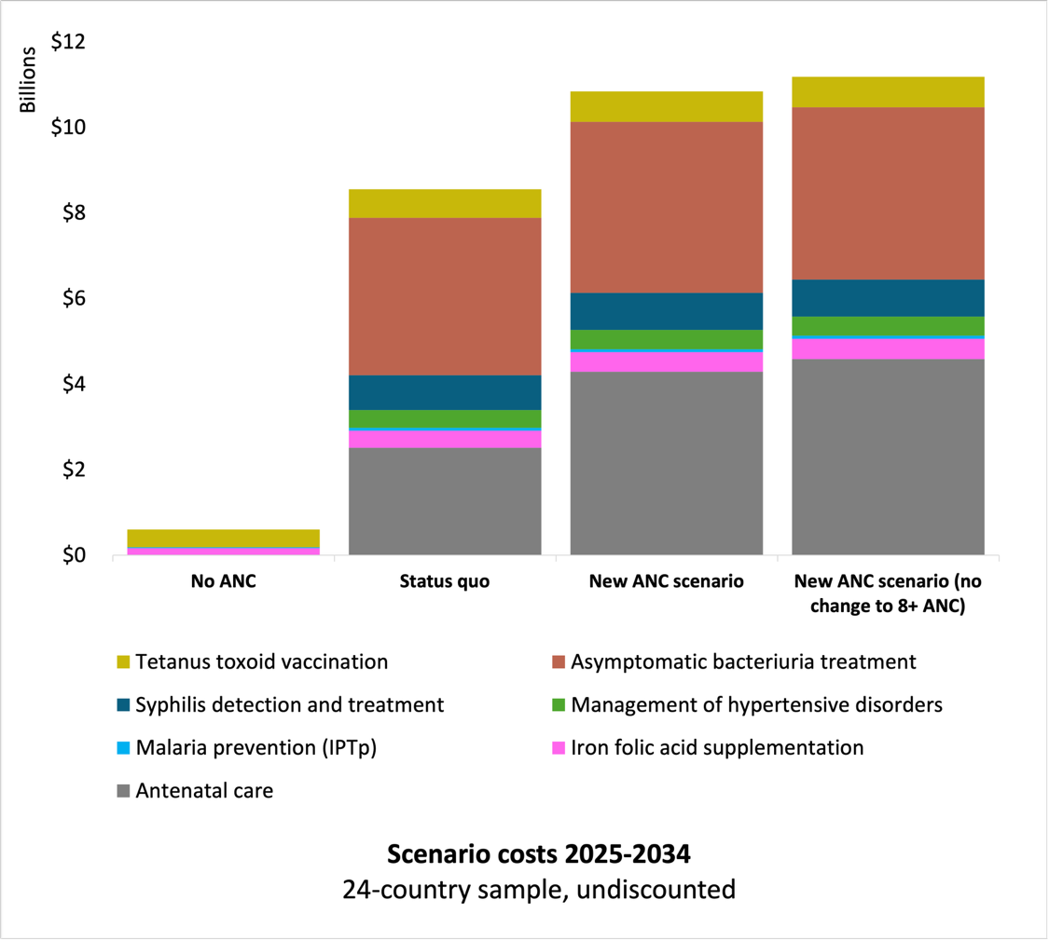
ANC, antenatal care; IPTp, intermittent preventive treatment in pregnancy.

Figure S1. Sensitivity analysis – the total costs of additional scenario.
Estimated total costs of the no ANC scenario, status-quo, new ANC scenario, and new ANC scenario (no change to women with ANC 8+ contacts) are US$599.2 million, US$8.6 billion, US$10.8 billion, and US$11.2 billion, respectively. This is equivalent to the average annual cost per pregnant woman of US$0.97 in the no ANC scenario, US$13.90 in the status-quo, US$17.62 in the new ANC scenario, and US18.17 in the new ANC scenario (no change to women with ANC 8+ contacts).

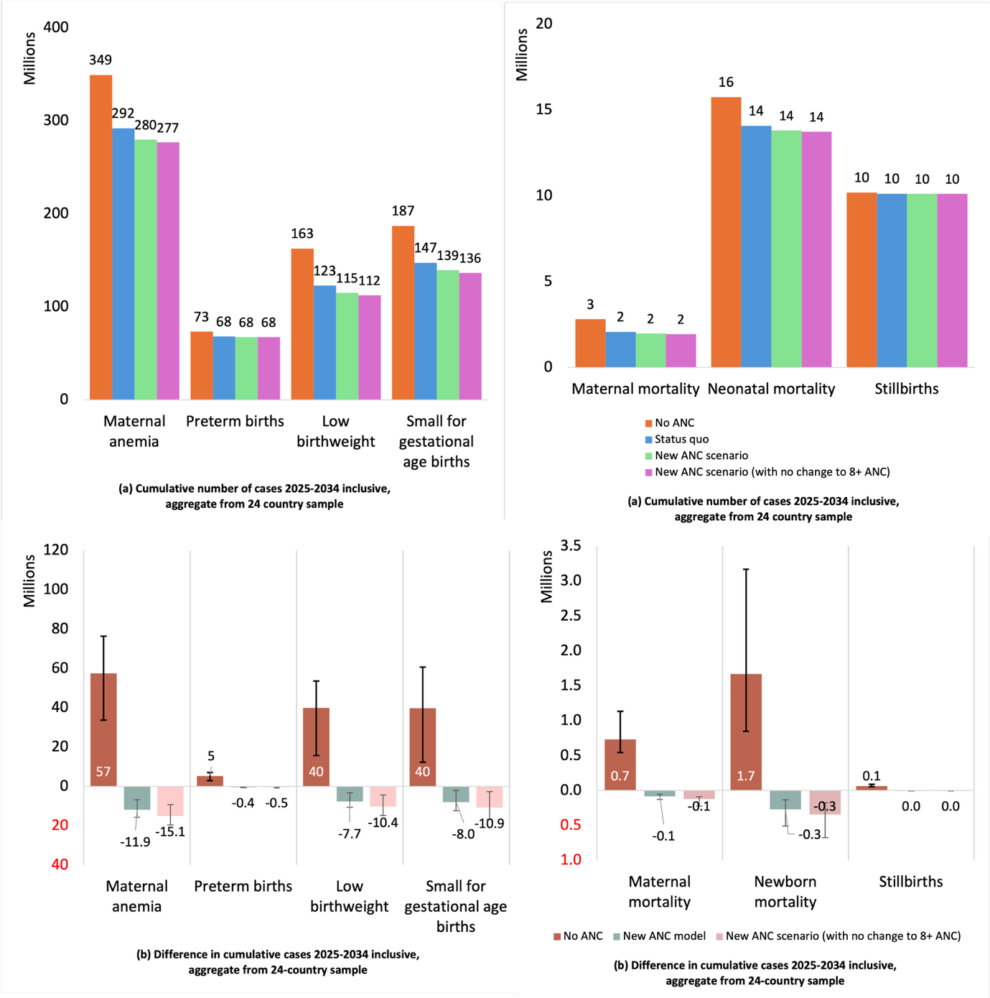
ANC, antenatal care.

Figure S2. Sensitivity analysis – the outcomes for 24-country sample of additional scenario.

References
1. WHO GHO. The Global Health Observatory: https://www.who.int/data/gho; 2024 [Available from: https://www.who.int/data/gho.
2. UNICEF-WHO. Low birthweight database, 2023 Edition: https://www.who.int/teams/nutrition-and-food-safety/monitoring-nutritional-status-and-food-safety-and-events/joint-low-birthweight-estimates; 2024 [Available from: https://www.who.int/teams/nutrition-and-food-safety/monitoring-nutritional-status-and-food-safety-and-events/joint-low-birthweight-estimates.
3. The Lives Saved Tools. The Lives Saved Tool (LiST): https://www.livessavedtool.org/; 2024 [Available from: https://www.livessavedtool.org/.
4. Chinkhumba J, De Allegri M, Muula AS, Robberstad B. Maternal and perinatal mortality by place of delivery in sub-Saharan Africa: a meta-analysis of population-based cohort studies. BMC Public Health. 2014;14(1):1014.
5. Tura G, Fantahun M, Worku A. The effect of health facility delivery on neonatal mortality: systematic review and meta-analysis. BMC Pregnancy and Childbirth. 2013;13(1):18.
6. Hansen R, Sejer EPF, Holm C, Schroll JB. Iron supplements in pregnant women with normal iron status: A systematic review and meta-analysis. Acta Obstet Gynecol Scand. 2023;102(9):1147-58.
7. Lassi ZS, Padhani ZA, Rabbani A, Rind F, Salam RA, Bhutta ZA. Effects of nutritional interventions during pregnancy on birth, child health and development outcomes: A systematic review of evidence from low- and middle-income countries. Campbell Syst Rev. 2021;17(2):e1150.
8. Hofmeyr GJ, Black RE, Rogozińska E, Heuer A, Walker N, Ashorn P, et al. Evidence-based antenatal interventions to reduce the incidence of small vulnerable newborns and their associated poor outcomes. Lancet. 2023;401(10389):1733-44.
9. Oh C, Keats EC, Bhutta ZA. Vitamin and Mineral Supplementation During Pregnancy on Maternal, Birth, Child Health and Development Outcomes in Low- and Middle-Income Countries: A Systematic Review and Meta-Analysis. Nutrients. 2020;12(2).
10. Pollard SL, Mathai M, Walker N. Estimating the impact of interventions on cause-specific maternal mortality: a Delphi approach. BMC Public Health. 2013;13(3):S12.
11. Blencowe H, Cousens S, Kamb M, Berman S, Lawn JE. Lives Saved Tool supplement detection and treatment of syphilis in pregnancy to reduce syphilis related stillbirths and neonatal mortality. BMC Public Health. 2011;11(3):S9.
12. Smaill FM, Vazquez JC. Antibiotics for asymptomatic bacteriuria in pregnancy. Cochrane Database Syst Rev. 2019;2019(11).
13. Blencowe H, Lawn J, Vandelaer J, Roper M, Cousens S. Tetanus toxoid immunization to reduce mortality from neonatal tetanus. Int J Epidemiol. 2010;39 Suppl 1(Suppl 1):i102-9.
14. Moorthy D, Merrill R, Namaste S, Iannotti L. The Impact of Nutrition-Specific and Nutrition-Sensitive Interventions on Hemoglobin Concentrations and Anemia: A Meta-review of Systematic Reviews. Adv Nutr. 2020;11(6):1631-45.
15. Eisele TP, Larsen DA, Anglewicz PA, Keating J, Yukich J, Bennett A, et al. Malaria prevention in pregnancy, birthweight, and neonatal mortality: a meta-analysis of 32 national cross-sectional datasets in Africa. Lancet Infect Dis. 2012;12(12):942-9.
16. Hofmeyr GJ, Lawrie TA, Atallah Á N, Torloni MR. Calcium supplementation during pregnancy for preventing hypertensive disorders and related problems. Cochrane Database Syst Rev. 2018;10(10):Cd001059.
17. Say L, Chou D, Gemmill A, Tunçalp Ö, Moller AB, Daniels J, et al. Global causes of maternal death: a WHO systematic analysis. Lancet Glob Health. 2014;2(6):e323-33.
18. Awoke N, Tekalign T, Teshome M, Lolaso T, Dendir G, Obsa MS. Bacterial Profile and asymptomatic bacteriuria among pregnant women in Africa: A systematic review and meta analysis. EClinicalMedicine. 2021;37:100952.
19. Sescon NC, Garingalao-Molina FD, Ycasiano CJ, et al. Prevalence of asymptomatic bacteriuria and associated risk factors inpregnant women. Philippines Journal of Microbiology and Infectious Disease. 2003;32:63-9.
20. Khapre M, Sharma D, Mehta A, Sinha S. Prevalence of Asymptomatic Bacteriuria (ASB) in Pregnant Women in India: A Systematic Review and Meta-Analysis. Indian J Community Med. 2023;48(6):879-87.
21. Gore-Langton GR, Cano J, Simpson H, Tatem A, Tejedor-Garavito N, Wigley A, et al. Global estimates of pregnancies at risk of Plasmodium falciparum and Plasmodium vivax infection in 2020 and changes in risk patterns since 2000. PLOS Glob Public Health. 2022;2(11):e0001061.
22. Hill AM, Barber MJ, Gotham D. Estimated costs of production and potential prices for the WHO Essential Medicines List. BMJ Global Health. 2018;3(1):e000571.

