Attachment
Decision tree model operation diagram of canine owners
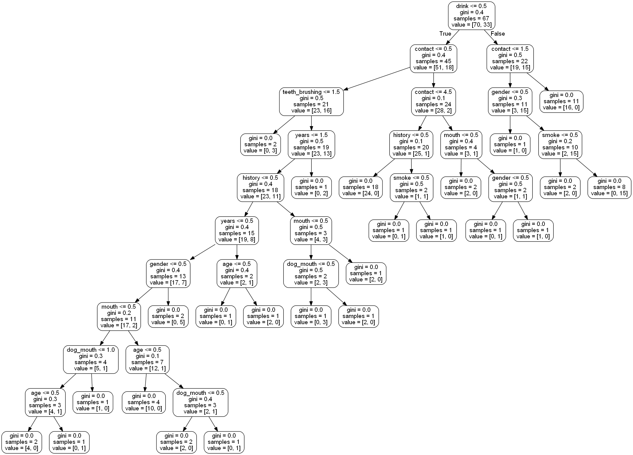

Decision tree model operation diagram of veterinarians
