Supplementary File

Table 1: Rabies suspected human exposure cases and death per year and region
Region | Year |  |  |  |  |  |  |  |  |  | Total case | Total death | Case fatality (per 1000)
Region | 2018 |  | 2019 |  | 2020 |  | 2021 |  | 2022 |  | Total case | Total death | Case fatality (per 1000)
Region | Case | Death | Case | Death | Case | Death | Case | Death | Case | Death | Total case | Total death | Case fatality (per 1000)
Addis Ababa | 546 | 1 | 1139 | 2 | 1521 | 6 | 304 | 0 | 18 | 2 | 3528 | 11 | 3.1
Afar |  |  |  |  | 11 | 0 |  |  | 1 | 0 | 12 | 0 | 0.0
Amhara | 515 | 7 | 991 | 18 | 2822 | 23 | 6055 | 27 | 9053 | 39 | 19436 | 114 | 5.9
Benishangul-Gumuz | 589 | 5 | 402 | 1 | 404 | 2 | 493 | 3 | 673 | 1 | 2561 | 12 | 4.7
Diredawa |  |  |  |  | 7 | 0 |  |  |  |  | 7 | 0 | 0.0
Gambella | 9 | 1 | 8 | 0 | 1 | 0 | 3 | 1 | 8 | 1 | 29 | 3 | 103.4
Harari |  |  |  |  |  |  |  |  | 1 | 0 | 1 | 0 | 0.0
Oromia | 282 | 24 | 308 | 22 | 273 | 6 | 399 | 5 | 500 | 9 | 1762 | 66 | 37.5
SNNP | 98 | 22 | 87 | 5 | 380 | 5 | 568 | 4 | 757 | 2 | 1890 | 38 | 20.1
Somali | 32 | 0 | 20 | 0 |  |  | 5 | 2 |  |  | 57 | 2 | 35.1
SWE |  |  |  |  |  |  |  |  | 287 | 0 | 287 | 0 | 0.0
Tigray | 3146 | 1 | 3114 | 48 | 1901 | 2 | 258 | 0 |  |  | 8419 | 51 | 6.1
Sum | 5217 | 61 | 6069 | 96 | 7320 | 44 | 8085 | 42 | 11298 | 54 | 37989 | 297 | 7.8
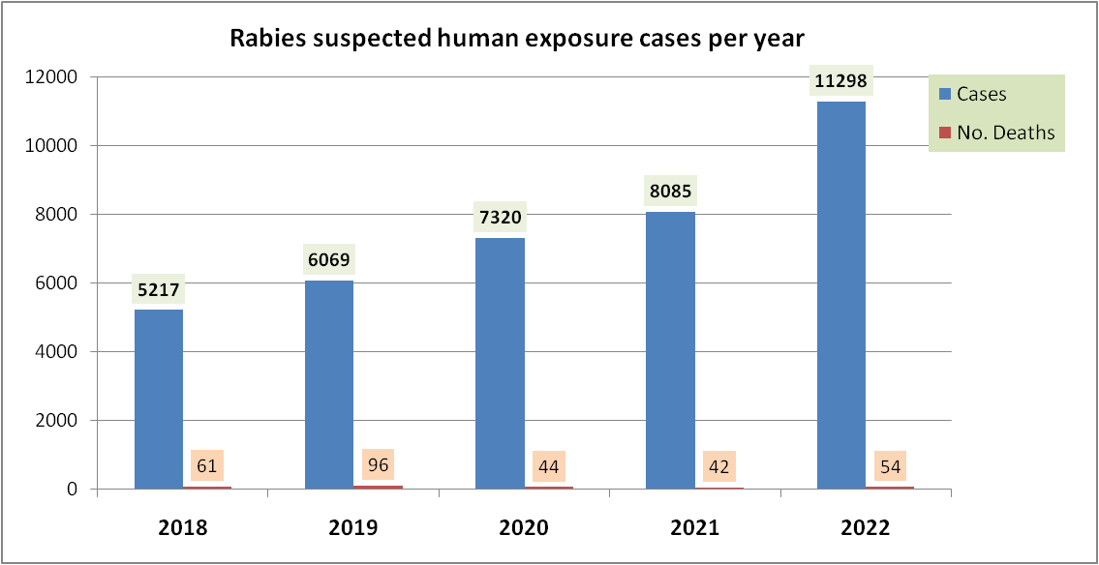

Fig. 1: Rabies suspected human exposure cases and deaths per year

Table 2: Areas with continuous annual reports of Rabies suspected human exposure cases
No | Region | District/town | Year |  |  |  |  | Total
No | Region | District/town | 2018 | 2019 | 2020 | 2021 | 2022 | Total
1 | Amhara | Enarj Enawuga | 4 | 1 | 1 | 2 | 5 | 13
 |  | Aneded | 3 | 18 | 18 | 16 | 44 | 99
 |  | Dese Town | 12 | 5 | 3 | 4 | 3 | 27
 |  | Gozamin | 12 | 4 | 7 | 15 | 5 | 43
 |  | Takusa | 7 | 3 | 3 | 42 | 116 | 171
2 | Benishangul Gumuz | Bambasi | 26 | 17 | 20 | 45 | 35 | 143
 |  | Kurmuk | 2 | 3 | 3 | 3 | 4 | 15
 |  | Menge | 24 | 12 | 13 | 4 | 23 | 76
3 | Gambella | Godere | 7 | 6 | 1 | 3 | 8 | 25
4 | Oromia | Robe town | 4 | 1 | 1 | 4 | 15 | 25
 |  | Sebeta Town | 20 | 82 | 103 | 103 | 100 | 408

Table 3: Dog rabies vaccination by vaccination type per year
Year | Control | Prophylaxis | Total vaccination
2018 | 2,633 | 16,366 | 18,999
2019 | 650 | 37,927 | 38,577
2020 | 396 | 34,102 | 34,498
2021 | 4,959 | 50,120 | 55,079
2022 | 2,991 | 219,489 | 222,480
Sum | 11,629 | 358,004 | 369,633

Table 4: Dog rabies vaccination data per region and year
No. | Region | Year |  |  |  |  | Total
 |  | 2018 | 2019 | 2020 | 2021 | 2022
1 | Afar | - | - | - | - | - | -
2 | Addis Ababa |  | 14268 | 9386 | 27880 | 40113 | 91,647
3 | Amhara | 4634 | 8140 | 9920 | 13210 | 71637 | 107,541
4 | Benishangul Gumuz | - | - | - | - | 10839 | 10,839
5 | Diredawa | - | - | - | - | 5202 | 5,202
6 | Gambella | - | - | - | - | 2840 | 2,840
7 | Harari | - | - | - | - | - | -
8 | Oromia | 500 | 3877 | 3294 | 4227 | 50211 | 62,109
9 | Sidama* |  |  | 30 | 6591 | 6176 | 12,797
10 | SNNP* | 1088 | 10601 | 11868 | 2166 | 21454 | 47,177
11 | Somale | 1094 | - | - | - | - | 1,094
12 | SWE* | - | - | - | 1005 | 14008 | 15,013
13 | Tigrai | 11683 | 1691 |  |  |  | 13,374
 | Sum | 18,999 | 38,577 | 34,498 | 55,079 | 222,480 | 369,633
* New regions established after the splitting of the former SNNP region in 2020
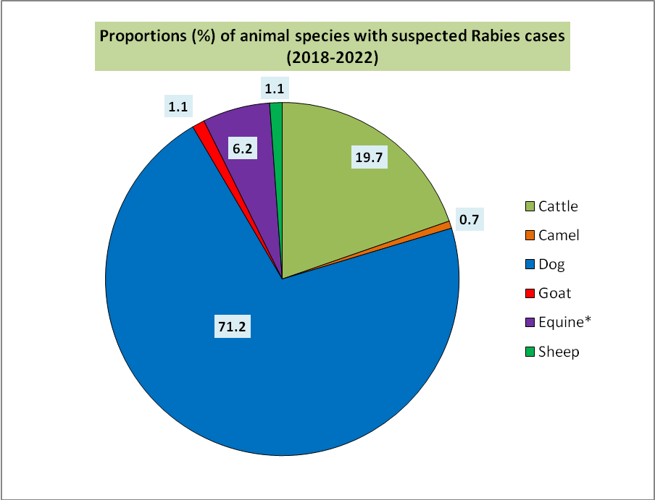

* Equines include donkey, horse and mule
Fig. 2: Proportion of animal species with suspected Rabies cases

