Supplementary information
Occurrence of Alternaria mycotoxins and aflatoxins contamination in vegetable oils by enzyme immunoassay study
Anastasia G. Moshcheva¹, Fatima D. Shykhalieva², Inna A. Galvidis¹, Artem O. Melekhin^{3,4}, Maksim A. Burkin^{1*}

¹ I. Mechnikov Research Institute for Vaccines and Sera, Moscow 105064, Russia;
² MIREA – Russian Technological University, Moscow 119454, Russia;
³ Department of Chemistry, Lomonosov Moscow State University, Moscow 119991, Russia;
⁴ Federal Centre for Animal Health, Moscow 111622, Russia

*Corresponding author: Maksim A. Burkin
Tel/Fax: +7 495 9172753
E-mail: burma68@yandex.ru (M. Burkin)

Content
- HPLC-MS/MS procedure
- Sample preparation
- Table S1. HPLC-MS/MS parameters of MTs
- Figure S1. Chromatogram of MTs by HPLC-MS/MS
- Table S2. Examination of sunflower unrefined and refined oils for mycotoxin residues Table S3. Results of parallel testing of oil samples using ELISA and HPLC-MS/MS

HPLC-MS/MS procedure

A Shimadzu HPLC Nexera X2 liquid chromatograph equipped with a binary pump and an autosampler was used. Separation was carried out using an Acclaim™ 120 C18 column (100 × 2.1 mm) with an adsorbent grain size of 3.0 μm (Thermo Scientific, United States) in a gradient elution mode. The column oven and the autosampler were maintained at 40 and 15 ◦C respectively during operation. The analytes were separated using a mobile phase containing 0.5% acetic acid in water (eluent A) and 0.5% acetic acid in mixture MeCN / MeOH 1:1 (eluent B). The gradient program was as follows: 0–1.0 min 5% B; 1.0 –12.0 min: increase from 5% to 95% B; 12.0–13.0 min: 95% B; 13.0–13.1 min: return to 5% B; 13.1–15.0 min: 5% B. The mobile phase flow rate was 0.3 mL min− 1. The injection volume was 10 μL. A triple quadrupole mass spectrometer LCMS 8060 Shimadzu was configured to collect data in the multiple reaction monitoring (MRM) mode.
The following optimal parameters for ESI were set: nebulizer gas: 3 L/min, drying gas: 10 L/min, heating gas: 10 L/min, interface temperature: 200 °C, desolvation line temperature: 300 °C. MRM conditions, collision energy (CE), Q1 Pre Bias (V), Q3 Pre Bias (V) were first optimized for each analyte by injecting solutions of the mycotoxin (MT) standards prepared in the mobile phase. Characteristic molecular ions were selected as precursor ions, and two product ions were monitored for each compound. For quantification, the most intense MRM transition was monitored, along with a second transition for identity confirmation. MRM parameters and retention times for MTs and internal standards are provided in Table 1.

Sample preparation
Oil samples (1.00 ± 0.02 g) were weighed into 15 mL polypropylene centrifuge tubes. 200 μL aliquots of the appropriate working standards were added to prepare the spiked samples at six concentrations for calibration (or 200 μL of methanol for analyzed samples). Then, 100 μL portions of the working internal standard mixture were added into all samples. Liquid-liquid extraction was carried out with 4 mL of MeCN. The resulting mixture was thoroughly agitated on a shaker for 10 min. After that, the samples were centrifuged at 6800 g for 10 min. The upper layer with the volume of 4 mL was withdrawn using a pipette into a new tube. The MeCN were evaporated under a gentle stream of high purity nitrogen at 40 °C until they were almost dry, and then re-dissolved in 1 mL of 5 % mobile phase B.

Table S1. HPLC-MS/MS parameters of MTs
Compound | Ionization mode | m/z of precursor ion | m/z of product ions | Q1 Pre Bias  (V) | Collision energy (V) | Q3 Pre Bias  (V) | Retention time, min²
Aflatoxin B1 | ES+ | 312,9 | 128,0* | -15 | -55 | -12 | 9,3
Aflatoxin B1 | ES+ | 312,9 | 241,1 | -11 | -37 | -25 | 9,3
Aflatoxin B2 | ES+ | 315,0 | 259,1* | -16 | -31 | -27 | 9,0
Aflatoxin B2 | ES+ | 315,0 | 287,1 | -12 | -26 | -13 | 9,0
Aflatoxin G1 | ES+ | 329,0 | 243,1* | -12 | -28 | -25 | 8,8
Aflatoxin G1 | ES+ | 329,0 | 200,0 | -16 | -43 | -21 | 8,8
Aflatoxin G2 | ES+ | 331,0 | 245,0* | -16 | -33 | -25 | 8,5
Aflatoxin G2 | ES+ | 331,0 | 189,1 | -23 | -44 | -18 | 8,5
Tenuazonic acid | ES+ | 198,3 | 125,1* | -11 | -16 | -22 | 9,4
Tenuazonic acid | ES+ | 198,3 | 139,0 | -19 | -15 | -16 | 9,4
Alternariol | ES- | -257,3 | -215,0* | 18 | 24 | 22 | 9,9
Alternariol | ES- | -257,3 | -147,1 | 18 | 31 | 27 | 9,9
*Quantitation ion
(IS) Internal standard

Aflatoxin B1
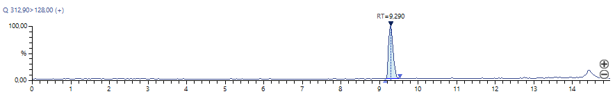
Aflatoxin B2
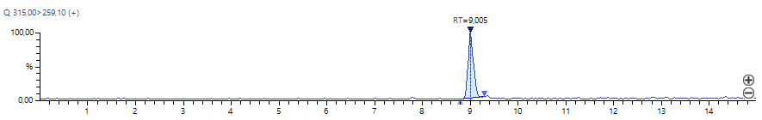
Aflatoxin G1
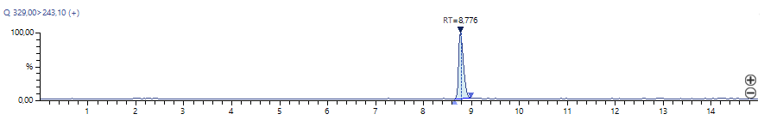
Aflatoxin G2
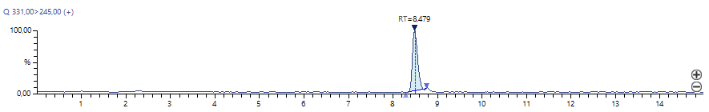
Tenuazonic acid
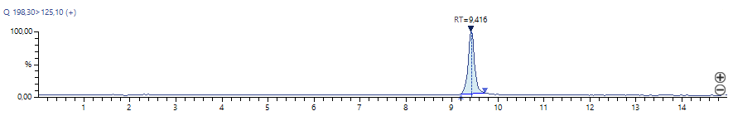
Alternariol
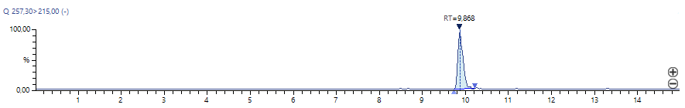

Figure S1. Chromatogram of MTs by HPLC-MS/MS

Table S2. Examination of unrefined and refined sunflower oils for AFs, AOH, and TEA residues in ELISA
Oil | AFB₁ |  |  | AOH |  |  | TEA |  |  | Total
Oil | < LOD (0.03 ng/mL) | < 2 ng/mL | > 2 ng/mL | < LOD (0.2 ng/mL) | < 10 ng/mL | > 10 ng/mL | < LOD (7.5 ng/mL) | < 100 ng/mL | > 100 ng/mL | Total
Unrefined | 5 | 6 | 0 | 1 | 6 | 4 | 1 | 7 | 3 | 11
Refined | 13 | 5 | 0 | 3 | 14 | 1 | 12 | 6 | 0 | 18

Table S3. Results of parallel testing of oil samples (n = 12) using ELISA and HPLC-MS/MS
Sample | Oil type | AFB₁ |  | AOH |  | TEA
Sample | Oil type | ELISA* | HPLC-MS/MS** | ELISA* | HPLC-MS/MS** | ELISA* | HPLC-MS/MS**
#1 | Linen | 0.05 | < LOQ | 2.7 | 13.0 | 165 | 325
#4 | Sunflower | 0.04 | < LOQ | 23.0 | 106 | 320 | 249
#13 | Sunflower | 0.03 | < LOQ | 10.0 | 28.6 | < LOD | < LOQ
#36 | Sunflower | 0.04 | < LOQ | 5.0 | 15.2 | 412 | 417
#39 | Sunflower | < LOD | < LOQ | 14.4 | 43.1 | 8.7 | 14.4
#48 | Linen | < LOD | < LOQ | 5.7 | 14.5 | 19.6 | 26.3
#51 | Sunflower | < LOD | < LOQ | 17.1 | 79.8 | 50.0 | 46.2
#53 | Hemp | 0.08 | < LOQ | 5.4 | 35.1 | 1097 | 728
#68 | Hemp | < LOD | < LOQ | 3.3 | 17.0 | 493 | 962
#84 | Pumpkin | 0.22 | < LOQ | < LOD | < LOQ | 10.8 | < LOQ
#86 | Linen | 0.14 | < LOQ | < LOD | < LOQ | < LOD | < LOQ
#107 | Hemp | 0.05 | < LOQ | 1.4 | 2.3 | 371 | 290
* ELISA concentrations are presented in ng/mL
** HPLC-MS/MS concentrations are in µg/kg. The density of most oil types is 0.8 g/cm³.
ELISA LODs of AFB₁, AOH, and TEA in oils were 0.03 ng/mL, 0.2 ng/mL, and 7.5 ng/mL.
HPLC-MS/MS LOQs of AFB₁, AOH, and TEA in oils were 0.5 µg/kg, 1.0 µg/kg, and 5.0 µg/kg, respectively.

