Supporting information
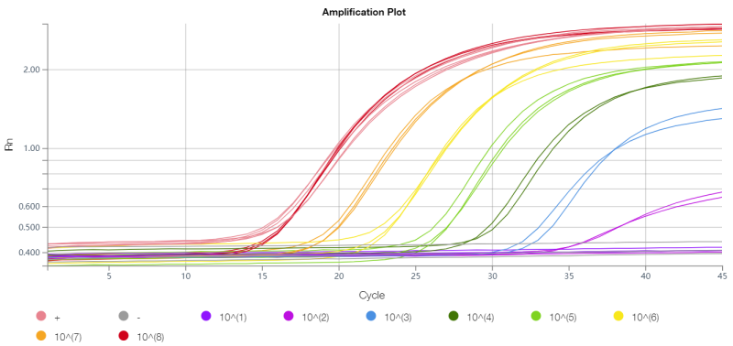
Fig. S1 Amplification curves of positive quality control samples ranging from 1.0 × 10⁸ to 1. 0 × 10 copies µL⁻¹

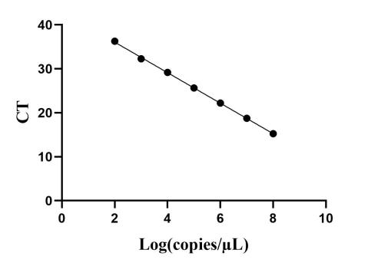
Fig. S2 Standard curve for positive quality control samples from 1.0 × 10⁸ to 1. 0 × 10² copies µL⁻¹
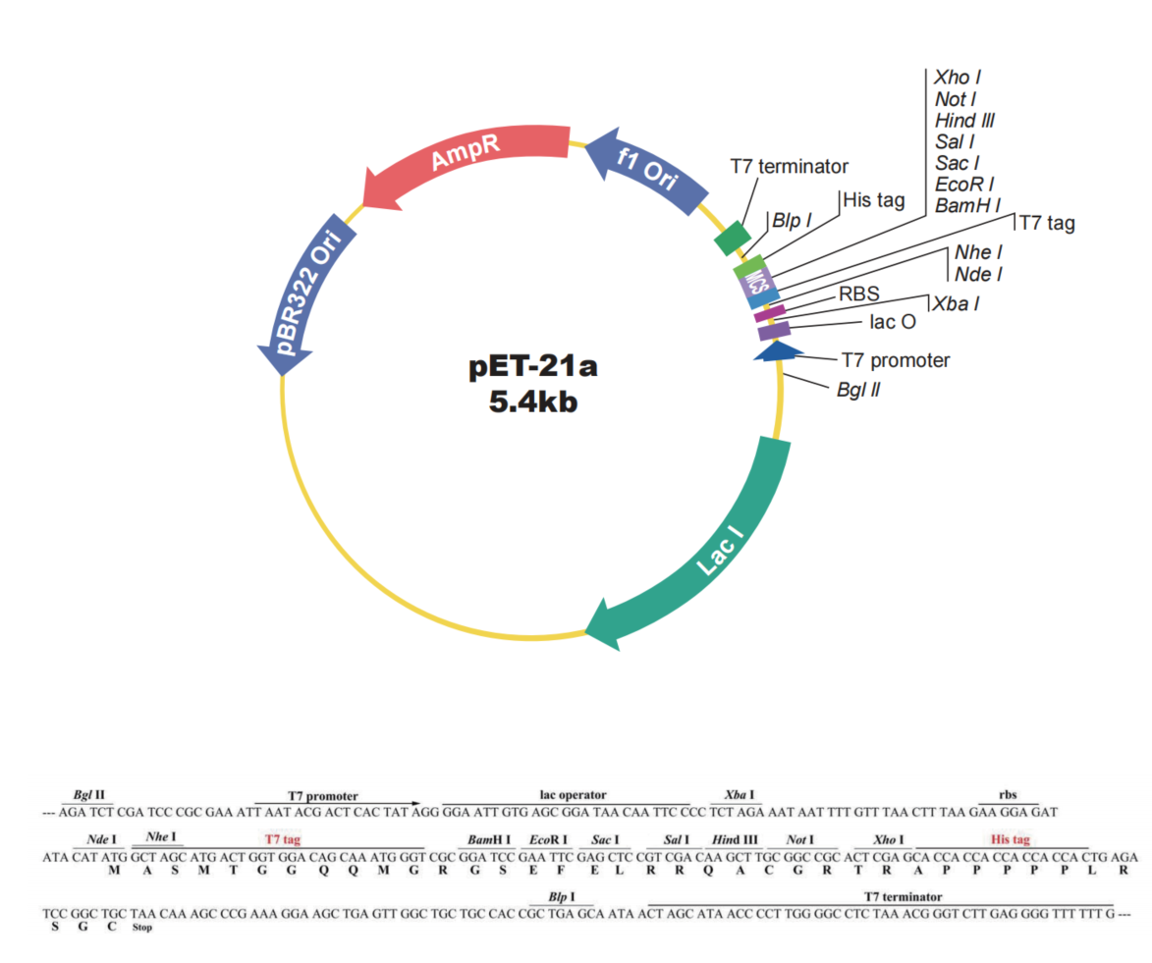
Fig. S3 Schematic representation of pET-21a(+)
Table S1 RT-PCR primers
Primer | Base sequence (5’–3’) | Number of bases
COGI(F) | CGCTGGATGCGNTTCCAT | 18
COGI(R) | CCTTAGACGCCATCATCATTTAC | 23
GI(PROBE) | FAM-TGGACAGGAGAYCGCRATCT-TAMRA | 20
COGII(F) | ATGTTCAGRTGGATGAGRTTCTCWGA | 26
COGII(R) | TCGACGCCATCTTCATTCACA | 21
GII(PROBE) | FAM-AGCACGTGGGAGGGCGATCG-TAMRA | 20

