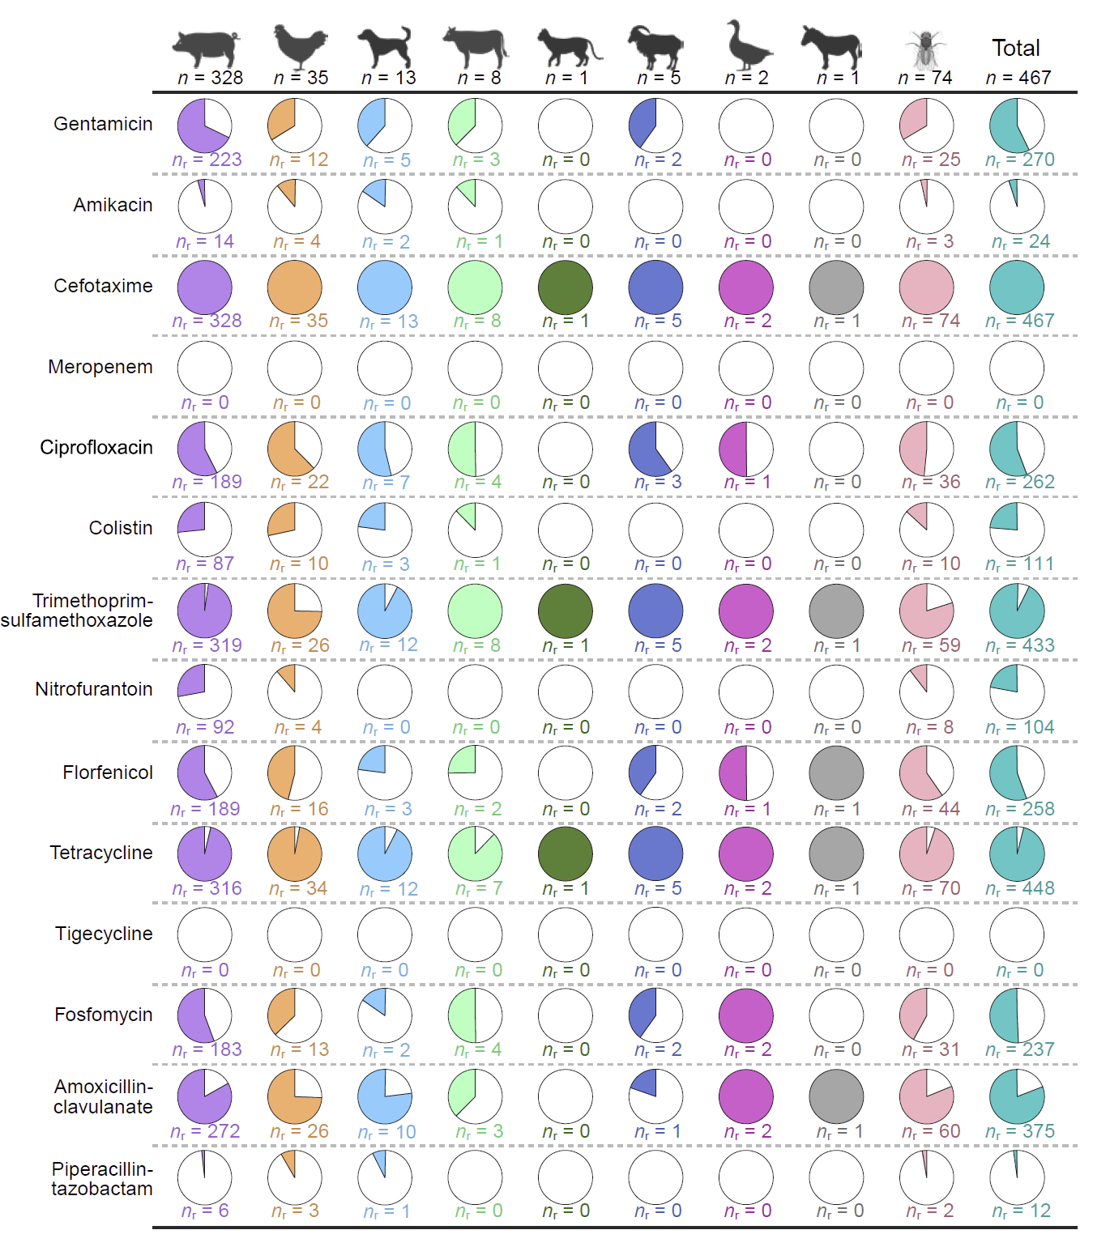
Fig. S1 Distribution of ESBL-Ec isolates and antimicrobial resistance in each backyard animal species. The numbers atop the horizontal lines indicate the total count of ESBL-Ec isolates retrieved from samples of each animal species, and the n_{r} values below each pie chart denote the subset of isolates exhibiting resistance to the specific antimicrobial agent. Each pie chart embodies the collective isolate count for the species, with the shaded portions signifying the quantity of resistant isolates.

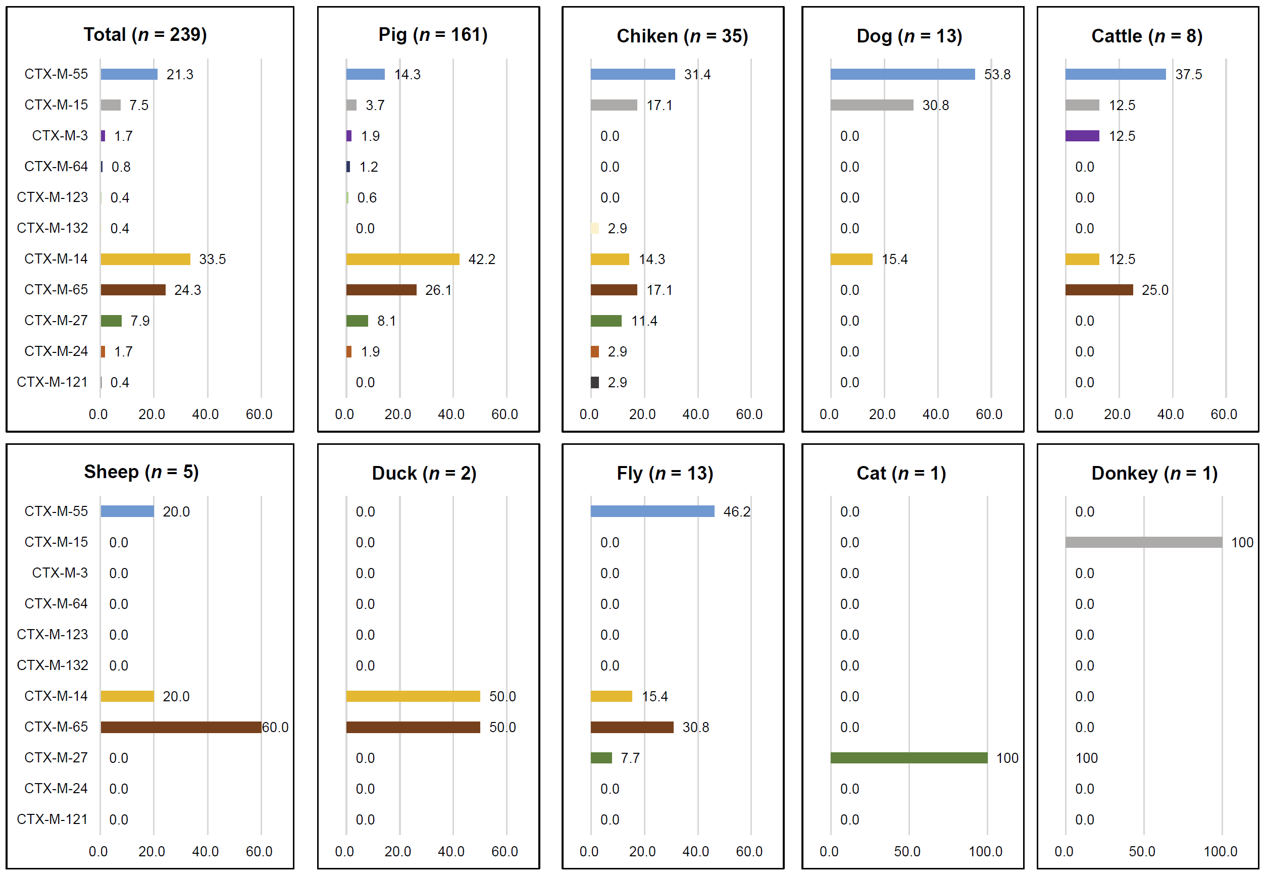Fig. S2 Distribution of bla_{CTX-M} subtypes among bla_{CTX-M}-positive isolates from different backyard animal species.

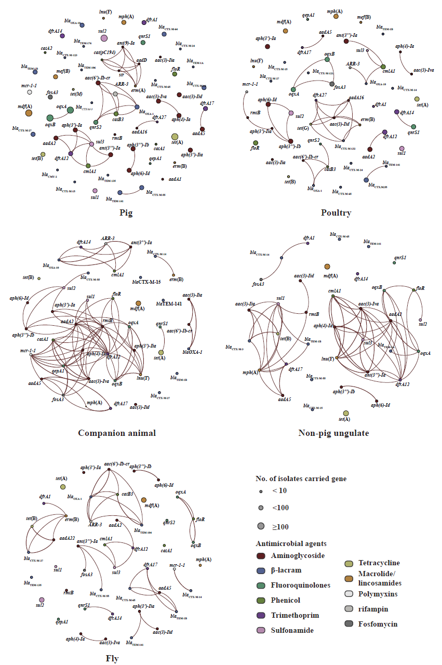
Fig. S3 Co-occurrence networks of AMR genes among isolates from different animals. Nodes in the network represent individual genes and differentiated by color to their corresponding antimicrobial class for AMR genes. The grouping of isolates corresponds to the host species as presented in Figure 2. Lines connecting nodes indicate statistically significant correlations between gene pairs (R > 0.6, P < 0.05), where the thickness of the lines is proportional to the strength of the correlation.
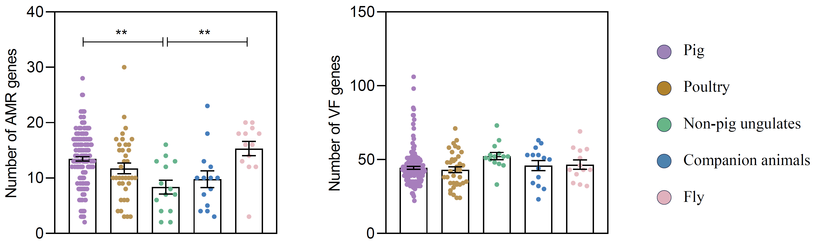
Fig. S4 Comparison of AMR genes and virulence genes among ESBL-Ec isolates derived from different source. The animal group classifications and nomenclature used are in accordance with Figure 2. Asterisks indicate statistically significant differences in the counts of these genes between isolates from two different animal groups.

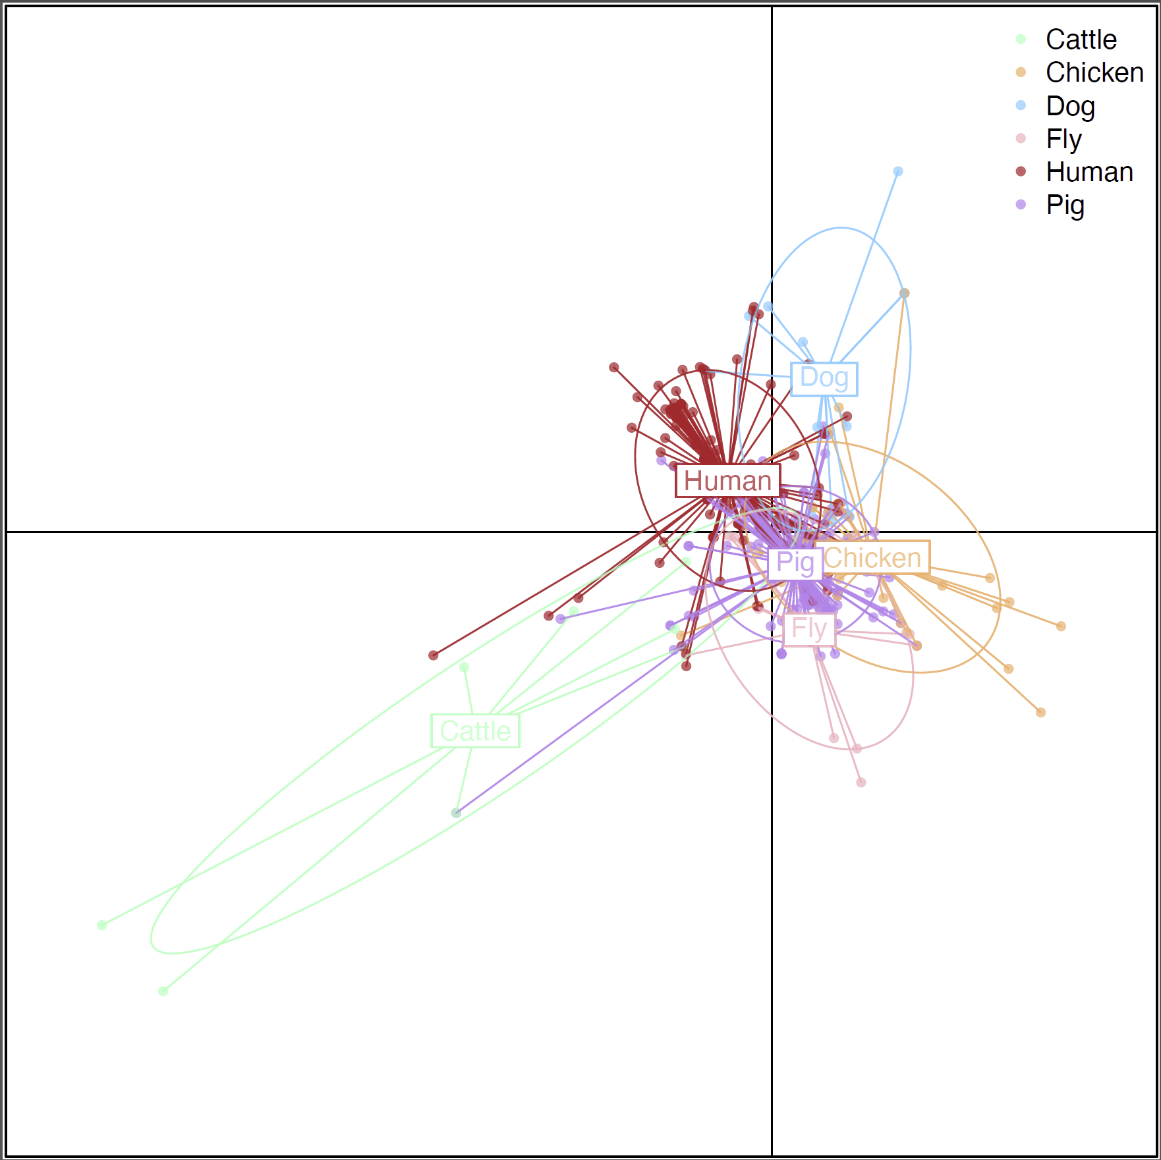Fig. S5 Discriminant analysis of principal components (DAPC) based on core-genome single-nucleotide polymorphism (SNP) profiles of ESBL-Ec isolates from backyard animals (pig, chicken, dog, cattle and fly) in this study and human isolates from China retrieved from the NCBI database. Each point represents an individual isolate, and colors indicate host sources. Ellipses represent the clustering of isolates from each host group. The substantial overlap among clusters from different animal hosts and humans indicates a high degree of genetic similarity and lack of clear host-specific separation, suggesting potential inter-host transmission and shared genetic backgrounds of ESBL-Ec isolates.

