Engineering novel Yarrowia lipolytica whole-cell biocatalysts by cell surface display of the native Lip2 lipase for biodiesel production
Maria Orfanidou, Eleftheria Panagiotidou, Antonios M Makris, Eleni Theodosiou

SUPPLEMENTARY MATERIAL
Table S1. List of plasmids used in this study.
Plasmid | Characteristics | Source
TOPO-ΤΑ cloning vectors
pCRII-LIP2 | prLac, LacZa, prSp6, LIP2, prT7, f1 ori, KmR, AmpR, pUC ori | [1]
pCRII-TOPO-LIP2 | prLac, LacZa, prSp6, LIP2, prT7, f1 ori, KmR, AmpR, pUC ori | This study
pCRII-TOPO-mCherry | prLac, LacZa, prSp6, mCherry, prT7, f1 ori, KmR, AmpR, pUC ori | INAB/CERTH strain collection
pCRII-TOPO-PIR1 | prLac, LacZa, prSp6, PIR1, prT7, f1 ori, KmR, AmpR, pUC ori | This study
pCRII-TOPO-EGFP | prLac, LacZa, prSp6, EGFP, prT7, f1 ori, KmR, AmpR, pUC ori | INAB/CERTH strain collection
Addgene plasmids for reporter gene amplification
pLentiCRISPRv2-mCherry | http://n2t.net/addgene:99154;  RRID:Addgene_99154 | Gift from Agata Smogorzewska
pcDNA3-EGFP | http://n2t.net/addgene:13031;  RRID:Addgene_13031 | Gift from Doug Golenbock
Basic EasyCloneYALI integrative vectors
pCfB4782 | http://n2t.net/addgene:106141;  RRID:Addgene_106141 | Gift from Irina  Borodina [2]
Parental replicative vectors
pBlueScript SK(-) | AmpR, f1 ori, pUC ori
Replicative vectors
pBlue-YlPIR1 | AmpR, f1 ori, pUC ori, YlPIR1 | This study
pΒlue-YlPIR1-LIP2 | AmpR, f1 ori, pUC ori, YlPIR1-LIP2 | This study
pΒlue-YlPIR1-mCherry | AmpR, f1 ori, pUC ori, YlPIR1-mCherry | This study
Basic integrative vectors
pYLEXP1 IntE_4 | AmpR, pUC ori, IntE_4 UP, TPex20, prEXP1, TLip2, loxP, prTEFintron-NAT-Tcyc1, loxP, IntE_4 DW | [1]
pYLEXP1 IntF_3 | AmpR, pUC ori, IntF_3 UP, TPex20, prEXP1, TLip2, loxP, prTEFintron-NAT-Tcyc1, loxP, IntF_3 DW | [1]
pYLH3 IntF_3 | AmpR, pUC ori, IntF_3 UP, TPex20, prH3, TLip2, loxP, prTEFintron-NAT-Tcyc1, loxP, IntF_3 DW | [1]
pYLUAS1B8_TMAL(250) IntC_2 | AmpR, pUC ori, IntC_2 UP, TPex20, prUAS1B8-TMAL(250), TLip2, loxP, prTEFintron-NAT-Tcyc1, loxP, IntC_2 DW | [1]
Intermediate integrative vectors
pYLEXP1-YlPIR1 IntE_4 | AmpR, pUC ori, IntE_4 UP, TPex20, prEXP1-YlPIR1-Tlip2, loxP, prTEFintron-NAT-Tcyc1, loxP, IntE_4 DW | This study
pYLEXP1-mCherry IntF_3 | AmpR, pUC ori, IntF_3 UP, Tpex20, prEXP1-mCherry-Tlip2, loxP, prTEFintron-NAT-Tcyc1, loxP, IntF_3 DW | This study
Integrative vectors with YlPIR1-LIP2 fusion
pYLEXP1-YlPIR1-LIP2 IntE_4 | AmpR, pUC ori, IntE_4 UP, TPex20, prEXP1-YlPIR1- LIP2-TLip2, loxP, prTEFintron-NAT-Tcyc1, loxP, IntE_4 DW | This study
pYLEXP1-YlPIR1-LIP2 IntF_3 | AmpR, pUC ori, IntF_3 UP, TPex20, prEXP1-YlPIR1-LIP2-TLip2, loxP, prTEFintron-NAT-Tcyc1, loxP, IntF_3 DW | This study
pYLH3-YlPIR1-LIP2 IntF_3 | AmpR, pUC ori, IntF_3 UP, TPex20, prH3-YlPIR1-LIP2-TLip2, loxP, prTEFintron-NAT-Tcyc1, loxP, IntF_3 DW | This study
pYLUAS1B8-TMAL(250)-YlPIR1-LIP2 IntC_2 | AmpR, pUC ori, IntC_2 UP, TPex20, pr prUAS1B8-TMAL(250)-YlPIR1-LIP2-TLip2, loxP, prTEFintron-NAT-Tcyc1, loxP, IntC_2 DW | This study
Integrative vectors with YlPIR1-mCherry fusion
pYLEXP1-YlPIR1-mCherry IntE_4 | AmpR, pUC ori, IntE_4 UP, TPex20, prEXP1-YlPIR1-mCherry-TLip2, loxP, prTEFintron-NAT-Tcyc1, loxP, IntE_4 DW | This study
pYLEXP1-YlPIR1-mCherry IntF_3 | AmpR, pUC ori, IntF_3 UP, TPex20, prEXP1-YlPIR1-mCherry-TLip2, loxP, prTEFintron-NAT-Tcyc1, loxP, IntF_3 DW | This study
pYLH3-YlPIR1-mCherry IntF_3 | AmpR, pUC ori, IntF_3 UP, TPex20, prH3-YlPIR1-mCherry-TLip2, loxP, prTEFintron-NAT-Tcyc1, loxP, IntF_3 DW | This study
pYLUAS1B8-TMAL(250)-YlPIR1-mCherry IntC_2 | AmpR, pUC ori, IntC_2 UP, TPex20, prUAS1B8-TMALp(250)-YlPIR1-mCherry-TLip2, loxP, prTEFintron-NAT-Tcyc1, loxP, IntC_2 DW | This study
Integrative vector with EGFP gene
pYLH3-EGFP IntF_3 | AmpR, pUC ori, IntF_3 UP, TPex20, prH3-EGFP-TLip2, loxP, prTEFintron-NAT-Tcyc1, loxP, IntF_3 DW | This study
Εpisomal vector for excision of the antibiotic resistance gene NAT
pHYLH3-Cre rec | AmpR, f1 ori, pUC ori, ARS18, prH3-Cre rec-Tsynth2, loxP, prEXP1-HphSyn-Ttef, loxP | INAB/CERTH strain collection

Table S2. List of primers used in this study.
Template DNA | Amplified Element | Name | Sequence
Genomic DNA (gDNA) of Y. lipolytica MUCL 28849 | YlPIR1 | YlPIR1-BamHI-F | ggatccatgctcttcaagtccgctgccgtctc
Genomic DNA (gDNA) of Y. lipolytica MUCL 28849 | YlPIR1 | YlPIR1-EcoRI-nS-R | gaattcacagtcctcgaggttgacgatgg
pCRII-LIP2 | LIP2 | LIP2-EcoRI-F | gaattcatgaagctttccaccatcctcttcacag
pCRII-LIP2 | LIP2 | LIP2-SalI-R | gtcgacttagataccacagacaccctcggtgacgaag
pLentiCRISPRv2-mCherry | mCherry | mChe-B-E | ggatccgaattcatggtgagcaagggcgag
pLentiCRISPRv2-mCherry | mCherry | mChe-XhoI | ctcgagttacttgtacagctcgtcc
pcDNA3-EGFP | EGFP | mChe-B-E | ggatccgaattcatggtgagcaagggcgag
pcDNA3-EGFP | EGFP | mChe-XhoI | ctcgagttacttgtacagctcgtcc
pYLEXP1-YlPIR1-mCherry IntF_3 | YlPIR1-mCherry | GBN-H3-PIR1 | cactccaacaaacaaatacaggatccatgctcttcaagtccgctgcc
pYLEXP1-YlPIR1-mCherry IntF_3 | YlPIR1-mCherry | GBN-ts-mChe-SalI-R | cagaaggaatgcacgcgatctcgaggtcgacttacttgtacagctcgtccat
pYLUAS1B8-TMAL(250) IntC_2 | UAS1B8-TMAL(250) | pCfB-F | tccacacttcaacggaatgcgtg
pYLUAS1B8-TMAL(250) IntC_2 | UAS1B8-TMAL(250) | pCfB-R | gattccgaacagaaggaatgcac

Table S3. List of primers used in this study for verification of successful excision of antibiotic resistance gene NAT.
Primers used for excision verification
Integrative vectors | Nat2-F | tggatggttctttcactactgacactgt
Integrative vectors | Nat2-R | caaggcttgttcaccatctgatgcag
Episomal vector pHLYH3/Cre rec used for excision | HYG373-F | tcggctccaacaatgtcctgacgg
Episomal vector pHLYH3/Cre rec used for excision | HYG373-R | tctacacagccatcggtccagacgg
Integrative vectors with YlPIR1-LIP2 genes | PIR1seq | tcaggctggtgcttggtacgctg
Integrative vectors with YlPIR1-LIP2 genes | RT-LIP2-A-R | ggactcctggtcaatgtgagaggt
Integrative vectors with YlPIR1-mCherry genes | PIR1seq | tcaggctggtgcttggtacgctg
Integrative vectors with YlPIR1-mCherry genes | mChe-XhoI | ctcgagttacttgtacagctcgtcc

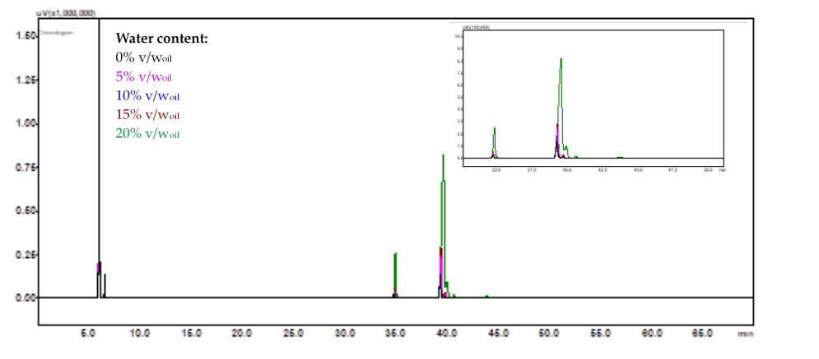
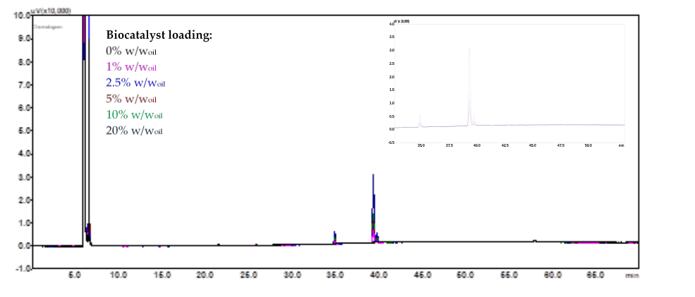
Figure S1. GC-FID chromatograms obtained from the analysis of reaction mixtures after 7 days reaction at 40 °C, 200 rpm, 3:1 ratio of methanol:olive oil, and catalysed by UAS1B8-TMAL(250)-YlPIR1-LIP2 IntC_2 biomass grown in bioreactor under low agitation conditions (150-300 rpm), harvested after 72 h of cultivation, and lyophilized. Upper panel: Water content of 0% v/w (black), 5% v/w (pink), 10% v/w (purple), 15% v/w (brown), 20% v/w (green). Lower panel: Biocatalyst loading of 0% w/w (black), 1% w/w (pink), 2.5% w/w (purple), 5% w/w (brown), 10% w/w (green), 20% w/w (dark blue).

REFERENCES
[1] I. Georgiadis et al., ‘Identification and Construction of Strong Promoters in Yarrowia lipolytica Suitable for Glycerol-Based Bioprocesses’, Microorganisms, vol. 11, no. 5, 2023, doi: 10.3390/microorganisms11051152.
[2] C. Holkenbrink et al., ‘EasyCloneYALI: CRISPR/Cas9-Based Synthetic Toolbox for Engineering of the Yeast Yarrowia lipolytica’, Biotechnology Journal, vol. 13, no. 9, Sep. 2018, doi: 10.1002/biot.201700543.

