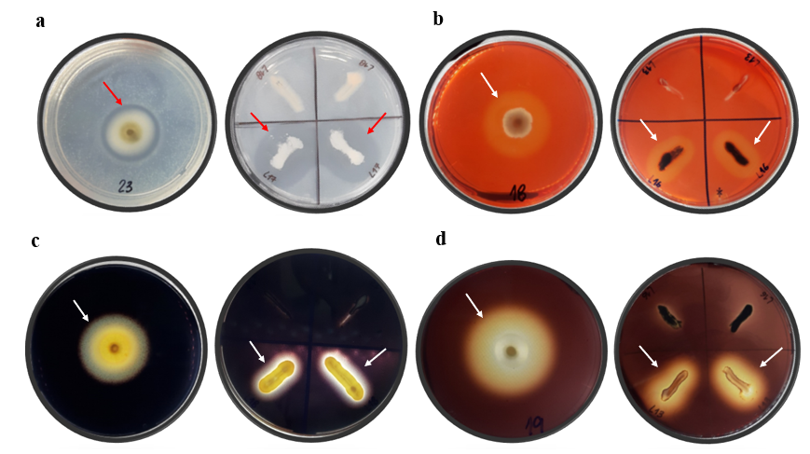
Supplementary Figure 1. Observation of halos, indicated by arrows, formed by the degradation of the substrate present in solid medium in filamentous isolates (left) and yeasts (right). (a) Pectinase action, with the formation of a transparent halo on a white background; (b) cellulase action, with the formation of an orange halo on a red background; (c) amylase action, with the formation of a transparent halo on a dark background; (d) inulinase action, with the formation of a yellowish halo on a brown background. Photographs: E.A.A. Teixeira.

Supplementary Figure 2. Growth of the yeast Solicoccozyma terricola at different temperatures for 3 and 7 days. (a) Growth on day 3 and (b) on day 7. Photographs: E.A.A. Teixeira.

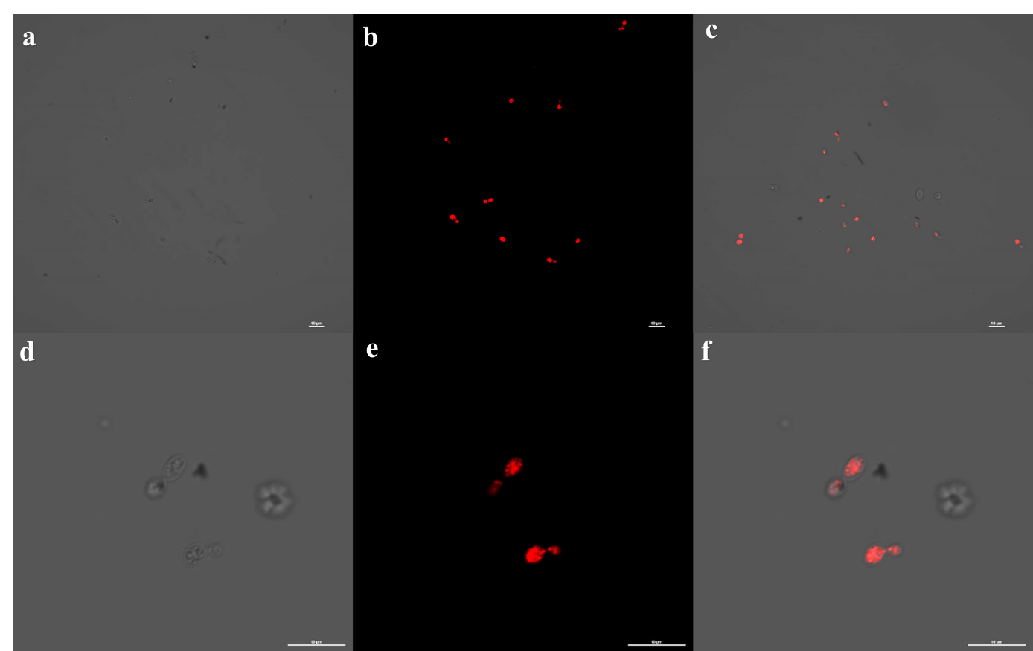
Supplementary Figure 3. Lipid production by yeast isolate Solicoccozyma terricola UFMGCB 18984. (a) Bright field view, (b) fluorescence filter view, (c) overlay of images (a) and (b); (d) close-up view of two cells in bright field, (e) close-up view of two cells with fluorescence filter, (f) overlay of images (d) and (e). The internal bar scales represent 10 µm. Photographs: C.R. Carvalho.

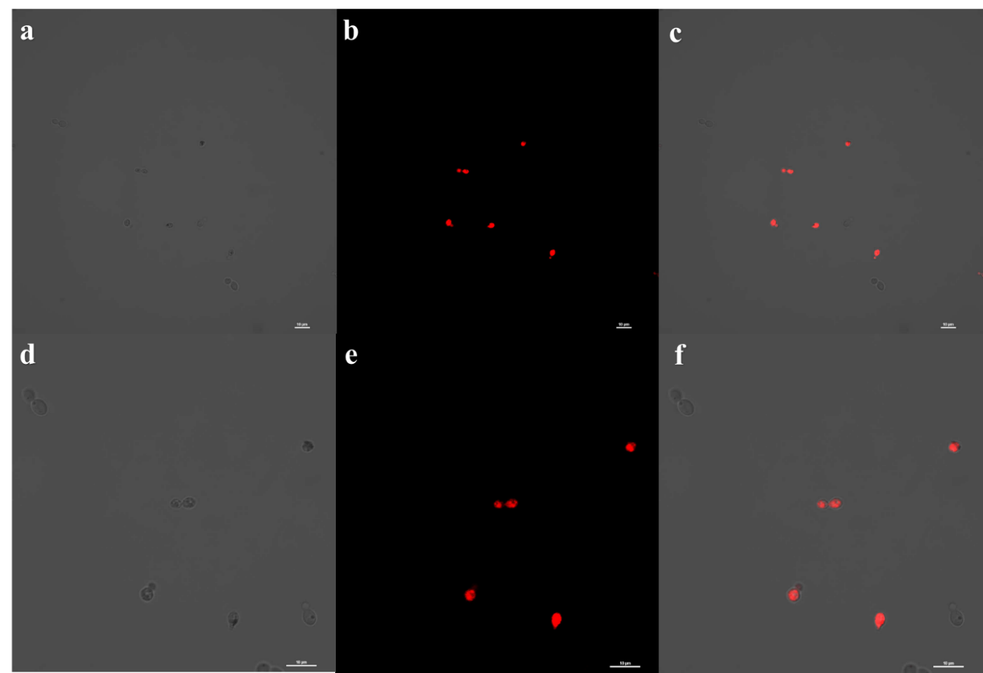
Supplementary Figure 4. Lipid production by yeast isolate Solicoccozyma terricola UFMGCB 18985. (a) Bright field view, (b) view with fluorescence filter, (c) overlay of images (a) and (b); (d) close-up view of cells in bright field, (e) close-up view of cells with fluorescence filter, (f) overlay of images (d) and (e). The internal bar scales represent 10 µm. Photographs C.R. Carvalho.

