Supplementary File
Unlocking the potential of Chitosan and Alginate for Congo red Dye Removal by Economical Modifications in Batch and Column Study
Palak Saket¹, Gunjan Nagpure¹, Kiran Bala¹, Abhijeet Joshi^{1,*}

¹ Department of Biosciences and Biomedical Engineering, Indian Institute of Technology Indore, Khandwa Road, Indore- 453552, Madhya Pradesh, India

*Corresponding author
1. Dr. Abhijeet Joshi, PhD
Associate Professor,
Department of Biosciences and Biomedical Engineering
Indian Institute of Technology Indore, Khandwa Road,
Simrol, Indore 453552, Madhya Pradesh
Email: abhijeet.joshi@iiti.ac.in

S1 Adsorption isothermal modelling
Isothermal modelling helps in comprehending the correlation between the quantity of dye adsorbed per unit mass of adsorbent at a constant temperature and the equilibrium concentration of dye in the liquid phase. The adsorption data applied in Langmuir, Freundlich, and Temkin adsorption isothermal models and allowed for a comparison among different carriers in the present study. Langmuir isotherm model is commonly studied model which states: formation of a single layer of adsorbate molecules on adsorbent’s surface. Moreover, it also suggests the distribution of homogenous adsorption energy of adsorbed molecule on surface of adsorbent. The model anticipates the dispersion of uniform adsorption energy and the formation of a single layer of adsorbed species on the surface of adsorbent. Hence, the linear equation of Langmuir model is shown by equation 1 -
$$\frac{C_{e}}{q_{e}}=\frac{1}{K_{L}q_{0}}+\frac{C_{e} }{q_{0}} \left(1\right)$$
Here, C_{e} (mg L⁻¹) represent the dye concentration at equilibrium, q_{e} (mg g⁻¹) is the quantity of dye adsorbed by a particular amount of adsorbent at equilibrium. K_{L} – model constant (slope value) and q₀ (mg g⁻¹) - maximum adsorption capacity (intercept value) and the linear curve plotted as 1/q_{e} against 1/C_{e} [1]. On the other hand, Freundlich isotherm model also describes about the distribution of solute on the adsorbent surface. This model predicts the variations in the heterogenous distribution of adsorption energy on the adsorbent surface. Hence, the linear equation of Freundlich model is shown by equation 2-
$\log{q_{e}= }logK_{F}+\left(\frac{1}{n}\right)C_{e} \left(2\right)$ Here, q_{e} (mg g⁻¹) - quantity of dye adsorbed by a particular amount of adsorbent at equilibrium, C_{e} (mg L⁻¹) - dye concentration at equilibrium, K_{F} (L g⁻¹) - adsorption capacity (intercept) and 1/n is the adsorption intensity (slope). The linear plot log q_{e} against log C_{e} shows the applicability of Freundlich Isotherm [2]. Similarly, Temkin isothermal model also discusses about the interaction mechanism of adsorbate and adsorbent. This model operates under the following assumptions: (i) during the interaction of adsorbate and adsorbent adsorption energy for adsorbing molecules decreases linearly with its distribution over the adsorbent surface and (ii) The adsorption is defined by a consistent distribution of binding energies, until reaching a specific maximum binding energy. The linear equation of Temkin Isotherm is shown in equation 3-
$$qe=B_{1}lnK_{t}+B_{1}lnC_{e} \left(3\right)$$
Here, q_{e}- quantity of dye adsorbed by a particular amount of adsorbent at equilibrium (mg g⁻¹), C_{e} – dye concentration at equilibrium (mg L⁻¹), K_{t} - binding constant at equilibrium (L g⁻¹) and B₁ - related to the heat of adsorption. The linear plot of q_{e} against ln C_{e} shows the applicability of Temkin isotherm.

List of figures:
- Fig. S1 Column set up for dye adsorption study
- Fig. S2 Impact of contact time on dye removal (a) Ch, (b) Ch/char, (c) Ch/algae, (d) Alg, (e) Alg/char, (f) Alg/algae, (g) Algae and (h) Char in batch experiment
- Fig. S3 Linear plots for Pseudo seconder order kinetic model for the adsorption of CR dye onto (a) Ch, (b) Ch/char, (c) Ch/algae, (d) Alg, (e) Alg/char (f) Alg/algae, and (g) charcoal
- Fig. S4 Intraparticle diffusion model for (a) Ch, (b) Ch/char, (c) Ch/algae, (d) Alg, (e) Alg/char (f) Alg/algae, and (g) charcoal
- Fig. S5 Linear plots for Langmuir isotherm for CR adsorption by (a) Ch. (b) Ch/char and (c) Ch/algae
- Fig. S6 Linear plots for Freundlich isotherm for CR adsorption by (a) Alg. (b) Alg/char, (c) Alg/algae, and (d) charcoal

Fig. S1 Column set up for dye adsorption study
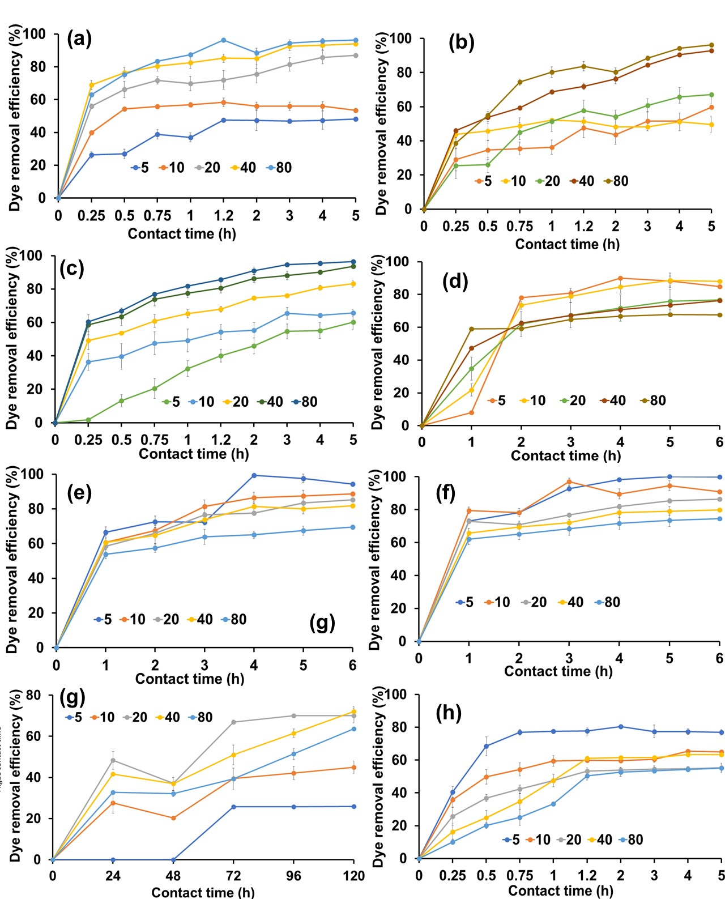
Fig. S2 Impact of contact time on dye removal (a) Ch, (b) Ch/char, (c) Ch/algae, (d) Alg, (e) Alg/char, (f) Alg/algae, (g) Algae and (h) Char in batch experiment

Fig. S3 Linear plots for Pseudo seconder order for the adsorption of CR dye onto (a) Ch, (b) Ch/char, (c) Ch/algae, (d) Alg, (e) Alg/char (f) Alg/algae, and (g) charcoal

Fig. S4 Intraparticle diffusion model for (a) Ch, (b) Ch/char, (c) Ch/algae, (d) Alg, (e) Alg/char (f) Alg/algae, and (g) charcoal
Fig. S5 Linear plots for Langmuir isotherm for CR adsorption by (a) Ch. (b) Ch/char and (c) Ch/algae
Fig. S6 Linear plots for Freundlich isotherm for CR adsorption by (a) Alg. (b) Alg/char, (c) Alg/algae, and (d) charcoal

References:
- Miri, N. S. S. (2022). Equation Study of Langmuir and Freundlich Isotherms on Adsorption of Heavy Metal Fe (II) with Zeolite and Activated Carbon from Biomass: Review: Kajian Persamaan Isoterm Langmuir dan Freundlich pada Adsorpsi Logam Berat Fe (II) dengan Zeolit dan Karbon Aktif dari Biomassa. Jurnal Kimia Dan Rekayasa, 2(2), 58-71.
- Kalam, S., Abu-Khamsin, S. A., Kamal, M. S., & Patil, S. (2021). Surfactant adsorption isotherms: A review. ACS omega, 6(48), 32342-32348.

