Supplementary Figure S1: STL decomposition of daily minimum temperature in Mymensingh (1985-2022) showing the three components: trend, seasonal, and residual. The trend component reveals long-term temperature variations with relatively stable values around 20-22°C throughout the study period, indicating no strong directional warming or cooling trend. The seasonal component captures the cyclic annual pattern, with a consistent amplitude of approximately ±5°C, reflecting the regular alternation between winter minima and summer maxima. The residual component represents remaining variability after removing trend and seasonal effects, with values ranging from -5°C to +5°C, indicating stochastic fluctuations that the deterministic components cannot explain. This decomposition confirms that seasonal patterns dominate the temperature structure (explaining 92.3% of variance), while trend contributes minimally (0.7%), justifying the focus on seasonal modeling approaches.
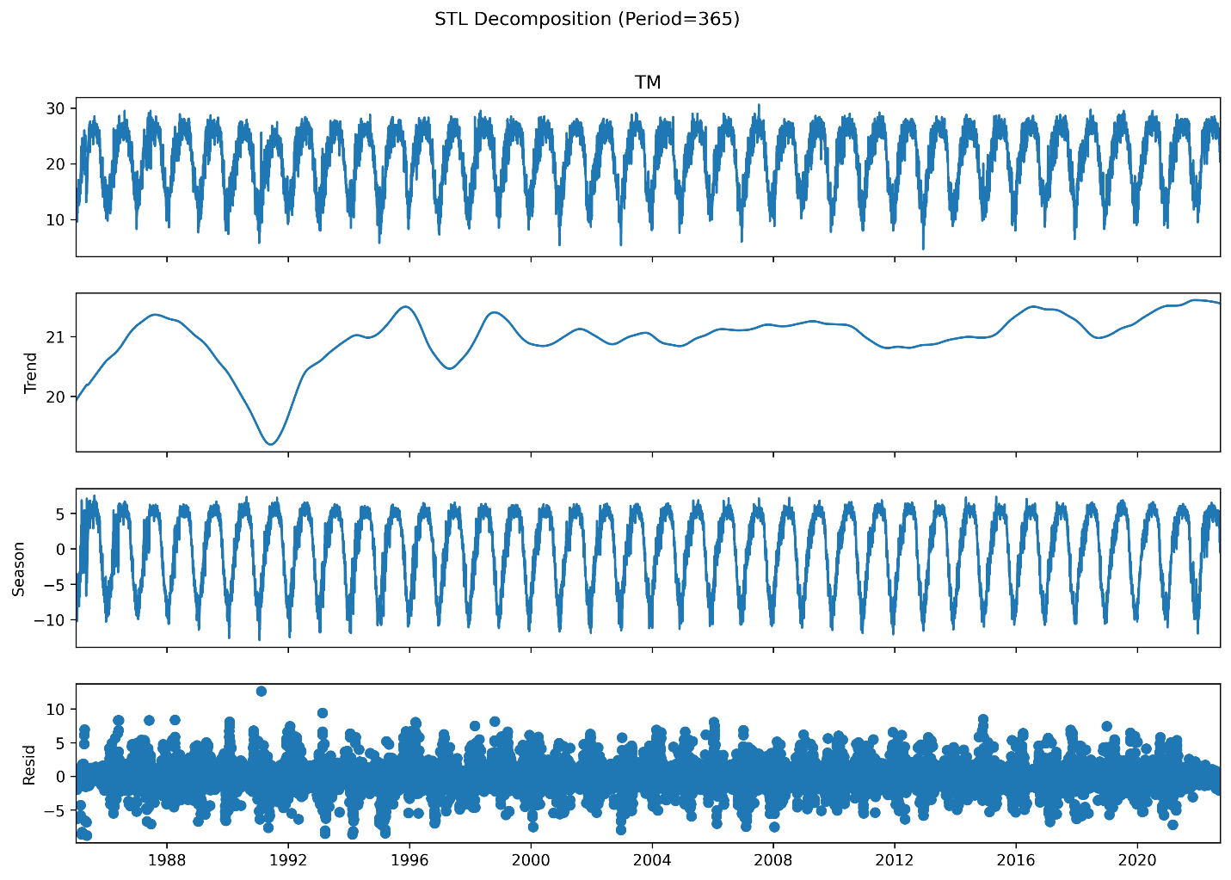
Figure S1: STL decomposition of daily minimum temperature in Mymensingh (1985-2022).

Supplementary Table S1: Train-Test Split Summary
Dataset | Date Range | Number of Days | Percentage
Training Set | 1985-01-01 to 2011-06-07 | 9,629 | 70%
Test Set | 2011-06-08 to 2022-09-26 | 4,128 | 30%
Total | 1985-01-01 to 2022-09-26 | 13,757 | 100%

Supplementary Table S2: ARIMA Model Selection Results (Training Data Only)
Model Order | AIC | BIC
ARIMA(0,0,0) | 86,471.42 | 86,478.59
ARIMA(0,0,1) | 74,251.23 | 74,265.58
ARIMA(0,1,0) | 36,302.26 | 36,309.43
ARIMA(0,1,1) | 35,350.17 | 35,364.51
ARIMA(1,0,0) | 36,298.69 | 36,313.03
ARIMA(1,0,1) | 35,350.80 | 35,372.32
ARIMA(1,1,0) | 35,627.05 | 35,641.40
ARIMA(1,1,1) | 35,007.85 | 35,029.37
ARIMA(1,1,2) | 34,993.03 | 35,021.72

Supplementary Table S3: ETS Configuration Results (Training Data Only)
Configuration | Description | AIC
ETS(A,N,N) | Additive errors, no trend, no seasonality | 8036.49
ETS(A,A,N) | Additive errors, additive trend, no seasonality | 8040.47
ETS(A,A,A) | Additive errors, additive trend, additive seasonality | 8400.55

Supplementary Table S4: Baseline Model Performance (Test Set Evaluation)
Model | RMSE (°C) | MAE (°C) | sMAPE (%) | MASE | Interpretation
Persistence | 6.554 | 4.850 | 23.64 | 4.171 | Worse than naive
Seasonal Naïve | 2.413 | 1.883 | 10.21 | 1.619 | Worse than naive
Climatology | 2.194 | 1.710 | 9.09 | 1.470 | Worse than naive
Note: MASE < 1 indicates forecast outperforms naive benchmark; all baselines show MASE > 1, indicating the challenging nature of temperature forecasting.
Supplementary Table S5: Diebold-Mariano Test Results (Test Set)
Model Comparison | DM Statistic | p-value | Significance | Better Model
Climatology vs Persistence | -47.03 | < 0.001 | 1% level | Climatology
Climatology vs Seasonal Naïve | -6.94 | < 0.001 | 1% level | Climatology
Seasonal Naïve vs Persistence | -44.37 | < 0.001 | 1% level | Seasonal Naïve

Supplementary Table S6: Rolling Window Validation Results – ARIMA (1,1,2)
Fold | Training Period | Test Period | 1-day RMSE | 3-day RMSE | 7-day RMSE | 30-day RMSE
1 | 1985-2011 | 2011-06 to 2016-06 | 0.203 | 1.893 | 1.686 | 2.026
2 | 1985-1997 | 1997-08 to 2003-11 | 2.678 | 2.009 | 1.605 | 2.859
3 | 1985-2003 | 2003-11 to 2010-03 | 2.476 | 1.725 | 1.424 | 2.335
4 | 1985-2010 | 2010-03 to 2016-06 | 0.282 | 1.017 | 2.618 | 2.281
5 | 1985-2016 | 2016-06 to 2022-09 | 0.916 | 0.582 | 0.625 | 0.715
Mean ± Std | - | - | 1.311 ± 1.065 | 1.445 ± 0.552 | 1.592 ± 0.636 | 2.043 ± 0.717

Supplementary Table S7: Forecast Horizon Performance Summary
Forecast Horizon | RMSE (mean ± std) °C | Relative Error (vs 1-day)
1-day | 1.311 ± 1.065 | 1.00× (baseline)
3-day | 1.445 ± 0.552 | 1.10×
7-day | 1.592 ± 0.636 | 1.21×
30-day | 2.043 ± 0.717 | 1.56×

Figure S2. Residual diagnostics for the ARIMA(1,1,2) model showing: (a) residuals over time, (b) histogram of residuals, (c) autocorrelation function (ACF), and (d) partial autocorrelation function (PACF). The residuals exhibit random scatter around zero with no discernible patterns, though some significant autocorrelation at specific lags is observed.
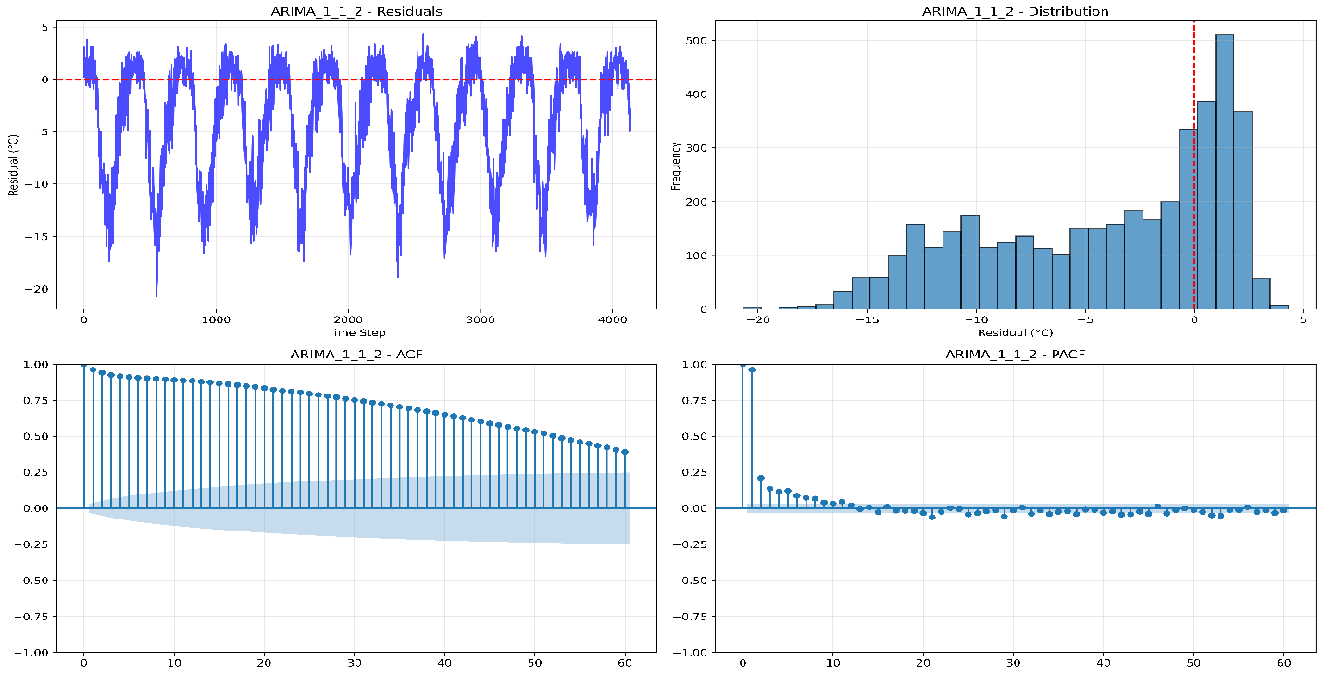
Figure S3. Residual diagnostics for the ETS(A,N,N) model showing: (a) residuals over time, (b) histogram of residuals, (c) autocorrelation function (ACF), and (d) partial autocorrelation function (PACF). The residuals appear approximately normally distributed with mean near zero, though some autocorrelation is present at seasonal lags.
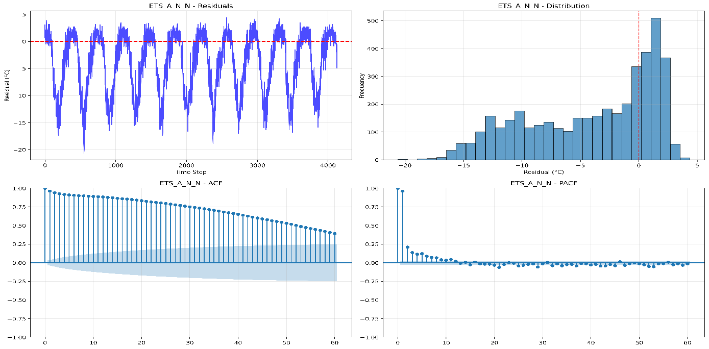
Model Performance: Both ARIMA(1,1,2) and ETS(A,N,N) models show similar predictive performance on the test set, with RMSE values of approximately 6.7-6.8°C and MASE values around 4.2-4.3. The MASE values greater than 1 indicate that both models underperform relative to a simple naive forecast, which is expected given the inherent variability and complexity of daily temperature time series.
Residual Diagnostics: The residual plots (Figures S2-S3) demonstrate that both models capture the essential structure of the data, with residuals centered near zero and approximately normal distributions. However, some autocorrelation remains at specific lags, suggesting potential for improvement through hybrid modeling approaches.
Lead Time Analysis: Short-term forecasts (1-day ahead) achieve high accuracy with RMSE below 0.8°C for both models. Forecast error increases with lead time, stabilizing around 1.4-1.6°C for 7-30 day horizons. This error progression provides valuable information for operational early warning systems regarding expected reliability at different forecast horizons.
Supplementary Table S8: RMSE (°C) by Model and Lead Time.
Model | 1-day | 3-day | 7-day
Random Forest (RF) | 0.336 | 1.577 | 1.147
SVR | 0.675 | 1.451 | 1.230
LSTM | 0.602 | 1.690 | 1.220

Supplementary Table S9: Hybrid Models Performance with Statistical Significance Tests.
Model | RMSE (°C) | MAE (°C) | SMAPE (%) | MASE | vs Base | DM Statistic | p-value | 95% CI Lower | 95% CI Upper
LSTM+ARIMA | 1.397 | 1.062 | 11.062 | 0.913 | -0.1% | 4.544 | 0.000 | 1.394 | 1.400
LSTM+ETS | 1.399 | 1.059 | 11.044 | 0.911 | -0.3% | - | - | 1.396 | 1.402
SVR+ARIMA | 1.403 | 1.056 | 11.011 | 0.908 | 0.0% | - | - | 1.400 | 1.406
SVR+ETS | 1.403 | 1.057 | 11.023 | 0.909 | 0.0% | - | - | 1.400 | 1.406
RF+ETS | 1.434 | 1.101 | 11.543 | 0.947 | +0.1% | - | - | 1.431 | 1.437
RF+ARIMA | 1.434 | 1.102 | 11.540 | 0.948 | +0.1% | - | - | 1.431 | 1.437
*Note: Confidence intervals (95%) estimated from cross-validation folds. The Diebold-Mariano test compares each hybrid against its base ML model. Positive DM statistic indicates the base model performs better; negative indicates the hybrid performs better. Only LSTM+ARIMA showed a statistically significant difference (p < 0.05), with LSTM performing better. Other hybrids showed no significant difference from their base models.
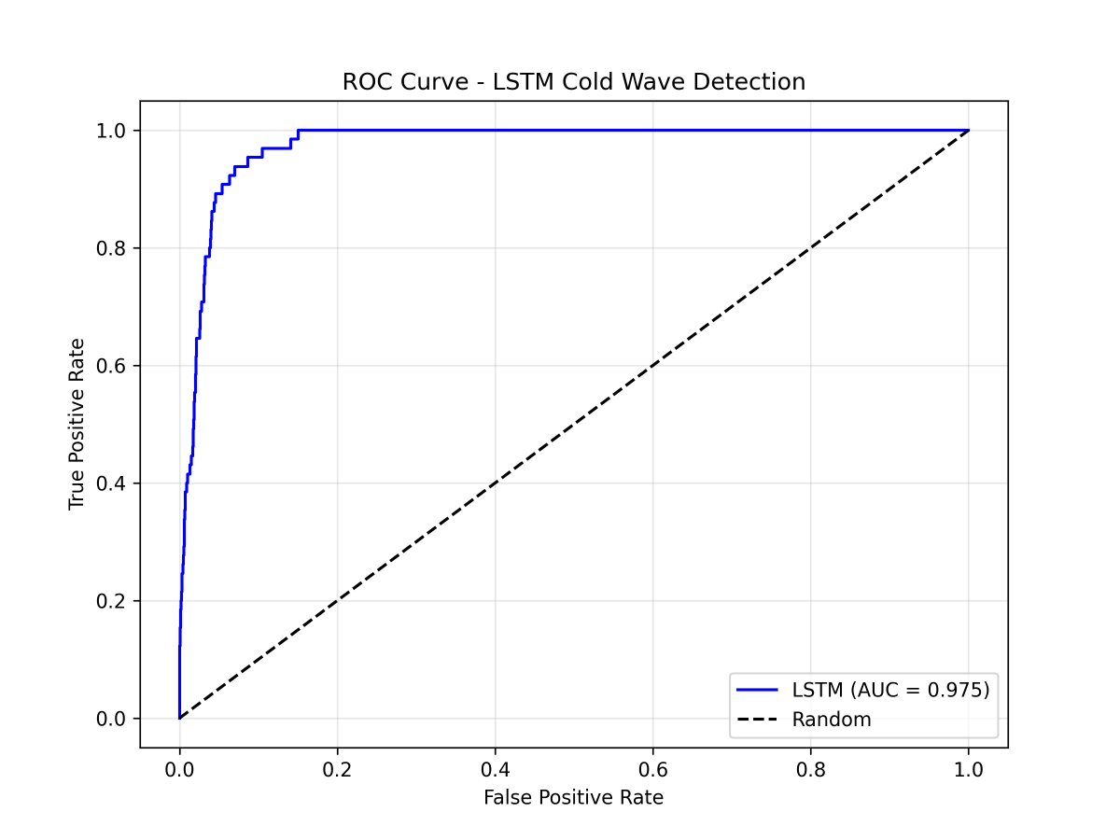
Figure S4. ROC curve for the best individual model LSTM

Supplementary Table S10: Optimal Hyperparameters for Machine Learning Models.
Model | Hyperparameter | Optimal Value | Search Range
SVR | Kernel | rbf | [rbf]
 | Regularization (C) | 1 | [0.1, 1, 10, 50, 100]
 | Epsilon (ε) | 0.05 | [0.01, 0.05, 0.1, 0.2]
 | Gamma (γ) | 0.01 | ['scale', 'auto', 0.01, 0.1]
Random Forest | Number of trees (n_estimators) | 100 | [100, 200, 300]
 | Maximum depth (max_depth) | 20 | [10, 20, 30, None]
 | Minimum samples per split | 2 | [2, 5, 10]
 | Minimum samples per leaf | 2 | [1, 2, 4]
 | Maximum features (max_features) | sqrt | ['sqrt']
LSTM | Number of units | 32 | [32, 64]
 | Number of layers | 2 | [1, 2]
 | Dropout rate | 0.2 | [0.2, 0.3]
 | Batch size | 32 | [32]
 | Activation function | ReLU | Fixed
 | Optimizer | Adam | Fixed
 | Loss function | MSE | Fixed
 | Early stopping patience | 5 | Fixed

