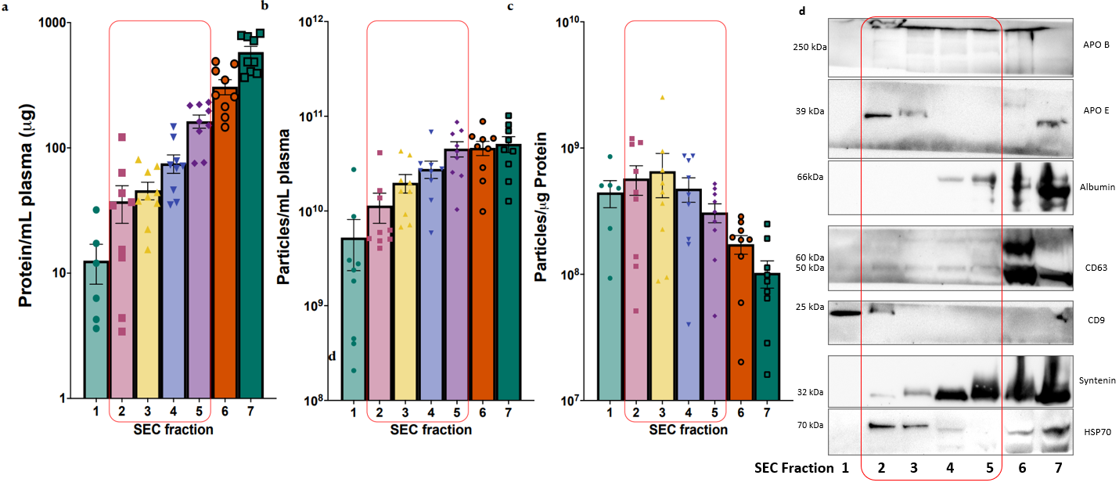
Supplementary Figure 1. Comparison of the yield and purity from the separate size exclusion chromatography (SEC) fractions a BCATM assay identified the total protein level of the samples from the five different plasma EV separation methods. b Nanoparticle tracking analysis identified the particle concentration of the separated samples. c Sample purity as assessed by the particle concentration to protein concentration ratio. d Western blot analysis of EV surface markers (CD63 and CD9), cargo markers (syntenin and HSP70), and the most commonly co-separated contaminants (albumin, apolipoprotein B and apolipoprotein E), following loading of equal volumes of SEC fraction. Representative images are shown.

