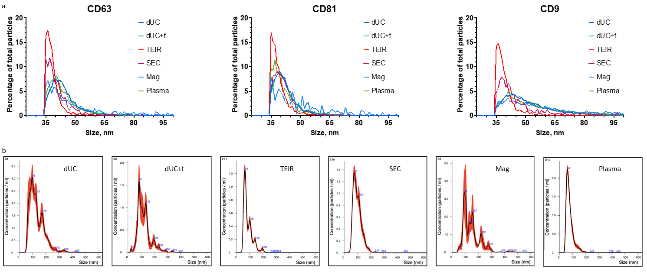
Supplementary Figure 2. a The size distribution of the separated particles as assessed by single particle interferometric reflectance imaging sensing (Leprechaun® analysis) and b representative nanoparticle tracking analysis graphs for each separation method.

