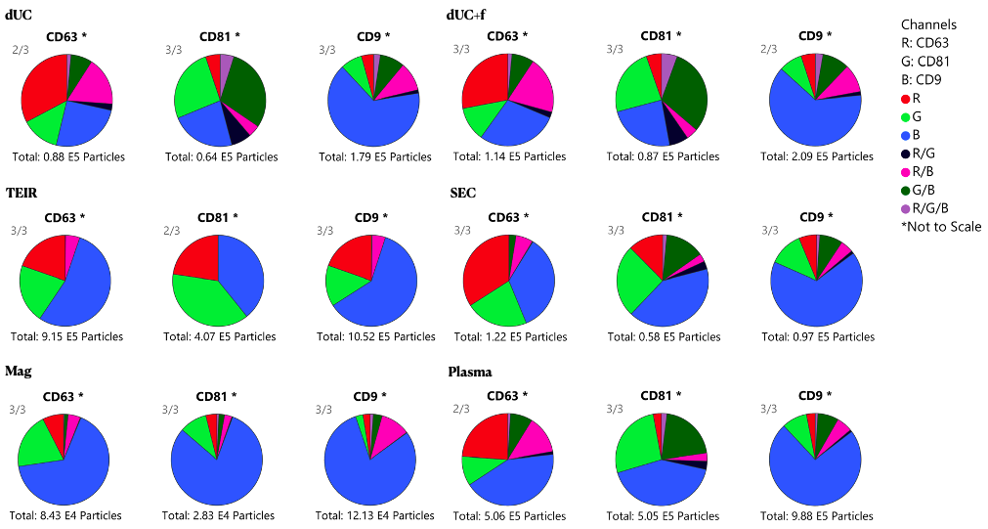
Supplementary Figure 3. Pie chart comparison of the tetraspanin EV surface markers by single particle interferometric reflectance imaging sensing (Leprechaun® analysis).

