Supplementary Figure 1
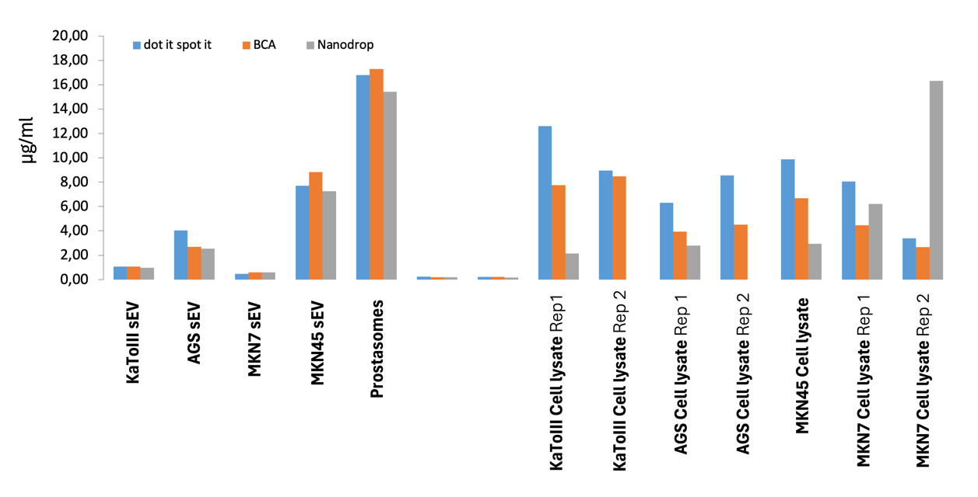
Supplementary Figure 1: Protein concentration measurement by different methods. Bicinchoninic acid assay (BCA), Nanodrop, and Dot-It-Spot-It total protein concentration measurement techniques were used to measure the total protein concentration for the cell lysates and sEVs.

Supplementary Figure 2
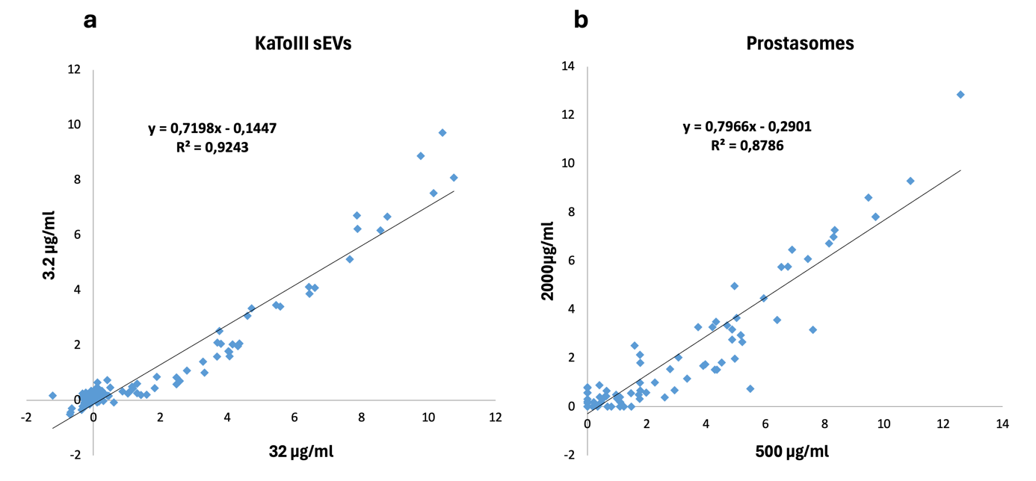
Supplementary Figure 2: Protein expression comparison in different plates, time, and concentrations.
(a) sEVs from the KaToIII cell line analyzed in the same plate with the Oncology panel with different concentrations of 32 μg/ml and 3.82 μg/ml. (b) Prostasomes were analyzed with an Inflammation panel at two different concentrations of 500 μg/ml and 2000 μg/ml and in different plates at different times.

Supplementary Figure 3
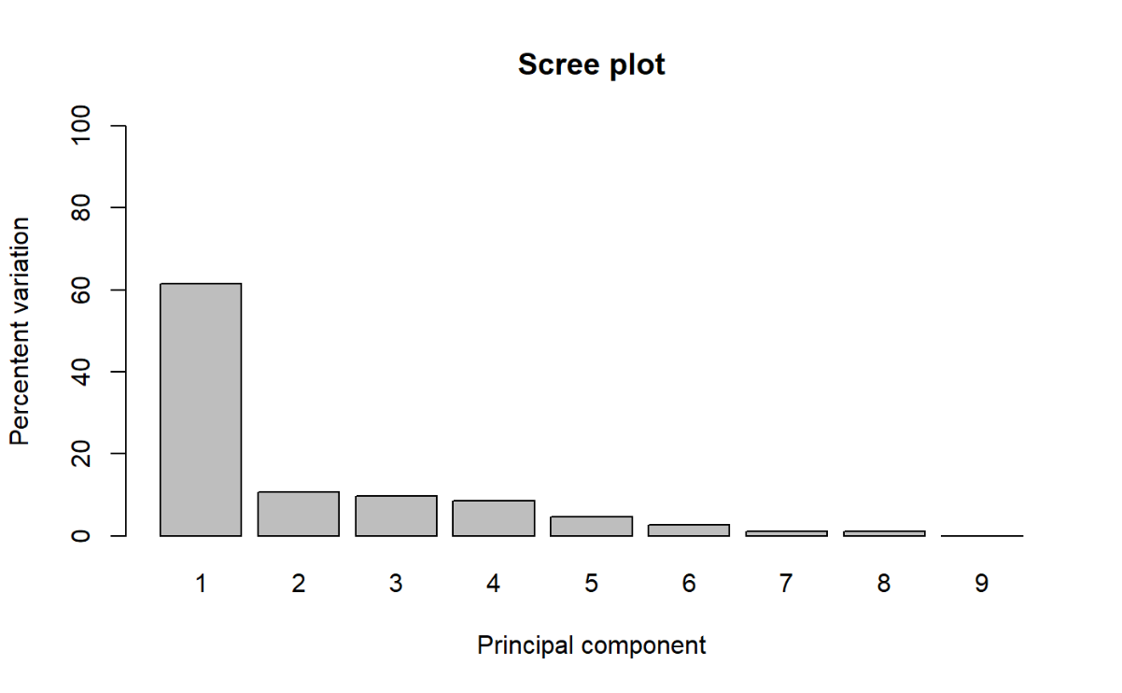
Supplementary Figure 3: Scree plot of principal components (PC)
The plot displays the percentage of total variance explained by each principal component. PC1 and PC2 together account for the majority of variance, with a sharp decline observed in subsequent components.

Supplementary Figure 4
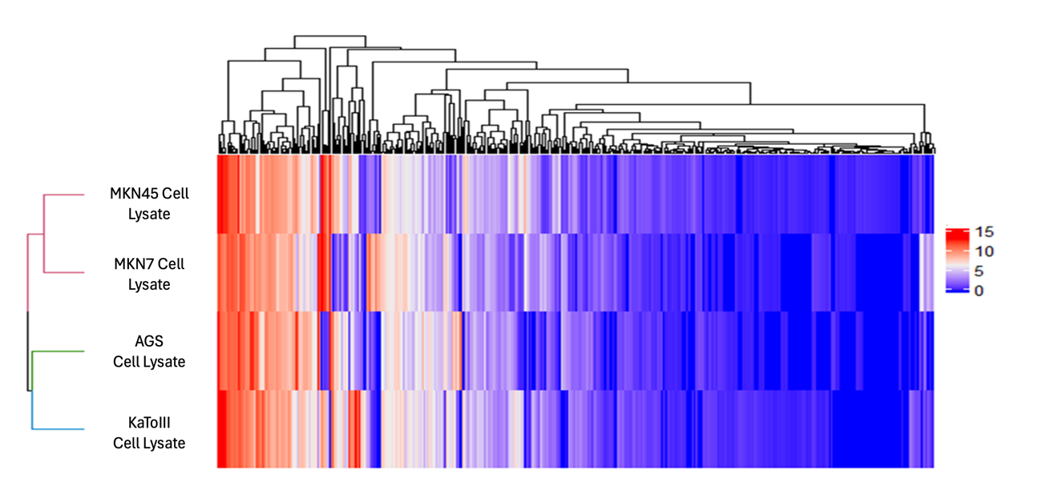
a
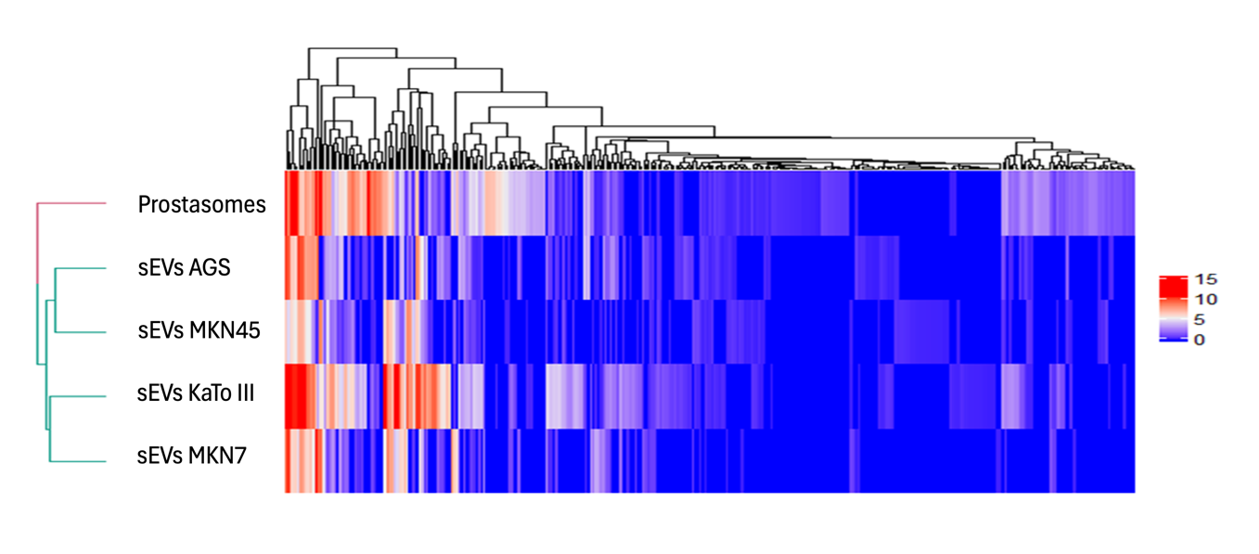
b
Supplementary Figure 4. Heatmap Plot for GC cell lines, GC sEVs, and prostasomes.
(a) Heatmap Plot for GC cell lines with 417 positive proteins in at least one cell line. (b) Heatmap Plot for GC sEVs and prostasome with 343 different proteins that are positive in at least one GC EV or prostasome.

Supplementary Figure 5
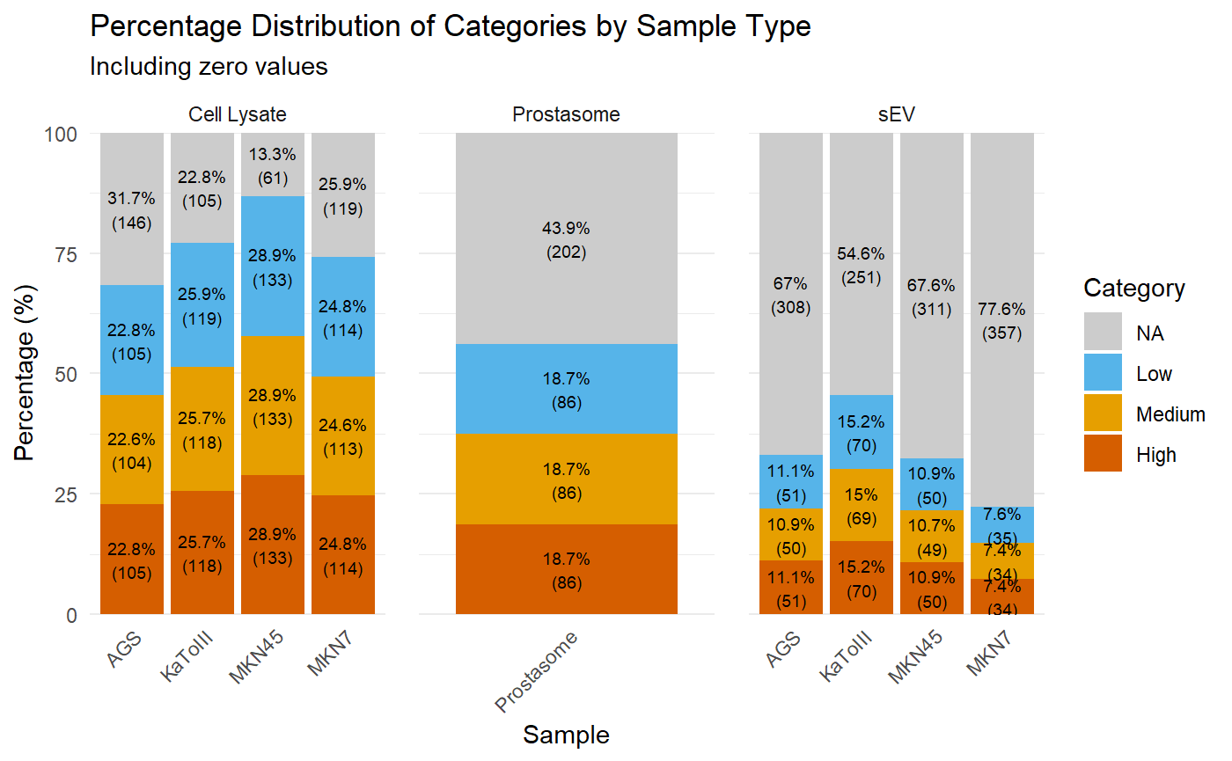

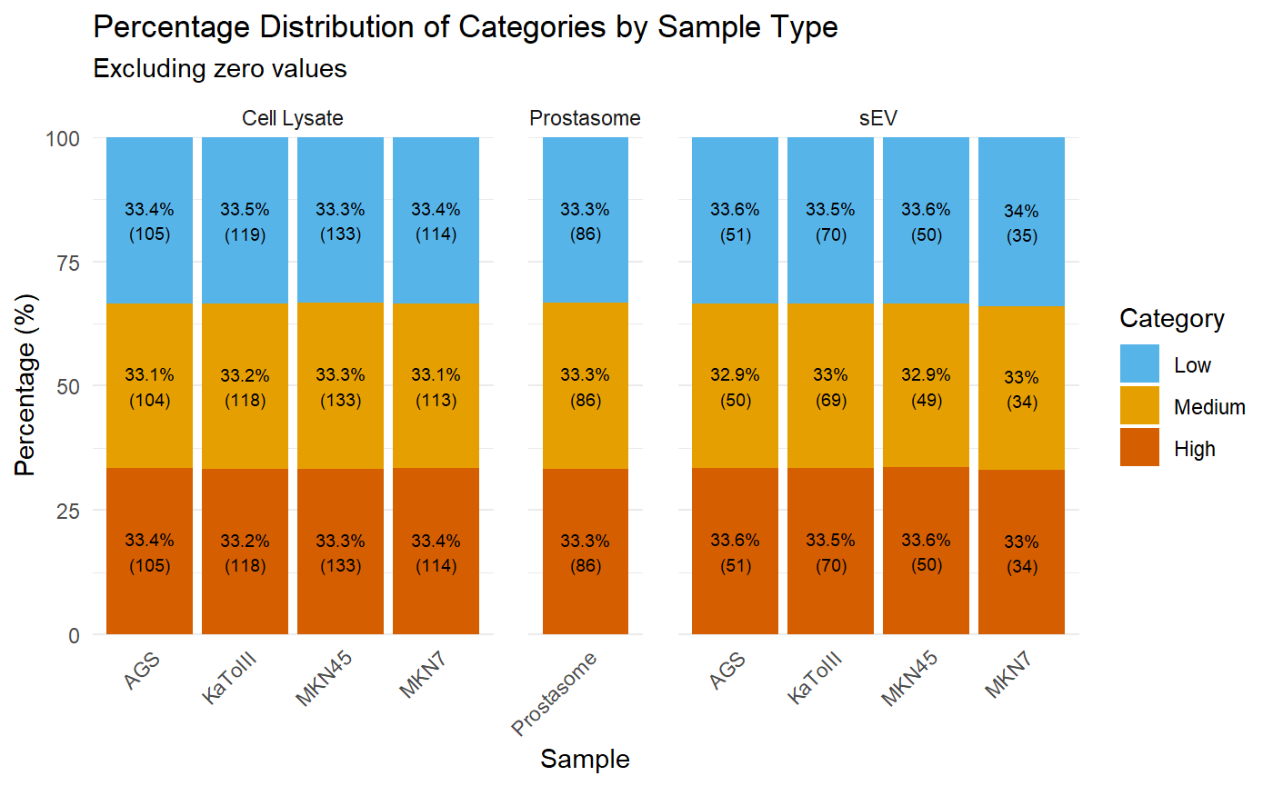

Supplementary Figure 5: Category-wise percentage distribution across sample types using quartile (with zeros) and tertile (without zeros) classification.

Stacked bar plots illustrate the distribution of Low, Medium, and High categories across cell lysate, GC sEV, and prostasome samples. The upper panel uses quartile-based thresholds including zero values (with NA indicating zeros), while the lower panel applies tertile-based thresholds after excluding zeros, resulting in an even categorical distribution. The numbers in parentheses indicate the total number of proteins in that category.

Supplementary Figure 6
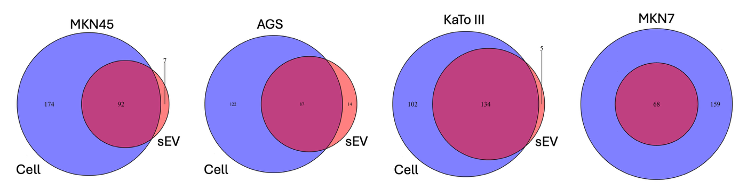

Supplementary Figure 6: Venn diagram of different GC cell lines and their sEVs.
Venn diagram compares protein differences with medium and high expression in all GC cell lines and their corresponding sEVs.

Supplementary Figure 7
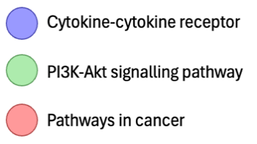
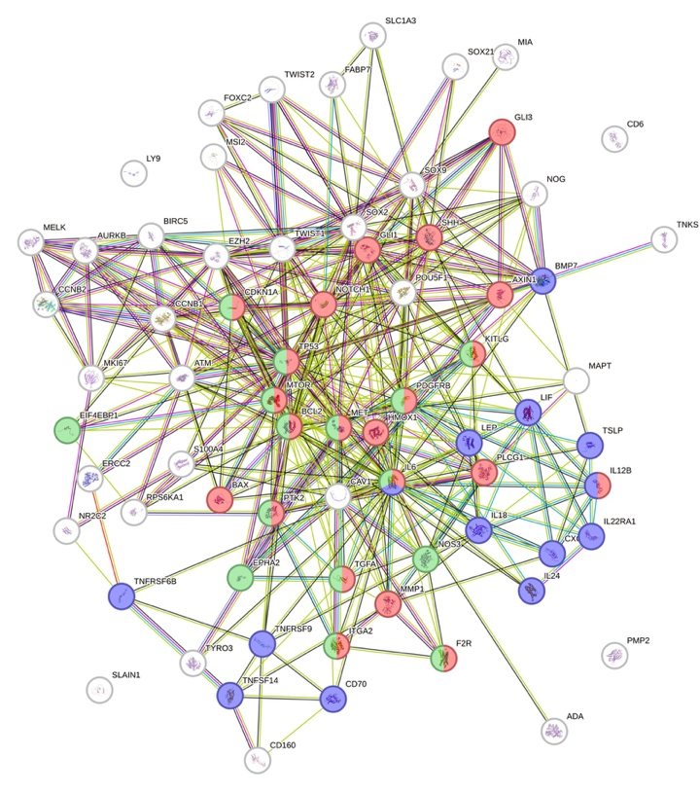
Supplementary Figure 7 Protein-protein interaction network of 71 proteins (77 proteins before removing duplicates) expressed at high or medium range in at least one GC sEVs visualized by STRING. STRING network of the 71 GC sEV–enriched proteins (minimum interaction score = 0.4, medium confidence). Node size reflects degree; edge thickness denotes interaction confidence.
Based on KEGG pathway enrichment analysis, the three top pathways are (1) Pathways in cancer (FDR = 2.80 E-15; Red), (2) Cytokine-cytokine receptor interaction (FDR = 3.94 E-10; Blue), (3) PI3K-Akt signaling pathway (FDR = 3.94 E-10; Green)

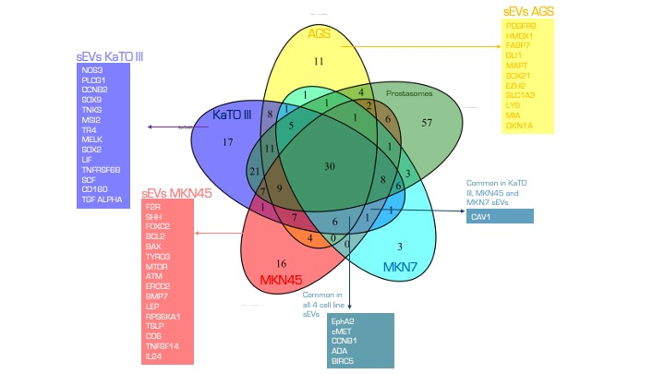
Supplementary Figure 8
Supplementary Figure 8: List of the proteins unique to KaTO III sEVs, the proteins common in sEVs from KaTO III, MKN45 and MKN7 cell line sEVs and proteins common in all four cell line sEVs.

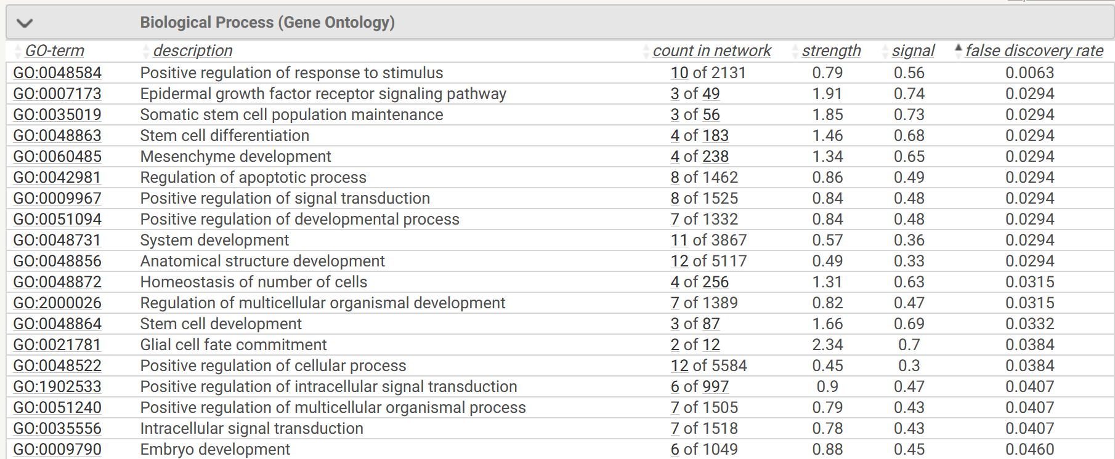
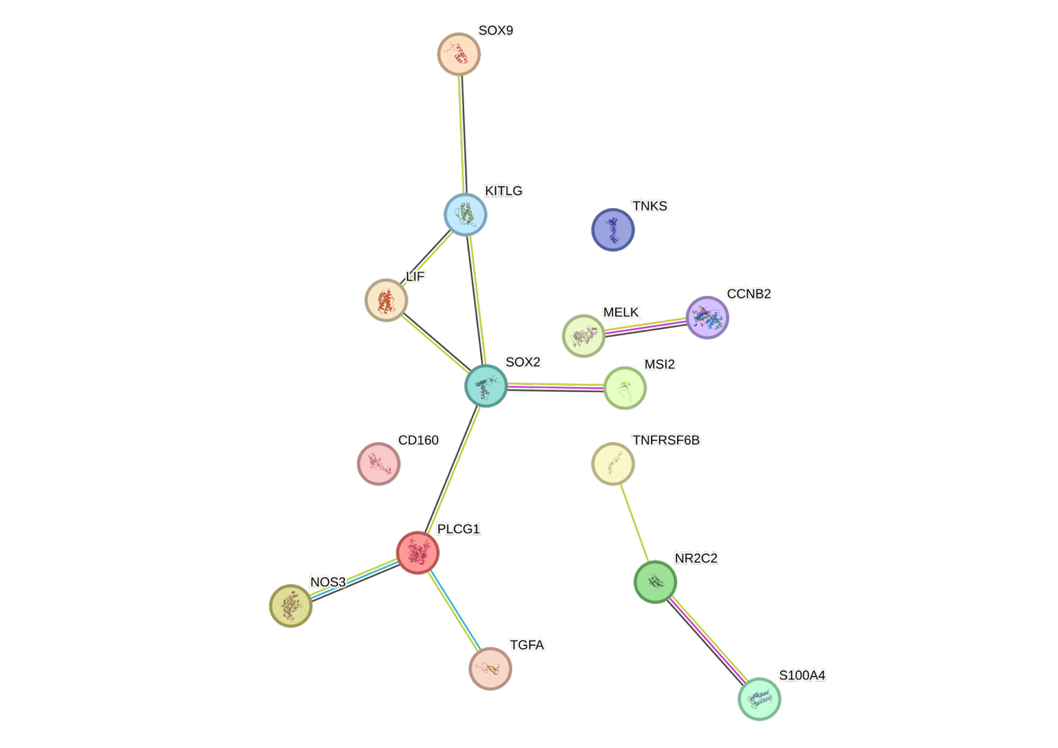
Supplementary Figure 9

Supplementary Figure 9: Protein-protein interaction network of 17 unique proteins (15 proteins after removing replicates) in KaTO III sEVs, visualized by STRING.

