Supplementary Information

Chitosan-Stabilized Sulfur Nanoparticles Tailored via Chemometric Design: Physicochemical Properties, Biocompatibility, and Seed Priming Assessments

Caio A. Marzenta¹, Renan S. Nunes^{1,*}, Victor D. P. Cinel¹, Talita S. Amador², Roberta A. dos Reis¹, Gabriela C. Battistini¹, Ricardo A. Galdino da Silva³, Halley C. Oliveira², Amedea B. Seabra^{1,*}

¹Center for Natural and Human Sciences, Federal University of ABC (UFABC), Santo André, São Paulo, Brazil
²Department of Animal and Plant Biology, State University of Londrina (UEL), Londrina, Paraná, Brazil
³ Federal University of São Paulo (UNIFESP), Diadema, São Paulo, Brazil

* corresponding authors: amedea.seabra@ufabc.edu.br, r.nunes@ufabc.edu.br

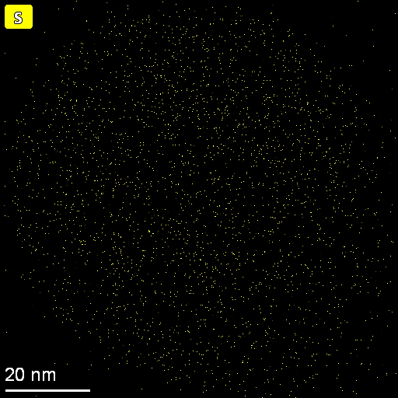
Figure S 1: EDS mapping revealing sulfur localization in a single SNP.
Figure S 2: TGA and DTGA thermogram of the pure CS.

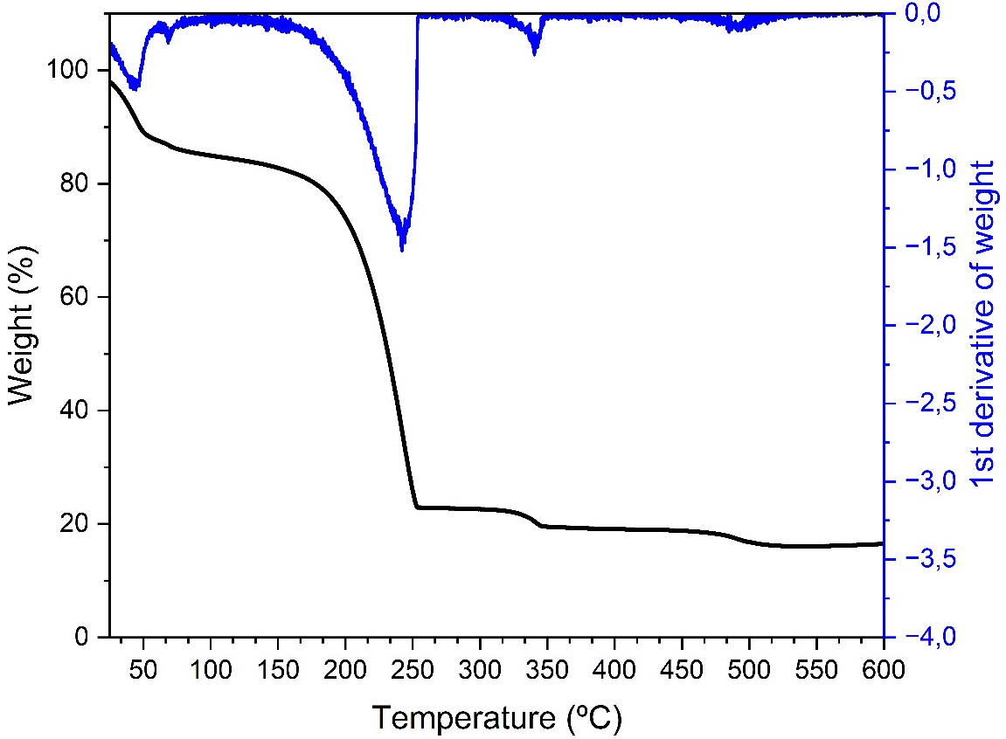
Figure S 3: TGA and DTGA thermogram of control SNPs.

Table S 1 - Experiments and responses obtained in the first 2³ factorial design.
Experiments | STS Final Concentration (mM) | HAc:STS molar proportion (mol/mol) | CS:STS proportion (gcs/gsts) | Average Hydrodynamic Diameter (nm) | PDI | Zeta Potential (mV)
1 | 10 | 2 | 10 | 416.6 | 0.484 | 4.29
2 | 50 | 2 | 10 | 352.2 | 0.379 | 10.5
3 | 10 | 6 | 10 | 343.5 | 0.424 | -0.163
4 | 50 | 6 | 10 | 561.8 | 0.343 | 15.1
5 | 10 | 2 | 40 | 525.8 | 0.523 | 0.111
6 | 50 | 2 | 40 | 402.6 | 0.359 | 13.6
7 | 10 | 6 | 40 | 355.3 | 0.426 | 16.6
8 | 50 | 6 | 40 | 421.6 | 0.357 | 15.8
9 | 30 | 4 | 25 | 433.5 | 0.456 | 14.7
10 | 30 | 4 | 25 | 474 | 0.461 | 15.2
11 | 30 | 4 | 25 | 418.3 | 0.408 | 15.2

Table S 2 - Experiments and responses obtained in the second 2³ factorial design.
Experiments | STS Final Concentration (mM) | HAc:STS molar proportion (mol/mol) | CS:STS proportion (gcs/gsts) | Average Hydrodynamic Diameter (nm) | PDI | Zeta Potential (mV)
1 | 50 | 6 | 40 | 329.8 | 0.359 | 11.2
2 | 100 | 6 | 40 | 399.2 | 0.336 | 13
3 | 50 | 10 | 40 | 322.1 | 0.394 | 12
4 | 100 | 10 | 40 | 285.9 | 0.368 | 11.9
5 | 50 | 6 | 80 | 258.4 | 0.189 | 13.1
6 | 100 | 6 | 80 | 310.3 | 0.24 | 13.4
7 | 50 | 10 | 80 | 283.6 | 0.239 | 14.3
8 | 100 | 10 | 80 | 372 | 0.295 | 12.8
9 | 75 | 8 | 60 | 289.9 | 0.203 | 14.7
10 | 75 | 8 | 60 | 292.5 | 0.203 | 14.4
11 | 75 | 8 | 60 | 309.1 | 0.253 | 13.6

