Appendix 1- Dependence of concentration (C_{t}) and percentage (%) released as a function of time for PMAA-co-PAAm, CH-PMAA-co-PAAm, and CH-Zeolite(1.5%)-PMAA-co-PAAm nanocomposites obtained at pH 4.0, 7.0, and 10.0 for the herbicides paraquat (a-f) and difenzoquat (g-l).
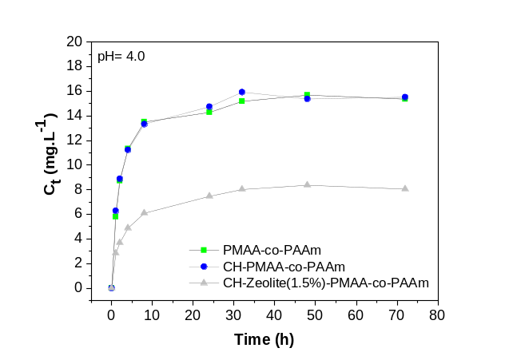 | 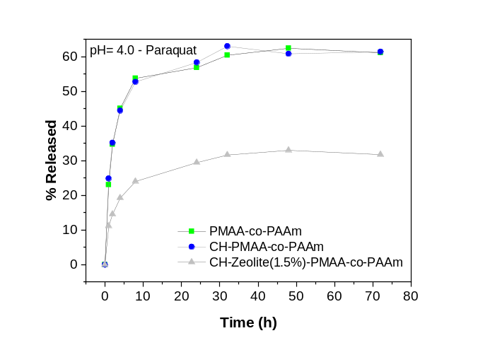
(a) | (b)
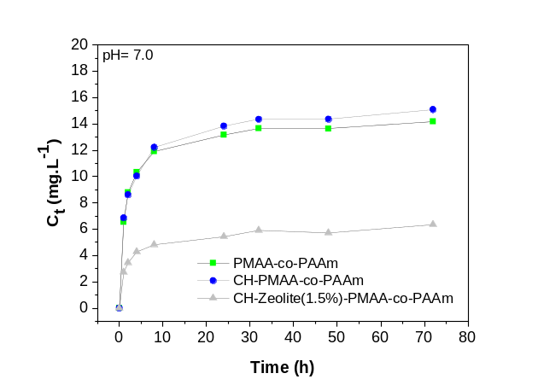 | 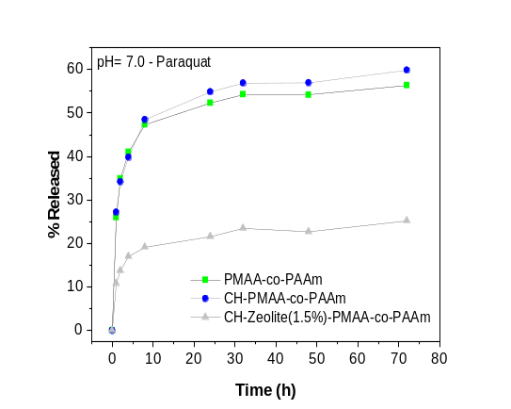
(c) | (d)
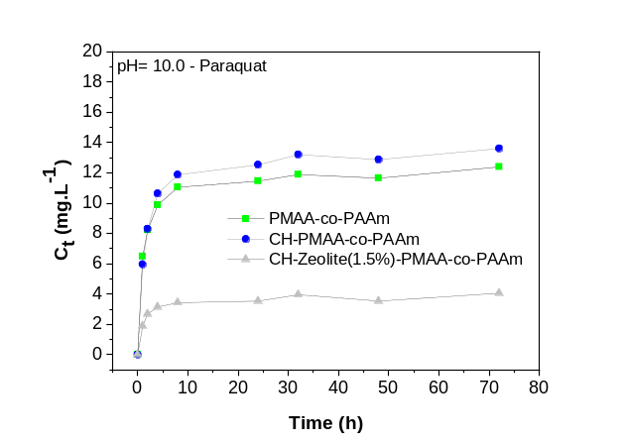 | 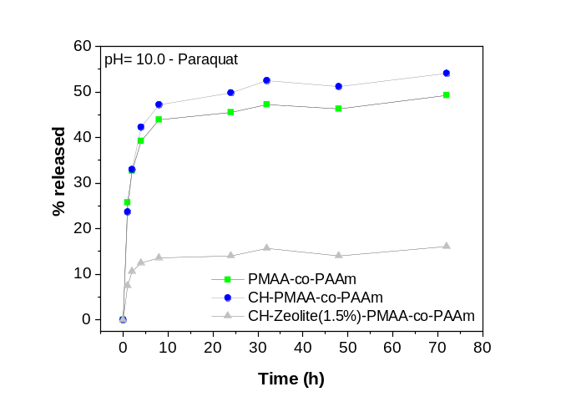
(e) | (f)
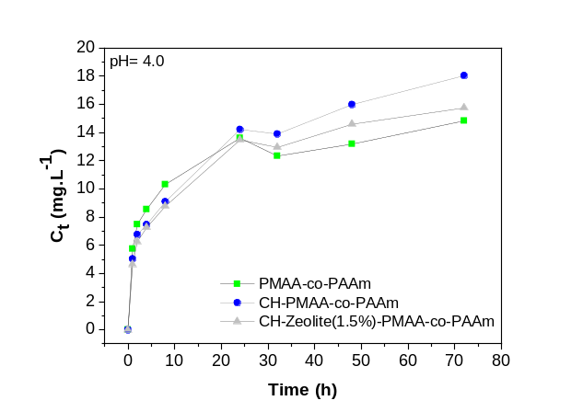 | 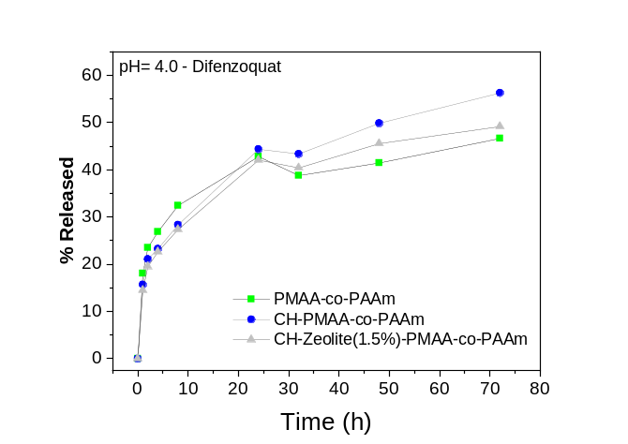
(g) | (h)
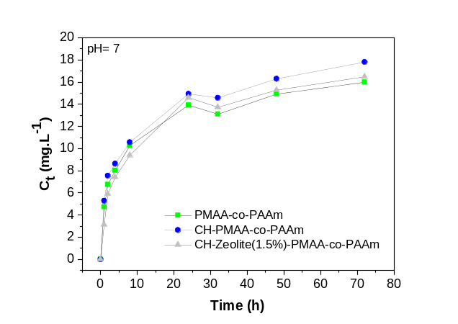 | 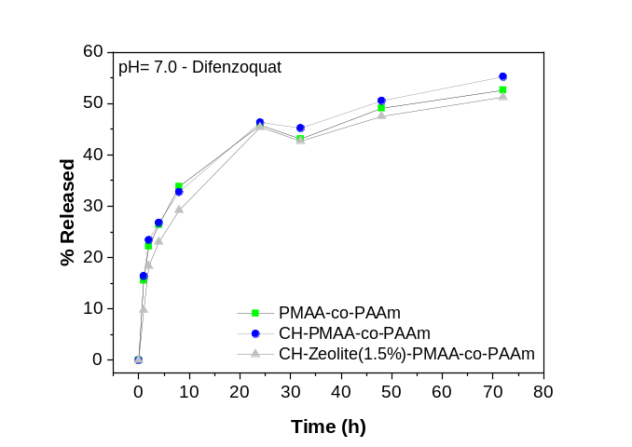
(i) | (j)
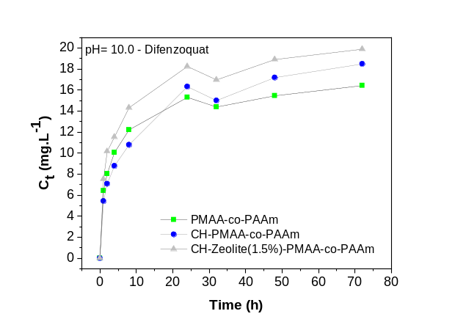 | 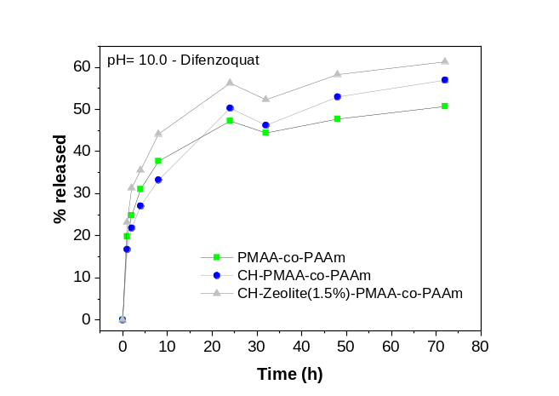
(k) | (l)

Appendix 2- Kinetic curves of released concentration (C_{t}) (a), mass of paraquat released per gram of hydrogel (q_{t}) (b), and percentage (%) released (c) in different saline media for PMAA-co-PAAm hydrogel.
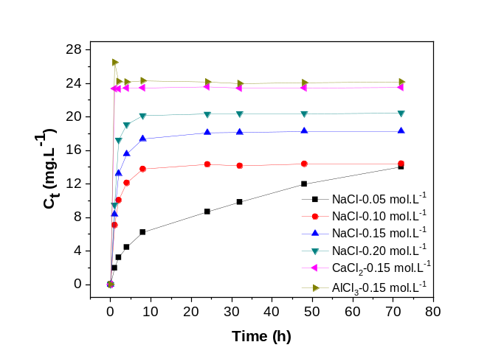 | 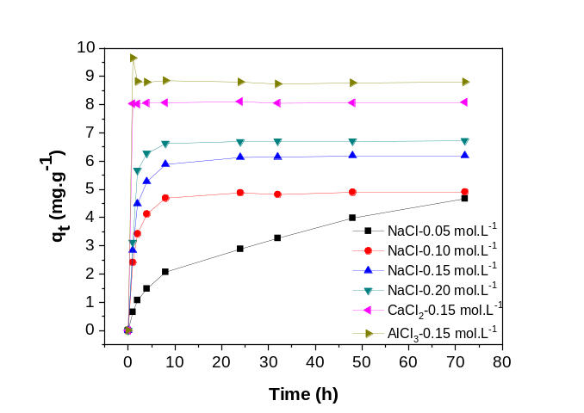
(a) | (b)
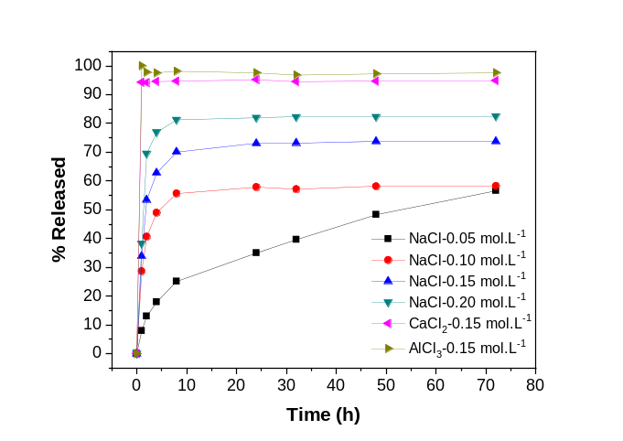
(c)

Appendix 3 - Kinetic curves of released concentration (C_{t}) (a), mass of paraquat released per gram of hydrogel (q_{t}) (b), and percentage (%) released (c) in different saline media for CH-PMAA-co-PAAm hydrogel.
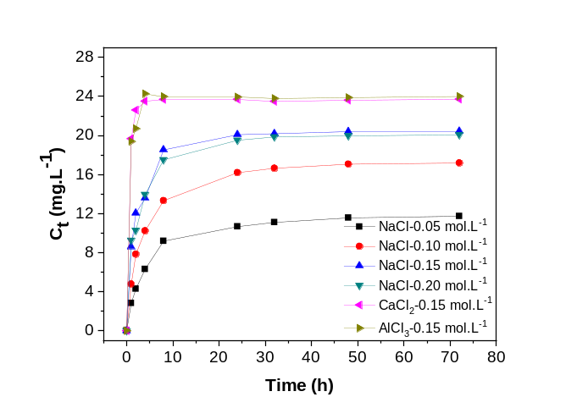 | 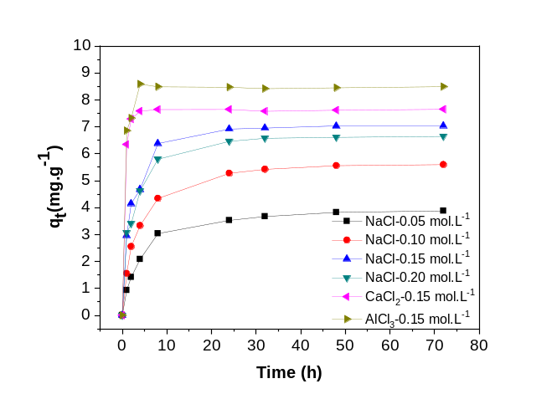
(a) | (b)
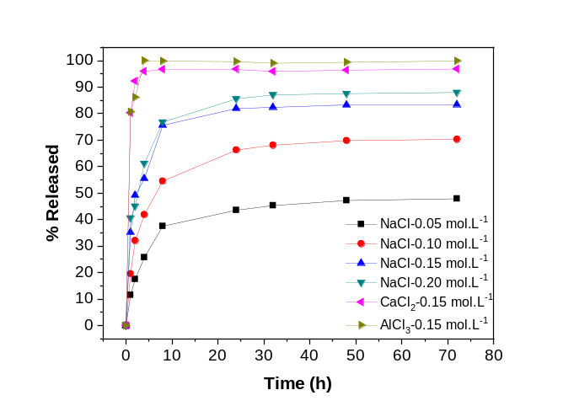
(c)

Appendix 4- Kinetic curves of released concentration (C_{t}) (a), mass of paraquat released per gram of hydrogel (q_{t}) (b), and percentage (%) released (c) in different saline media for CH-Zeolite(1.5%)-PMAA-co-PAAm nanocomposites.
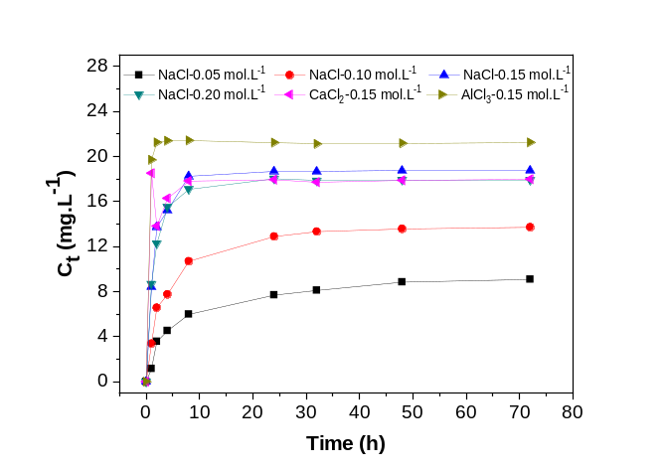 | 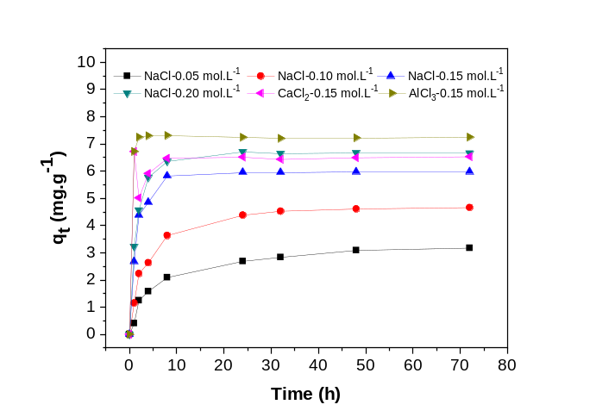
(a) | (b)
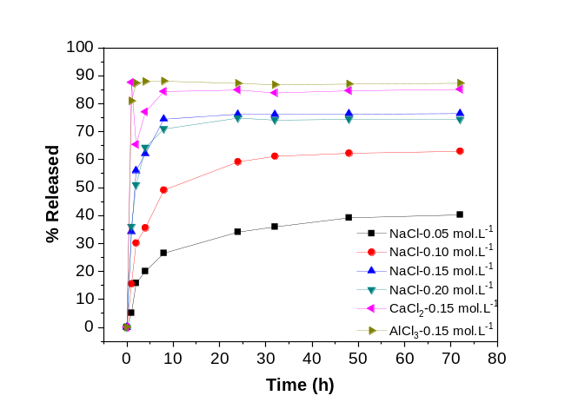
(c)

Appendix 5- Adsorption isotherms for determining the best-fitting model for CH-PMAA-co-PAAm hydrogel obtained for paraquat: Langmuir (a), Freundlich (b), Dubinin-Radushkevich (c), Temkin (d), Langmuir-Freundlich (e), and Harkins-Jura (f).
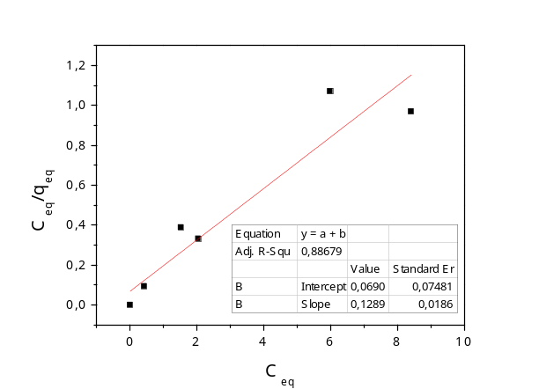 | 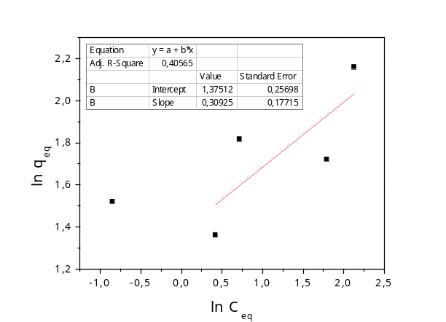
(a) | (b)
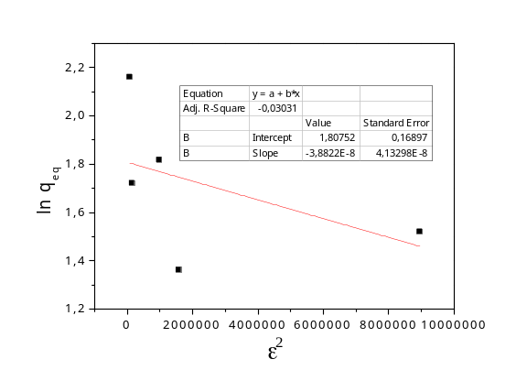 | 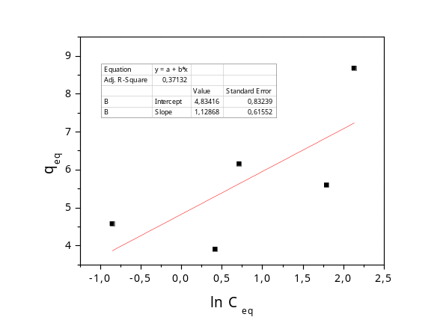
(c) | (d)
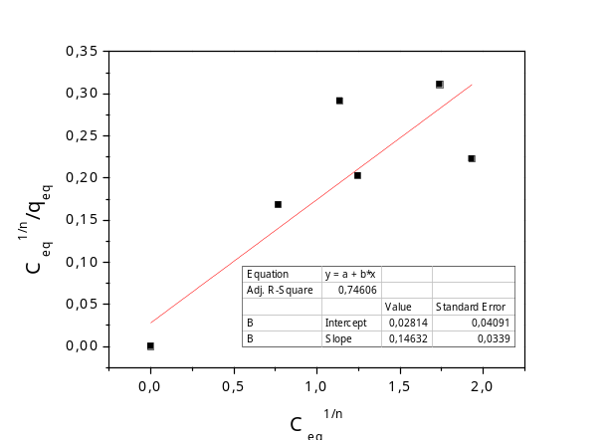 | 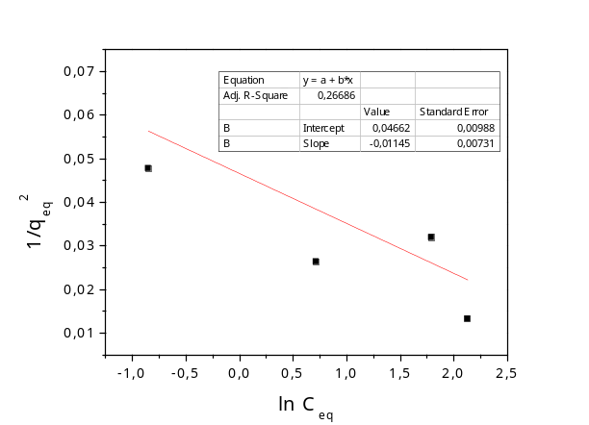
(e) | (f)

Appendix 6 - Adsorption isotherms for determining the best-fitting model for CH-Zeolite(1.5%)-PMAA-co-PAAm nanocomposites obtained for paraquat: Langmuir (a), Freundlich (b), Dubinin-Radushkevich (c), Temkin (d), Langmuir-Freundlich (e), and Harkins-Jura (f).
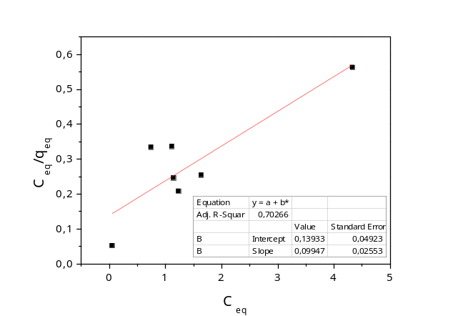 | 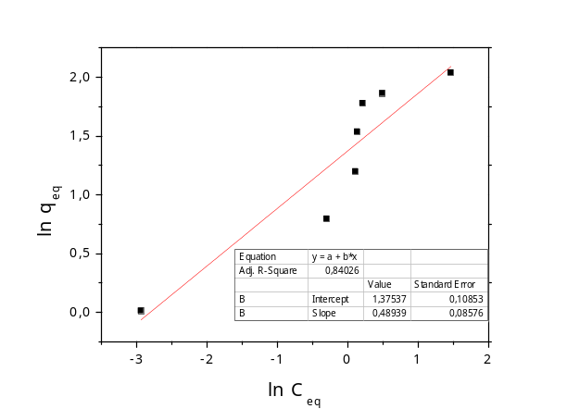
(a) | (b)
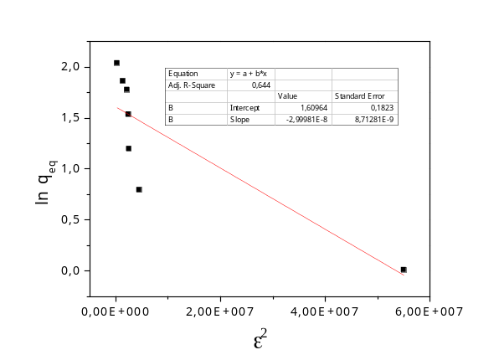 | 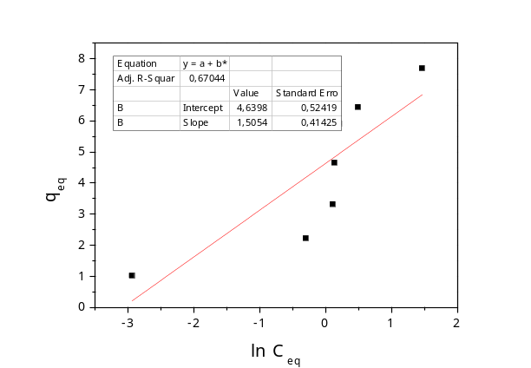
(c) | (d)
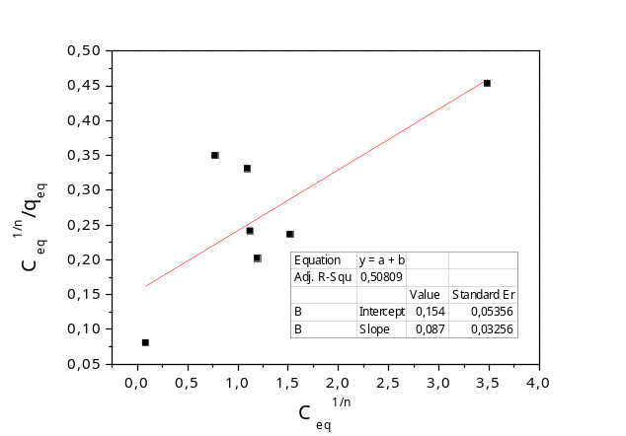 | 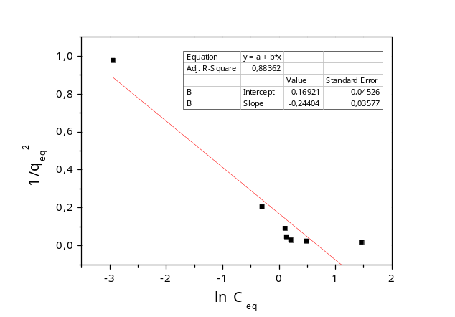
(e) | (f)

Appendix 7- Pseudo-first-order kinetic model obtained for CH-PMAA-co-PAAm hydrogel (a-paraquat; c-difenzoquat) and CH-Zeolite(1.5%)-PMAA-co-PAAm nanocomposites (b-paraquat; d-difenzoquat).
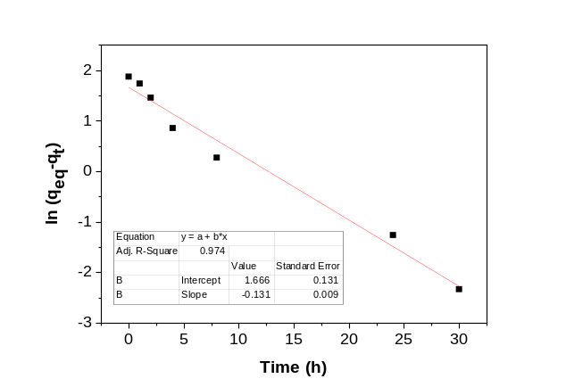 | 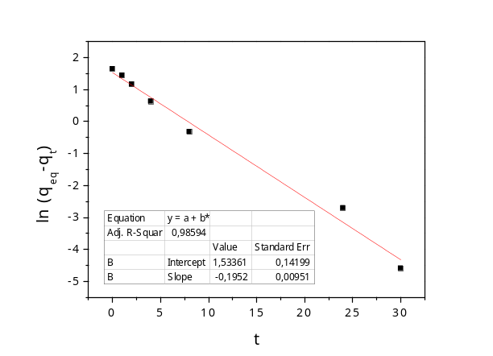
(a) | (b)
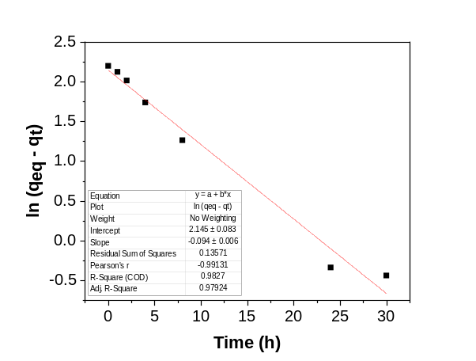 | 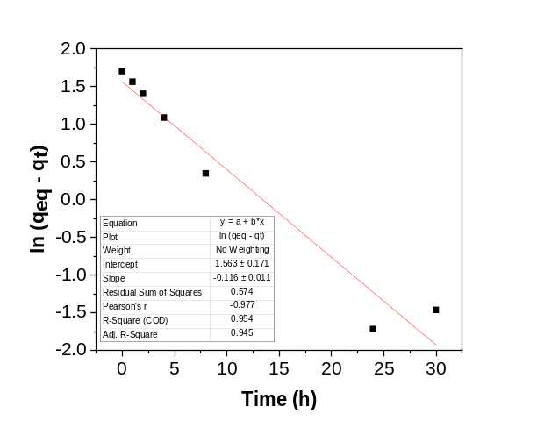
(c) | (d)

Appendix 8 - Pseudo-second-order kinetic model obtained for CH-PMAA-co-PAAm hydrogel (a-paraquat; c-difenzoquat) and CH-Zeolite(1.5%)-PMAA-co-PAAm nanocomposites (b-paraquat; d-difenzoquat).
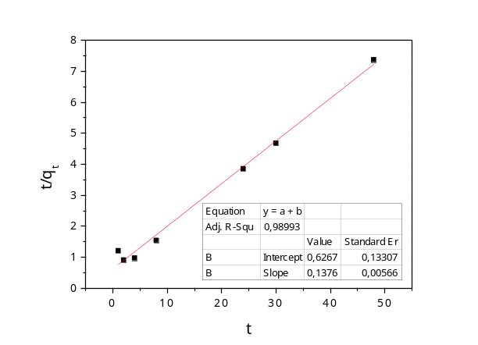 | 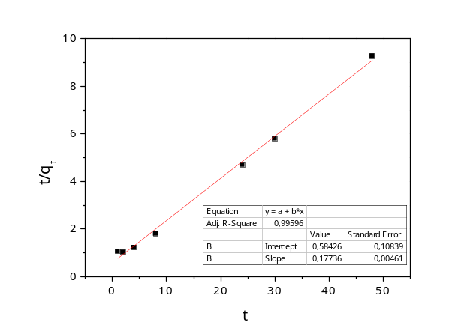
(a) | (b)
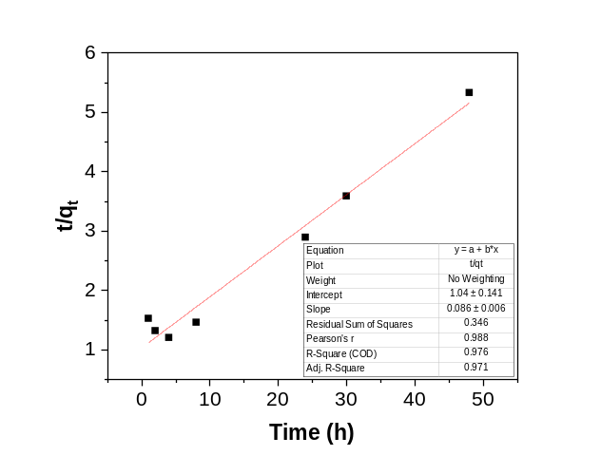 | 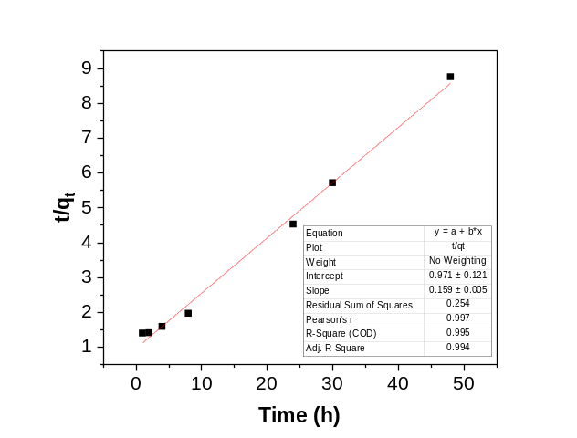
(c) | (d)

