Supplementary Figure 1. Bland Altman plot for intra observer reproducibilities of MM GLS

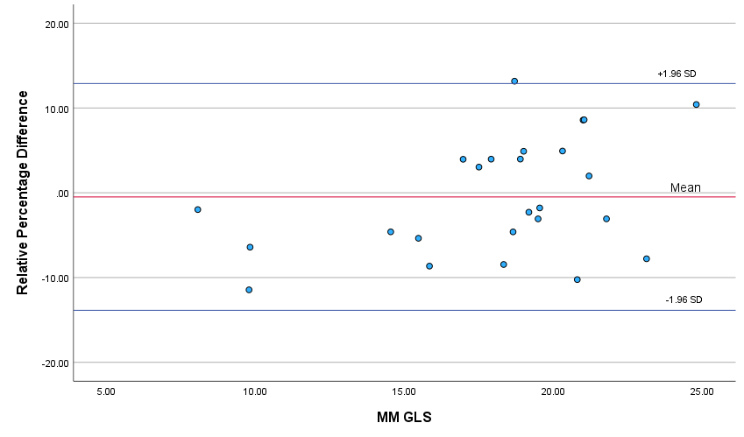

Supplementary Figure 2. Bland Altman plot for inter observer reproducibilities of MM GLS

