Supplementary materials

Supplementary Fig. 1. Flowchart

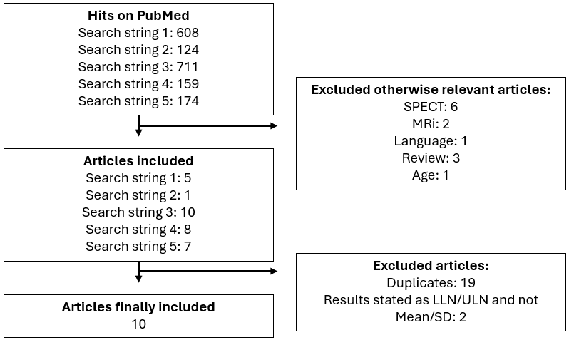

Supplementary Fig. 2. Meta-analysis of studies using 3D echocardiography.
A. Mean LVEF

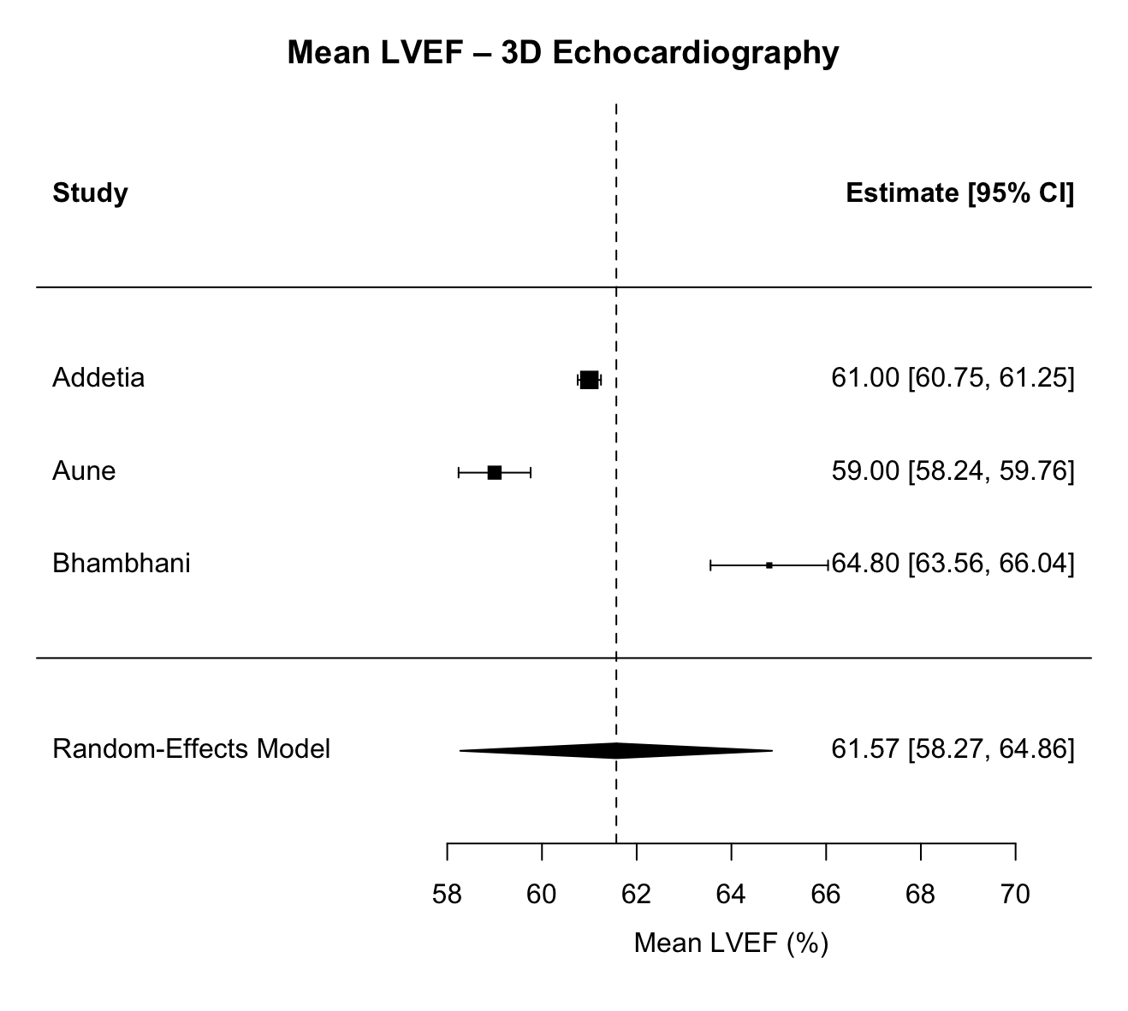
τ² value 8.28, I² 98.6%.

Supplementary Figure 2 – meta-analysis of studies using 3D echocardiography.

B. Standard deviation LVEF
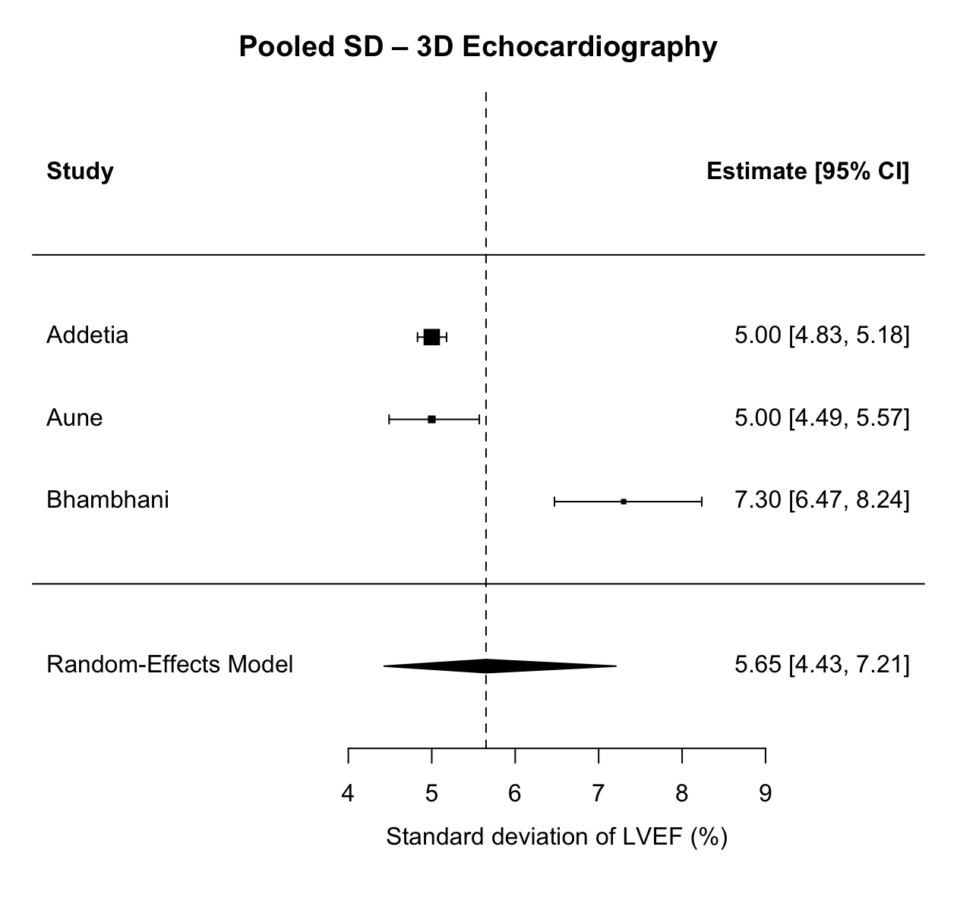
τ² value 0.18, I² 95.8%.

Supplementary Figure 3 – meta-analysis of studies using 2D echocardiography.
A. Mean LVEF
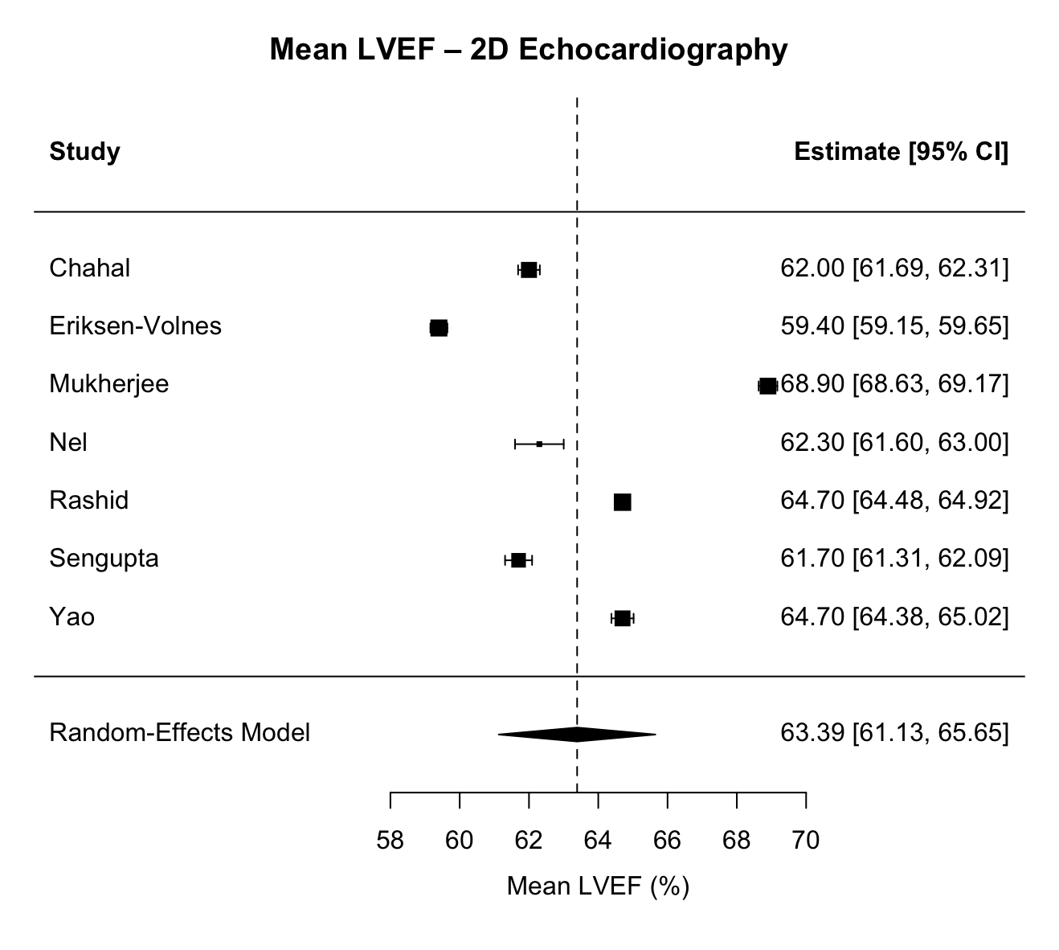
τ² value 9.28, I² 99.8%.

Supplementary Figure 3 – meta-analysis of studies using 2D echocardiography.
B. Standard deviation LVEF
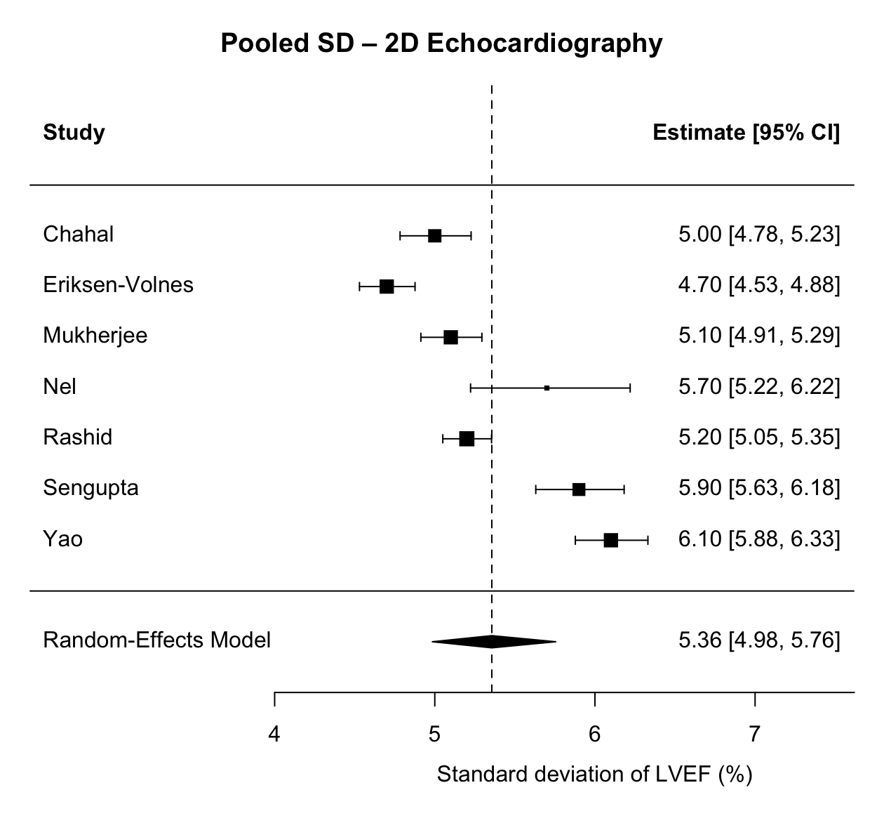
τ² value 0.035, I² 95.4%.
Supplementary Figure 4 – Funnel plot of included studies
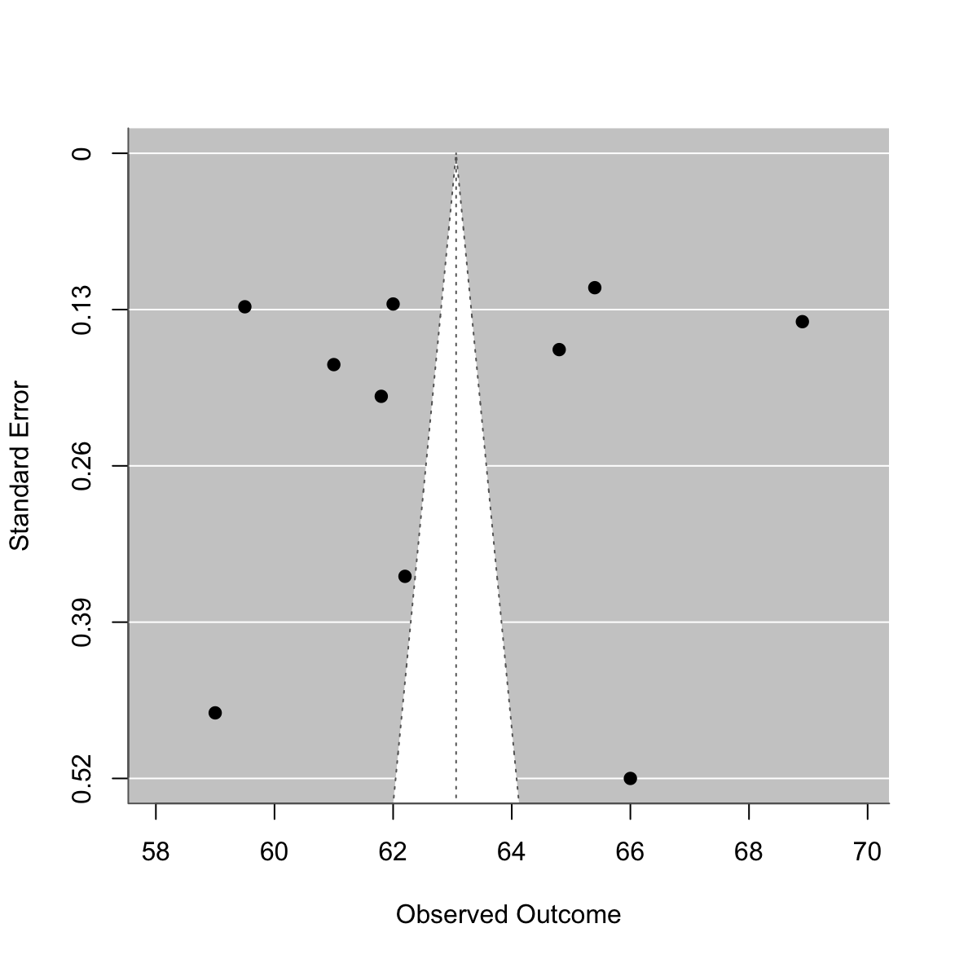

Supplementary Table 1. Search strings
Search string 1 | (“left ventricular ejection fraction” OR “LVEF”) AND ("sex" OR “gender” OR “male” OR “female” OR “men” OR “women”) AND ("mean value" OR “normal”) AND (“population based” OR “population-based” OR “cohort” OR “community”)
Search string 2 | (“left ventricular ejection fraction” OR “LVEF”) AND ("sex-specific”)
Search string 3 | (“left ventricular ejection fraction” OR “LVEF”) AND ("sex” OR “gender”) AND (“normal”)
Search string 4 | ("left ventricular ejection fraction" OR "LVEF") AND ("echo*" OR "magnetic") AND ("normal" OR "population-based" OR "cohort") NOT ("heart failure" OR "dysfunction" OR "cancer" OR "cardiomyopathy" OR "pulmonary") AND (“healthy”)
Search string 5 | ("left ventricular ejection fraction" OR "LVEF") AND ("normal value*")

Supplementary Table 2. Exclusion criteria in included articles
Exclusion criteria | Articles | n
Age $<$ 18 | Addetia¹⁴⁾, Aune¹⁵⁾, Bhambhani¹⁶⁾, Chahal¹³⁾, Eriksen-Volnes¹⁷⁾, Mukherjee¹²⁾, Nel¹¹⁾, Rashid¹⁸⁾, Sengupta¹⁰⁾, Yao¹⁹⁾ | 10
Cardiac/coronary disease / abnormalities including infarcts including treatment of it, HF | Addetia¹⁴⁾, Aune¹⁵⁾, Bhambhani¹⁶⁾, Chahal¹³⁾, Eriksen- Volnes¹⁷⁾, Mukherjee¹²⁾, Nel¹¹⁾, Rashid¹⁸⁾, Sengupta¹⁰⁾, Yao¹⁹⁾ | 10
History or current use of antihypertensives / hypertension (> 160 / 90 mmHg) > 140 / 90 mmHg, 140 / 85 mmHg | Addetia¹⁴⁾, Aune¹⁵⁾, Bhambhani¹⁶⁾, Chahal¹³⁾, Eriksen-Volnes¹⁷⁾, Mukherjee¹²⁾, Nel¹¹⁾, Rashid¹⁸⁾, Sengupta¹⁰⁾, Yao¹⁹⁾ | 10
Diabetes type 1 / 2 or impaired fasting blood glucose ($≥$ 100 mg/dL), > 7 mmol/L | Addetia¹⁴⁾, Aune¹⁵⁾, Chahal¹³⁾, Eriksen-Volnes¹⁷⁾, Mukherjee¹²⁾, Nel¹¹⁾, Rashid¹⁸⁾, Sengupta¹⁰⁾, Yao¹⁹⁾ | 9
Incomplete echocardiography / poor image quality | Addetia¹⁴⁾, Aune¹⁵⁾, Nel¹¹⁾, Sengupta¹⁰⁾, Yao¹⁹⁾ | 5
Pregnancy or lactating women | Addetia¹⁴⁾, Mukherjee¹²⁾, Sengupta¹⁰⁾, Yao¹⁹⁾ | 4
Dyslipidemia | Addetia¹⁴⁾, Mukherjee¹²⁾, Rashid¹⁸⁾, Yao¹⁹⁾ | 4
Pulmonary disease | Addetia¹⁴⁾, Eriksen-Volnes¹⁷⁾, Mukherjee¹²⁾, Yao¹⁹⁾ | 4
Treatment for or current arrythmia including AF | Aune¹⁵⁾, Eriksen-Volnes¹⁷⁾, Rashid¹⁸⁾, Sengupta¹⁰⁾, | 4
Obesity (BMI >30, > 28) | Mukherjee¹²⁾, Rashid¹⁸⁾, Sengupta¹⁰⁾, Yao¹⁹⁾ | 4
Renal disease / renal insufficiency / dysfunction | Addetia¹⁴⁾, Mukherjee¹²⁾, Rashid¹⁸⁾ | 3
Competitive / professional athlete or long-term physical training | Addetia¹⁴⁾, Mukherjee¹²⁾, Yao¹⁹⁾ | 3
History of or current alcoholism | Addetia¹⁴⁾, Mukherjee¹²⁾, Yao¹⁹⁾ | 3
Malignant disease | Aune¹⁵⁾, Eriksen-Volnes¹⁷⁾, Sengupta¹⁰⁾ | 3
Angina pectoris | Eriksen-Volnes¹⁷⁾, Mukherjee¹²⁾ | 2
Abnormal 12-lead ECG | Nel¹¹⁾, Yao¹⁹⁾ | 2
Prior stroke | Nel¹¹⁾, Yao¹⁹⁾ | 2
LBBB | Aune¹⁵⁾ | 1
Indian Asian ancestry | Chahal¹³⁾ | 1
European ancestry | Chahal¹³⁾ | 1
Thyroid disease | Mukherjee¹²⁾ | 1
Treatment with corticosteroids | Mukherjee¹²⁾ | 1
Any chronic medical condition | Nel¹¹⁾ | 1
Any chronic medication | Nel¹¹⁾ | 1
HR > 100 BPM | Sengupta¹⁰⁾ | 1
Any endocrine disease | Yao¹⁹⁾ | 1
Anemia | Yao¹⁹⁾ | 1
Connective tissue disease | Yao¹⁹⁾ | 1
Abnormal hepatic function (serum alanine / aspartate aminotransferase > 2x upper limit) | Yao¹⁹⁾ | 1

Supplementary Table 3: Statistical likelihood that certain values of LVEF could be “normal”
LVEF (%) | All  Mean = 62.8, SD = 5.43 |  |  | Female  Mean = 63.7, SD = 5.65 |  |  | Male  Mean = 61.9, SD = 5.19
 | Z-score | Prob (≤ X) | p-value | Z-score | Prob (≤ X) | p-value | Z-score | Prob (≤ X) | p-value
55 | -1.45 | 7.41% | 0.0741 | -1.55 | 6.08% | 0.0608 | -1.33 | 9.15% | 0.0915
54 | -1.63 | 5.15% | 0.0515 | -1.73 | 4.22% | 0.0422 | -1.52 | 6.37% | 0.0637
53 | -1.81 | 3.48% | 0.0348 | -1.90 | 2.85% | 0.0285 | -1.72 | 4.30% | 0.0430
52 | -2.00 | 2.28% | 0.0228 | -2.08 | 1.88% | 0.0188 | -1.91 | 2.81% | 0.0281
51 | -2.18 | 1.45% | 0.0145 | -2.26 | 1.20% | 0.0120 | -2.10 | 1.78% | 0.0178
50 | -2.37 | 0.90% | 0.0090 | -2.43 | 0.75% | 0.0075 | -2.29 | 1.09% | 0.0109
49 | -2.55 | 0.54% | 0.0054 | -2.61 | 0.45% | 0.0045 | -2.49 | 0.64% | 0.0064
48 | -2.74 | 0.31% | 0.0031 | -2.79 | 0.26% | 0.0026 | -2.68 | 0.37% | 0.0037
47 | -2.92 | 0.18% | 0.0018 | -2.97 | 0.15% | 0.0015 | -2.87 | 0.20% | 0.0020
46 | -3.10 | 0.10% | 0.0010 | -3.14 | 0.08% | 0.0008 | -3.06 | 0.11% | 0.0011
45 | -3.29 | 0.05% | 0.0005 | -3.32 | 0.05% | 0.0005 | -3.26 | 0.06% | 0.0006

Supplementary Table 4: Values by age groups and sex in the subset of available studies
 | Female |  |  | Male
Age | 18-40 | 41-65 | >65 | 18-40 | 41-65 | >65
Addetia et al, N | 309 | 275 | 172 | 347 | 291 | 195
LVEF mean, % | 61.8 | 62.3 | 62.7 | 59.5 | 60.3 | 61.2
Std | 4.3 | 4.4 | 5.3 | 4.4 | 4.7 | 5.1
Bhambhani et al., N | 30 | 29 |  | 43 | 31
LVEF mean, % | 65.1 | 69.1 |  | 63.9 | 61.7
Std | 6.3 | 8.3 |  | 6.5 | 6.4
Eriksen-Volnes et al., N | 64 | 367 | 367 | 49 | 284 | 291
LVEF mean, % | 60 | 61 | 60 | 58 | 60 | 60
Std | 4 | 5 | 5 | 6 | 5 | 5
Mukherjee et al., N | 604 |  |  | 773
LVEF mean, % | 69.1 |  |  | 68.7
std | 5.5 |  |  | 4.8
Rashid et al, N | 905 | 240 |  | 750 | 350
LVEF mean, % | 66.5 | 66.1 |  | 63.2 | 63.7
std | 5.2 | 5.6 |  | 5.1 | 5.3
Yao et al., N | 255 | 276 | 185 | 246 | 244 | 188
LVEF mean, % | 64.7 | 64.7 | 65.8 | 63 | 64.7 | 65.7
std | 6.3 | 6.2 | 6 | 5.8 | 6 | 6
Summary
Total N across studies | 2,167 | 1,187 | 724 | 1,435 | 1,200 | 674
LVEF mean, % (95% CI) | 64.5 (61.9, 67.2) | 64.4 (61.8, 67.1) | 62.8 (59.5, 66.1) | 62.7 (59.7, 65.8) | 62.1 (60.2, 64.0) | 62.3 (58.9, 65.7)
Std (95% CI) | 5.2 (4.5, 6.0) | 5.6 (4.7, 6.8) | 5.4 (4.8, 6.0) | 5.3 (4.7, 5.9) | 5.3 (4.8, 5.9) | 5.3 (4.8, 6.0)
Upper and lower limit of normal LVEF, % | 54.4, 74.7 | 53.4, 75.5 | 52.2, 73.4 | 52.4, 73.1 | 51.6, 72.5 | 51.8, 72.7
$τ^{2}$ (mean) | 10.6 | 8.5 | 8.3 | 13.8 | 4.4 | 8.9
$τ^{2}$ (SD) | 0.1 | 0.2 | 0.0 | 0.1 | 0.0 | 0.0
$I^{2}$ (mean) | 99.2% | 98.6% | 98.4% | 99.4% | 97.3% | 98.6%
$I^{2}$ (SD) | 94.6% | 94.9% | 74.7% | 91.0% | 81.2% | 76.5%
Footnote: Age groups are approximate as the split differed slightly in the various studies.

Supplementary Table 5: Likelihood of an LVEF being normal in sex- and race-specific subgroups.
 | Asian female |  |  | Asian male
LVEF (%) | Z-score | Prob (≤ X) | p-value | Z-score | Prob (≤ X) | p-value
55 | -1.77 | 3.85% | 0.0385 | -1.62 | 5.23% | 0.0523
54 | -1.95 | 2.58% | 0.0258 | -1.81 | 3.50% | 0.035
53 | -2.13 | 1.68% | 0.0168 | -2 | 2.28% | 0.0228
52 | -2.3 | 1.06% | 0.0106 | -2.19 | 1.43% | 0.0143
51 | -2.48 | 0.65% | 0.0065 | -2.38 | 0.87% | 0.0087
50 | -2.66 | 0.39% | 0.0039 | -2.57 | 0.51% | 0.0051
49 | -2.84 | 0.23% | 0.0023 | -2.75 | 0.29% | 0.0029
48 | -3.02 | 0.13% | 0.0013 | -2.94 | 0.16% | 0.0016
47 | -3.2 | 0.07% | 0.0007 | -3.13 | 0.09% | 0.0009
46 | -3.38 | 0.04% | 0.0004 | -3.32 | 0.04% | 0.0004
45 | -3.55 | 0.02% | 0.0002 | -3.51 | 0.02% | 0.0002
 | White female |  |  | White male
LVEF (%) | Z-score | Prob (≤ X) | p-value | Z-score | Prob (≤ X) | p-value
55 | -1.29 | 9.93% | 0.0993 | -0.81 | 20.83% | 0.2083
54 | -1.49 | 6.81% | 0.0681 | -1.02 | 15.37% | 0.1537
53 | -1.69 | 4.51% | 0.0451 | -1.23 | 10.95% | 0.1095
52 | -1.9 | 2.89% | 0.0289 | -1.44 | 7.53% | 0.0753
51 | -2.1 | 1.78% | 0.0178 | -1.65 | 4.99% | 0.0499
50 | -2.31 | 1.06% | 0.0106 | -1.85 | 3.19% | 0.0319
49 | -2.51 | 0.60% | 0.006 | -2.06 | 1.96% | 0.0196
48 | -2.71 | 0.33% | 0.0033 | -2.27 | 1.16% | 0.0116
47 | -2.92 | 0.18% | 0.0018 | -2.48 | 0.66% | 0.0066
46 | -3.12 | 0.09% | 0.0009 | -2.69 | 0.36% | 0.0036
45 | -3.33 | 0.04% | 0.0004 | -2.9 | 0.19% | 0.0019
 | Black female |  |  | Black male
LVEF (%) | Z-score | Prob (≤ X) | p-value | Z-score | Prob (≤ X) | p-value
55 | -1.16 | 12.29% | 0.1229 | -1.02 | 15.41% | 0.1541
54 | -1.34 | 9.02% | 0.0902 | -1.21 | 11.36% | 0.1136
53 | -1.52 | 6.45% | 0.0645 | -1.4 | 8.13% | 0.0813
52 | -1.7 | 4.49% | 0.0449 | -1.58 | 5.65% | 0.0565
51 | -1.88 | 3.04% | 0.0304 | -1.77 | 3.81% | 0.0381
50 | -2.05 | 2.00% | 0.02 | -1.96 | 2.49% | 0.0249
49 | -2.23 | 1.28% | 0.0128 | -2.15 | 1.57% | 0.0157
48 | -2.41 | 0.80% | 0.008 | -2.34 | 0.97% | 0.0097
47 | -2.59 | 0.48% | 0.0048 | -2.53 | 0.57% | 0.0057
46 | -2.77 | 0.28% | 0.0028 | -2.72 | 0.33% | 0.0033
45 | -2.95 | 0.16% | 0.0016 | -2.91 | 0.18% | 0.0018

