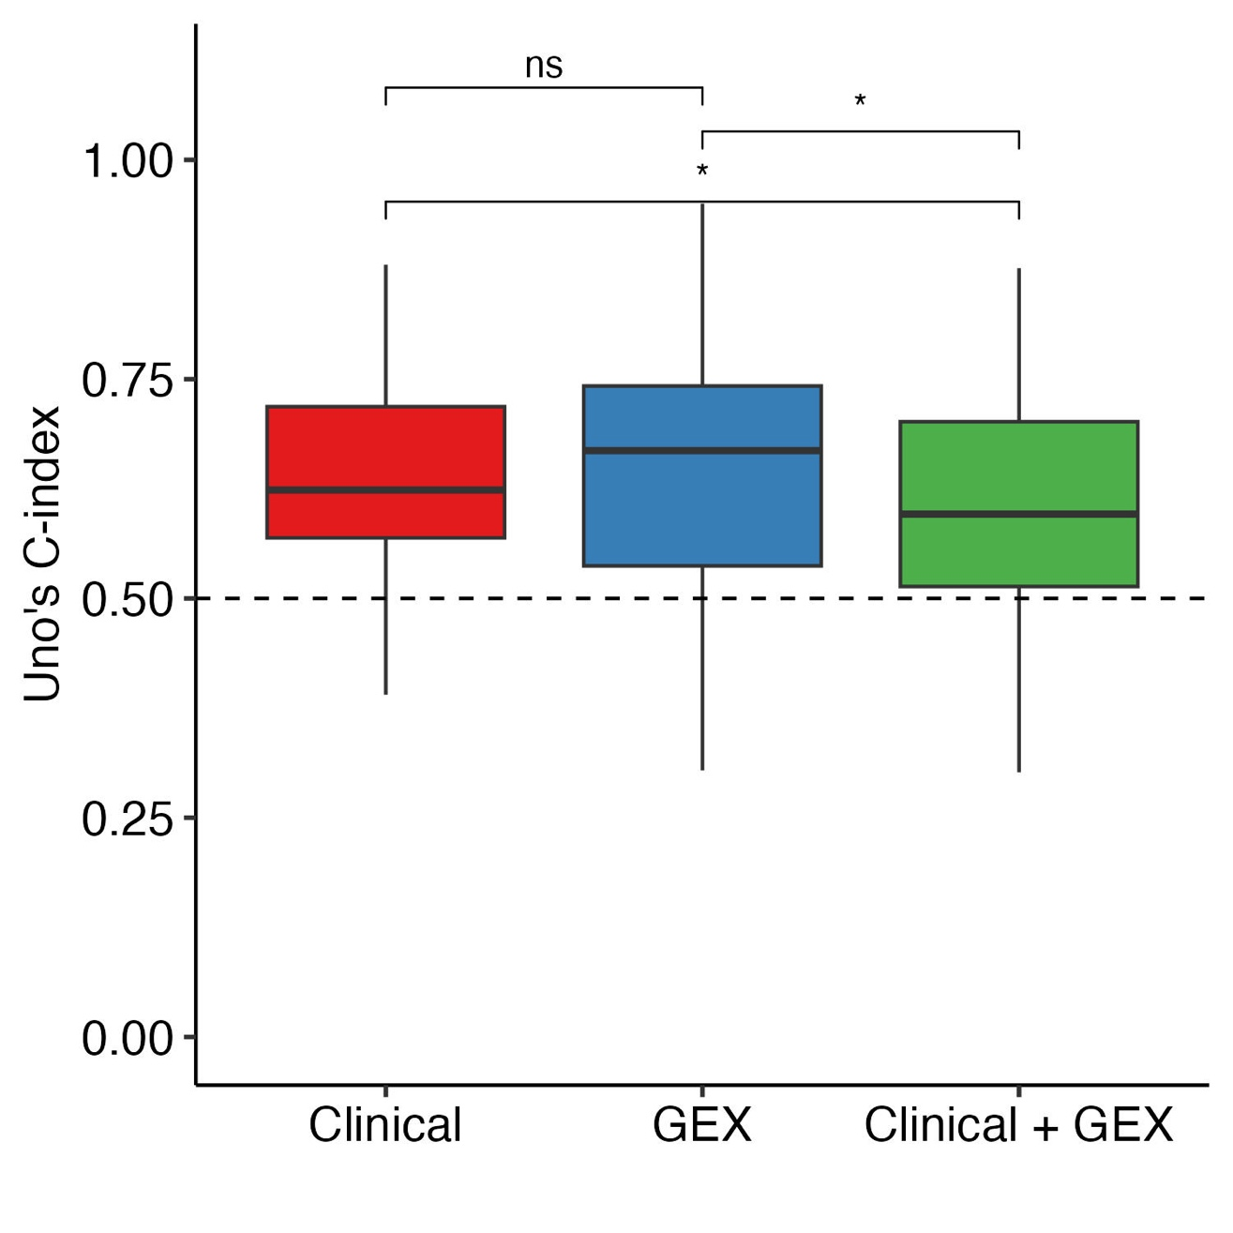

Supplementary figure 2. Overall discrimination performance with less strict pre-filtering. For gene pre-filtering, the 5000 most variable genes were retained and subjected to univariate filtering, keeping genes with FDR < 0.2 were kept. Median C- index for the Clinical model, the GEX model and the GEX + clinical models was 0.624, 0.669 and 0.596, respectively. The three models are all Cox proportional hazards models, each fitted and predicted over 100 iterations. The boxplots display the distribution of predicted Uno C-indexes from all iterations for each model at three time points. The median is shown as the middle line, the inter quartile range (IQR) as a box, and the whiskers represent the range of values within 1.5 x IQR. The dashed line indicates random prediction. Statistical significance between models is indicated with asterisks: p < 0.05 (*) and non-significant (ns).

