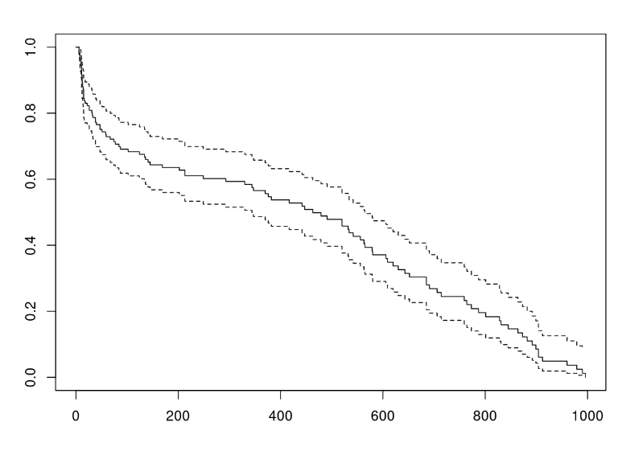
Supplementary figure 3. Censoring distribution graph G(t). The graph displays days on the x-axis and proportion of dogs not yet censored on the y-axis. The dashed upper and lower lines indicate 95% confidence interval.

