Supplementary Table S1: Experimental feed composition
Ingredients | Experimental feed (g/100g)^{b}
Ingredients | T₀ | T₁ | T2 | T₃ | T₄ | T₅ | T₆ | T₇ | T₈
Corn | 35 | 35 | 35 | 35 | 20 | 35 | 35 | 35 | 35
Wheat | 05 | 09 | 15 | 12 | 20 | 05 | 05 | 10 | 10
Rice polishing | 15 | 10 | 05 | 08 | - | 15 | 15 | 10 | 08
Canola meal | 15 | 10 | 05 | 08 | - | 15 | 15 | 10 | 09
Flaxseed | - | 10 | 20 | - | - | - | - | 05 | 05
Chia seed | - | - | - | 15 | 30 | - | - | 05 | 10
Fish oil | - | - | - | - | - | 01 | 02 | 01 | 01
Gluten 60% | 05 | 4.5 | 03 | 03 | - | 05 | 05 | 04 | 03
Gluten 30% | - | - | - | - | 5.5 | - | - | - | -
Wheat bran | - | - | - | - | 07 | - | - | - | -
Soybean meal | 08 | 08 | 08 | 08 | 08 | 08 | 08 | 08 | 08
ªVegetable oil | 08 | 04 | - | 02 | - | 07 | 06 | 03 | 02
Dicalcium phosphate | 1.5 | 1.5 | 1.5 | 1.5 | 1.5 | 1.5 | 1.5 | 1.5 | 1.5
Lime stone (ground) | 07 | 7.5 | 07 | 07 | 7.5 | 07 | 07 | 07 | 07
*Vitamin/mineral premix | 0.5 | 0.5 | 0.5 | 0.5 | 0.5 | 0.5 | 0.5 | 0.5 | 0.5

ªCottonseed oil
^{b}Crumble form of feed &Isocaloric feeds
*A commercial premix (VitaMix Poultry Premix®, Hi-Tech Feeds Pvt. Ltd., Lahore, Pakistan)

Supplementary Table S2
Diet code | Crude fat  (%) | Crude protein  (%) | Metabolizable energy  (kcal/kg)
¹T₀ | 10.24±0.32ª | 17.00±0.10^{b} | 2850.12±2.21^{c}
²T₁ | 10.20±0.29ª | 17.03±0.14^{b} | 2853.46±2.34^{c}
³T₂ | 10.31±0.31ª | 17.05±0.13^{b} | 2858.57±2.56^{c}
⁴T₃ | 10.29±0.35ª | 17.01±0.05^{b} | 2851.89±2.71^{c}
⁵T₄ | 10.27±0.30ª | 17.04±0.07^{b} | 2855.10±2.10^{c}
⁶T₅ | 10.33±0.37ª | 17.10±0.15^{b} | 2853.66±2.60^{c}
⁷T₆ | 10.21±0.34ª | 17.07±0.06^{b} | 2859.90±2.75^{c}
⁸T₇ | 10.38±0.40ª | 17.09±0.09^{b} | 2857.12±2.14^{c}
⁹T₈ | 10.22±0.32ª | 17.08±0.06^{b} | 2860.34±2.89^{c}
Values reported as means ± SD of three replicate analyses (n = 3)
Means followed by similar superscript letters in the same column are not significantly different (p>0.05)

Supplementary Table S3. Vaccination and medication schedule of experimental birds
Age (weeks) | Vaccine/Medication
0 | Marek’s disease (at hatchery)
2 | NDV (Newcastle Disease) – Live
3 | IB (Infectious Bronchitis) – Live
4 | Gumboro (IBD) – Live
6 | Fowlpox vaccine
8 | NDV – Booster
12 | IBD – Booster
16 | NDV + IB killed vaccine

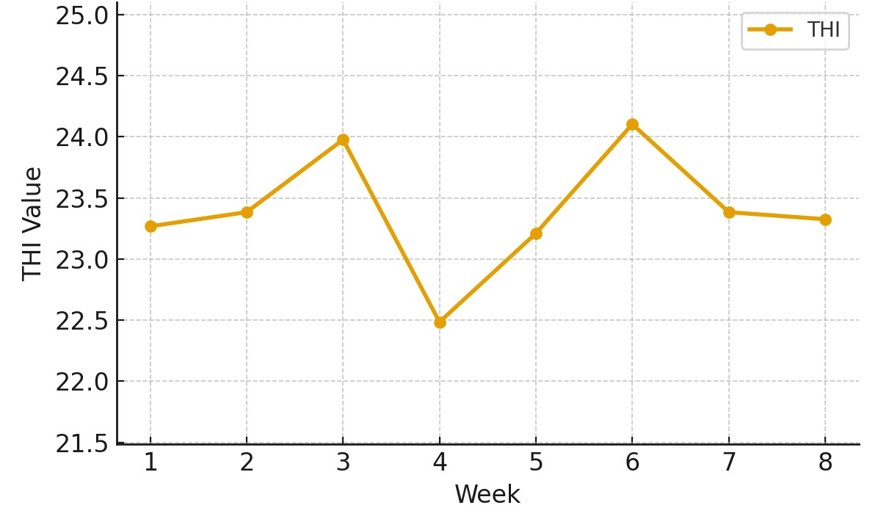
Figure S1. Temperature-Humidity Index (THI) monitored daily during the 8-week trial.

