Supplementary information to:
High contribution of dark dissolved inorganic carbon uptake to microbial carbon cycling in a shallow Mediterranean basin
Vincenzo Manna^{1,2} ; vmanna@ogs.it Primary corresponding author.

Cecilia Balestra¹ ; cbalestra@ogs.it

Elisa Banchi^{1,2}; ebanchi@ogs.it

Viviana Fonti¹; vfonti@ogs.it

Martina Kralj¹; mkralj@ogs.it

Mauro Celussi^{1,2}; mcelussi@ogs.it Corresponding author

Affiliations:
1: National Institute of Oceanography and Applied Geophysics - OGS; Trieste, Italy.
2: NBFC - National Biodiversity Future Center; Palermo, Italy.
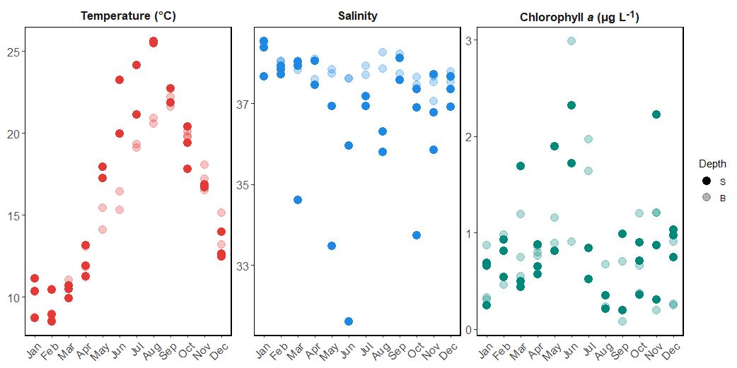
Figure S1: Trends of temperature, salinity and chlorophyll a concentration at the sampling site.
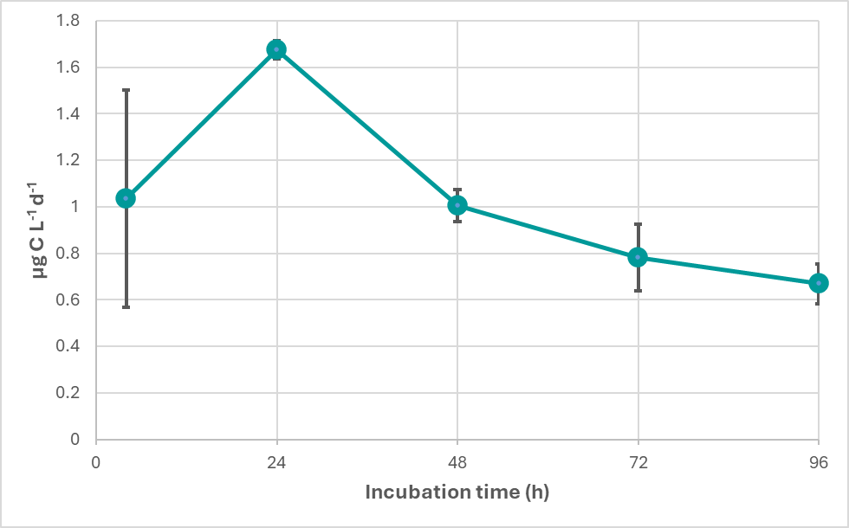
Figure S2: Time course (4-96h) of dark Dissolved Inorganic Carbon (dDIC) fixation in samples collected from the northern Adriatic Sea in October 2018, before the beginning of time-series measurements to determine the optimal incubation time. Datapoints are presented as the average ± SD of two data points.
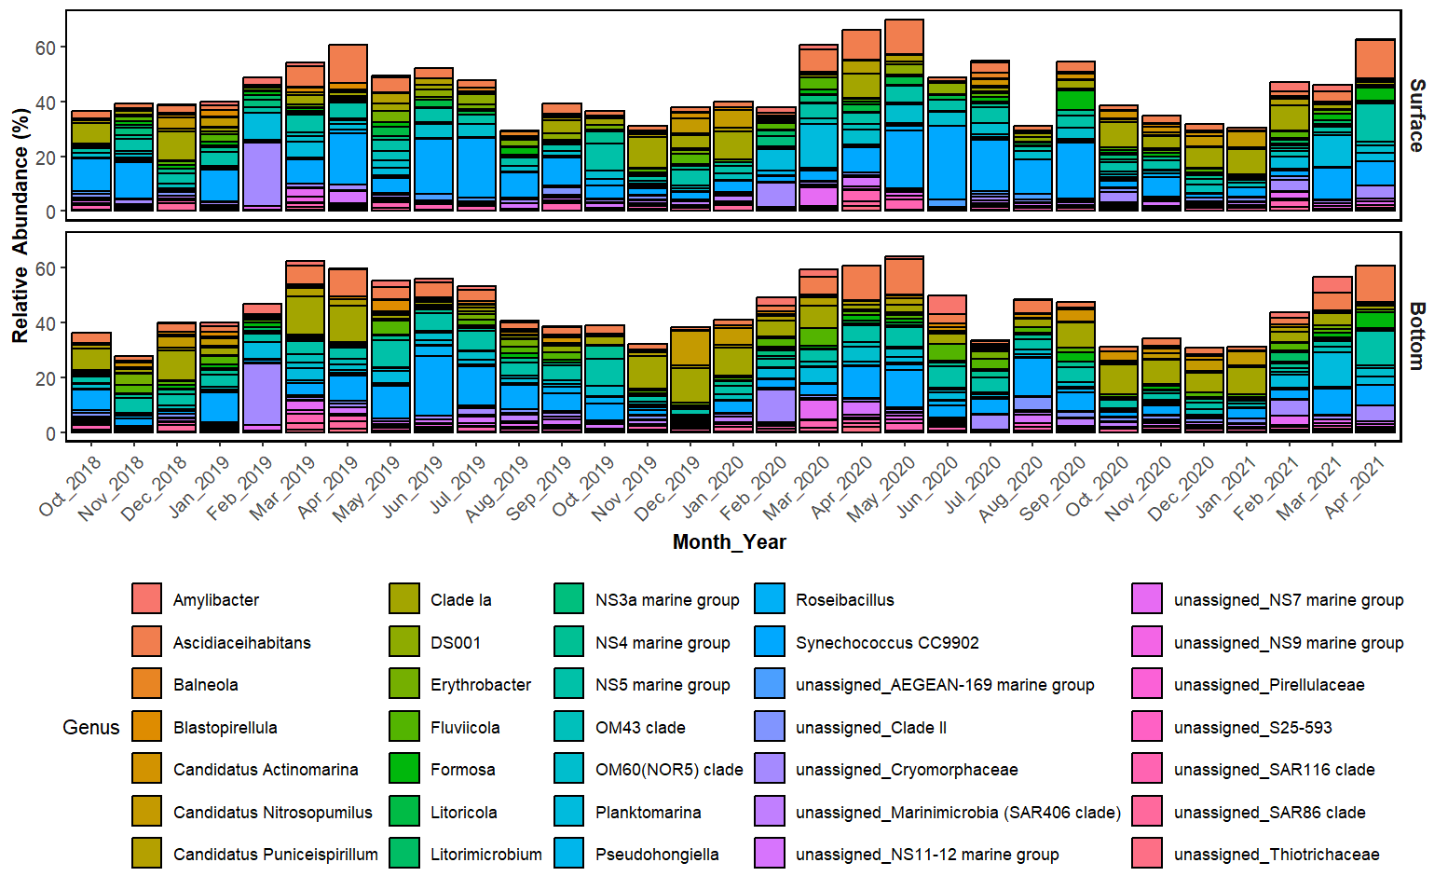
Figure S3: Main taxonomic patterns of the Gulf of Trieste microbiome from October 2018 to April 2021 in surface and bottom (~15m) samples.
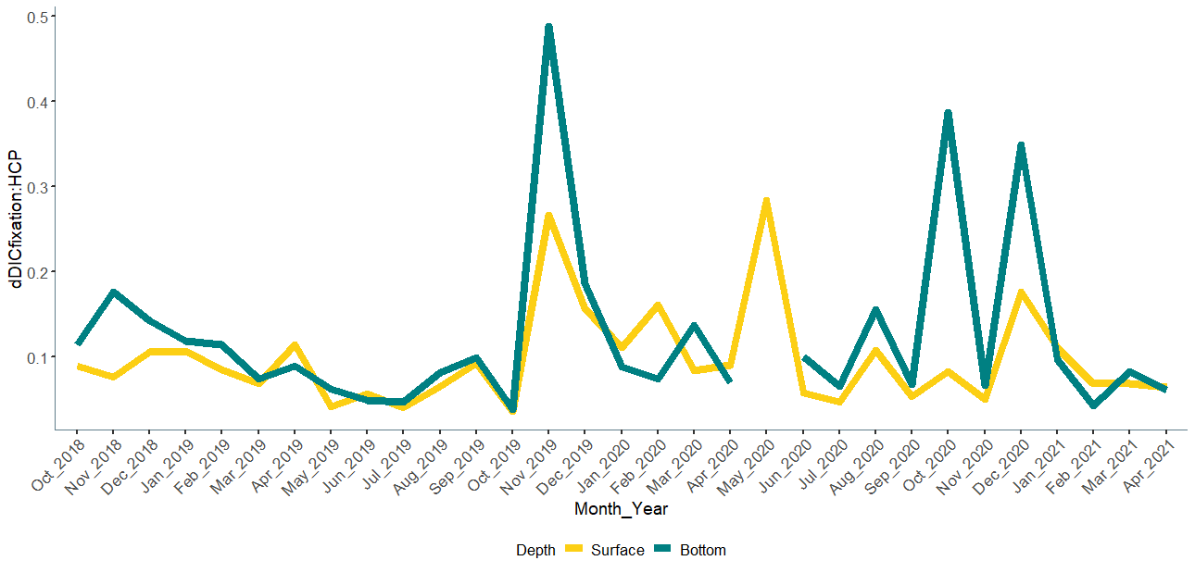
Figure S4: Temporal trends of the ratio between dark Dissolved Inorganic Carbon (dDIC) fixation and heterotrophic carbon production (HCP) in surface (~1m) and bottom (15m) samples.
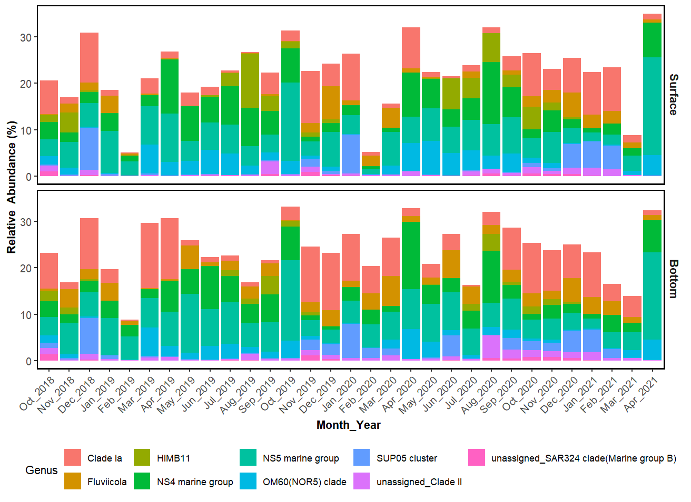
Figure S5: Relative abundance of selected genera putatively involved in autotrophic, heterotrophic or photoheterotrophic dDIC uptake.

