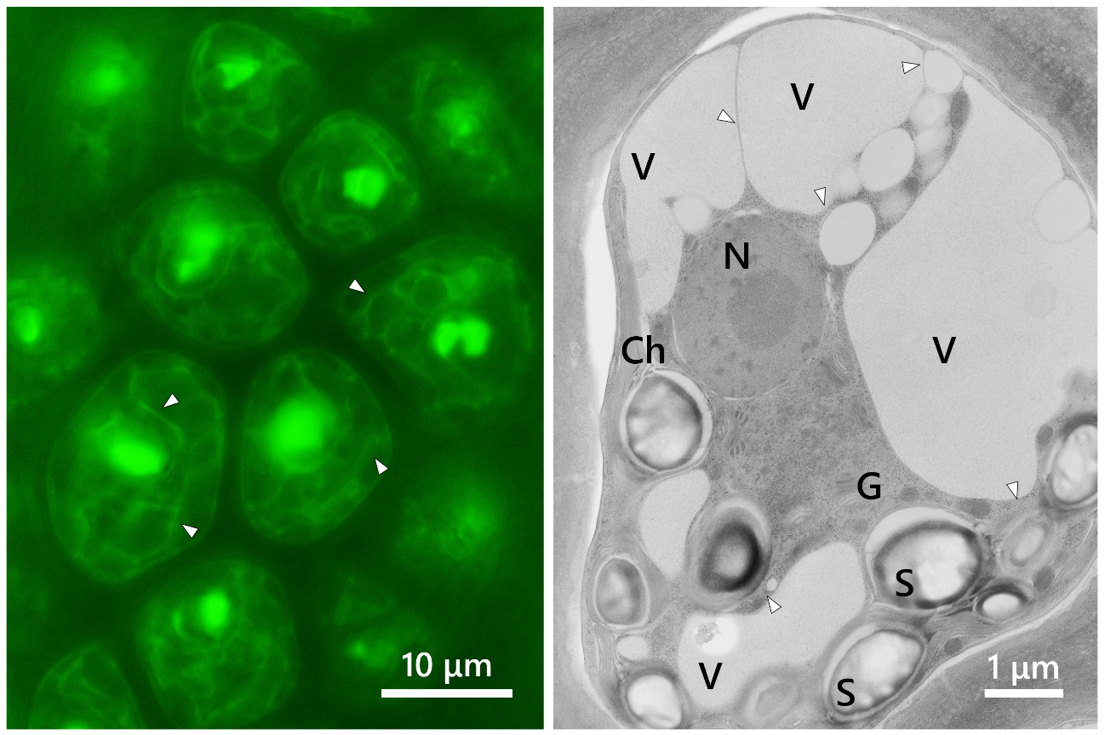

Fig. S5 Observation of RbcS-P2A-T2A-EGFP mutants by fluorescence and transmission electron microscopy of wild type cell. Left: Enlarged fluorescence microscopy image of RbcS-P2A-T2A-EGFP mutant cells. Green fluorescence is derived from EGFP. Right: Transmission electron microscopy (TEM) image of wild-type. Arrowheads indicate thread-like cytoplasmic region. Ch, chloroplast; G, golgi body; N, nucleus; S, starch; V, vacuole.

