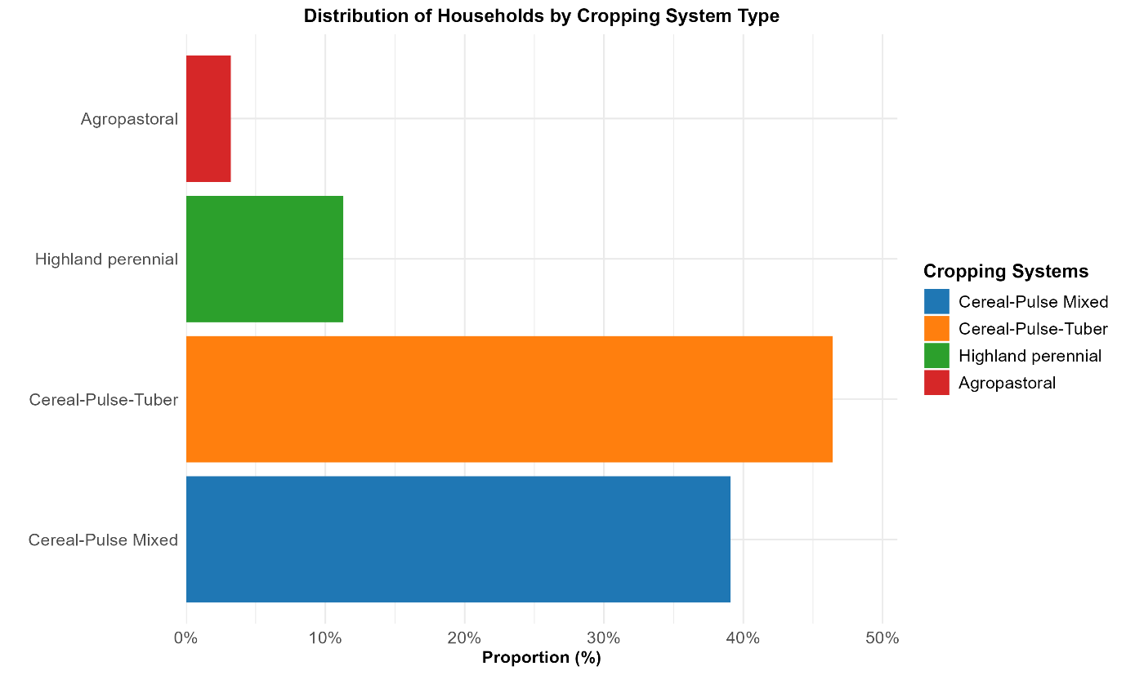

Supplementary Fig 1. Agricultural Cropping Systems in Rural Households: A Comparative Analysis

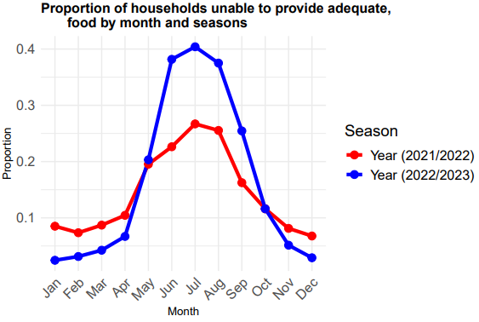
Supplementary Fig. 2. Monthly household food insecurity trends by season across two consecutive years in rural Ethiopia.

The proportion of households unable to provide adequate food varied seasonally across months and years (see Supplementary Fig. 2). Food insecurity peaked during the lean months of June to September, particularly in the 2022/2023 period, with the highest proportions observed in July and August. In contrast, lower proportions were recorded from November to March, aligning with post-harvest periods. The seasonal trend was more pronounced in 2022/2023 compared to 2021/2022, indicating a possible worsening of food insecurity in the second year.

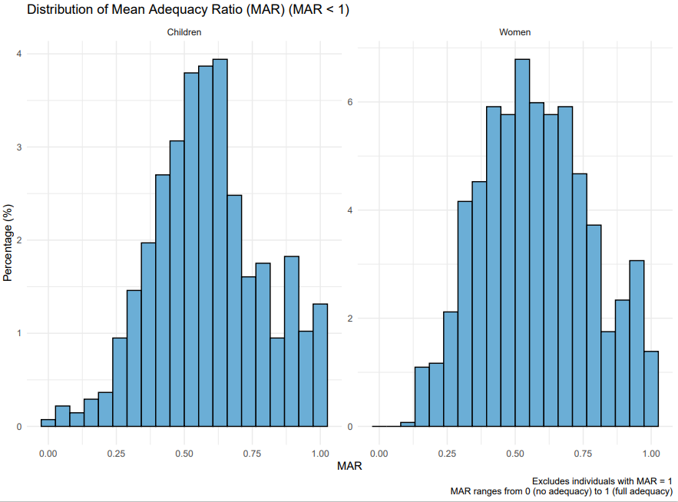

Supplementary Fig.3: Distribution of Mean Adequacy Ratio (MAR) among Children and Women (MAR < 1)

Supplementary Fig. 3 Legend
Histograms illustrating the percentage distribution of the Mean Adequacy Ratio (MAR) for children (left panel) and women (right panel), excluding individuals who achieved full nutrient adequacy (MAR = 1). The MAR represents the average nutrient adequacy ratio across key micronutrients, ranging from 0 (no adequacy) to 1 (full adequacy). Data are binned to show the prevalence of varying levels of nutrient inadequacy in the population, with percentages on the y-axis and MAR values on the x-axis. This figure provides supplementary insight into the spread of nutrient inadequacies observed in the study.

Supplementary Table 1. List of Food Groups Used to Construct the Women’s Dietary Diversity Score (WDDS)

Food Groups | Food Group Name
1 | Grains, white roots and tubers, and plantains (e.g., teff, maize, cassava, enset)
2 | Pulses (beans, peas, and lentils) (e.g., fava beans, chickpeas)
3 | Nuts and seeds
4 | Dairy (e.g., milk, yogurt, cheese)
5 | Meat, poultry, and fish (e.g., beef, chicken, tilapia)
6 | Eggs
7 | Dark green leafy vegetables (e.g., kale, spinach)
8 | Other vitamin A-rich fruits and vegetables (e.g., carrots, mangoes, papaya)
9 | Other vegetables (e.g., tomatoes, onions)
10 | Other fruits (e.g., bananas, oranges)

Supplementary Table 2. Hierarchical Cropping System Classification

Cluster | Original Crops | Cropping system | Rationale
Cluster 1 | Barley, wheat, pulses, teff, maize, sorghum, millet | Cereal-Pulse Mixed Farming | Predominantly characterized by a diverse array of cereals (barley, wheat, teff, maize, sorghum, millet) integrated with pulses, reflecting a balanced agroecological system common in Ethiopia’s highland and midland regions, optimizing both grain and legume production.
Cluster 2 | Maize, pulse, potato, Enset | Cereal-Pulse-Tuber Mix | A versatile system combining cereals (maize), pulses, root crops (potatoes), and the culturally significant Enset (false banana), a staple in southern Ethiopia. This mix is widespread across highland and midland areas, supporting food security with diverse staple crops.
Cluster 3 | Maize, coffee, kchat, pepper, spices | Perennial crops | Dominated by high-value perennial and cash crops, including coffee, khat (a stimulant crop), pepper, and spices. This system is tailored for economic returns and is prevalent in regions suitable for such specialty agriculture.
Cluster 4 | Animal rearing and agrarian mix | Agropastoral | Primarily focused on livestock rearing, supplemented by limited cereal production, representing a hybrid system that leverages pastoral traditions with minimal crop cultivation, typical in semi-arid or transitional agroecological zones.

