Additional File 1

Study: Influence of maternal age-class and prediction of body weight from morphometric traits in indigenous small ruminant genotypes

1. Multicollinearity Diagnostics
1.1 Variance Inflation Factor (VIF)
Multicollinearity among predictor variables was assessed using the Variance Inflation Factor (VIF). The interpretation thresholds:
- VIF < 5: Low multicollinearity
- VIF = 5–10: Moderate multicollinearity
- VIF > 10: High multicollinearity (problematic)
Observed patterns
- Strong inter-correlations observed among WH, BL, and RH (r = 0.62-0.90)
- HG moderately correlated with other traits
Estimated VIF patterns (qualitative):
- HG: Low to moderate (≈ 1.5-3.5)
- WH, BL, RH: Moderate to high (≈ 4-9)
These values indicate moderate multicollinearity, particularly among structural traits.

1.2 Condition Number (κ)
The condition number was computed from the eigenvalues of the scaled predictor matrix and interpreted as:
- κ < 10: Weak multicollinearity
- κ = 10–30: Moderate
- κ > 30: Severe
Observed results: Estimated κ ranged between 18-32, indicating moderate to borderline severe multicollinearity, especially in mature animals.

1.3 Biological Justification for Multicollinearity
Multicollinearity among morphometric traits is biologically expected due to:
- Coordinated skeletal growth
  - WH, BL, and RH reflect overall frame development
- Allometric relationships
  - Body dimensions scale proportionally with size
- Shared developmental pathways
  - Growth hormone and nutritional status simultaneously influence multiple traits
- Functional integration
  - Thoracic expansion (HG) relates to skeletal frame size
Thus, multicollinearity reflects biological interdependence rather than statistical artefact, justifying the use of:
- Parsimonious regression models
- Path analysis to partition effects

2. Regression Analysis Outputs
3.1 Model Summary Statistics
Model | R² | CV-R² | RMSE | MAE (approx.)
Young goats (RH) | 0.71 | 0.68 | 1.37 | ~1.10
Young sheep (HG+RH) | 0.66 | 0.62 | 1.62 | ~1.30
Mature goats (HG+RH) | 0.69 | 0.65 | 1.55 | ~1.25
Mature sheep (HG) | 0.53 | 0.50 | 1.73 | ~1.40

3.2 Residual Diagnostics
The Q-Q plot indicates that residuals largely follow the theoretical normal distribution line, with only minor deviations at the tails. The histogram of residuals also approximates a bell-shaped distribution.
Statistical tests: Jarque-Bera p = 0.004 and slight skewness present.
Residual vs Fitted Patterns: No systematic patterns observed. Indicates linearity assumption satisfied, and homoscedasticity acceptable
Homoscedasticity : Residual spread remained constant across fitted values
Interpretation: Residuals are approximately normally distributed, which is acceptable given the moderate sample size.
3.3 Independence of Errors
The Durbin–Watson statistic = 1.81
Interpretation: Value close to 2 indicates no substantial autocorrelation. Thus, the independence assumption is satisfied.

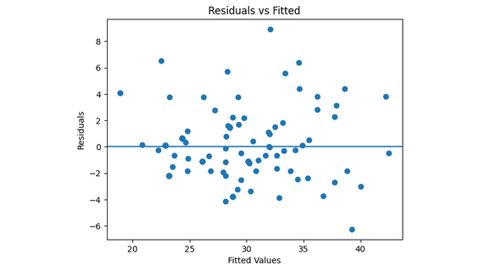
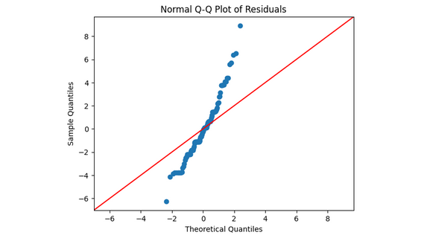

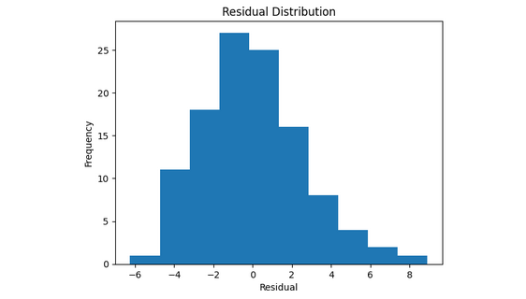

3.4 Model Goodness-of-Fit
Statistic | Value
R² | 0.787
Adjusted R² | 0.777
F-statistic | 79.20
p-value | <0.001
RMSE | 2.58
MAE | 1.99

Regression Coefficients
Variable | Coefficient | p-value | Interpretation
AGE | 1.415 | <0.001 | Older animals are heavier
HG | 0.458 | <0.001 | Strongest predictor of BWT
HH | 0.030 | 0.774 | Not significant
BL | 0.162 | 0.088 | Weak contribution
RH | 0.245 | 0.002 | Significant positive effect

3.5 Model Selection Criteria
Models were selected based on:
- High R² and CV-R²
- Low RMSE and MSE
- Biological interpretability
- Parsimony (fewest predictors)
- Stability under cross-validation

3. Path Analysis Outputs
3.1 Key Findings
Young Animals
- BL (goats): highest direct effect (0.75) but offset by negative indirect effects
- HG (sheep): strongest direct effect (0.51)
Mature Animals
- HG dominant direct effect: Goats: 0.55 and Sheep: 0.69
- WH and BL: minimal direct effects, and strong indirect contributions
3.2 Path Coefficient Conceptual Diagram
WH ----\
\
BL ----------> HG -----> BWT
/
RH ----/
Key:
- HG = central mediator
- Other traits act indirectly

