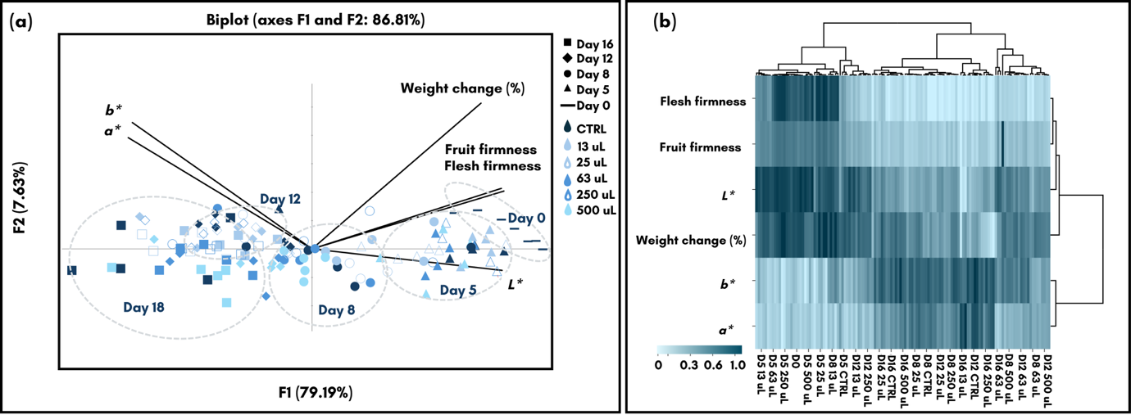
Supplementary Figure 1 The PCA dendrogram of mango treated with difference amount of Thai basil essential oil based on their physical appearance (a), and heatmap plot cluster (b)
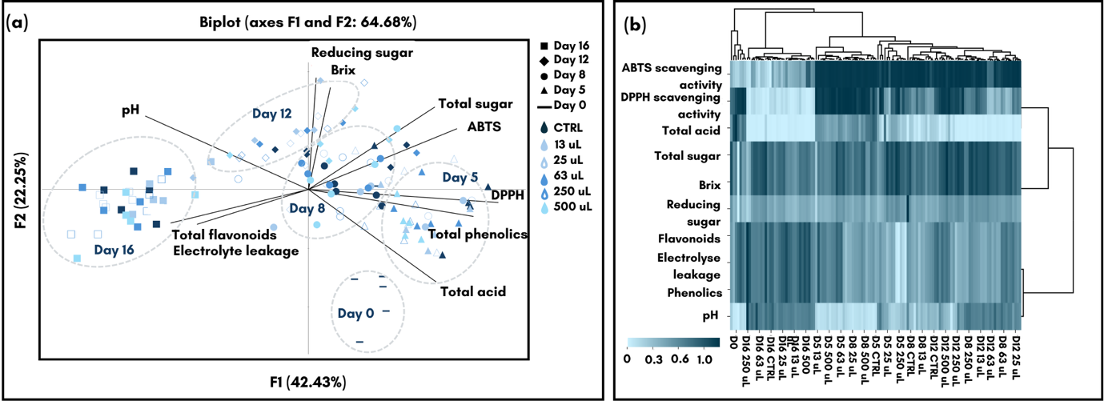
Supplementary Figure 2 The PCA dendrogram of mango treated with difference amount of Thai basil essential oil based on their physiochemical and chemical characteristic (a), and their heatmap plot cluster (b)

