Similar sensitivity and resilience to marine heatwaves of giant kelp (Macrocystis pyrifera) sporophytes from the northern and southern edges of their distribution in Aotearoa New Zealand.

Imogen C. Bunting, Roberta D’Archino, Neill Barr, Sarah J. Bury, Matthew J. Desmond, Christopher Hepburn, Yun Yi Kok, Erik C. Krieger, Duong Minh Le and Christopher E. Cornwall

Table S1: Timeline of the collection and culture of Macrocystis pyrifera gametophytes and sporophytes and the heatwave experiment. Dashed portions of the line represent scale breaks.

Date | Event
18/12/2019 | Gametophytes collected: Breaksea Sound
05/03/2020 | Gametophytes collected: Karitane
09/06/2020 | Gametophytes collected: D’Urville Island
22/09/2020 | Gametophytes collected: Port Pegasus
10/10/2020 | Gametophytes collected: Scorching Bay
07/2022 | Gametophytes transferred to NIWA system
04/2023 | Gametophytes collected: Scorching Bay A
11/07/2023 | Gametophytes from red light cultures fragmented and incubated under white light
09/10/2023 | Scorching Bay A males and females combined
31/10/2023 | Males and females from red light cultures combined
28/02/2024 | Sporophytes transferred to experimental tanks
29/04/2024 | Tank setup modified to flow-through
5/06/2024 | Heatwave experiment commenced
26/06/2024 | Recovery phase commenced
16/07/2024 | Experiment ended

Table S2: Weekly temperature (T), pH, salinity (S), and dissolved oxygen (DO) data taken from the experimental tanks throughout the heatwave experiment.
Date | Tank ID | 11 | 12 | 13 | 14 | 15 | 16 | 21 | 22 | 23 | 24 | 25 | 26
11/06/24 | T (°C) | 22.2 | 18.3 | 13.9 | 17.9 | 22.2 | 13.6 | 22.0 | 18.1 | 14.5 | 18.1 | 14.6 | 21.9
11/06/24 | pH | 7.82 | 7.82 | 7.88 | 7.85 | 7.81 | 7.90 | 7.82 | 7.72 | 7.87 | 7.85 | 7.88 | 7.83
11/06/24 | S (PSU) | 34 | 32.9 | 32.6 | 33.3 | 33.7 | 32.8 | 34 | 33.2 | 32.5 | 33.3 | 32.6 | 33.8
18/06/24 | T (°C) | 22.1 | 18.2 | 14.0 | 18.1 | 22.2 | 13.8 | 21.8 | 18.4 | 14.4 | 18.4 | 14.8 | 22.1
18/06/24 | pH | 7.69 | 7.72 | 7.72 | 7.70 | 7.69 | 7.74 | 7.70 | 7.67 | 7.69 | 7.70 | 7.73 | 7.71
18/06/24 | S (PSU) | 34.8 | 34.1 | 33.8 | 35.3 | 35.9 | 33.9 | 35.9 | 35.1 | 34.9 | 35.5 | 34.6 | 36
18/06/24 | DO (%) | 104.4 | 100.9 | 99.1 | 103.2 | 105.4 | 99.5 | 103.6 | 97.9 | 98.7 | 102.9 | 99.8 | 104.9
24/06/24 | T (°C) | 21.9 | 18.3 | 13.9 | 18.1 | 22.2 | 13.9 | 22.1 | 18.3 | 14.4 | 18.5 | 14.8 | 22.5
24/06/24 | pH | 7.75 | 7.79 | 7.80 | 7.79 | 7.77 | 7.83 | 7.76 | 7.74 | 7.76 | 7.76 | 7.81 | 7.77
24/06/24 | S (PSU) | 36.3 | 35.5 | 35 | 36.4 | 36.8 | 34.9 | 36.9 | 35.9 | 35.6 | 36.5 | 35.7 | 36.9
24/06/24 | DO (%) | 103.3 | 101.6 | 100 | 104.2 | 103.7 | 99.2 | 101.7 | 98.3 | 99.1 | 102.5 | 99.9 | 103
03/07/24 | T (°C) | 14.5 | 13.6 | 14.1 | 13.8 | 14.5 | 13.7 | 14.6 | 13.2 | 14.6 | 14.5 | 14.5 | 13.3
03/07/24 | pH | 7.92 | 7.94 | 7.93 | 7.94 | 7.93 | 7.94 | 7.93 | 7.90 | 7.91 | 7.92 | 7.93 | 7.94
03/07/24 | S (PSU) | 35.8 | 35.4 | 35.6 | 35.5 | 35.7 | 35.4 | 35.6 | 35 | 35.7 | 35.5 | 35.6 | 35
03/07/24 | DO (%) | 103.7 | 105.4 | 103 | 102.8 | 104.2 | 101.8 | 103.2 | 100.4 | 101.7 | 102.5 | 103.7 | 102.1
08/07/24 | T (°C) | 14.4 | 13.8 | 14.0 | 13.7 | 14.2 | 13.7 | 14.6 | 13.2 | 14.4 | 14.4 | 14.5 | 13.4
08/07/24 | pH | 7.85 | 7.87 | 7.87 | 7.88 | 7.88 | 7.87 | 7.86 | 7.83 | 7.85 | 7.86 | 7.86 | 7.87
08/07/24 | S (PSU) | 34.6 | 34.4 | 34.5 | 34.4 | 34.5 | 34.4 | 34.5 | 33.8 | 34.4 | 34.4 | 34.5 | 33.8
08/07/24 | DO (%) | 104.8 | 104.2 | 104.2 | 104.5 | 105.2 | 103.8 | 106.3 | 102.3 | 103.4 | 103.6 | 104.3 | 103.4
15/07/24 | T (°C) | 14.4 | 13.6 | 14.1 | 13.8 | 14.5 | 14.1 | 14.5 | 13.1 | 14.5 | 14.4 | 14.6 | 13.5
15/07/24 | pH | 7.97 | 7.99 | 7.98 | 7.98 | 7.99 | 7.97 | 7.97 | 7.96 | 7.96 | 7.97 | 7.97 | 7.98
15/07/24 | S (PSU) | 36.1 | 35.4 | 36 | 36 | 36 | 35.9 | 36.1 | 35.3 | 36.1 | 36.1 | 36.1 | 35.4

Table S3: Ammonia, NO_{x}, and orthophosphate concentrations (µg L⁻¹) in seawater samples taken from the experimental tanks during the heatwave and recovery phases. NA values represent samples in which nutrient concentrations were too low to be detected.
Date | Tank | Ammonia | NO_{x} | Orthophosphate
18/06/24 | 11 | 15.61 | 101.50 | 18.05
18/06/24 | 12 | 7.31 | 81.76 | 19.74
18/06/24 | 13 | 13.84 | 100.27 | 18.22
18/06/24 | 14 | 9.38 | 63.21 | 14.47
18/06/24 | 15 | 11.32 | 89.26 | 16.29
18/06/24 | 16 | 11.03 | 54.58 | 11.25
18/06/24 | 21 | 8.16 | 96.54 | 17.57
18/06/24 | 22 | 10.78 | NA | NA
18/06/24 | 23 | 24.82 | 102.20 | 15.83
18/06/24 | 24 | 9.26 | 107.87 | 18.18
18/06/24 | 25 | 7.35 | 66.56 | 11.37
18/06/24 | 26 | 6.53 | 85.41 | 15.82
01/07/24 | 11 | 4.43 | 79.24 | 15.20
01/07/24 | 12 | 10.10 | 55.80 | 11.71
01/07/24 | 13 | 5.77 | 59.94 | 13.80
01/07/24 | 14 | 5.63 | 92.67 | 15.58
01/07/24 | 15 | 4.51 | 62.75 | 12.39
01/07/24 | 16 | 5.06 | 72.10 | 14.60
01/07/24 | 21 | 7.01 | 50.76 | 11.47
01/07/24 | 22 | 10.28 | 23.62 | 7.97
01/07/24 | 23 | 7.61 | 28.51 | 8.36
01/07/24 | 24 | 11.47 | 54.19 | 12.25
01/07/24 | 25 | 9.97 | 34.68 | 10.94
01/07/24 | 26 | 6.14 | 65.19 | 14.52
15/07/24 | 11 | 23.14 | 69.97 | 9.96
15/07/24 | 12 | 4.34 | 72.54 | 15.19
15/07/24 | 13 | 6.19 | 72.96 | 13.90
15/07/24 | 14 | 6.02 | 57.61 | 11.61
15/07/24 | 15 | 7.47 | 1.53 | 10.04
15/07/24 | 16 | 8.87 | NA | 8.70
15/07/24 | 21 | 5.94 | 72.29 | 12.26
15/07/24 | 22 | 10.54 | 30.04 | 6.00
15/07/24 | 23 | 9.21 | 60.65 | 11.05
15/07/24 | 24 | 6.20 | 55.79 | 10.21
15/07/24 | 25 | 8.15 | 51.70 | 10.78
15/07/24 | 26 | 6.33 | 50.82 | 7.87

Table S4: Number (n) and mean blade length and wet weight, with standard error, of M. pyrifera sporophytes taken from all experimental cultures, measured the day before the simulated heatwave experiment commenced.
Population | n | Mean blade length (mm) | Mean wet weight (mg)
Scorching Bay | 24 | 30.7 ± 1.7 | 301 ± 34
Scorching Bay A (no red light) | 24 | 20.7 ± 2.0 | 283 ± 22
D’Urville Island | 12 | 13.0 ± 2.1 | 193 ± 28
Breaksea Sound | 24 | 13.0 ± 1.4 | 243 ± 18
Karitane | 24 | 23.3 ± 2.3 | 252 ± 15
Port Pegasus | 24 | 14.5 ± 1.2 | 207 ± 18

Table S5: Number of M. pyrifera sporophytes from each culture and temperature treatment sacrificed for chemical analysis at the conclusion of the heatwave and recovery periods. The 22°C treatments were not sampled destructively after the heatwave due to low survival rates, but one sample was taken from a blade from the Scorching Bay culture that broke off during measurements.
Population | Temperature (°C) | Heatwave | Recovery
Scorching Bay | 14 | 4 | 2
Scorching Bay | 18 | 2 | 1
Scorching Bay | 22 | 1
Scorching Bay A  (not incubated under red light) | 14 | 3 | 1
Scorching Bay A  (not incubated under red light) | 18 | 2 | 2
Scorching Bay A  (not incubated under red light) | 22 |  | 1
D’Urville Island | 14 |  | 1
D’Urville Island | 18 |  | 3
D’Urville Island | 22
Breaksea Sound | 14 |  | 1
Breaksea Sound | 18 |  | 1
Breaksea Sound | 22
Karitane | 14 | 3 | 3
Karitane | 18 | 3 | 3
Karitane | 22 |  | 1
Port Pegasus | 14 | 2 | 3
Port Pegasus | 18 | 3 | 3
Port Pegasus | 22

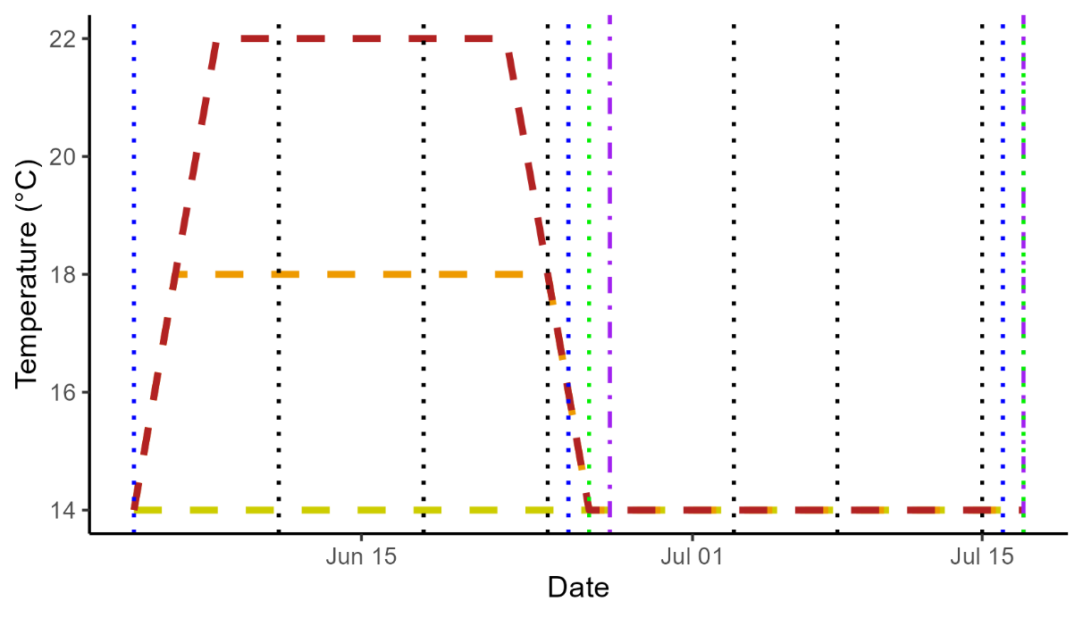
Figure S1: Timeline of the heatwave experiment and recovery phase. Dashed lines represent seawater temperatures in each treatment. Dotted vertical lines represent dates on which measurements or sampling were carried out: blue represents growth measurements, green represents F_{v}/F_{m} measurements, purple represents tissue sampling for carbon and nitrogen content, and black represents measurements of abiotic conditions in tanks. Pre-heatwave F_{v}/F_{m} measurements were carried out on 30 May 2024.

a)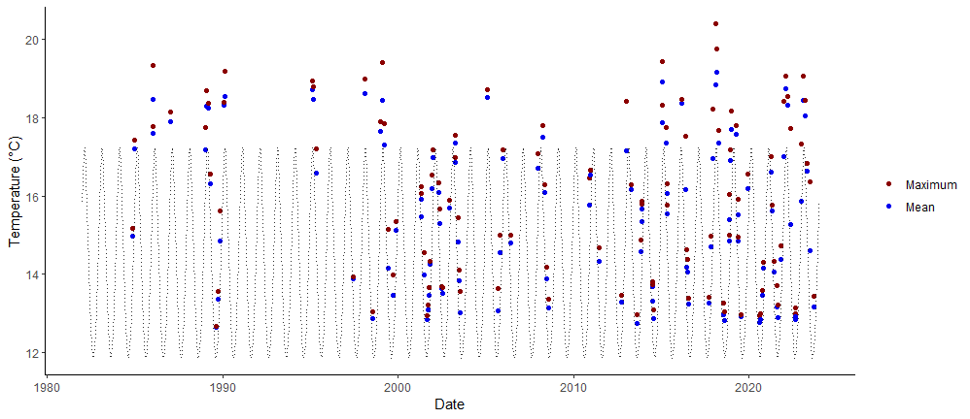
b)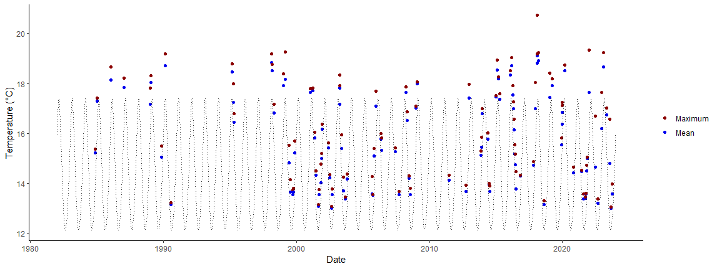
c)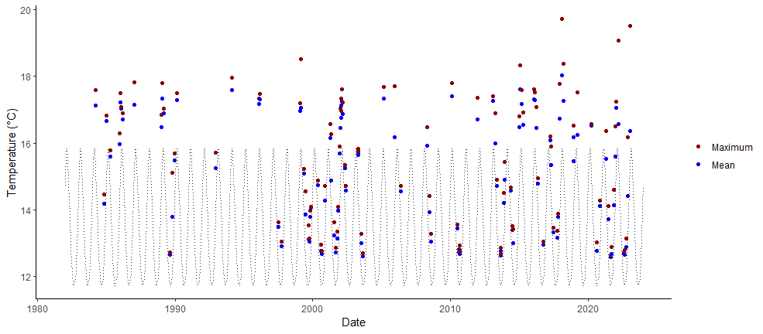
d)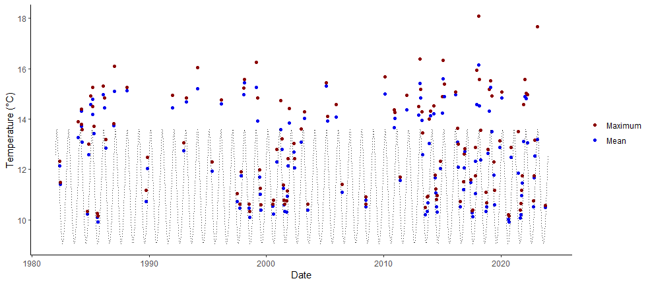
e)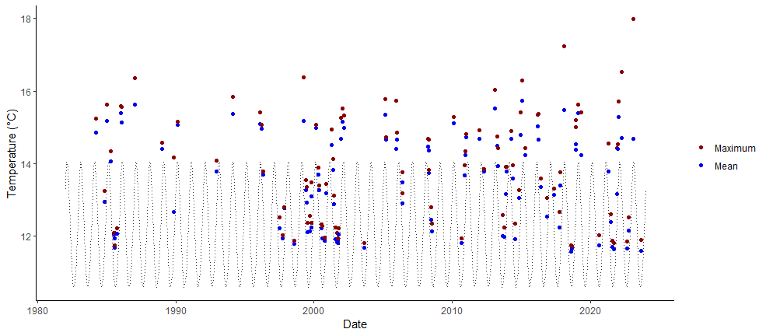

Figure S2: Mean and maximum sea surface temperatures during marine heatwave events that occurred within the regions of a) Marlborough, b) Wellington, c) Fiordland, d) Otago, and e) Stewart Island between 1982 and 2023, detected using the R package “heatwaveR” (Schlegel and Smit, 2021) and the National Oceanic and Atmospheric Administration (NOAA) “Optimum Interpolation Sea Surface Temperature V2.1” dataset (Reynolds and Banzon, 2008). The dotted black line represents seasonal mean sea surface temperatures for the region, obtained from a 30-year baseline period from 1982 to 2011. Note: Figure S2b was previously published as Supplementary Material in Bunting et al. (2024) and is included with permission from the authors.

a)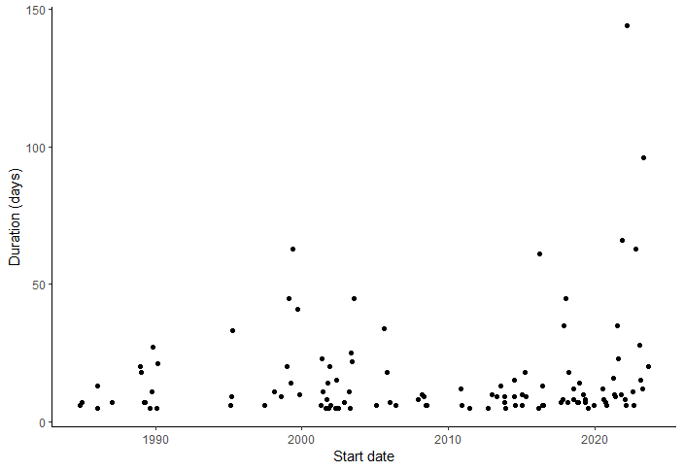b)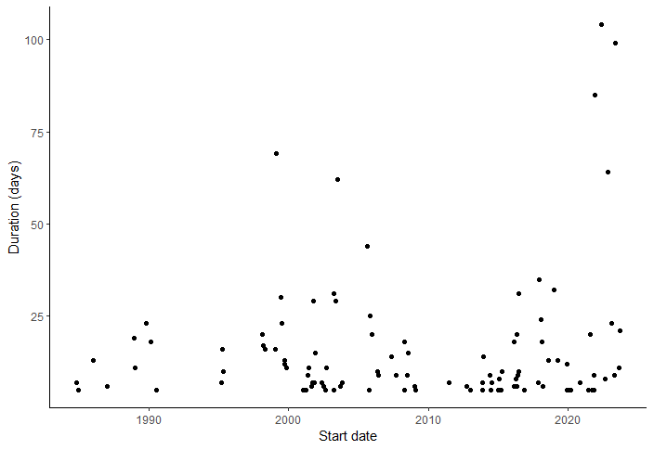
c)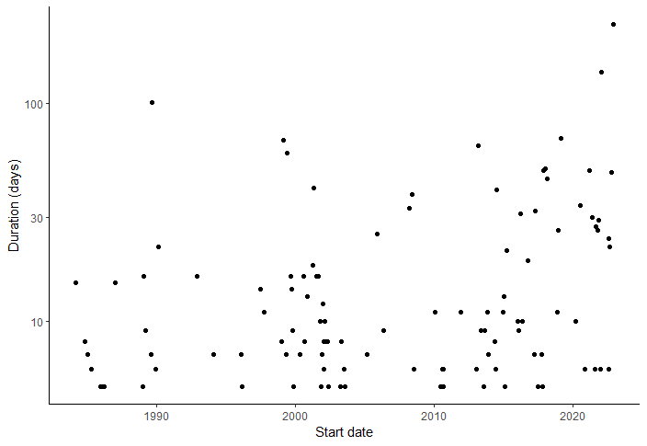d)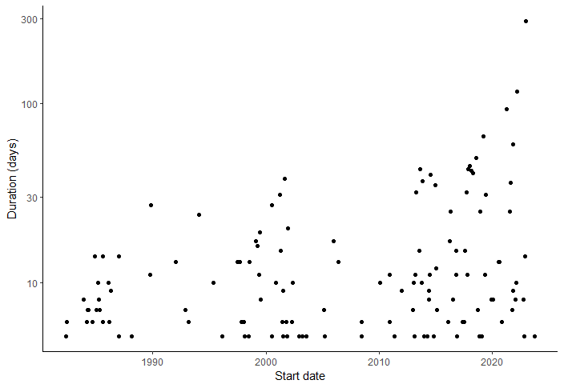
e)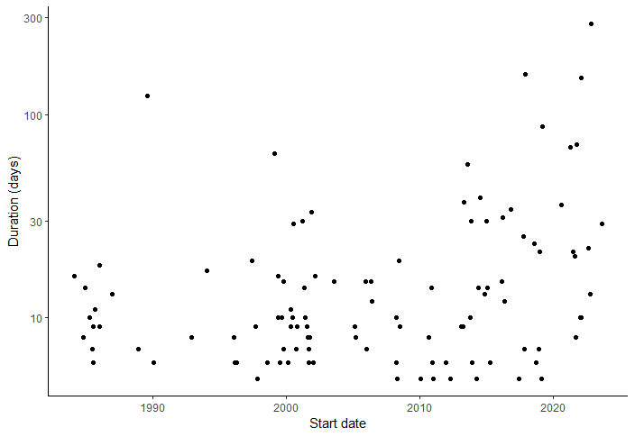
Figure S3: Durations of marine heatwave events that occurred within the regions of a) Marlborough, b) Wellington, c) Fiordland, d) Otago, and e) Stewart Island between 1982 and 2023, detected using the R package “heatwaveR” (Schlegel and Smit, 2021) and the National Oceanic and Atmospheric Administration (NOAA) “Optimum Interpolation Sea Surface Temperature V2.1” dataset (Reynolds and Banzon, 2008). Note: Figure S3b was previously published as Supplementary Material in Bunting et al. (2024) and is included with permission from the authors.

a)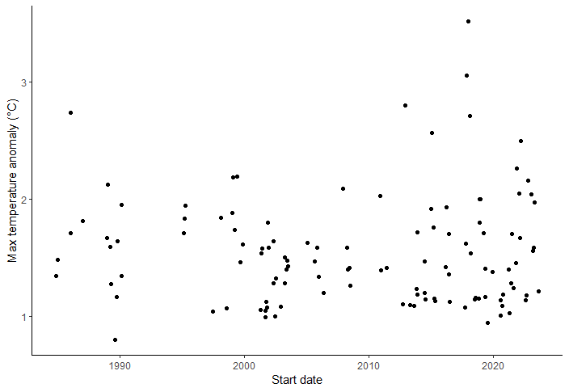b)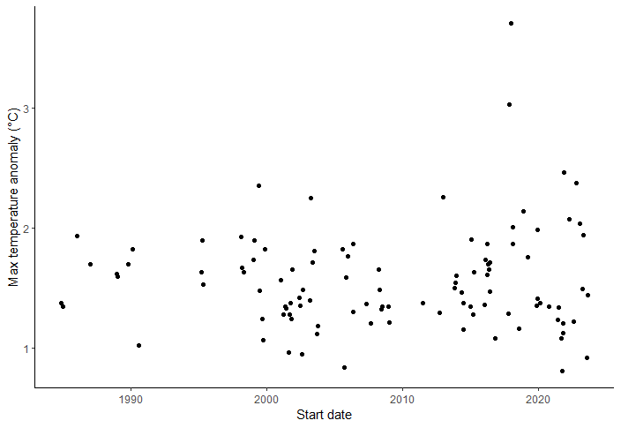
c)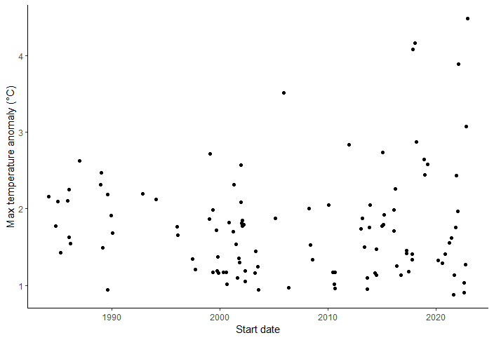d)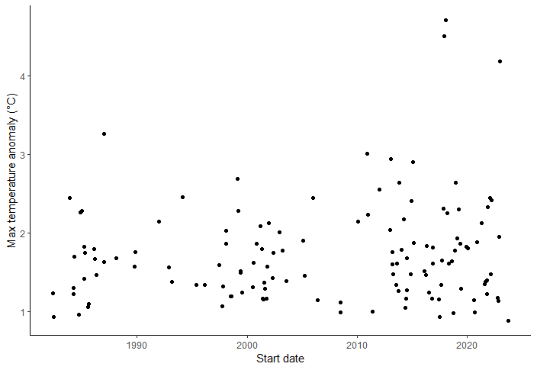
e)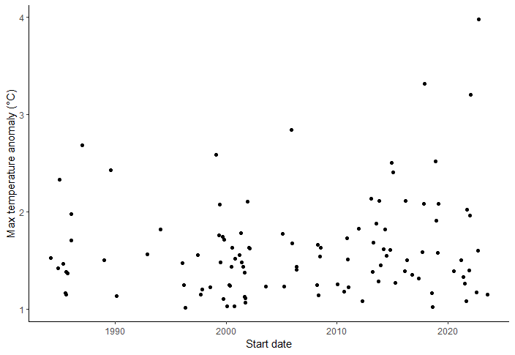
Figure S4: Maximum temperature anomalies, relative to seasonal mean temperatures, of marine heatwave events that occurred within the regions of a) Marlborough, b) Wellington, c) Fiordland, d) Otago, and e) Stewart Island between 1982 and 2023, detected using the R package “heatwaveR” (Schlegel and Smit, 2021) and the National Oceanic and Atmospheric Administration (NOAA) “Optimum Interpolation Sea Surface Temperature V2.1” dataset (Reynolds and Banzon, 2008). Note: Figure S4b was previously published as Supplementary Material in Bunting et al. (2024) and is included with permission from the authors.

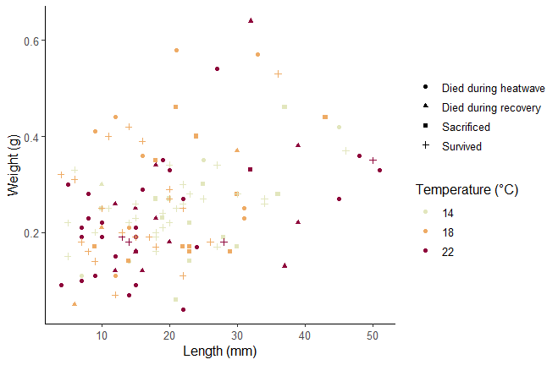
Figure S5: Day 0 blade length and wet weight and survival outcome of sporophytes in each temperature treatment.

