Supplementary Figures
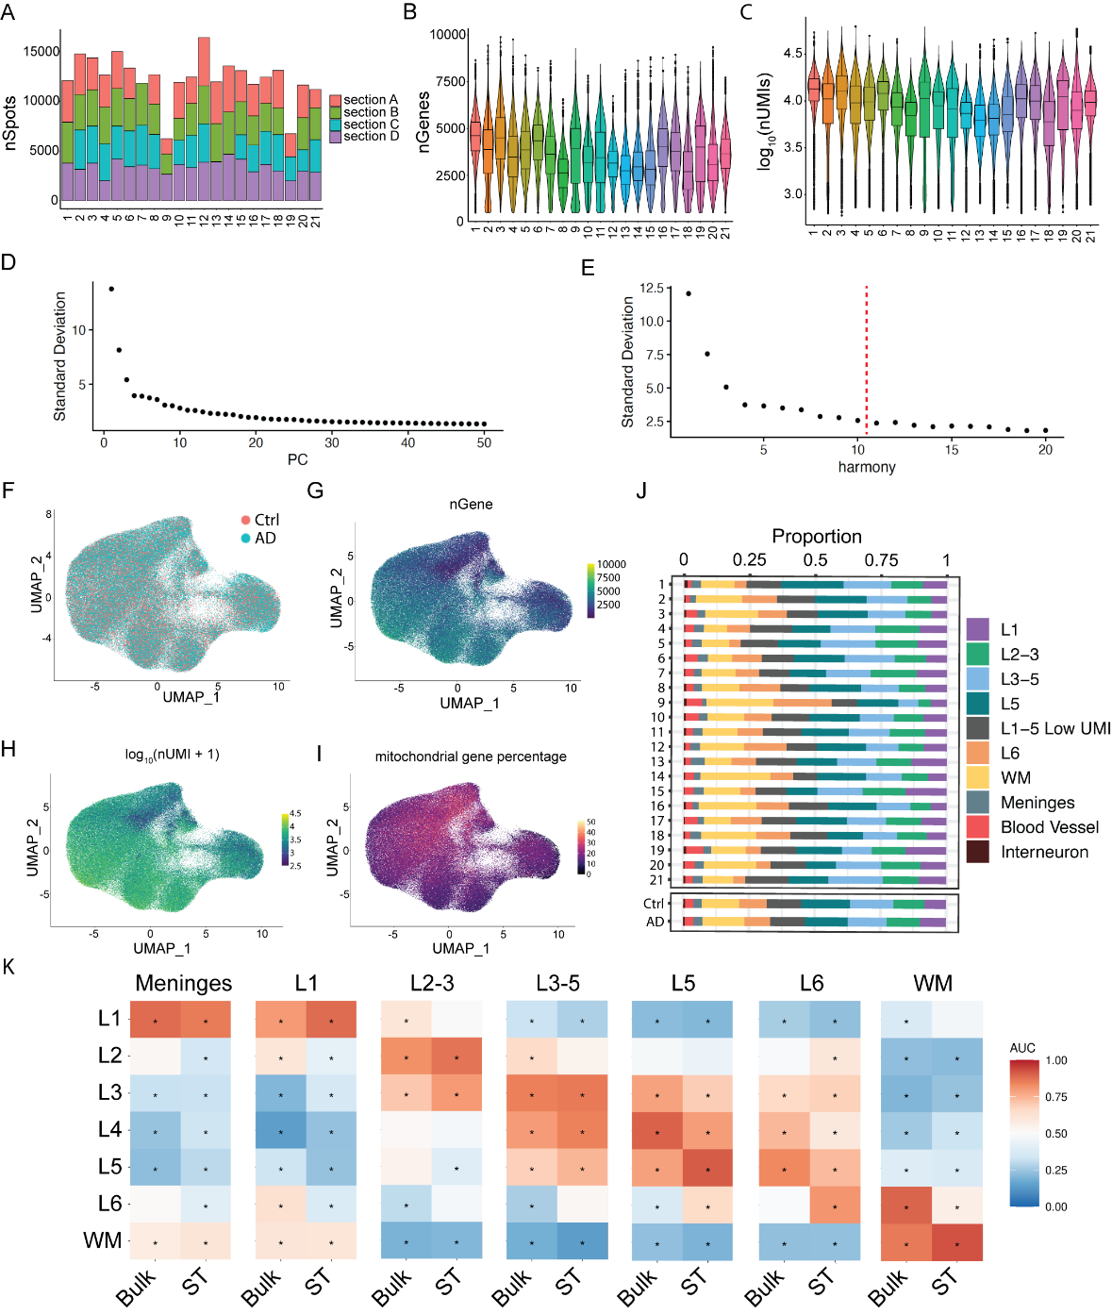

Supplementary Figure 1. Spatial Transcriptomics QC. (A) Number of spots/sections analyzed for each individual. (B) Distribution of the number of detected genes per spot for each individual. (C) Distribution of the log-transformed number of detected UMIs for each individual. (D-E) Elbow plots showing the standard deviation for each principal component (D) or harmony embedding (E). (F-I) UMAP plots with spots colored by AD diagnosis (F), number of detected genes (G), number of detected UMIs (H), or mitochondrial gene percentage (I). (J) Proportion of spots represented by each spot cluster, by individual (top), or AD diagnosis (bottom). (K) Heatmap showing AUC values among cluster-enriched genes, comparing our cluster-enriched genes (columns) to cortical layer-enriched genes identified from previous studies(20–22).
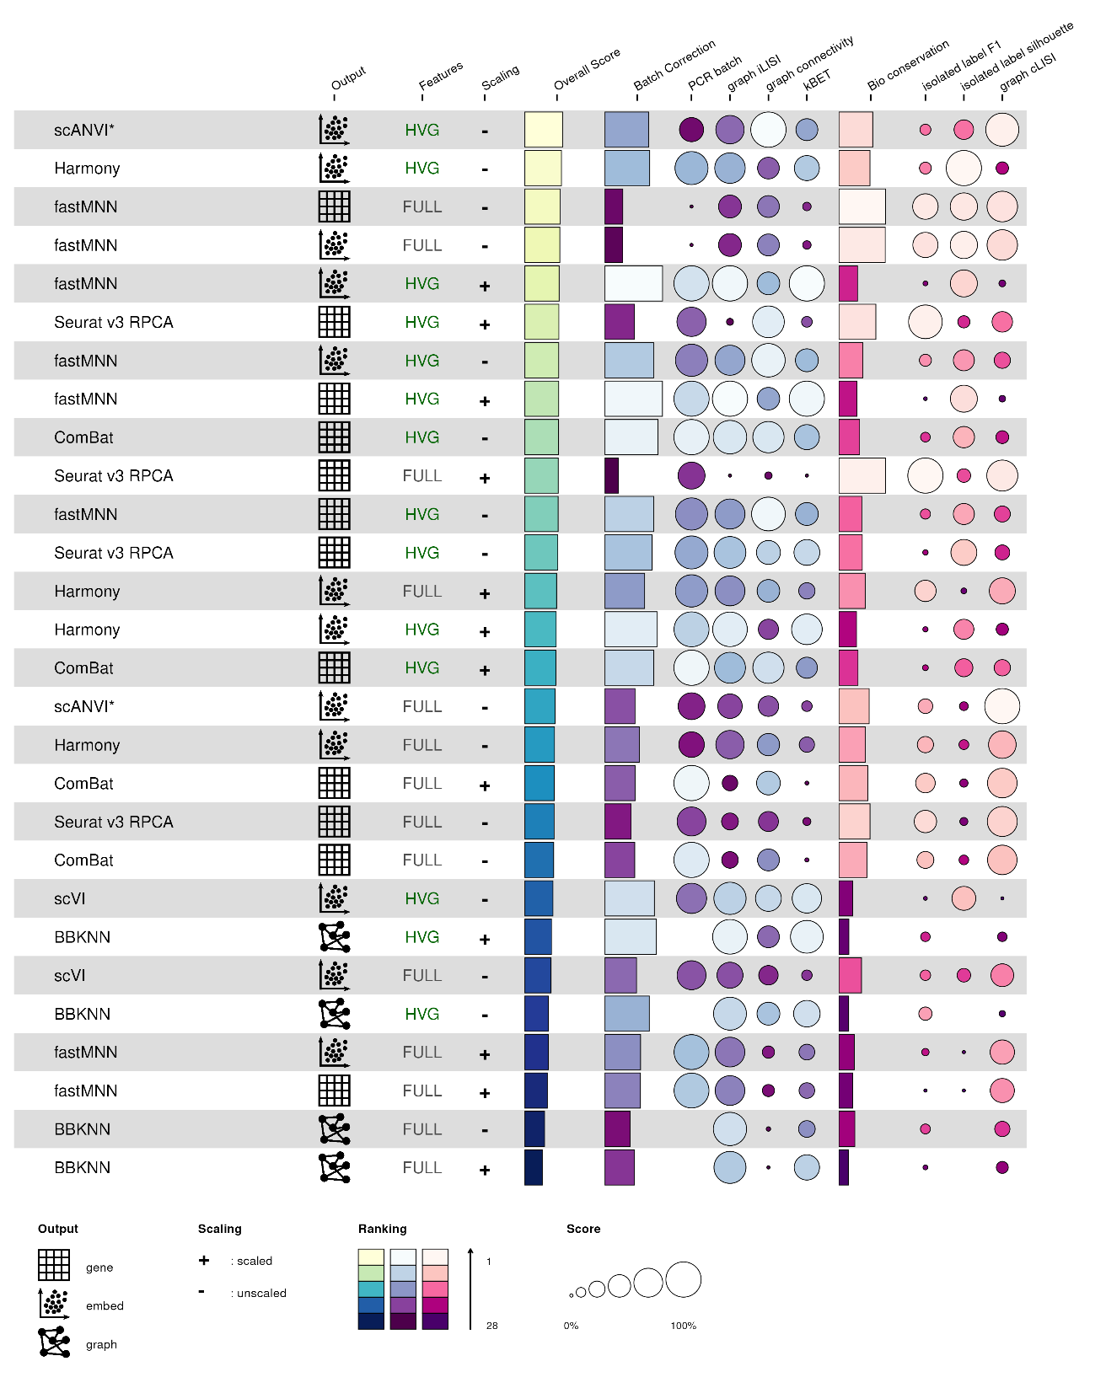
Supplementary Figure 2. scib benchmarking of data integration methods. The scib snakemake pipeline (https://github.com/theislab/scib-pipeline) was applied on a subset of brain sections (16 sections from 4 individuals). Each row represents a combination of methods and parameter settings ranked by the overall score. Methods were applied using either Highly Variable Genes (HVG) or the full dataset (FULL), and with (+) or without (-) data scaling. Columns correspond to different metrics for batch correction and biological conservation. Performance is visually encoded using color gradients where darker shades indicate better performance. Dot sizes represent the score for each metric, with larger dots signifying higher performance. Subject identifiers were used as batch labels, and Louvain-derived clusters were used as identity labels.
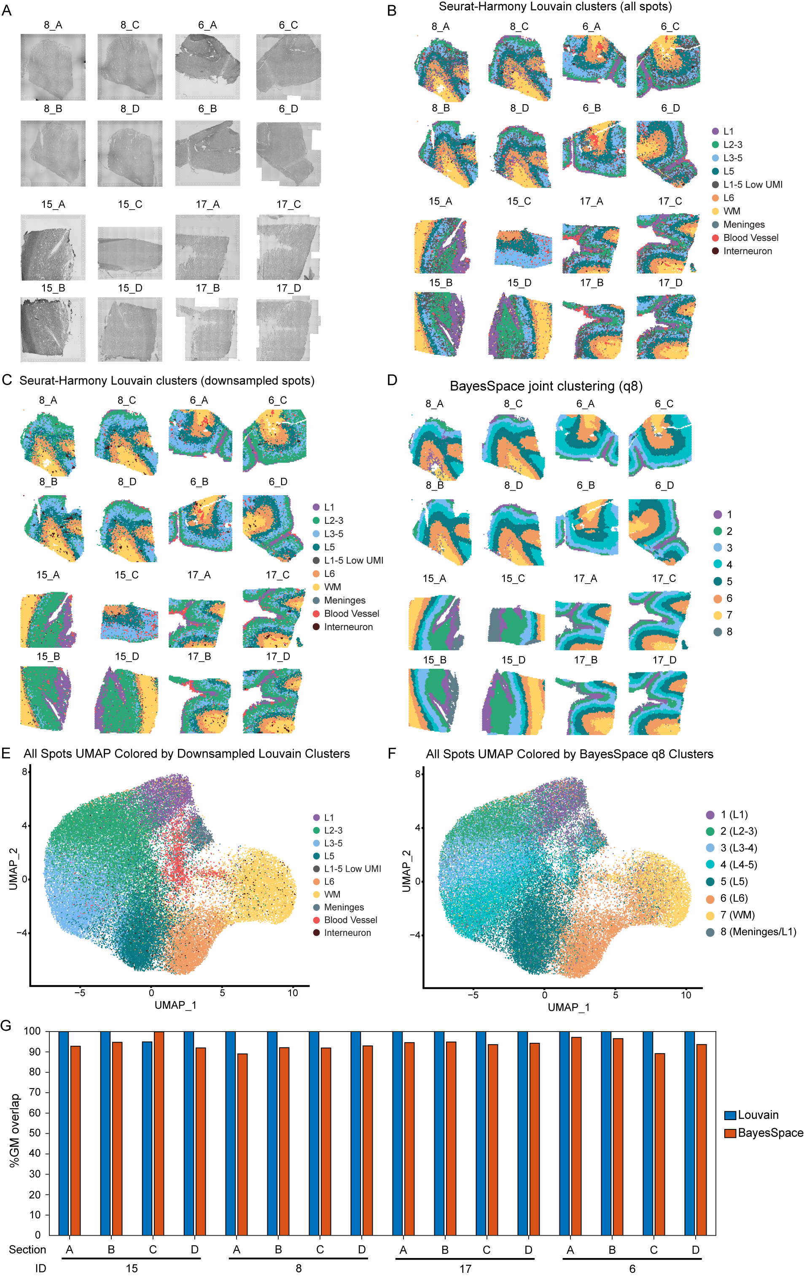
Figure S3. Clustering method comparison. (A) H&E images of 16 representative sections from 4 individuals. (B) Feature plots of 16 sections with spots colored by their cluster identity as derived using Louvain on all ST spots. (C) For the same 16 sections, spots (n = 51,184 total) were subsetted and re-processed using the Seurat-Harmony pipeline (normalization, harmonization, PCA, clustering, and UMAP). Spots are colored by cluster identity, which matches closely to the 10 major clusters identified using all spots. (D) The same 16 sections were subjected to joint clustering using BayesSpace with a q setting of 8. (E) Spots from the 16 subsetted sections are plotted on the full dataset UMAP and colored according to Louvain clusters. (F) BayesSpace counterpart of (E). (G) Percent GM spot overlap. Blue and red correspond to using spots labeled as GM by Louvain and BayesSpace, respectively, as reference.
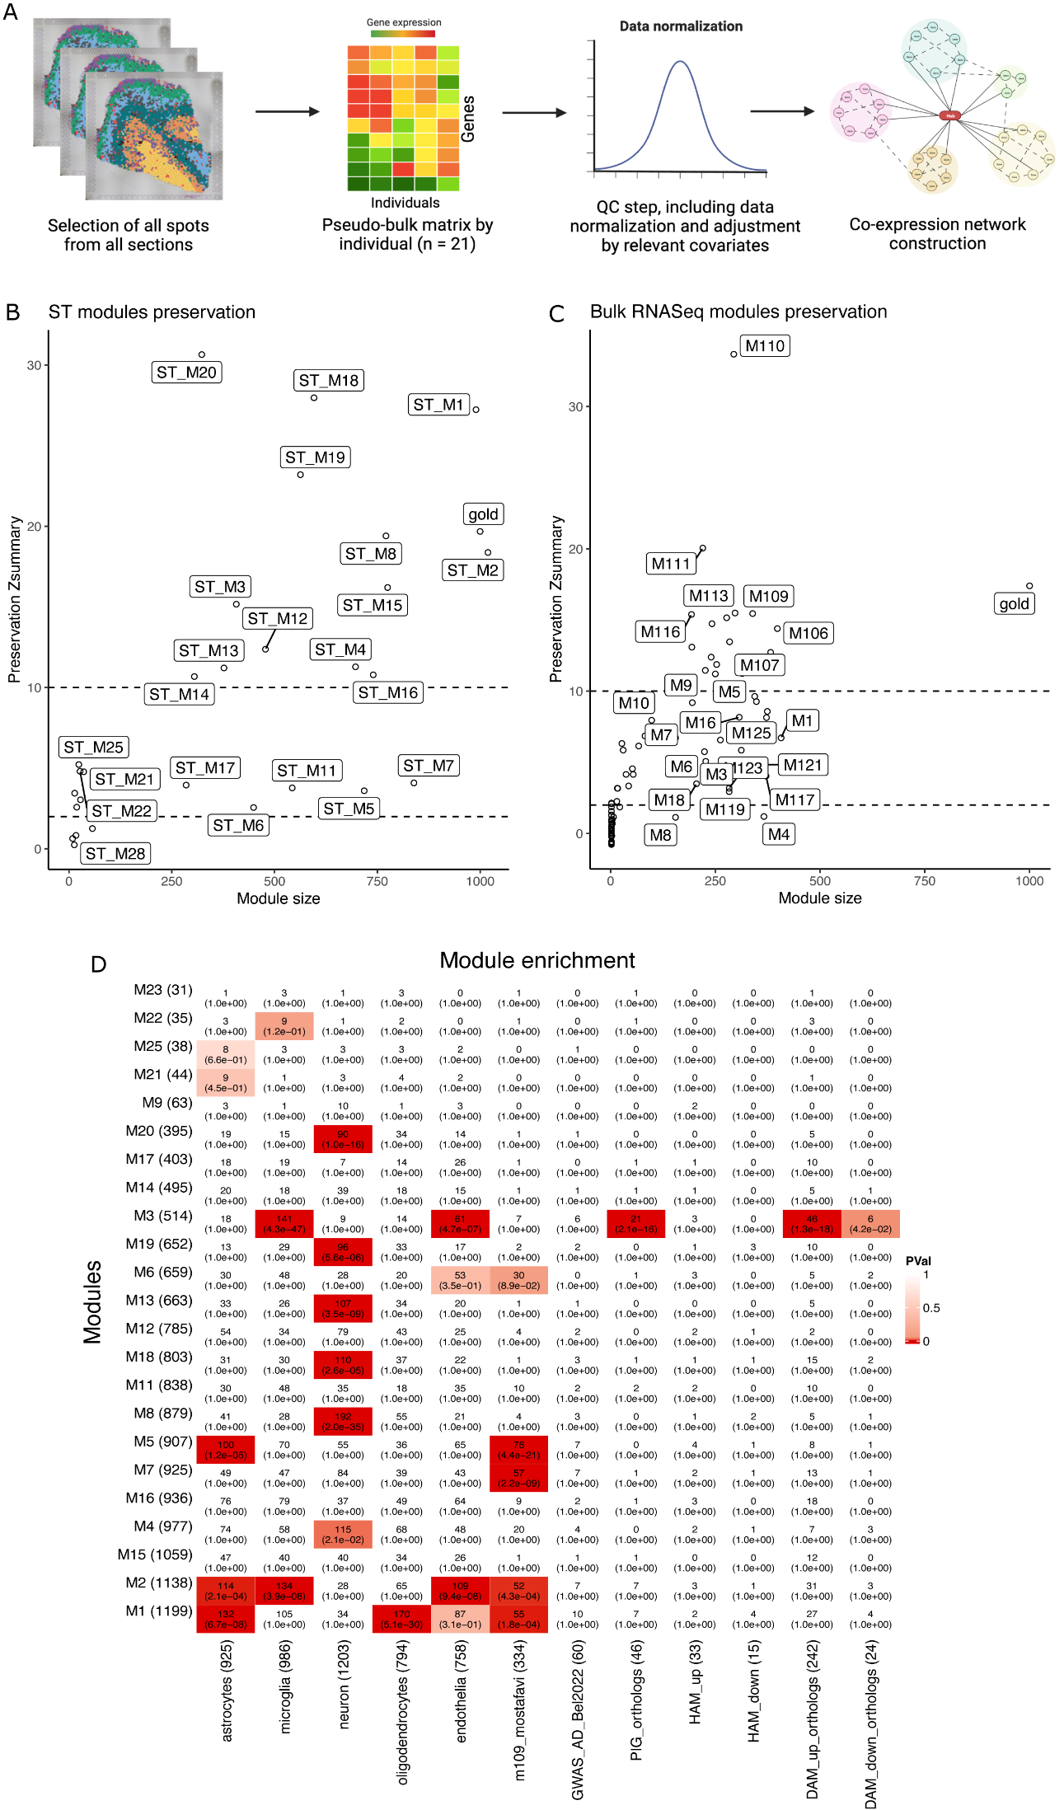
Supplementary Figure 4. Spatial transcriptome network analysis. (A) Spots were selected by the donor to generate a pseudo-bulk expression matrix. Following the quality control (QC) steps, the data was normalized and adjusted to remove technical confounders, and the final matrix was used as input to build the co-expression network. (B-C) Composite module preservation statistics of the ST networks and previously published bulk RNASeq from the DLPFC region (11). Plots show the summary statistics Z (y-axis) as a function of the module size (x-axis). Each dot represents a module labeled accordingly. The dashed lines indicate the Z = 2 and Z = 10 thresholds, respectively. (B) The ST modules were used as reference. (C) Bulk RNASeq DLPFC modules used as reference. (D) Enrichment results between each module (y-axis) and the following gene lists on the x-axis: cell type marker genes for module 109 (11), AD GWAS genes(68); plaque-induced genes (PIG orthologs)(³¹⁾; human-associated microglia (HAM)(7); and damage-associated microglia (DAM)(32). The number inside each cell represents gene overlap. P-values are from one-sided Fisher's exact test followed by Bonferroni adjustment. The red color highlights the significant results (Adj p < 0.05).

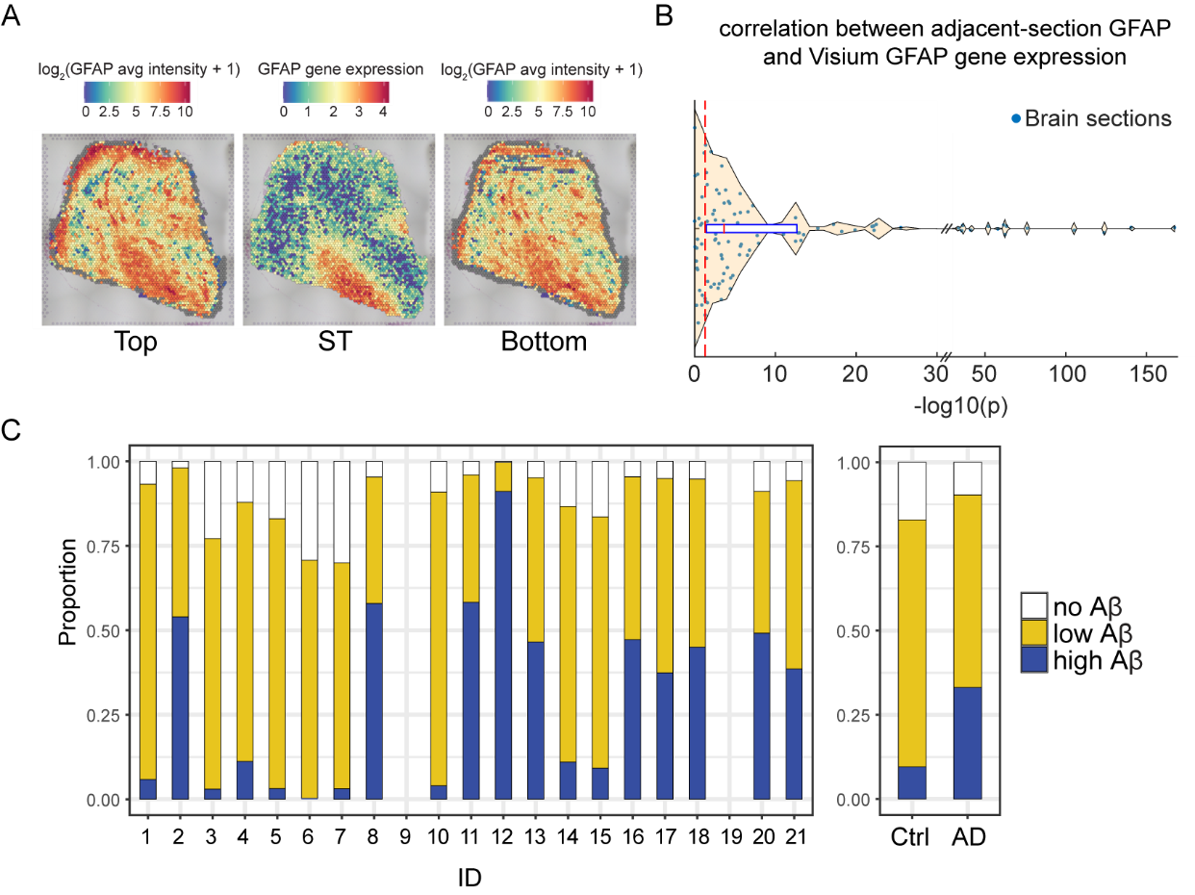
Supplementary Figure 5. Validation of ST-adjacent IHC staining. (A) Feature plot showing per-spot GFAP gene expression (center) and average GFAP fluorescence intensities of adjacent sections (left, right) for a representative section (section 8_C). (B) For each ST-adjacent section, we correlated GFAP fluorescence intensity and GFAP gene expression across all tissue-covered spots. The distribution of -log10(p) across ST-adjacent sections displayed. (C) Stacked barplot showing the proportion of no, low, or high Aβ spots by individual (left), or clinical AD diagnosis (right).

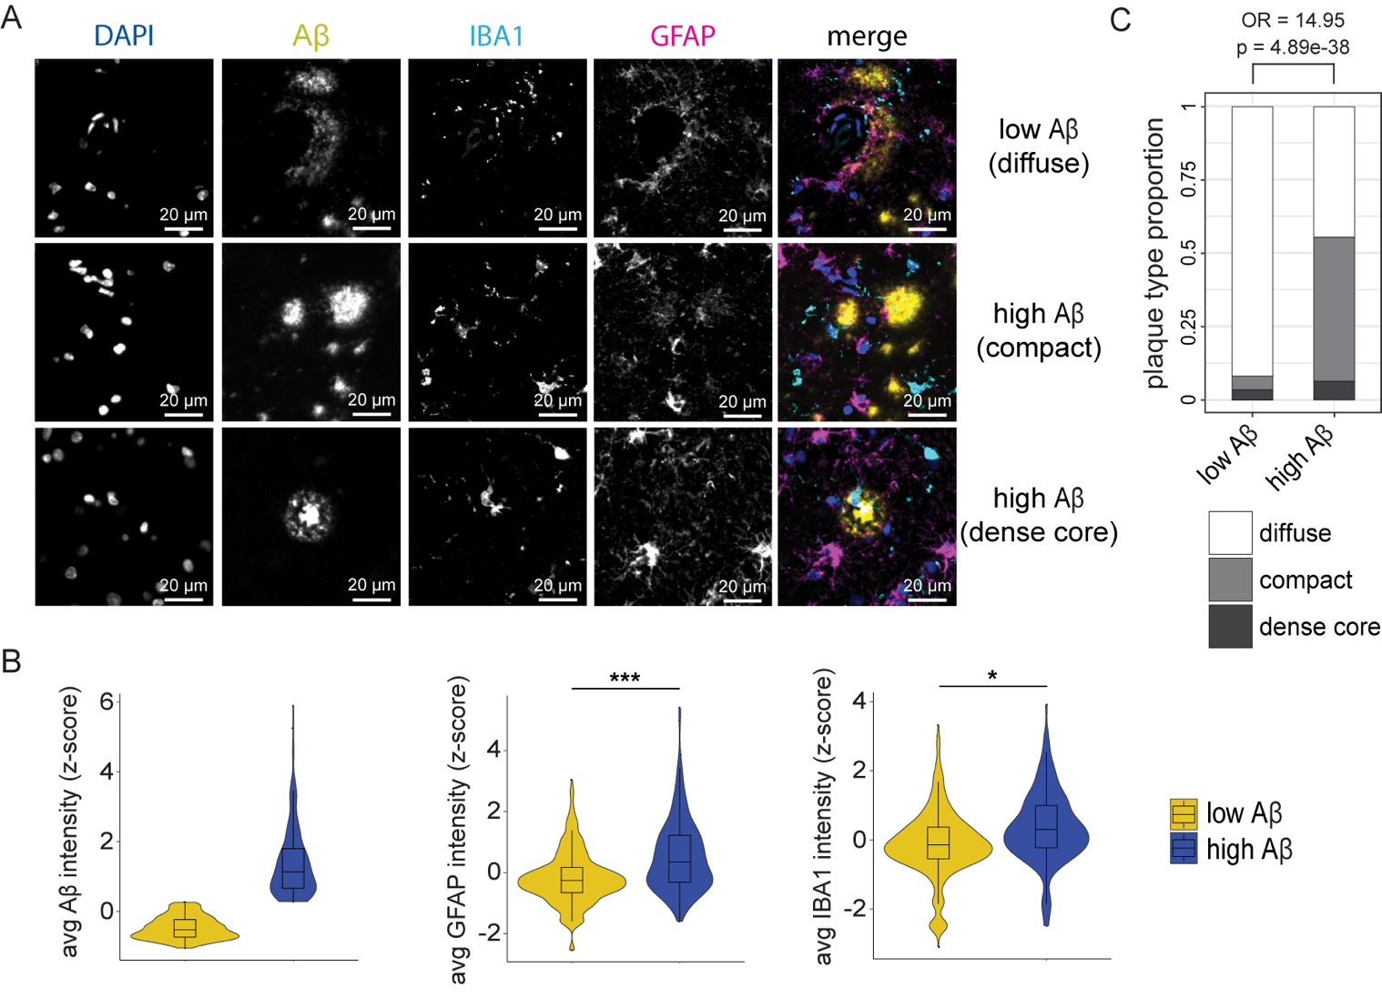
Supplementary Figure 6. IHC of FFPE tissue. (A) Images of stained FFPE tissue sections from an individual with amyloid pathology, including a representative image of each major type of amyloid plaque (blue: DAPI, yellow: Aβ (4G8), cyan: IBA1, magenta: GFAP). (B) We manually annotated 722 plaques from 9 individuals, stratified them by low (bottom 75%) or high (top 25%) intensity of Aβ, then plotted the intensity distributions of Aβ (left), GFAP (middle), and IBA1 (right) (*p = 2.23e-08; ***p = 5.66e-18). (C) The proportion of plaque types from manually annotated plaques, stratified by Aβ intensity (OR: odds ratio).

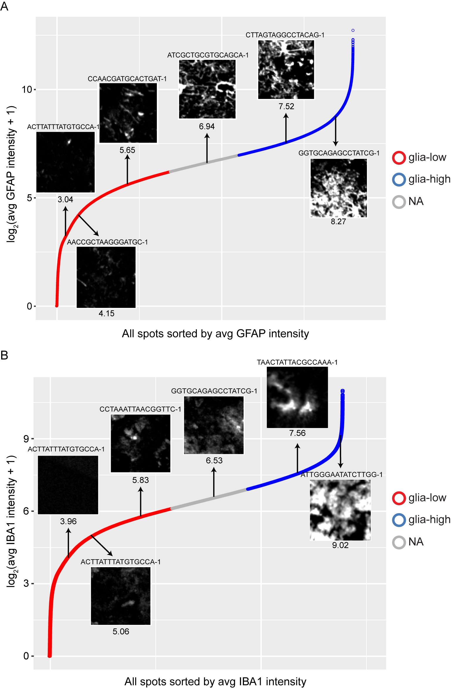
Supplementary Figure 7. Representative images of GFAP and IBA1 from ST-adjacent spots. Spot areas (55 µm diameter) are outlined in dashed yellow circles. (A) All spots are plotted ordered by average GFAP intensity and colored by spot stratification group (red: glia-low, blue: glia-high, gray: not assigned (NA)). Six representative spot images are shown from individual 11, labeled with their ST spot barcode (top) and log₂(average GFAP intensity) (bottom). (B) All spots are plotted ordered by average IBA1 intensity and colored by spot stratification group as in (A). Six representative spot images are shown from individual 11, labeled with their ST spot barcode (top) and log₂(average IBA1
intensity) (bottom).
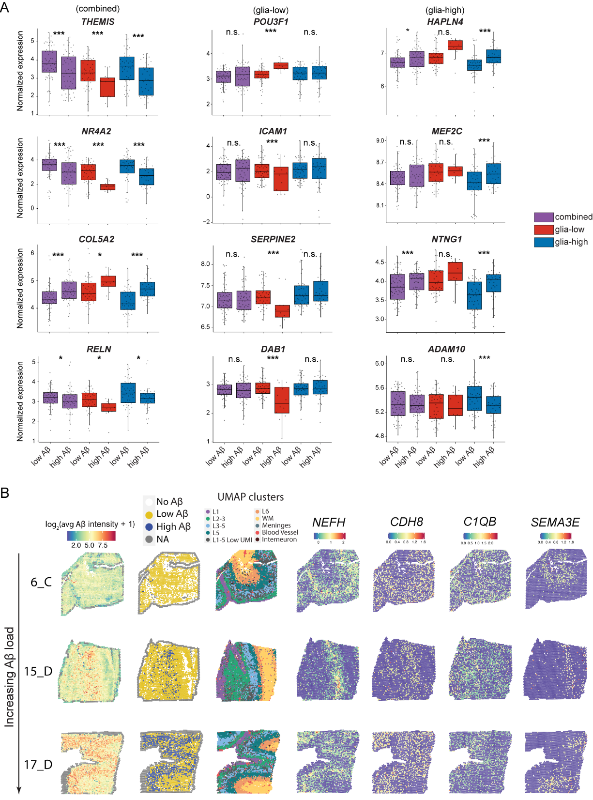
Supplementary Figure 8. Additional characterization of the effects of low vs. high Aβ on transcriptome and apoptosis. (A) Boxplots of representative genes for each Aβ contrast (*p<0.05, ***p<5e-4, n.s.: not significant). (B) Columns from left to right correspond to spatial patterns of IF Aβ intensity, Aβ stratification group, UMAP labels, and expression levels of example genes.
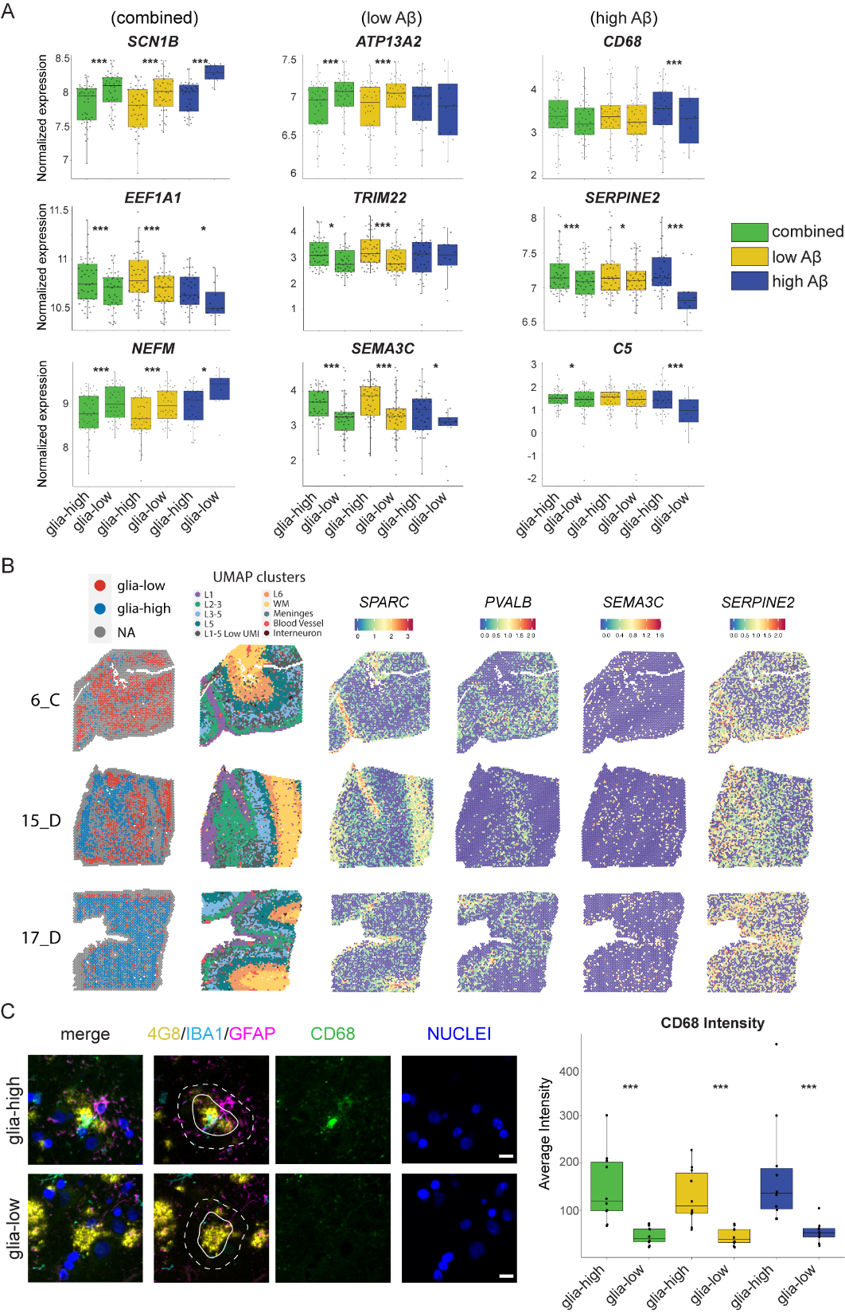
Supplementary Figure 9. Additional characterization of the effects of glia on transcriptome (A) Boxplots of representative genes for each Aβ contrast (*p<0.05, ***p<5e-4). (B) Columns from left to right correspond to spatial patterns of glia-high and glia-low microdomains, spot clusters, and expression levels of example genes. (C) Images of an FFPE tissue section stained with DAPI (blue), Aβ (4G8; yellow), IBA1 (cyan), GFAP (magenta), and CD68 (green) (Scale bar = 25 µm). CD68 average intensity was quantified in the area surrounding plaques (25 µm ring, between the solid and dotted lines in representative images; *** = p<1e-20).

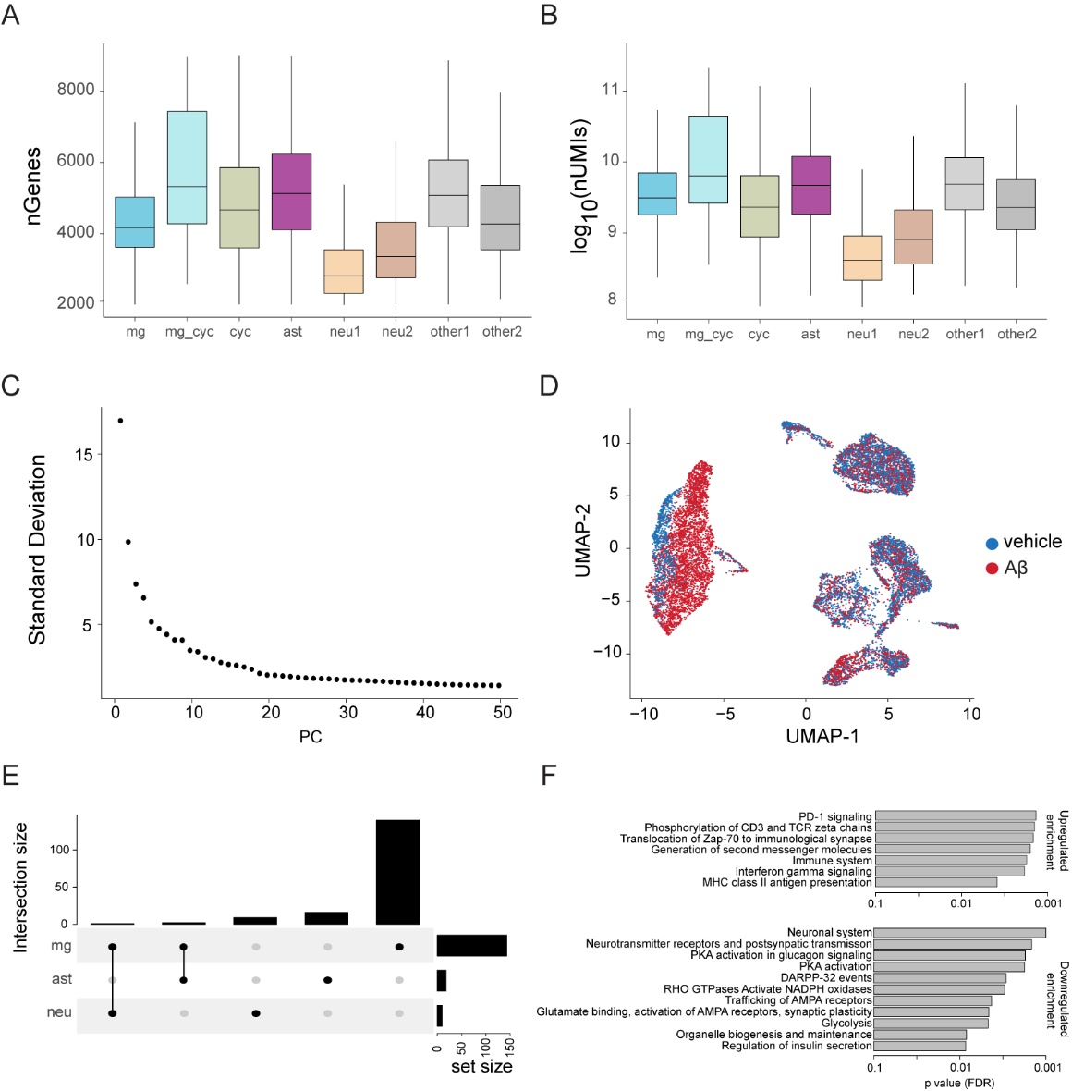
Supplementary Figure 10. Single-cell RNA-seq QC plots. (A and B) Distributions of numbers of detected genes (A) and log₁₀(nUMIs) (B) for each major cell type. (C) Elbow plot showing the standard deviation attributed to each PC. The top 15 PCs were used for UMAP dimension reduction. (D) UMAP plot with cells colored by treatment with vehicle (blue) or Aβ oligomers (red). (E) Upset plot showing overlap (matching fold-change direction) of ex vivo glia-high vs. glia-low DEGs with in vitro Aβ DEGs, for each cell type. (F) Gene set enrichment analysis on differentially expressed genes in iMGL upon Aβ treatment.

Supplementary Tables

Supplementary Table 1. Metadata for 21 ROSMAP participants analyzed by ST
Supplementary Table 2. Enriched genes for each ST spot cluster
Supplementary Table 3. GSEA of cell2location cell abundance estimates in each brain region
Supplementary Table 4. Genes and pathways associated with each ST gene module
Supplementary Table 5. Manual plaque type annotation for a subset of ST spots
Supplementary Table 6. Differential genes and pathways for low vs. high Aβ contrasts
Supplementary Table 7. Ligand-Receptor differential expression (NICHES) for each contrast between stratified spot groups
Supplementary Table 8. Differential genes and pathways for glia-high vs. glia-low contrasts
Supplementary Table 9. Differential genes and pathways for astrocyte- and microglia-specific contrasts
Supplementary Table 10. Differential genes and pathways for Aβ-responses in in vitro co-cultured glia
Supplementary Table 11. Differential genes for iMGL Aβ clusters
Supplementary Table 12. Differential genes for iMGL Aβ clusters contrasted to control iMGL
Supplementary Table 13. Key Resources Table

