Supplementary Information

STIP1/HOP Promotes the Formation of Cytotoxic a-Synuclein Oligomers
Benjamin S. Rutledge, Carter J. Wilson, Rachel M. Lau, Juan C. Jurado-Coronel, Esther del Cid-Pellitero, Mikko Karttunen, Thomas M. Durcan, Edward A. Fon, Marco A.M. Prado, Justin Legleiter*, Martin L. Duennwald* and Wing-Yiu Choy*

Supplementary Figures and Video
Figure S1. The TPR2A domain of STIP1 mediates binding of a-Syn and its pathological variants. ¹H-¹⁵N HSQC spectra of 100 µM a-Syn (A), pS129 a-Syn (B), A53T a-Syn (C) and pS129 A53T a-Syn (D) in the absence (black) and the presence (cyan) of 200 µM of mTPR2A.

Figure S2. The TPR2A domain of HOP mediates binding of a-Syn and its pathological variants. ¹H-¹⁵N HSQC spectra of 100 µM a-Syn (A), pS129 a-Syn (B), A53T a-Syn (C) and pS129 A53T a-Syn (D) in the absence (black) and the presence (red) of 200 µM of hTPR2A.

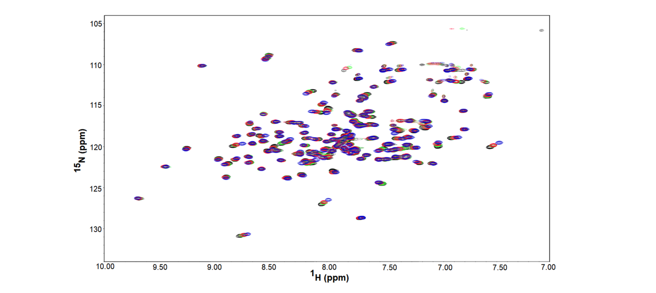
Figure S3. Interacting residues of hTPR2A upon the addition of a-Syn peptides. ¹H-¹⁵N HSQC spectra of 200 µM ¹⁵N-labeled hTPR2A (black) in the presence of 400 µM C-terminal a-Syn peptide (blue), 800 µM S1 peptide (green), and 400 µM S2 peptide (red).

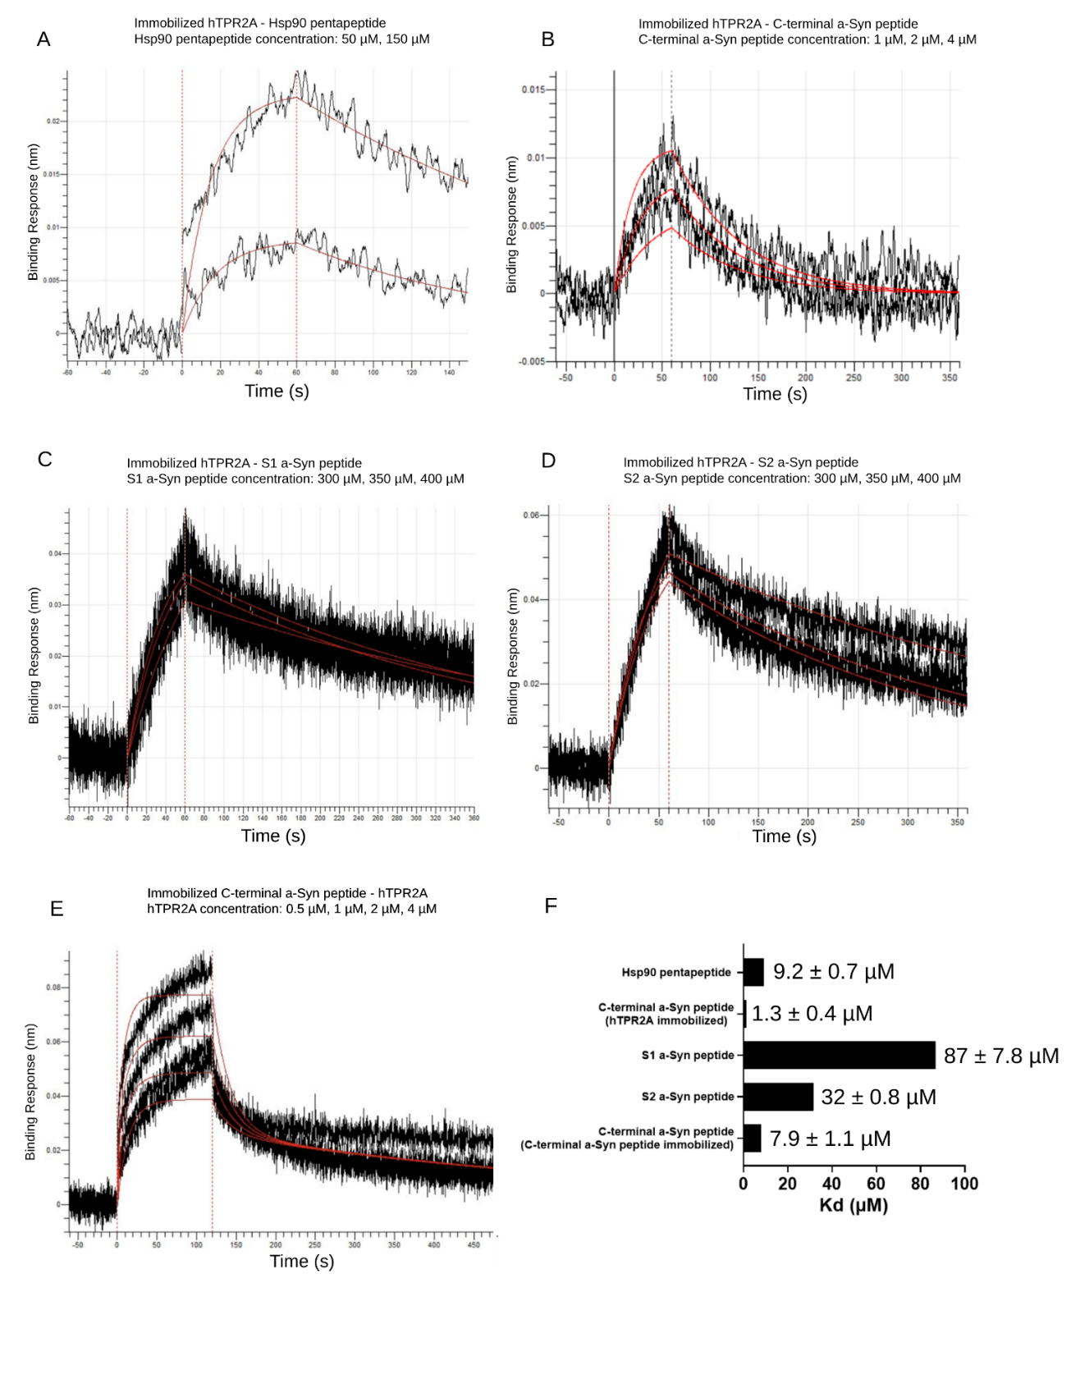
Figure S4. The C-terminal a-Syn peptide binds hTPR2A with a higher affinity than S1 and S2 peptides. BLI analysis of the binding of Hsp90 pentapeptide to immobilized hTPR2A (A), C-terminal peptide to immobilized hTPR2A (B), S1 a-Syn peptide to immobilized hTPR2A (C), S2 a-Syn peptide to immobilized hTPR2A (D), and hTPR2A to immobilized C-terminal peptide (E). Analytes were used at the indicated concentrations. Measured binding curves are depicted in black and fitted K_{d} curves are depicted in red. (F) Quantification of K_{d} values determined by kinetic analysis.

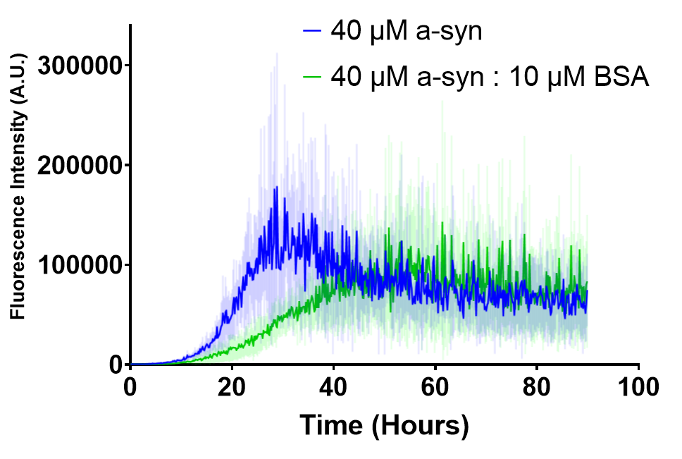
Figure S5. The addition of BSA does not significantly reduce ThT fluorescence of a-Syn aggregation samples. Aggregation kinetics of a-Syn (40 µM, 0.58 mg/ml) measured by ThT fluorescence in the absence (blue) or presence of Bovine serum albumin (BSA) (green; 10 µM, 0.67 mg/ml) at a similar mg/ml concentration equivalent to hTPR2A at 40 µM.

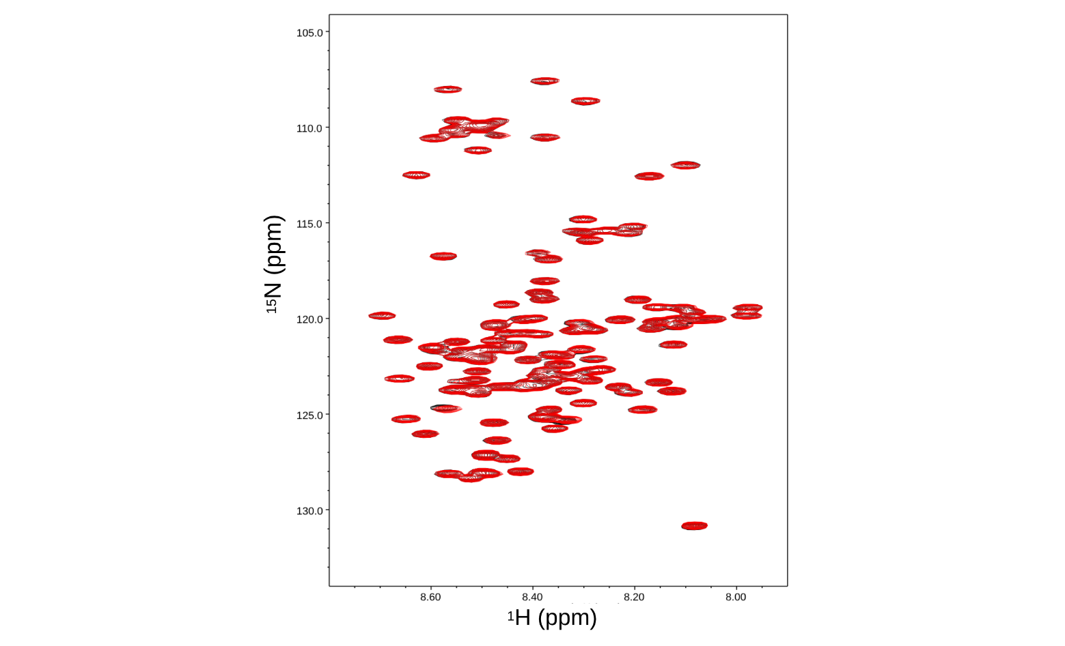
Figure S6. Addition of TPR1 domain of STIP1 does not cause notable chemical shift changes of a-Syn. ¹H-¹⁵N HSQC spectrum of 100 µM a-Syn in the absence (black) and the presence (red) of 200 µM of mTPR1.

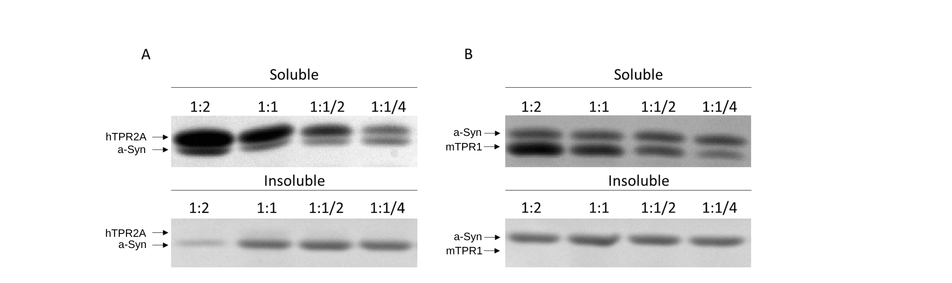
Figure S7. The TPR2A domain of HOP maintains the solubility of a-Syn during aggregation. Aggregation reactions containing 60 µM a-Syn in the presence of various concentration ratios of hTPR2A (A) or the non-specific binding control of mTPR1 (B) were incubated for 90 hours and separated into soluble and insoluble fractions by centrifugation.

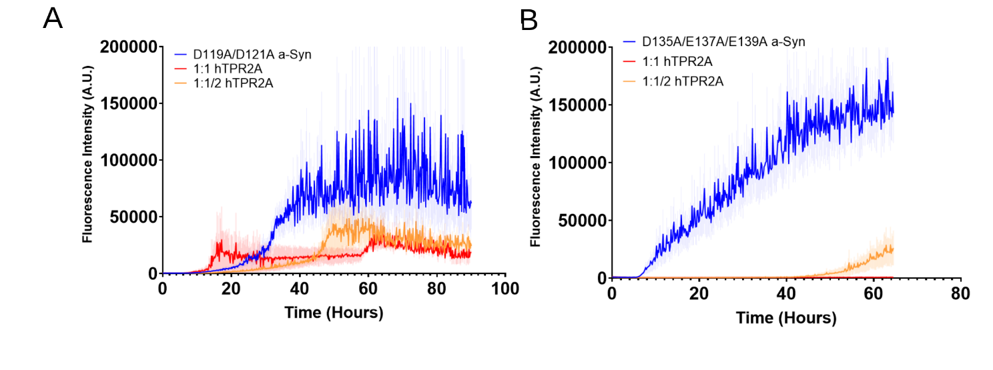
Figure S8. hTPR2A inhibits fibril formation of D119A/D121A and D135A/E137A/E139A a-Syn. (A) Fibril formation of D119A/D121A a-Syn (60 µM) measured by ThT fluorescence in the absence (blue) or presence of either equimolar (red) or half equimolar (orange) concentration of hTPR2A. (B) Fibril formation of D135A/E137A/E139A a-Syn (60 µM) measured by ThT fluorescence in the absence (blue) or presence of either equimolar (red) or half equimolar (orange) concentration of human hTPR2A.

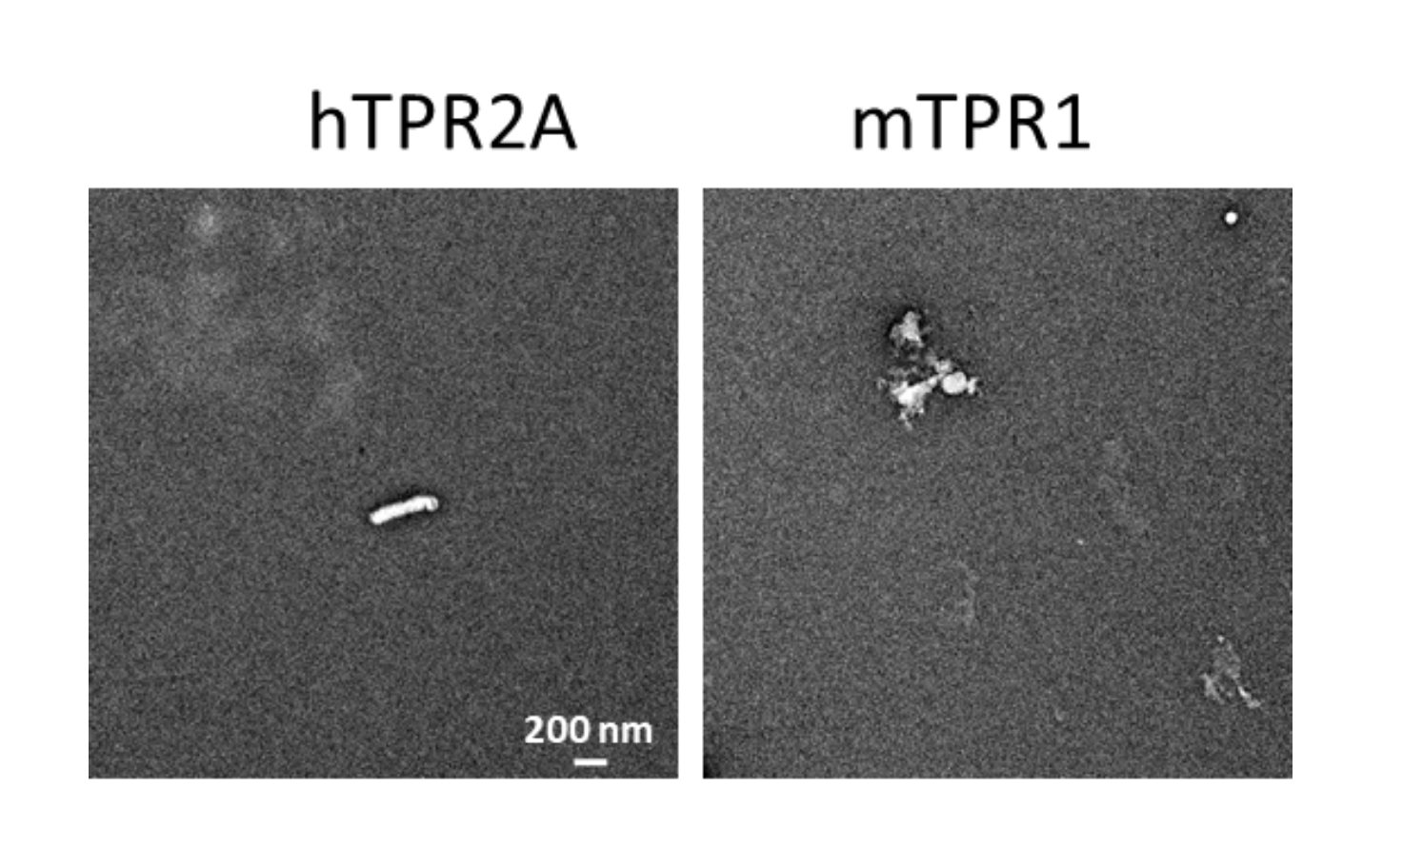
Figure S9. Electron microscopy images of aggregated hTPR2A and mTPR1 control samples. Representative EM images of precipitated species when present after 5 days for samples containing hTPR2A or mTPR1 undergoing standard a-Syn aggregation conditions in the absence of a-Syn.

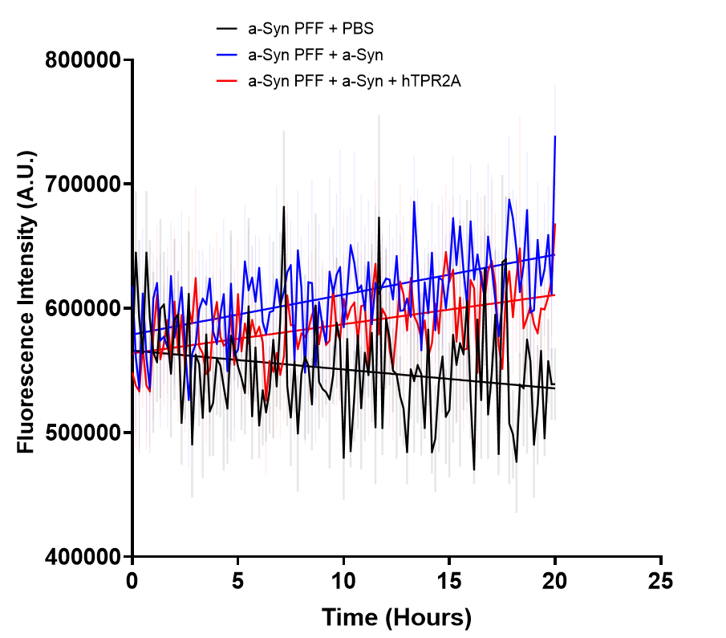 Figure S10. hTPR2A does not prevent the incorporation of a-Syn to existing a-Syn fibrils. Aggregation reactions containing 60 µM a-Syn were incubated for 90 hours, at which point ThT fluorescence plateaus. PBS buffer, a-Syn, or a-Syn with equimolar hTPR2A was then added and aggregation was continued.

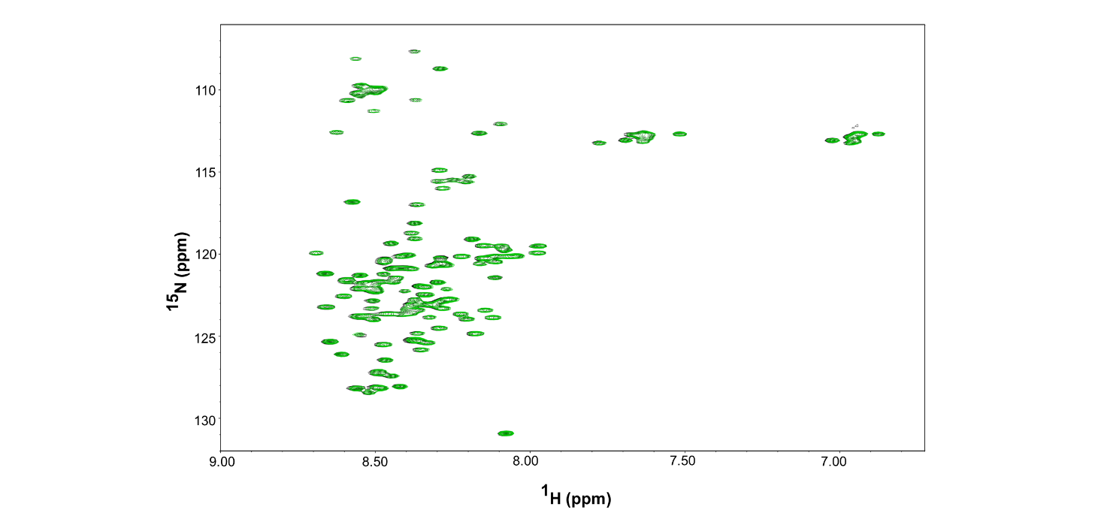
Figure S11. The Hsp90 pentapeptide does not interact with a-Syn. ¹H-¹⁵N HSQC spectrum of 100 µM a-Syn in the absence (black) and the presence (green) of 300 µM Hsp90 pentapeptide.

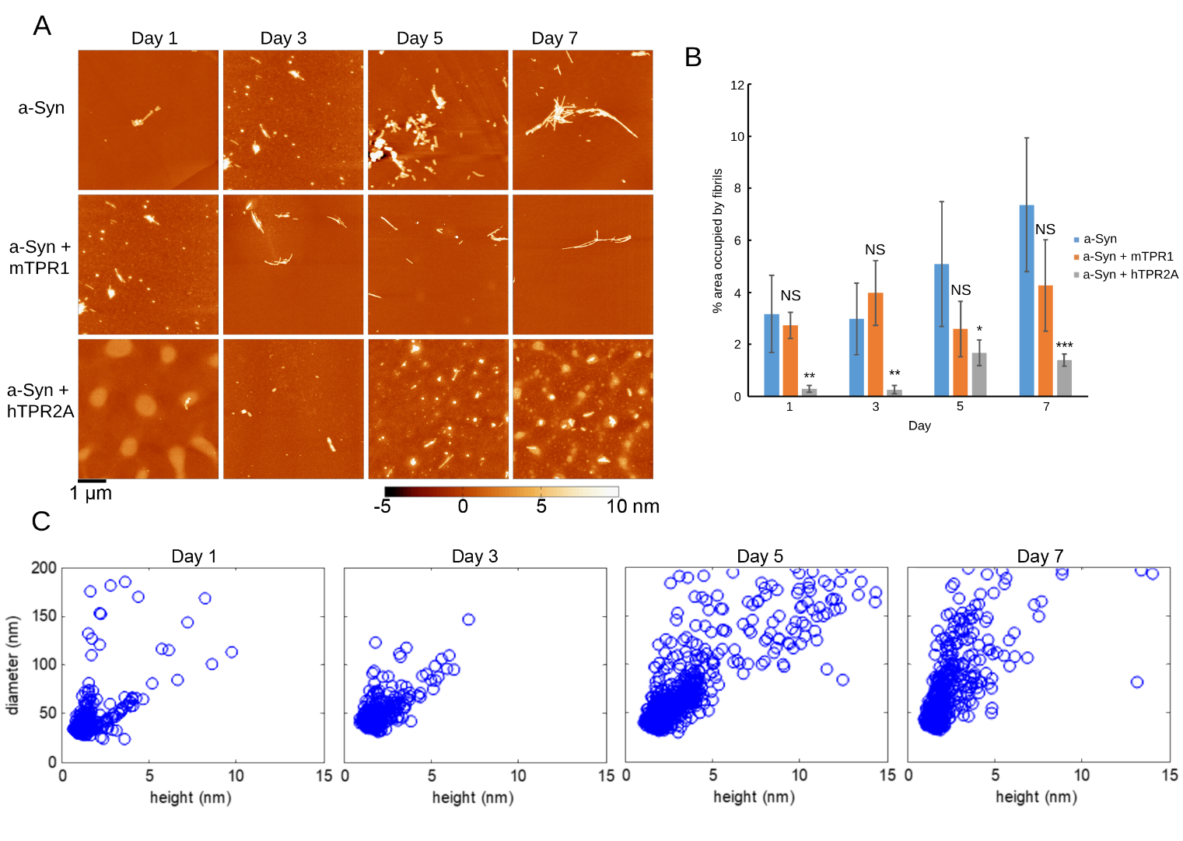
Figure S12. Analysis of a-Syn assemblies formed in the presence of hTPR2A by AFM. (A) Representative AFM images of a-Syn (175 µM) aggregation in the absence and presence of mTPR1 and hTPR2A at an equimolar concentration as a function of time. Protein samples are deposited on a mica surface. (B) Fibril load of a-Syn samples aggregated in the absence or presence of mTPR1 and hTPR2A as a function of time as estimated by area of AFM images occupied by fibrils. Statistical significance is represented by an asterisk, where **** is P < .0001, *** is P < .001, ** is P < .01, and * is P < .05. Error bars represent the standard deviation across a minimum of 5 images for each condition. (C) Correlation plots of the distribution of the heights and diameters of the amorphous high molecular weight a-Syn species produced in the presence of hTPR2A as a function of time.

Movie S1. Hierarchical cluster-ordered trajectory of a-Syn C-terminus binding to hTPR2A. Frames are arranged such that adjacent frames are most similar to each other. S1 motif residues are colored blue and S2 motif residues are colored yellow.

