Epitope Placement Tunes CSF Tau Biomarkers: Comparison of P-tau217 and BD-tau Designs
Helena Sophia Gleerup^{1†}, Christian Sandøe Musaeus^{1†}, Cristiano Santos², Hlin Kvartsberg^{2,4}, Peter Harrison³, Michael Turton³, Henrik Zetterberg^{2,4,5,6,7}, Kristian Steen Frederiksen^{1,8}, Steen Gregers Hasselbalch^{1,8}, Anja Hviid Simonsen^{1‡}, Fernando Gonzalez Ortiz^{2‡}
¹Department of Neurology, Danish Dementia Research Centre (DDRC), Copenhagen University Hospital, Rigshospitalet, Copenhagen, Denmark
²Department of Psychiatry and Neurochemistry, Institute of Neuroscience and Physiology, The Sahlgrenska Academy at the University of Gothenburg, Mölndal, Sweden
³Bioventix Plc, Farnham, UK
⁴Clinical Neurochemistry Laboratory, Sahlgrenska University Hospital, Mölndal, Sweden
⁵Department of Neurodegenerative Disease, Queen Square Institute of Neurology, University College London, Queens Square, London, United Kingdom
⁶Department of Pathology and Laboratory Medicine, University of Wisconsin School of Medicine and Public Health, Madison, WI, USA
⁷Wisconsin Alzheimer’s Disease Research Center, University of Wisconsin School of Medicine and Public Health, Madison, WI, USA
⁸Department of Clinical Medicine, Faculty of Health and Medical Science, University of Copenhagen, Copenhagen, Denmark
†These authors have contributed equally to this work
‡These authors have contributed equally to this work

Correspondence to:
Helena Sophia Gleerup, MD
Email: helena.sophia.coley.gleerup@regionh.dk
Fernando Gonzalez-Ortiz, MD, PhD
Email: fernando.gonzalez.ortiz@gu.se

Supplementary figure 1: Heatmap of CSF markers
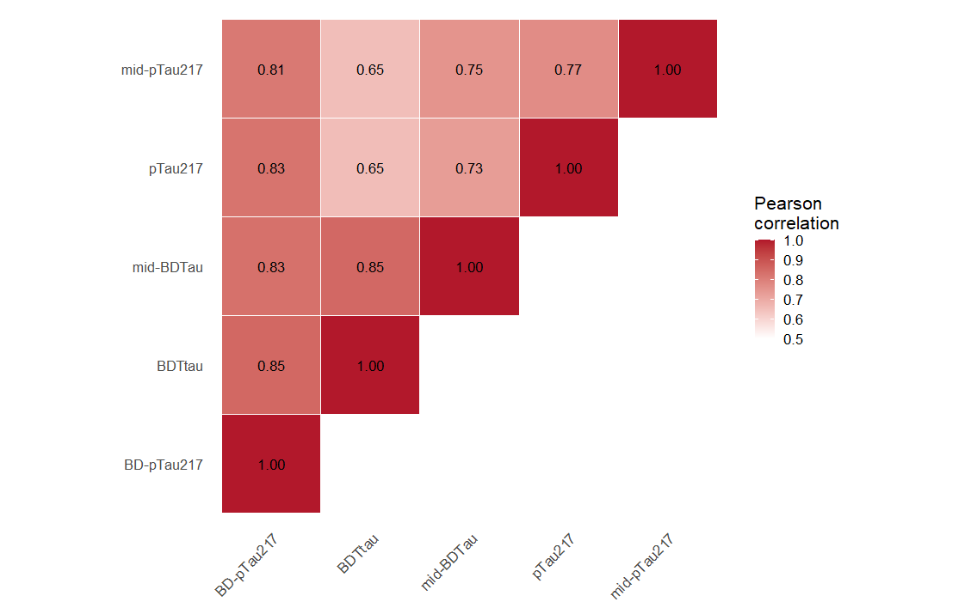
The heatmap show Pearson correlation coefficients (r) between all CSF markers (ptau217, BTtau, mid-BDTau, mid-pTau217, BD-pTau217

Supplementary table 1: AUC and 95% confidence intervals of CSF biomarkers
 | AUC | 95% CI
mid-BDTau | 0.88 | 0.84 – 0.92
BD-pTau217 | 0.95 | 0.92 – 0.97
BDTau | 0.86 | 0.82 – 0.90
Ptau217 | 0.91 | 0.88 - 0.95
mid-pTau217 | 0.91 | 0.87 – 0.95

The AUC and 95% confidence intervals show the accuracy of the different CSF biomarkers to determine amyloid status.

