SUPPLEMENTARY INFORMATION
A low-cost, flexible sensor patch for non-invasive respiratory monitoring capable of suppressing motion artifacts
Zhanglei Jin¹, Eugen Koch², Haochen Xu¹, Johannes Busse¹, Andreas Dietzel1*
1 Institute of Microtechnology, TU Braunschweig, Braunschweig, Germany
2 Engineering Office Dr.-Ing. Eugen Koch, Braunschweig, Germany
* Corresponding author: a.dietzel@tu-braunschweig.de

Supplementary Note SA. Sensor array dimensions
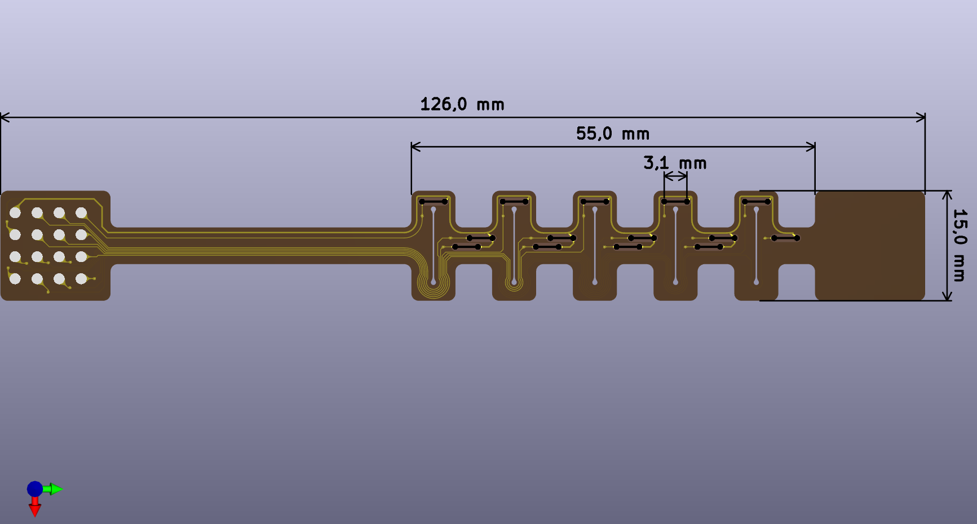
Figure SA1: Key Dimensions of the Segment Structure.
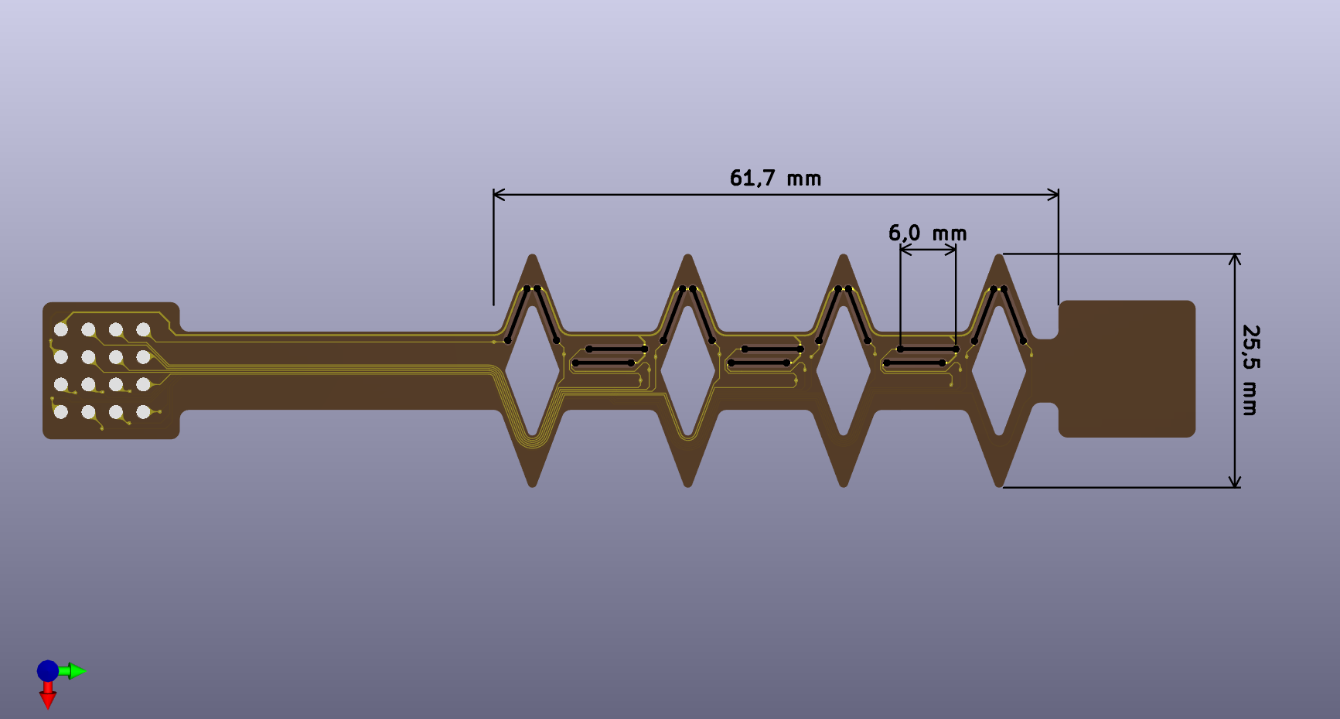
Figure SA2: Key Dimensions of the Kirigami spring Structure.
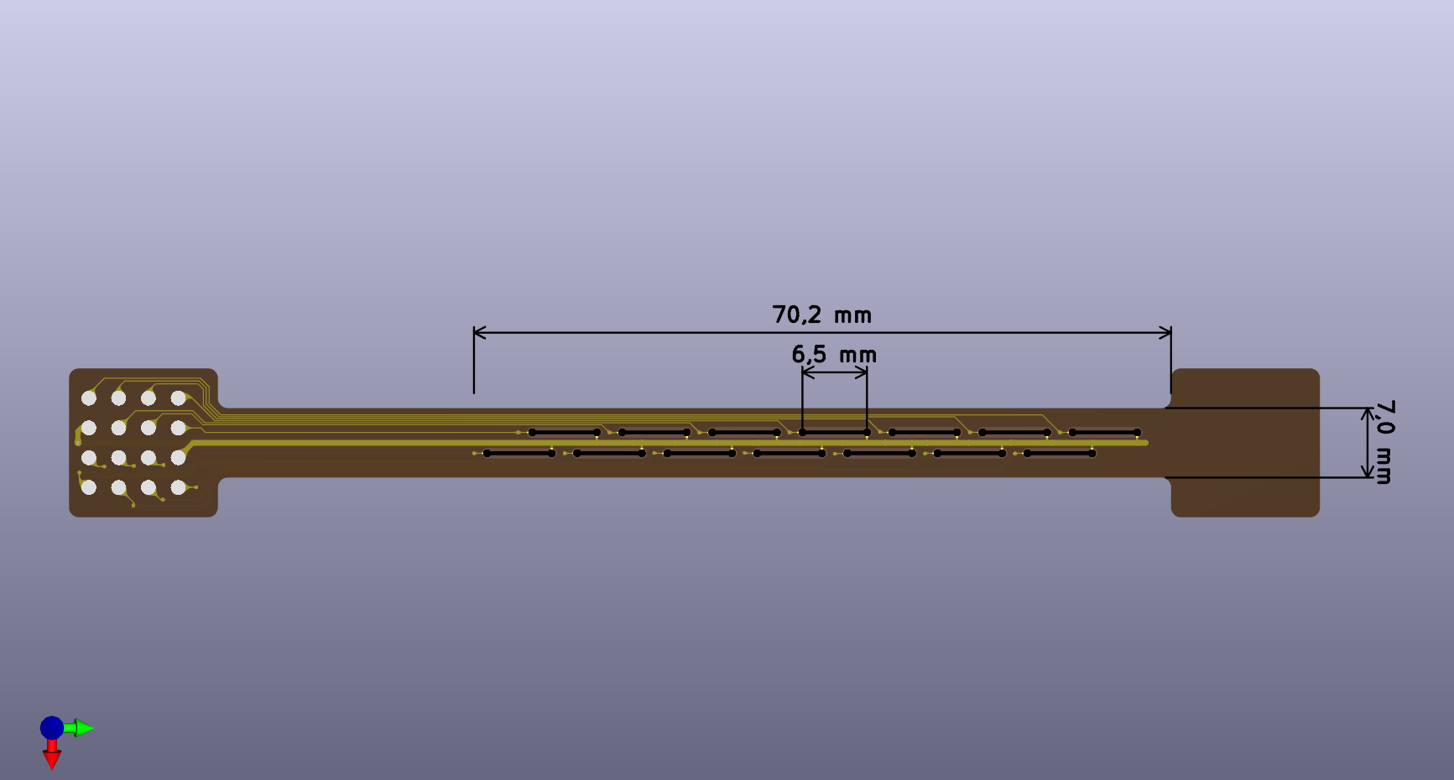
Figure SA3: Dimensions of the Straight Structure.
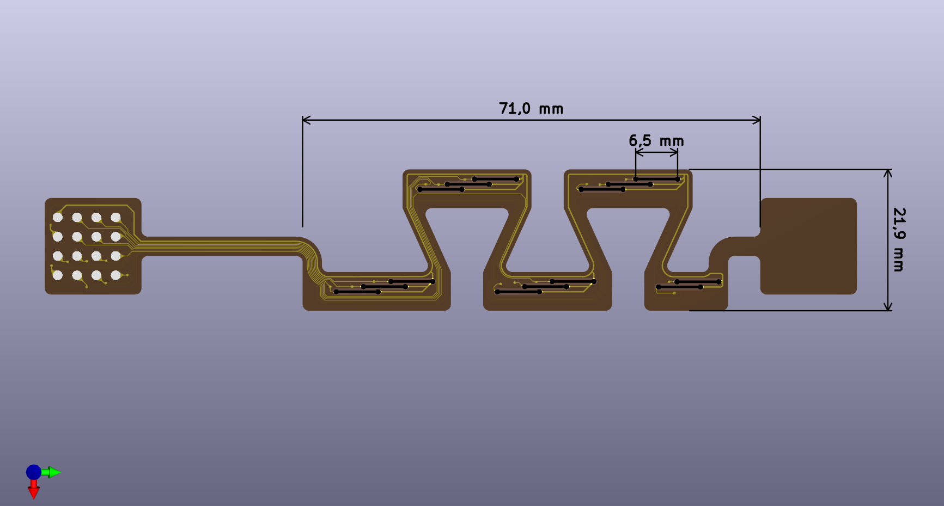
Figure SA4: Dimensions of the Island Structure.
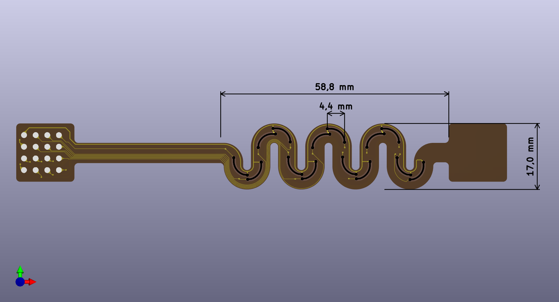
Figure SA5: Dimensions of the Serpentine Structure.
Figures SA1 through SA5 show detailed circuit diagrams and key dimensions for the five structures.

Supplementary Note SB. Relation between the single-resistor gauge factor and the voltage-divider curvature sensitivity
This section presents the derivation that establishes a relationship between the single resistance GF of a printed sensor element and the ideal voltage response of a two-resistor voltage divider. The purpose of this derivation is to distinguish the response of the sensor structure from the output of the complete PCB readout chain.

SB.1 Single-resistor gauge factor under bending
For one printed sensing resistor, the gauge factor is defined from the relative resistance change under strain:
$$\frac{∆R}{R_{0}}=GF∙ε$$
where $R_{0}$ is the resistance in the flat state, $∆R=R-R_{0}$, and $ε$ is the nominal bending strain at the printed resistor layer. In the static bending test, the effective working thickness is approximated as
$$t=t_{PI}+t_{R}$$
where $t_{PI}$ is the PI substrate thickness and $t_{R}$ is the single-side thickness of the printed carbon resistor. With the neutral axis assumed to be located close to the mid-plane of the PI substrate, the tensile and compressive sensing layers are positioned approximately at a distance $\frac{t}{2}$ from the neutral axis. The nominal bending strain is therefore
$$ε≈\frac{t}{2r_{b}}=\frac{tκ}{2}$$
where $r_{b}$ is the bending radius and $κ=1/r_{b}$ is the curvature.

SB.2 Ideal two-resistor voltage divider
The readout structure used in this work is not a complete Wheatstone bridge. It consists of two opposite printed resistors that form a voltage divider. For the ideal symmetric case, both resistors have the same initial resistance $R_{0}$. During bending, one resistor is under tensile strain and the other one is under compressive strain. With the sign convention that $R_{2}$ is tensile and $R_{1}$ is compressive, the resistances become
$$R_{2}=R_{0}(1+GF∙ε)$$
and
$$R_{1}=R_{0}(1-GF∙ε)$$
The voltage at the divider midpoint is
$$V_{out}=V_{in}\frac{R_{0}(1+GF∙ε)}{R_{0}\left(1-GF∙ε\right)+R_{0}(1+GF∙ε)}$$
and therefore
$$V_{out}=\frac{V_{in}}{2}(1+GF∙ε)$$
In the flat, the ideal midpoint voltage is $\frac{V_{in}}{2}$. The voltage change caused by bending is therefore
$${∆V}_{out}=V_{out}-\frac{V_{in}}{2}=\frac{V_{in}}{2}∙GF∙ε$$
Using $ε=\frac{t∙κ}{2}$, this becomes
$$ΔV_{out}=\frac{V_{in}GF∙t}{4}κ$$
Thus, the ideal curvature sensitivity of the two-resistor voltage divider is
$$S_{VD}=\frac{∆V_{out}}{κ}=\frac{V_{in}GF∙t}{4}$$

SB.3 Relation to a double-sided full bridge
A corresponding double-sided full bridge based on the same strain-gauge principle would contain two tensile and two compressive active resistors. Under otherwise identical conditions, the ideal voltage response of such a full bridge is twice that of the two-resistor voltage divider:
$$S_{FB}=\frac{V_{in}GF∙t}{2}=2S_{VD}$$
The present voltage-divider configuration can therefore be regarded as one active half of a corresponding double-sided full-bridge arrangement. The same strain-gauge basis was used by Koch and Dietzel [1] for the double-sided full-bridge curvature sensor.

SB.4 Calculation for the selected Island structure
For the Island structure, the measured single-resistor gauge factor was $GF=6.37$. The supply voltage was $V_{in}=3.3 V$. With $t_{PI}=25 µm$ and an average printed carbon resistor thickness of $t_{R}=18.9 µm$, the effective working thickness was
$$t=t_{PI}+t_{R}=25 µm+18.9 µm=43.9 µm=0.0439 mm$$
The ideal voltage-divider curvature sensitivity at the divider midpoint is therefore
$$S_{VD}=\frac{3.3 V∙6.37∙0.0439 mm}{4}≈230.7 mV∙mm$$

Supplementary Note SC. On-body comparison between the non-decoupled Straight design and the decoupled Island design
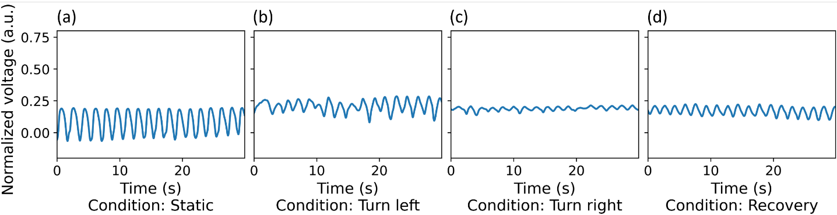
Figure SC1: On-body respiration signals recorded using the non-decoupled Straight design during (a) the initial standing posture, (b) the turn-left posture, (c) the turn-right posture, and (d) recovery after returning to the standing posture.
To further examine the difference between the decoupled and non-decoupled structures, an additional on-body experiment was performed using the Straight design as the non-decoupled reference. The patch position, the standing–left-turn–right-turn sequence, and the signal acquisition procedure were identical to those used for the Island design in Section 3.2. After the right-turn measurement, the volunteer returned to the standing posture for an additional recovery measurement. During the initial standing measurement, the volunteer reported a strong pulling sensation at the skin beneath the patch. This sensation became slightly weaker after several breaths. As shown in Fig. SC1(a), the Straight design produced a clear respiration waveform in the standing posture. However, the trough level gradually drifted, and the signal amplitude slowly decreased. Together with the volunteer’s report, these changes suggest that slight local detachment may have occurred at the patch–skin interface. When the volunteer moved from standing to the left-turn posture, a distinct sensation of the adhesive separating from the abdominal skin was reported. As shown in Fig. SC1(b), the baseline shifted, and the respiration waveform became markedly irregular, although it partly recovered toward the end of the recording. This behavior may reflect a detachment event during torso rotation, followed by partial reattachment during repeated abdominal expansion. Under the right-turn posture, the signal amplitude was much smaller, although the waveform was less irregular than in the left-turn posture, as shown in Fig. SC1(c). The transition from the left-turn to the right-turn posture also caused little additional baseline shift. One possible explanation is that a larger part of the patch had already detached, so that further torso deformation was accommodated mainly by the detached region rather than transferred to the sensing area. After the volunteer returned to the standing posture, the baseline again showed little change, as shown in Fig. SC1(d). The respiration waveform was clear, but its amplitude remained markedly lower than during the initial standing measurement and then increased gradually. This partial recovery further suggests a relationship between the signal amplitude and the mechanical contact between the patch and the abdominal skin. The observed deterioration of the Straight-design signal is consistent with weakened mechanical coupling at the skin–patch interface. The Straight design provides little geometric compliance for in-plane skin displacement. Torso rotation is therefore transferred more directly to the adhesive interface as shear and peeling loads. This may promote local sliding or detachment and reduce strain transfer from the skin to the sensing regions. In contrast, the Island geometry provides a structural deformation path that accommodates part of the in-plane displacement and helps maintain skin–sensor coupling during torso rotation. In the corresponding Island-design experiment described in Section 3.2, the respiration waveform remained clear during both rotation postures. This same-protocol comparison therefore supports the role of geometric decoupling in maintaining respiration-signal quality during posture changes.

Supplementary Note SD. On-body comparison with a Graseby capsule reference
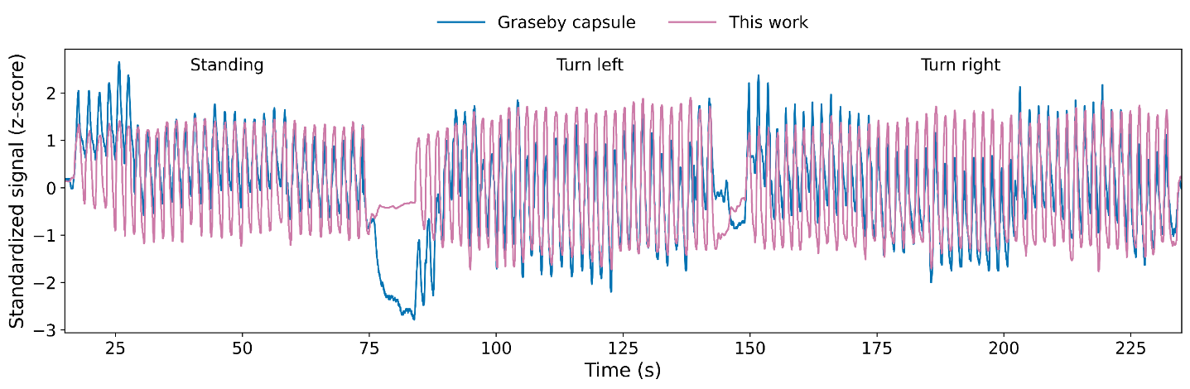
Figure SD1: Comparison of respiratory signals recorded in parallel using the Graseby capsule reference and the proposed sensor matrix during standing, left-turn, and right-turn postures. The signals were independently standardized using z-scores. Brief breath-hold intervals were introduced during posture transitions.
To verify that the periodic signals recorded by the sensor matrix originated from respiratory motion, an additional on-body comparison was performed using a Graseby capsule as the reference. The Graseby capsule was connected through its pressure tube to a LeoniPlus ventilator (Löwenstein Medical GmbH & Co. KG, Bad Ems, Germany). The capsule detects abdominal motion through pressure changes, and the processed abdomen-sensor output from the ventilator was recorded as the reference signal. The Graseby capsule and the sensor patch were attached side by side at adjacent positions immediately above the umbilicus. This arrangement was used to minimize the influence of differences in sensor position. The same healthy adult volunteer maintained the standing, left-turn, and right-turn postures described in section 3.2 while breathing naturally. The volunteer briefly held their breath during each posture transition to separate the three measurement stages and provide clear landmarks for temporal alignment. Because the Graseby system and the sensor patch have different output scales, the signals $x(t)$ were transformed into $z(t)$ according to:
$$z(t)=\frac{x(t)-μ}{σ}$$
with
$$μ=\frac{1}{N}\sum_{i=1}^{N}{x_{i}}$$
and
$$σ=\sqrt{\frac{1}{N}\sum_{i=1}^{N}{{(x_{i}-μ)}^{2}}}$$
where $x_{i}(t)$ represent the data points within a window defined by N. This step converts both signals to a dimensionless scale while preserving their waveform shapes. All following analyses were performed on these standardized signals. Pearson correlation coefficients were first calculated separately for the data points within the time windows of three maintained postures. The coefficients were 0.792, 0.838, and 0.773 for standing, left turn, and right turn, respectively. This showed positive correlations between the sensor patch and the Graseby reference in all three postures. As shown in Fig. SD1, the sensor-patch signal baseline did not show any persistent drift during posture change, while the Graseby signal showed a drift and recovered slowly to the baseline before posture change. Signal stability during the three maintained postures was then evaluated cycle by cycle on the standardized signals $z(t)$. Each complete respiratory cycle was defined by two consecutive troughs and the peak between them. For cycle $j$, the local trough level was calculated as
$L_{j}=\frac{T_{j,left}+T_{j,right}}{2}$,
where $T_{j,left}$ and $T_{j,right}$ are the two trough values. The respiratory amplitude of the cycle was then calculated as
$A_{j}=P_{j}-L_{j}$,
where $P_{j}$ is the peak value of the same cycle. The median of all $A_{j}$ values within one posture was defined as the typical respiratory amplitude:
$A_{typ}=median(A_{j})$.
The local baseline $B_{j}$ of each respiratory cycle was defined as the midpoint between the peak and the local trough level:
$B_{j}=\frac{P_{j}+L_{j}}{2}$.
The normalized baseline variation was then calculated as
$V_{baseline}=\frac{SD(B_{j})}{A_{typ}}$.
This value describes the baseline standard deviation $SD\left(B_{j}\right)$ relative to the typical respiratory amplitude of the same system. The normalized baseline variations of the Graseby reference and the sensor patch were 0.238 and 0.036 respectively during standing, 0.124 and 0.034 respectively during left turn, and 0.211 and 0.024 respectively during right turn. Thus, in this recording, the sensor-patch signal showed lower normalized baseline variation in all three maintained postures. Signal changes during the posture transitions were also evaluated. For each transition, the median signal level of the preceding maintained posture was used as the reference baseline. The largest absolute deviation from this baseline during the transition was then divided by the typical respiratory amplitude of the preceding posture:
$V_{transient}=\frac{∆_{max}}{A_{typ}}$,
where $∆_{max}$ is the maximum absolute signal deviation from baseline during the transition. During the standing to left-turn transition, the normalized transient signal drift were 2.014 for the Graseby reference and 0.649 for the sensor patch. During the left-to-right-turn transition, the corresponding values were 0.961 and 0.574. Thus, in this recording, the sensor-patch signal showed lower relative transient signal drift during both posture changes.

Supplementary Note SE. Discussion on system power consumption
The USB supply voltage and current were measured using a JT-UM25C USB power meter (JOY-IT, Germany) to provide an initial assessment of the power consumption of the current system. The power meter was connected in series between the host computer and the readout PCB. During the measurement, the Python-based data acquisition program was running and the sensor matrix operated under normal acquisition conditions, including multi-channel sampling and USB data transmission. The measured average voltage was 5.162 V and the average current was 19.2 mA, corresponding to an electrical power consumption of approximately 0.10 W. The current system is powered directly through USB and does not yet include an integrated battery or wireless communication module. Therefore, the measured value represents the power consumption of the wired readout prototype during normal data acquisition. For a future standalone wearable system, the operating time will need to be evaluated together with battery capacity, wireless communication, and power-management strategy.

Supplementary Note SF. On-body respiration measurement at different patch positions:
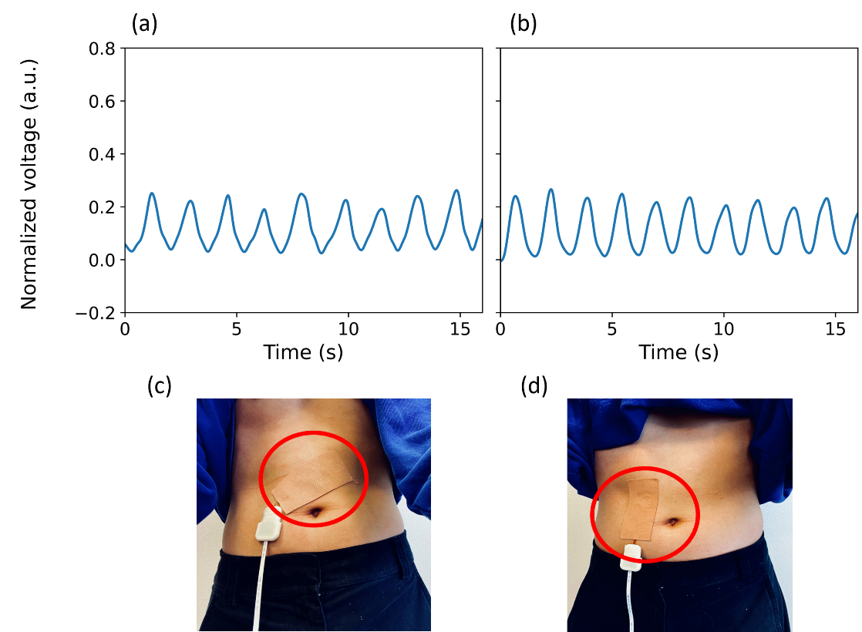
Figure SF1: On-body respiration measurements at two different abdominal patch positions and attachment orientations. (a,b) Representative normalized respiration signals obtained from the patch placements shown in (c,d), respectively.
To investigate the influence of patch placement, additional on-body measurements were performed using two different abdominal positions and attachment orientations. The same sensor patch and signal acquisition procedure described in Section 2.5 were used. For each placement, the volunteer stood naturally and breathed normally. The two measurements were performed independently. After each reattachment, the system initialization and channel-selection procedure was repeated, allowing the multi-channel sensor matrix to select a suitable sensing channel for the current patch position. Fig. SF1 shows the respiration signals obtained from the two patch placements. Despite the clear differences in position and orientation, clear periodic respiration signals were obtained in both cases. These results show that the sensor array can reliably monitor breathing even when it is not optimally positioned in a specific ideal location.

Reference
1. Koch E, Dietzel A. Skin attachable flexible sensor array for respiratory monitoring. Sensors and Actuators A: Physical. 2016;250:138–44. https://doi.org/10.1016/j.sna.2016.09.020

