Supplementary Material

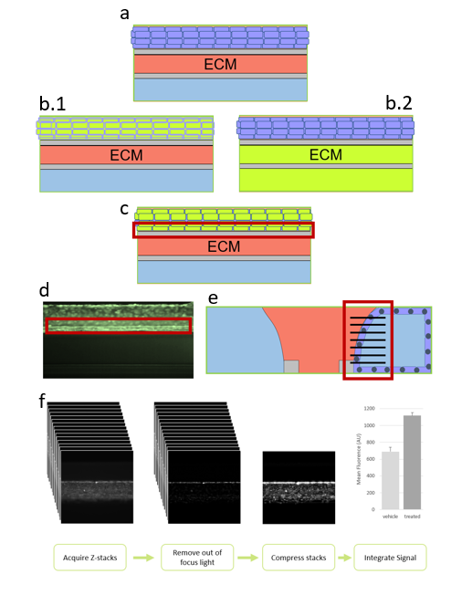
Supplementary figure S1: Cellular transport assay. a Perfused tubules in the top channel of the OrganoPlate. b Exposure of the tubule with a fluorescent compound either transported through influx transporters into cells, or by efflux transporters out of cells. Both transport mechanisms can be inhibited by specific inhibitors. b.1 Apical exposure with fluorescent compound from the apical side (inside of the tubule). b.2 Basal exposure from the basal side of the tubule. c Self-fluorescent compounds need to be washed out of the ECM, whereas compounds which are only fluorescent in the cells can be measured without washing. Compound retention in the cells is measured in the cells against the ECM surface (red square). d Fluorescent image of a tube with a green fluorescent compound retained in the cells. e Vertical illustration of the area imaged for the analysis. The black stripes indicate the planes of the z-stack images. f Image analysis: z-stack of the tubule is acquired, and the out of focus light is removed. Subsequently the stack is compressed, and the intensity of the image is measured. After blocking the transport of the compound, the nuclei of the cells are stained and the FITC signal is corrected for the nuclei count.

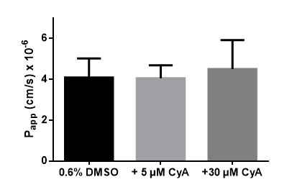
Supplementary figure S2: Apparent permeability (P_{app}) after cyclosporin A exposure. RPTEC tubules were exposed for 24 hours to 5 µM and 30 µM cyclosporin A. Both concentrations did not show a significant increase of the P_{app} after exposure. Each error bar represents the standard deviation of 4-5 chips.

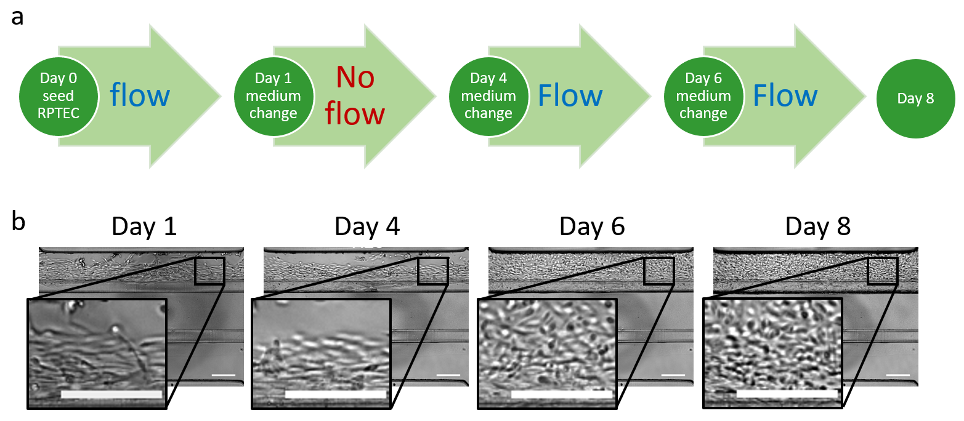
Supplementary figure S3: Importance of flow for tube formation. a Tubules were seeded and kept on the rocker platform for 24h hours. From day 1 to day 4 no flow was applied. The plate was placed back on the rocker platform from day 4 to 8. b Culturing the tubules without flow resulted in a lack of tubule formation at day 4 compared to the standard condition with flow (see fig. 1b). After reintroduction of flow the tube formation process recovered which resulted in a fully-grown tubule at day 8 (instead of day 6 as shown in fig. 1b). Scalebars = 200 µm.
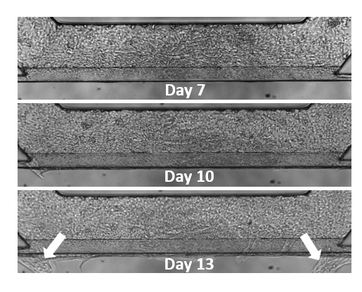
Supplementary figure S4: Stability of RPTEC tubules in the OrganoPlate. RPTEC tubules are stable up to day 11. After this time period RPTEC start invading the ECM and the tubules are not leak tight anymore. Therefore, experiments should be performed during day 6 and day 11.

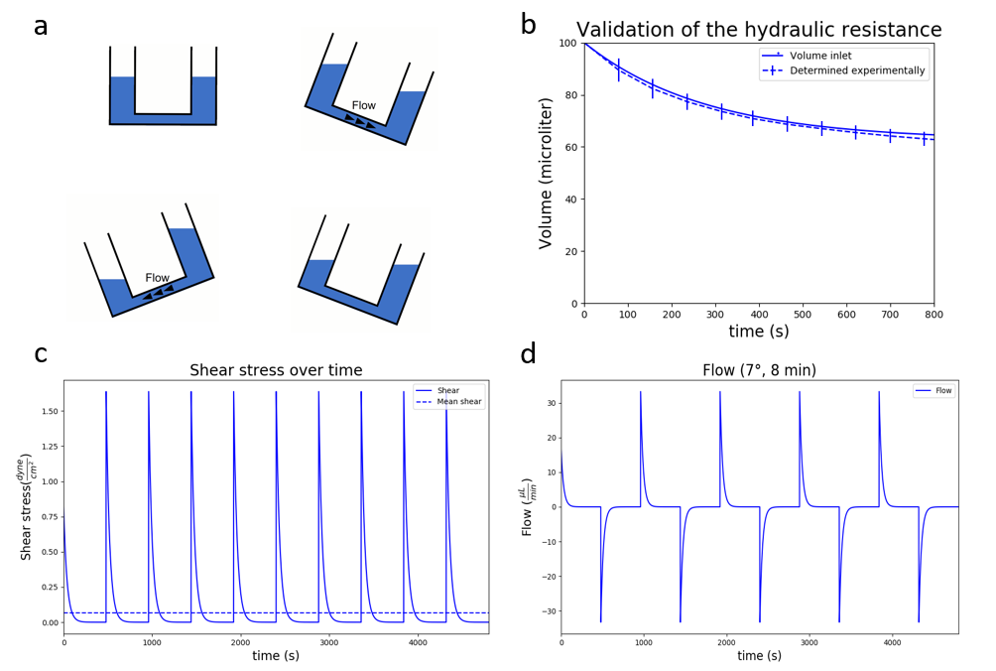

Supplementary figure S5: Validation of the hydraulic resistance. a Schematic of how the flow is generated in the system. The OrganoPlate was placed in an incubator on an interval rocker platform (+/- 7 degree angle, 8 min interval) enabling a bidirectional flow though the perfusion channels. By placing one inlet to the microfluidic system higher than the other inlet gravity-based perfusion can take place. When the liquid levels in connected wells the plate is tilted and the liquid flows into the opposite direction. b Empirical validation of a numerical model of gravity drive flow in an OrganoPlate. Change in fluorescence due to flow of FITC solution between wells in a 9603200B OrganoPlate (2-lane plate with 120 x 200 µm, w x h channels) (Solid line) showed high correlation with the associated simulated volumes (dashed line). c Sheer stress in the microfluidic channel over time simulated for the 3-lane OrganoPlate with 400 µm wide channels. d Simulated flow rate over time calculated for the microfluidic channel of the 3-lane OrganoPlate with 400 µm wide channels.

Supplementary Information

Flow rate and sheer stress
The platform described in this work uses a gravity-based perfusion system. When the liquid levels in connected wells are level, no difference in potential energy exists between the two wells, since the gravitational pull on the both volumes of fluid is identical, and no pressure difference exists between the two wells (fig. S5 a).
By periodically tilting a well plate with microfluidically connected wells, a height difference is imposed between the liquid levels in connected wells. The resulting pressure difference causes a fluid flow and associated shear stress.
The fluid flow rate and induced shear stress in the microfluidic channels of the OrganoPlate can be estimated using a numerical model simulated in Python (Python Software Foundation, USA). This model calculates the induced pressure difference between two volumes of fluid, which are present in two microtiter plate wells that are connected by a microfluidic channel. This pressure difference induces a fluid flow, with a flow rate that depends on the hydrodynamic resistance of the microfluidic channel and the fluid properties. This numerical model will be described in more detail below.
When a microfluidic chip is fully seeded, the inlet and outlet well of the perfusion channel are both filled with identical volume (50 µL). When the microtiter plate is levelled (0°) and both volumes are equal, an equilibrium is present: the gravity-induced pressure of both volumes of fluid is identical. The pressure, which is caused by the gravitational pull on a volume of fluid, is calculated by:
$$P= \frac{mg}{A}=\frac{ρVg}{A}=ρgh$$
In which pressure P (Pa) is calculated by dividing the weight of the fluid by the surface area of the microfluidic well. The weight is calculated by multiplying mass m (kg) with the gravitational constant g (9.81 m/s² or N·m²/kg²). Since m can be calculated by multiplying volume V (m³) with fluid density ρ (kg/m³), the pressure is calculated by ρgh.
Now, the induced pressure of both volumes of fluid can be calculated. When the microtiter plate is tilted under a certain angle (e.g. 7°), the induced pressure of both volumes is different, resulting in a pressure difference. This difference results in the flow of fluid, whom flow rate can be calculated by:
$$Q=\frac{ΔP}{R_{h}}$$
In which flow rate Q (m³/s) is calculated by dividing the pressure difference ΔP (Pa) by the R_{h} (kg/(m⁴·s)). This resistance is calculated by:
$$R_{h }=\frac{12µL }{wh^{3}\left(1-0.630h/w\right)}$$
In which w is the width (m) of the microfluidic channel, h the height of the channel (m), µ the fluid dynamic viscosity (0.001 kg/(m·s) or Pa·s), L the channel length (m) and R_{h} is the hydrodynamic resistance (kg/(m⁴·s))) of a channel with a rectangular cross-section (valid when h < w). This is validated by sequentially measuring the absorption at 494 nm of a 10 µg/ml Fluorescein in water (fig. S5 b). As the volume in the well changes over time, the absorption changes correspondingly. Now, this flow rate can be used to calculate the shear stress, which is exerted on the cells in the perfusion channel. This shear stress τ (Pa) is calculated by:
$$τ[i]=\frac{6µQ[i]}{wh^{2}}$$
The flow of liquid from one well to the other reduces the difference in liquid level height and thus reduces pressure and flow rate. Numerical integration is used to approximate the flow and resulting shear stress and flow rate over time (fig. S5 c,d) for the settings used in this research.

