Supplemental Data_1: Figures

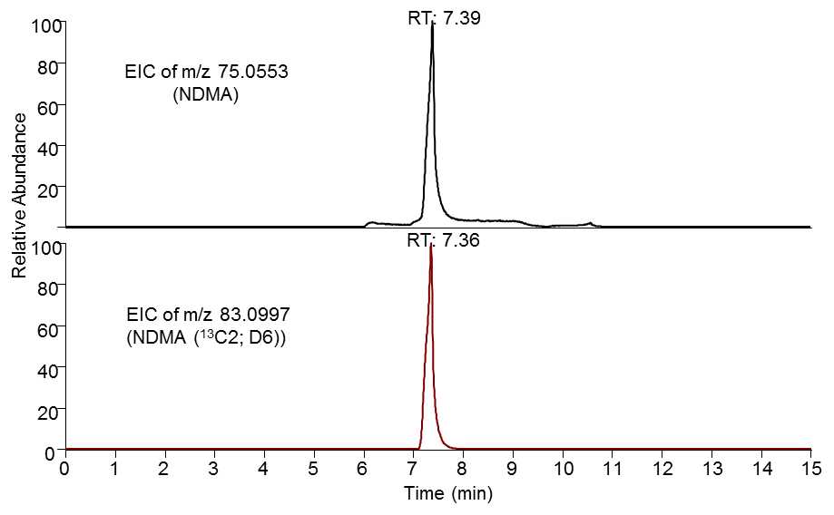

Figure S-1: Extracted ion chromatograms (EIC) of NDMA (top) and NDMA (¹³C2; D6) (bottom). NDMA elutes at 7.39 min, and NDMA (¹³C2; D6) elutes at 7.36 min.

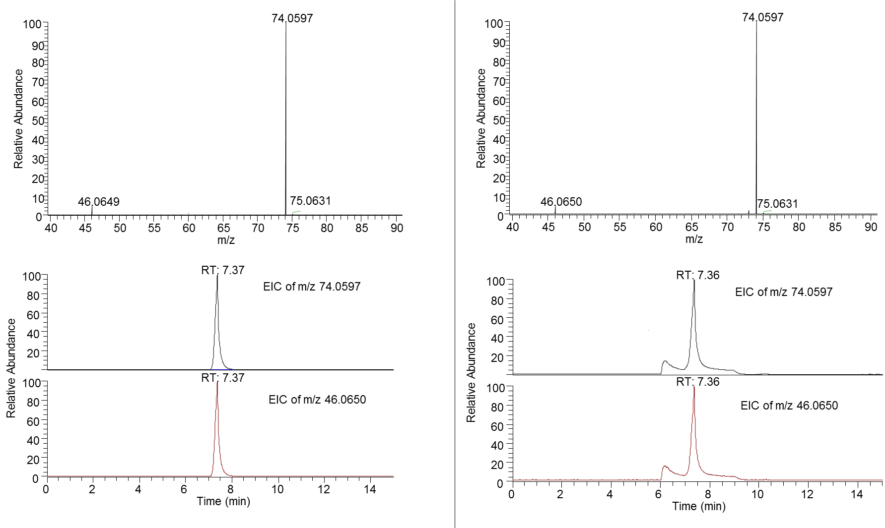
Sample | DMF standard

Figure S-2: Product ion mass spectra of m/z 74 (top) and the extracted ion chromatograms (EIC) of m/z 74.0597 and 46.0650 (bottom) for the metformin drug product sample (left) the DMF reference standard (right).

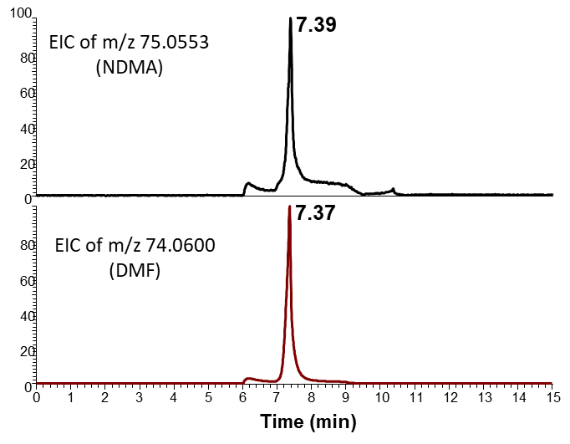
Figure S-3: Co-elution of NDMA and DMF in the chromatography used by the private laboratory. The EIC of the exact mass of NDMA (eluting at 7.39 min) and EIC of the exact mass of DMF (eluting at 7.37 min) are indicated in the Figure.

