Supplemental material 3: Additional details about models fitted.

Figure 1: Successful minimization, OFV of the base model, and dOFV between the base OFV and the average full OFV for the ADAS-cog data 2
Figure 2: Successful minimization, OFV of the base model, and dOFV between the base OFV and the average full OFV for the Likert-pain score data 3
Figure 3: Successful minimization, OFV of the base model, and dOFV between the base OFV and the average full OFV for the seizure count data 4

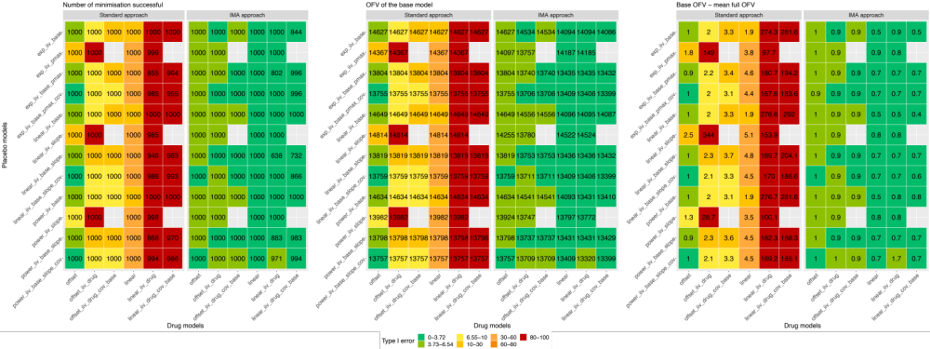
Figure 1: Successful minimization, OFV of the base model, and dOFV between the base OFV and the average full OFV for the ADAS-cog data
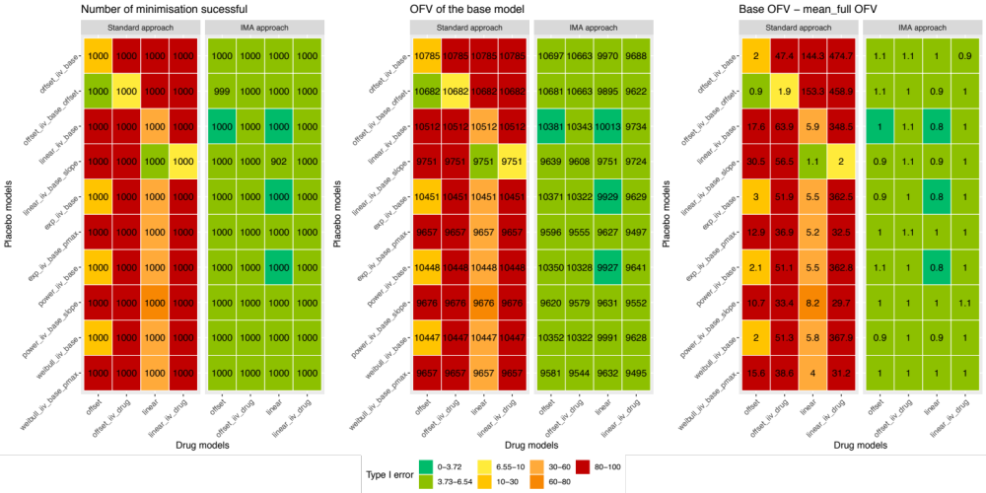
Figure 2: Successful minimization, OFV of the base model, and dOFV between the base OFV and the average full OFV for the Likert-pain score data
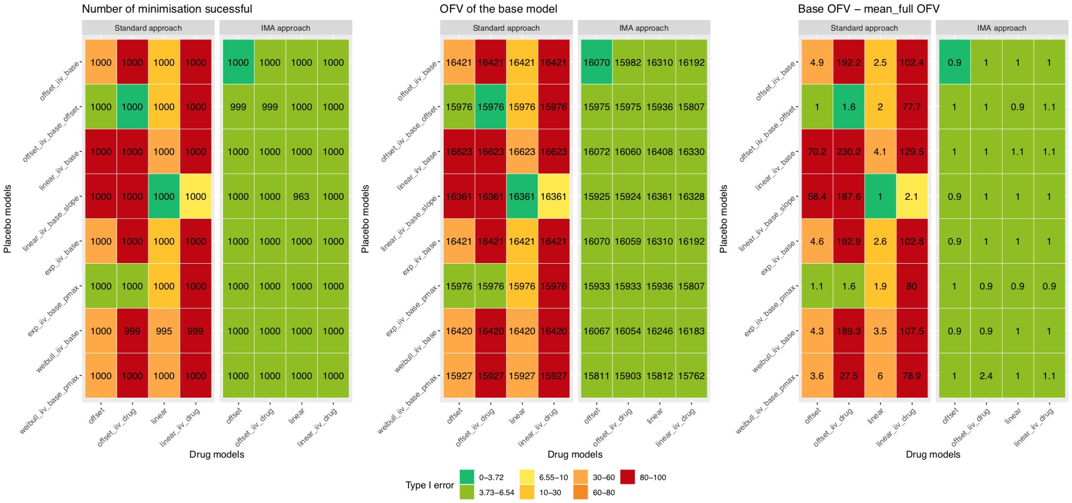
Figure 3: Successful minimization, OFV of the base model, and dOFV between the base OFV and the average full OFV for the seizure count data

