Supplementary material 4: Results for smaller sample size.

Figure 1: Type I error rate with the ADAS-cog data for n=400, n=200, and n=100 individuals 2
Figure 2: Type I error rate with the Likert-pain score data for n=60 and n=120 individuals 3
Figure 3: Type I error rate with the seizure count data for n=50 and n=250 individuals 3

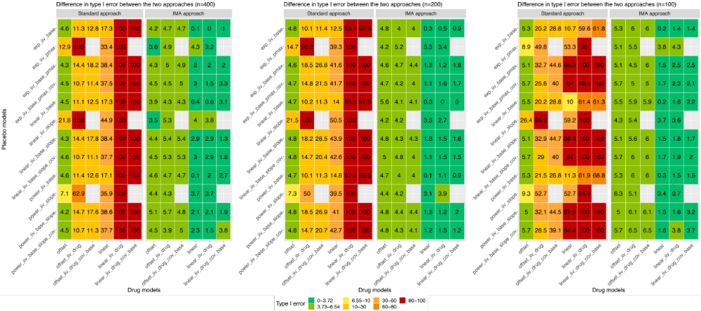
Figure 1: Type I error rate with the ADAS-cog data for n=400, n=200, and n=100 individuals

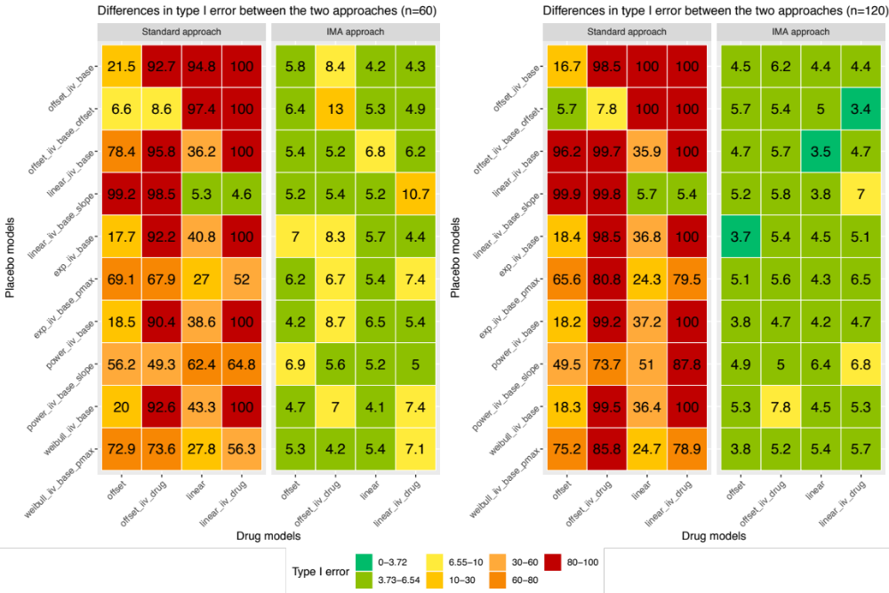
Figure 2: Type I error rate with the Likert-pain score data for n=60 and n=120 individuals
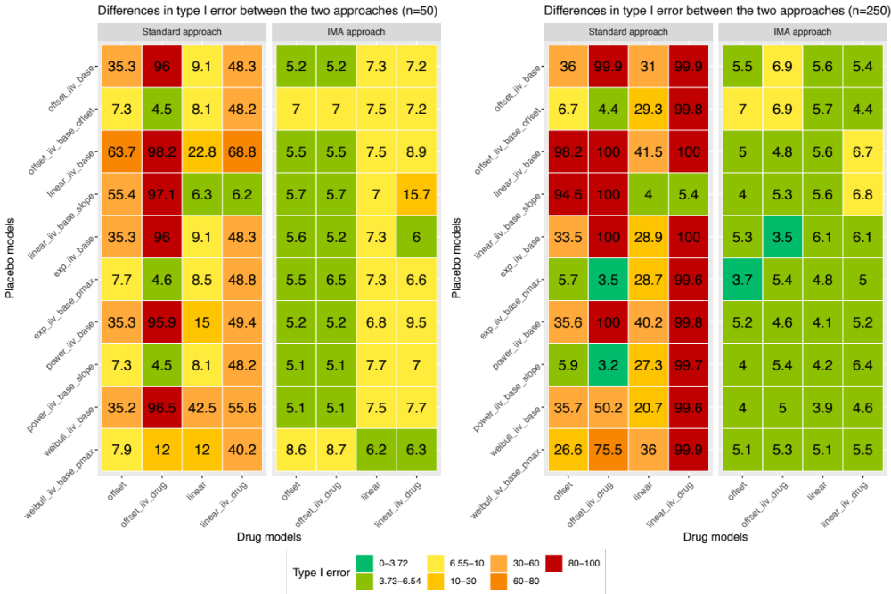
Figure 3: Type I error rate with the seizure count data for n=50 and n=250 individuals

