Supplemental Information

Pharmacokinetic analysis of peptide-modified nanoparticles with engineered physicochemical properties in a mouse model of traumatic brain injury
Lauren E. Waggoner¹, Marianne I. Madias², Alan A. Hurtado², Ester J. Kwon²*
Departments of ¹Nanoengineering and ²Bioengineering, University of California San Diego, La Jolla, California 92093
*To whom correspondence should be addressed. Postal address; 9500 Gilman Drive, La Jolla, California, 92093; email: ejkwon@ucsd.edu; phone: 1-(858) 246-0122

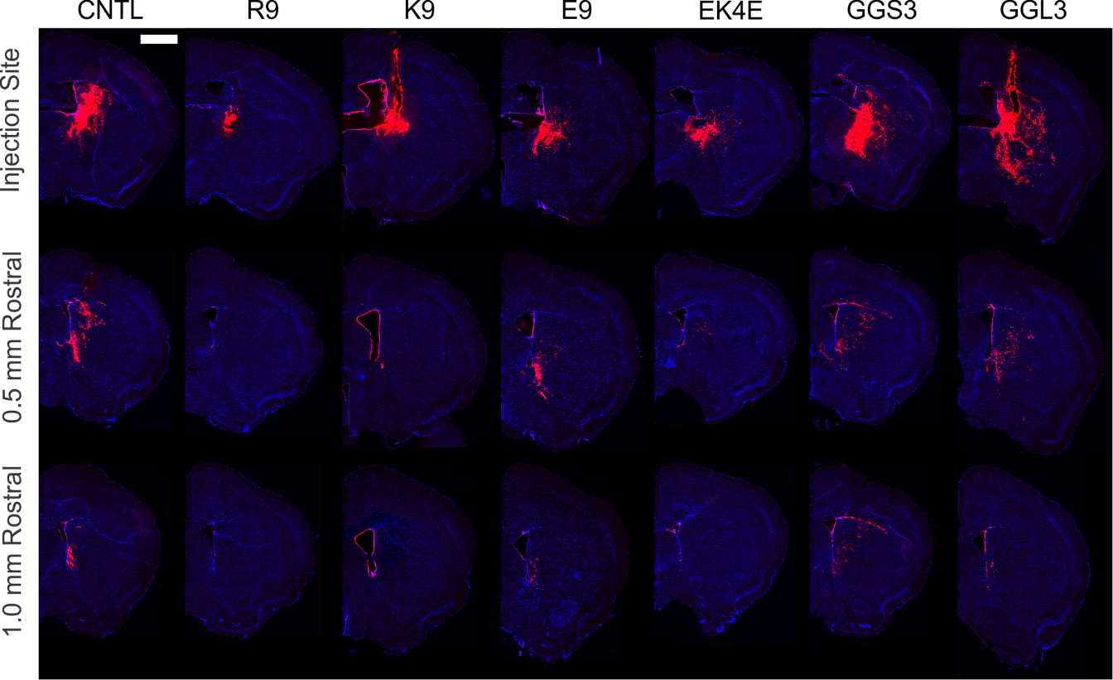
Supplemental Figure 1. Representative fluorescent images of brain sections taken at the injection site, 0.5 mm, and 1 mm rostral from the injection site 6 hours post-administration into a healthy mouse brain by convection enhanced delivery (CED) for each peptide-modified nanoparticle group (n=3). Injured brain hemisphere was imaged for nanoparticles (red) and Hoechst (blue; scale bar = 1 mm).

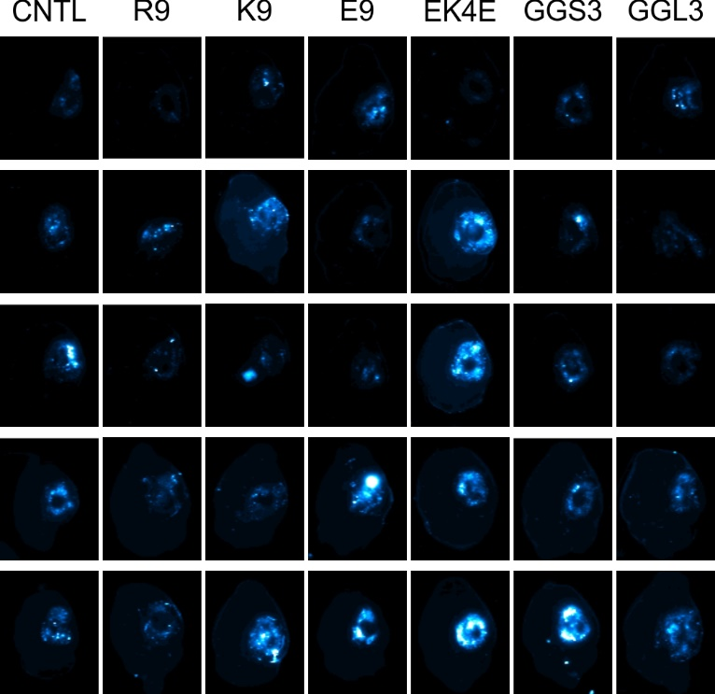
Supplemental Figure 2. Surface fluorescent imaging of intact brains, with injured hemisphere on the right side. Peptide-modified nanoparticles were administered intravenously 6 hours after controlled cortical impact (CCI) injury and brains collected 1 hour after administration.

