Supplementary material

Population pharmacodynamic modeling of eflornithine-based treatments against late-stage gambiense human African trypanosomiasis and efficacy predictions of L-eflornithine-based therapy

Carl Amilon^{1,2}*, Mikael Boberg¹*, Joel Tarning^{3,4}, Angela Äbelö¹, Michael Ashton¹ and Rasmus Jansson-Löfmark^{1,2,#}

¹ Unit for Pharmacokinetics and Drug Metabolism, Sahlgrenska Academy, University of Gothenburg, Gothenburg, Sweden
² DMPK, Research and Early Development Cardiovascular, Renal and Metabolism, BioPharmaceuticals R&D, AstraZeneca, Gothenburg, Sweden
³ Centre for Tropical Medicine and Global Health, Nuffield Department of Clinical Medicine, University of Oxford, Oxford, United Kingdom
⁴ Mahidol Oxford Tropical Medicine Research Unit, Faculty of Tropical Medicine, Mahidol University, Bangkok, Thailand

*Authors contributed equally
#Corresponding author

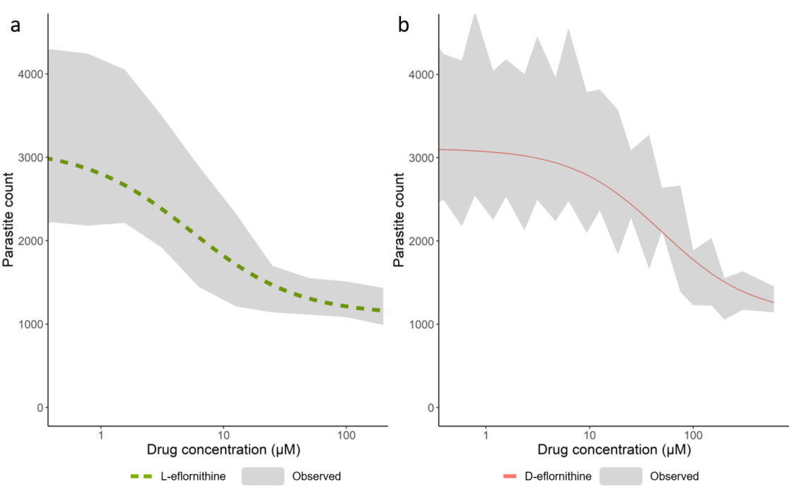
Fig. S1. Model fit of the predicted in vitro efficacy for a) L-eflornithine (dashed green line) and b) D-eflornithine (solid red line). The gray areas represent the 5th to 95th percentiles of experimental data from a previous study [16]. Data was accessed from the Swedish National Data Service (SND-ID: 2021-45) database [25]

Table SI In vitro parameter estimates for L-eflornithine and
D-eflornithine for the in vitro potency antitrypanosomal activity
Parameter | Estimate
E₀ | 2004*
Background fluorescence | 1108*
IC₅₀ L-eflornithine | 5.5 µM
IC₅₀ D-eflornithine | 49.6 µM
*Measured relative fluorescence value in assay, E₀ – Effect at zero drug concentration, IC₅₀ – 50% inhibitory drug concentration

Table SII Pharmacodynamic model parameters used
in the efficacy simulations of oral L-eflornithine
 | Assessed treatment
Parameter | Oral L-eflornithine | Oral L-eflornithine | Oral L-eflornithine
Dose  L-eflornithine (g) | 333 | 333 | 333
BASE  (month⁻¹) | 0.035 | 0.026 | 0.077
SHAPE | 2.53 | 1.93 | 1
ID₅₀  (g) | 118 | 118 | 118
Dose – Total dose administered, BASE – baseline hazard, SHAPE – Weibull shape, ID₅₀ – total dose that reduce BASE by 50%

