Article title: Prediction of individual disease progression including parameter uncertainty in rare neurodegenerative diseases: the example of Autosomal-Recessive Spastic Ataxia Charlevoix Saguenay (ARSACS)

Journal name: the AAPS Journal

Authors: Niels Hendrickx, MSc (1)*, France Mentré, MD, PhD (1), Andreas Traschütz, MD, PhD (2,3), Cynthia Gagnon, PhD (4), Rebecca Schüle, MD (2,3), ARCA Study Group#, EVIDENCE-RND consortium#, Matthis Synofzik, MD ** (2,3), Emmanuelle Comets, PhD** (1,5)
*Corresponding author: Niels Hendrickx, email: niels.hendrickx@inserm.fr
# for ARCA Study Group and EVIDENCE-RND authors, see Supplementary Materials 2
** Shared last authorship

Institutions:
(1) Université Paris Cité, IAME, Inserm, F-75018, Paris, France
(2) Division Translational Genomics of Neurodegenerative Diseases, Hertie Institute for Clinical Brain Research (HIH), University of Tübingen, Tübingen, Germany;
(3) German Center for Neurodegenerative Diseases (DZNE), Tübingen, Germany.
(4) Centre de recherche du CHUS et du Centre de santé et des services sociaux du Saguenay-Lac-St-Jean, Faculté de médecine, Université de Sherbrooke, Québec, Canada
(5) Univ Rennes, Inserm, EHESP, Irset - UMR_S 1085, 35000, Rennes, France.

Supplementary material 1: Contributors in the ARCA study group
Name, Title | Affiliation(s) | Contact
Astrid D. Adarmes-Gomez, MD | 1. Unidad de Trastornos del Movimiento, Servicio de Neurología y Neurofisiología Clínica, Instituto de Biomedicina de Sevilla, Hospital Universitario Virgen del Rocío/CSIC/Universidad de Sevilla, Seville, Spain  2. Centro de Investigación Biomédica en Red Sobre Enfermedades Neurodegenerativas (CIBERNED), Spain | astridadarmes@hotmail.com
Mathieu Anheim,  MD, PhD | 1. Service de Neurologie, Hôpitaux Universitaires de Strasbourg, Hôpital de Hautepierre, 1 avenue Molière, Strasbourg, 67098, Cedex, France  2. Fédération de Médecine Translationnelle de Strasbourg (FMTS), Université de Strasbourg, Strasbourg, France  3. Institut de Génétique et de Biologie Moléculaire et Cellulaire (IGBMC), INSERM-U964/CNRS-UMR7104/Université de Strasbourg, Illkirch, France | mathieu.anheim@chru-strasbourg.fr
Jonathan Baets,  MD, PhD | 1. Translational Neurosciences, Faculty of Medicine and Health Sciences, UAntwerpen, Antwerp, Belgium  2. Laboratory of Neuromuscular Pathology, Institute Born-Bunge, University of Antwerp, Antwerp, Belgium  3. Neuromuscular Reference Centre, Department of Neurology, Antwerp University Hospital, Antwerp, Belgium | jonathan.baets@uantwerpen.be
Bernard Brais,  MD, PhD | Department of Neurology, McGill University, Montreal Neurological Institute, Montréal, Quebec, Canada | bernard.brais@mcgill.ca
Cynthia Gagnon,  PhD | Centre de recherche du CHUS et du Centre de santé et des services sociaux du Saguenay–Lac-St-Jea, Faculté de médecine, Université de Sherbrooke, Québec, Canada | Cynthia.Gagnon4@usherbrooke.ca
Janina Gburek-Augustat, MD | Division of Neuropaediatrics, Hospital for Children and Adolescents, University of Leipzig, Leipzig, Germany | Janina.Gburek-Augustat@medizin.uni-leipzig.de
Sarah Doss,  MD | 1. Department of Neurology, Charité - Universitätsmedizin Berlin, corporate member of Freie Universität Berlin, Humboldt-Universität zu Berlin, Berlin, Germany  2. Department of Neurological Sciences, University of Nebraska Medical Center (UNMC), Omaha | sarah.doss@unmc.edu
Hasmet A. Hanagasi,  MD | Behavioral Neurology and Movement Disorders Unit, Department of Neurology, Istanbul Faculty of Medicine, Istanbul University, 34093, Istanbul, Turkey | hasmet@yahoo.com
Christoph Kamm,  MD | Department of Neurology, University of Rostock, Rostock, Germany | christoph.kamm@med.uni-rostock.de
Peter Klivenyi,  MD | Interdisciplinary Excellence Centre, Department of Neurology, Faculty of Medicine, Albert Szent-Györgyi Clinical Center, University of Szeged, Szeged, Hungary | klivenyi.peter@med.u-szeged.hu
Marcus Grobe-Einsler,  MD | 1. Department of Neurology, University Hospital Bonn, Bonn, Germany  2. German Center for Neurodegenerative Diseases (DZNE), Bonn, Germany | Marcus.Grobe-Einsler@ukbonn.de
Thomas Klopstock,  MD | 1. Department of Neurology, Friedrich-Baur-Institute, Ludwig-Maximilians-University of Munich, Munich, Germany  2. German Center for Neurodegenerative Diseases (DZNE), Munich, Germany  3. Munich Cluster for Systems Neurology (SyNergy), Munich, Germany | Thomas.Klopstock@med.uni-muenchen.de
Martina Minnerop,  MD | 1. Institute of Neuroscience and Medicine (INM-1), Research Centre Juelich, Juelich, Germany  2. Department of Neurology, Center for Movement Disorders and Neuromodulation, Medical Faculty, Heinrich Heine University, Düsseldorf, Germany  3. Institute of Clinical Neuroscience and Medical Psychology, Medical Faculty, Heinrich-Heine University, Germany | Martina.Minnerop@med.uni-duesseldorf.de
Alexander Münchau,  MD | Institute of Systems Motor Science, Neurogenetics, University of Lübeck, Lübeck, Germany | alexander.muenchau@neuro.uni-luebeck.de
Mathilde Renaud,  MD | 1. Service de Génétique Clinique, CHRU de Nancy, Nancy, France  2. INSERM-U1256 NGERE, Université de Lorraine, Nancy, France | M.RENAUD2@chru-nancy.fr
Filippo M. Santorelli,  MD | IRCCS Fondazione Stella Maris, Pisa, Italy | filippo3364@gmail.com
Dagmar Timmann,  MD | Department of Neurology and Center for Translational Neuro- and Behavioral Sciences, Essen University Hospital, University of Duisburg-Essen, Essen, Germany | dagmar.timmann-braun@uk-essen.de
Stefan Vielhaber,  MD | 1. Department of Neurology, Otto-von-Guericke University, Magdeburg, Germany  2. German Center for Neurodegenerative Diseases (DZNE) within the Helmholtz Association, Magdeburg, Germany  3. Center for Behavioral Brain Sciences, Magdeburg, Germany | stefan.vielhaber@med.ovgu.de
Bart P. van de Warrenburg, MD, PhD | Department of Neurology, Donders Institute for Brain, Cognition and Behaviour, Radboud University Medical Centre, Nijmegen, The Netherlands | Bart.vandeWarrenburg@radboudumc.nl
Ginevra Zanni,  MD, PhD | Unit of Neuromuscular and Neurodegenerative Disorders, Department of Neurosciences, Bambino Gesù Childrens' Hospital, IRCCS, Rome Italy | ginevra.zanni@opbg.net

Members of the Evidence-RND consortium:
Name, Title | Affiliation(s) | Contact
Emmanuelle Comets, PhD | Université Paris Cité, IAME, Inserm, F-75018, Paris, France; Univ Rennes, Inserm, EHESP, Irset - UMR_S 1085, 35000, Rennes, France. | Emmanuelle.comets@inserm.fr
Niels Hendrickx, MSc | Université Paris Cité, IAME, Inserm, F-75018, Paris, France | Niels.hendrickx@inserm.fr
Nicole Maria Heussen, PhD | Department of Medical Statistics, RWTH Aachen University, Aachen, Germany; Center of Biostatistics and Epidemiology, Medical School, Sigmund Freud University, Vienna, Austria. | nheussen@ukaachen.de
Ralf-Dieter Hilgers, PhD | Department of Medical Statistics, RWTH Aachen University, Aachen, Germany. | rhilgers@ukaachen.de
Thomas Klockgether, MD, PhD | German Center for Neurodegenerative Diseases (DZNE), Bonn, Germany;  Department of Neurology, University of Bonn, Bonn, Germany. | klockgether@uni-bonn.de
France Mentré, MD, PhD | Université Paris Cité, IAME, Inserm, F-75018, Paris, France | France.mentre@inserm.fr
Yevgen Ryeznik, PhD | AstraZeneca, Mölndal, Sweden | yevgen.ryeznik@astrazeneca.com
Oleksandr Sverdlov, PhD | Novartis Pharmaceuticals Corporation, East Hanover, New Jersey, USA. | alex.sverdlov@novartis.com
Alzahra Hamdan, MSc | Pharmacometrics Research Group, Department of Pharmacy, Uppsala University, Uppsala, Sweden | alzahra.hamdan@farmaci.uu.se
Andrew C. Hooker, PhD | Pharmacometrics Research Group, Department of Pharmacy, Uppsala University, Uppsala, Sweden | andrew.hooker@farmaci.uu.se
Xiaomei Chen, PhD | Pharmacometrics Research Group, Department of Pharmacy, Uppsala University, Uppsala, Sweden | xiaomei.chen@farmaci.uu.se
Andreas Traschütz, MD, PhD | Division Translational Genomics of Neurodegenerative Diseases, Hertie Institute for Clinical Brain Research (HIH), University of Tübingen, Tübingen, Germany; German Center for Neurodegenerative Diseases (DZNE), Tübingen, Germany. | andreas.traschuetz@uni-tuebingen.de
Rebecca Schüle, MD | Division Translational Genomics of Neurodegenerative Diseases, Hertie Institute for Clinical Brain Research (HIH), University of Tübingen, Tübingen, Germany; German Center for Neurodegenerative Diseases (DZNE), Tübingen, Germany. | rebecca.schuele-freyer@uni-tuebingen.de
Matthis Synofzik, MD | Division Translational Genomics of Neurodegenerative Diseases, Hertie Institute for Clinical Brain Research (HIH), University of Tübingen, Tübingen, Germany; German Center for Neurodegenerative Diseases (DZNE), Tübingen, Germany. | matthis.synofzik@uni-tuebingen.de
Mats O. Karlsson, PhD | Pharmacometrics Research Group, Department of Pharmacy, Uppsala University, Uppsala, Sweden | mats.karlsson@farmaci.uu.se
Sebastian Ueckert, PhD | Clinical Pharmacology and Quantitative Pharmacology, Clinical Pharmacology and Safety Sciences, R&D, AstraZeneca, Pepparedsleden 1, Mölndal, 431 83, Gothenburg, Sweden. | sebastian.ueckert@farmaci.uu.se

Supplementary material 2: Demographic characteristics of the ARSACS population with a SARA score below 20 points

Continuous covariates |  | median | min-max | nb of patients with observations
 | BMI (kg.m⁻²) | 23.6 | 13.6-57.1 | 58
 | INAS | 6 | 1-10 | 48
 | AOO (yr) | 2 | 0-40 | 63
Categorical covariates |  | N | percentage | nb of patients with observations
 | Loss of function | 18 | 31% | 58
 | Women | 31 | 44% | 70
‍ | AOO 0-4 yr | 54 | 77% | 63
‍ | 5-14 yr | 9 | 13% | 63
‍ | 15+ yr | 7 | 10% | 63
Table S2-1: Demographic characteristics of the 70 patients with a maximum SARA score below 20 points. BMI= Body Mass Index, INAS= Inventory of Non-Ataxia Signs, AOO= Age Of Onset, N=Number of patients

Supplementary material 3 - Pooled p-value method
Let $θ=\left(θ_{-β},β\right)$ denote the parameter vector of interest with $β$ a covariate-parameter relationship of dimension 1, and assume we test the hypothesis $θ=θ_{0}=\left(θ_{0,-β},β=0\right)$ for a given null hypothesis $θ_{0}.$ We first compute the mean of the LRT statistic across all imputed data sets:
$$\hat{d}=\frac{1}{M}\sum_{m=1}^{M}{-2}×\left(l\left(y^{\left(m\right)},\hat{θ_{0}^{\left(m\right)}}\right)-l\left(y^{\left(m\right)},\hat{θ^{\left(m\right)}}\right)\right)$$
where M is the number of imputed data sets, l the loglikelihood, $\hat{θ_{0}^{\left(m\right)}}$ is the Maximum Likelihood Estimator (MLE) of $θ_{0}$ in the restricted model where $β=0$ estimated on the imputed data set $m$, $\hat{θ^{\left(m\right)}}$ the MLE of $θ$ in the full model, estimated on the same data set m and $y^{\left(m\right)}$ the imputed data set m.
We then compute the mean of the MLE for the full model $\left(\overline{θ}=\frac{1}{M}\sum_{m}{\hat{θ^{\left(m\right)}}}\right)$ and the restricted model $\left(\overline{θ_{0}}=\frac{1}{M}\sum_{m}{\hat{θ_{0}^{\left(m\right)}}}\right).$ We compute the likelihood ratio test on each imputed data set m, with the likelihood evaluated at the mean MLE for the full and reduced model, and its average:
$$\overline{d}=\frac{1}{M}\sum_{m}{-2\left(l\left(y^{\left(m\right)},\overline{θ_{0}}\right)-l\left(y^{\left(m\right)},\overline{θ}\right)\right)}$$
The proposed test statistic is:
$$D=\frac{\overline{d}}{\left(1+r\right)}$$
where:
$$r=\frac{M+1}{\left(M-1\right)}\left(\hat{d}-\overline{d}\right)$$
Under an asymptotic normality assumption, the test statistic D follows a F-distribution $F_{k,ν}$ with k (=1 here) and $ν$ degrees of freedom, where:
$$ν=\left\{\begin{aligned}4+\left(t-4\right)×{\left(1+\left(1-2t^{-1}\right)r^{-1}\right)}^{2},ift=\left(M-1\right)>4 \\ t{\left(1+r^{-1}\right)}^{2},otherwise\end{aligned}\right.$$

Supplementary material 4 – Evaluation of the predictive performance using simulations

Methods
We assessed the predictive performance of the model of individual disease progression using simulations. We used the covariates and TSO at inclusion from the 173 patients from the original data set. For each subject, we drew 100 vectors of individual parameters to predict the SARA score at 5 years after inclusion for each subject (${SARA}_{pred}^{true}$), and to simulate observations at baseline, 1 and 2 years after inclusion adding a residual error. We hence simulated 17300 subjects. Then, for each subject, we re-evaluated the conditional distribution using one (baseline only) two (baseline & 1 year) or three (baseline & 1 & 2 year) visits, based on the population model. We estimated the median prediction 5 years after inclusion ( $SARA_{pred,i,n}$ for subject i and n visits), and its Prediction Interval (PI) as respectively the median and the 5th $(q_{SARA,i,n,5)}$ and the 95th ($q_{SARA,i,n,95}$) percentiles of 100 samples drawn in the conditional distribution.

We can then evaluate the predictive performance of the model by computing the Relative Estimation Error (REE) for each subject i, i=1,…,17300 using n visits for the conditional distribution:
$$REE_{i,n}=\frac{SARA_{pred,i,n}-SARA_{pred,i}^{true}}{SARA_{pred,i}^{true}}$$
We computed the Relative bias (RB) and relative root mean square error (RRMSE) for each case (n=1,23 visits) as the mean and standard deviation of the REE:
$$RB_{n}=\frac{1}{17300}\sum_{i=1}^{17300}{REE_{i,n}}$$
$$RRMSE_{n}=\sqrt{\frac{1}{17300}\sum_{i=1}^{17300}{REE_{i,n}^{2}}}$$
We also assessed the width of the PI ($W_{i,n}$) for each subject i, using n visits to compute their conditional distribution, and compute the mean widths over all subjects ( $\overline{W_{n}}$ ) for n=1, 2 or 3 visits
$$W_{i,n}=q_{SARA,i,n,95}-q_{SARA,i,n,5}$$
$$\overline{W_{n}}=\frac{1}{17300}\sum_{i=1}^{17300}{W_{i,n}}$$
Finally, we report the fraction of patients where the $SARA_{pred}^{true}$ was within the 90% PI ($F_{n}$) using n visits to compute the conditional distribution.

Results
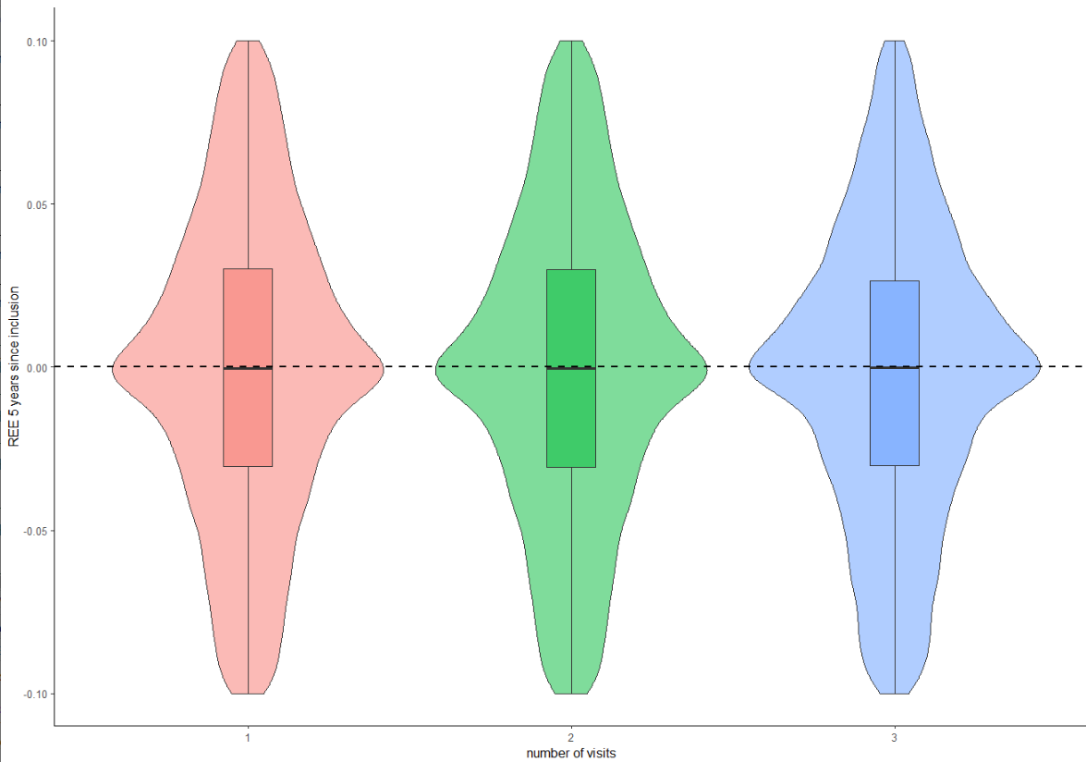

Figure S4-1: Violin plot of the Relative Estimation Error (REE) for the 17300 simulated subjects, using 1, 2 or 3 visits to compute their conditional distribution
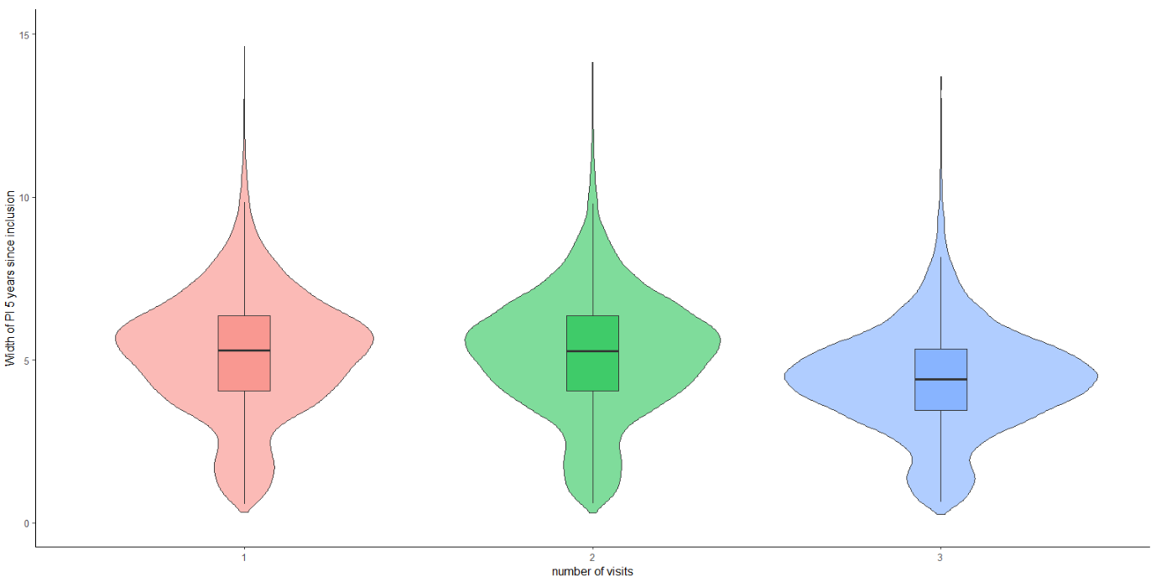
Figure S4-2: Violin plot of the Width of prediction interval (PI) for the 17300 simulated subjects, using 1, 2 or 3 visits to compute their conditional distribution

Number of visits (n) | 1 | 2 | 3
$$RB_{n}$$ | -1.5 % | -1.5 % | -1.7 %
$$RRMSE_{n}$$ | 10.9 % | 10.9 % | 9.2 %
$$\overline{W_{n}}$$ | 5.2 | 5.2 | 4.4
$$F_{n}$$ | 87.9 | 88.1 | 88.4
Table S4-1: Relative bias (RB), relative root mean square error (RRMSE), mean width of PI ($\overline{W_{n}}$) and fraction of predictions at 5 years after inclusion for the 17300 simulated patients, using 1, 2 or 3 visits to compute their conditional distribution

In figure S4-1 and table S4-1, we can see that the individual prediction at 5 years since inclusion is unbiased, with Relative bias of less than -2%. According to figure S4-2, we can see that the RRMSE is also low, with 10.9% for 1 or 2 visits, and 9.2% for 3 visits. The mean width of PI 5 years since inclusion also slightly decreases with the number of visits, from 5.2 for 1 or 2, and 4.4 for 3 visits. Finally, around 88% of “true” predictions at 5 years since inclusion fall within the PI for 1, 2 and 3 visits, which is consistent considering those are 90% prediction intervals.

