Supplemental material
Supplemental Figure 1: OAK study ADA heatmap (zoomed for ADA positive patients)
Supplemental Figure 1 Legend - This plot is a zoomed in version of Figure 1. The x-axis represents treatment cycles, and the y-axis represents patient data at each scheduled visit. Colored lines indicate ADA status: blue for negative, red for positive, and white for no sample. Patients are arranged by ADA onset times and data availability, with earlier onset times placed higher. To reduce complexity, data from unscheduled (25 visits), study discontinuation (356 visits), and day 120 follow-up (124 visits) visits were excluded, leaving results from 546 patients with at least one post-baseline ADA sample, of which 159 (29.1%) were ADA positive.
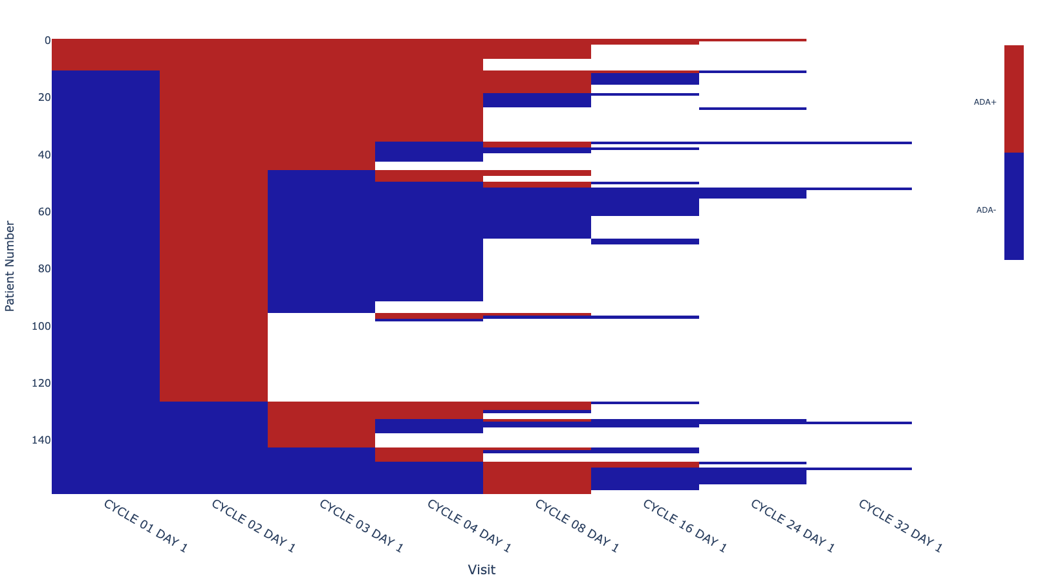
Supplemental Figure 2: ADA heat maps for additional atezolizumab studies
Supplemental Figure 2 Legend: Heatmaps of ADA data for four atezolizumab studies are shown. a) IMpower 130 study of first line non-small cell lung cancer (NSCLC), b) IMpower 133 study of small cell lung cancer (SCLC), c) IMbrave150 study of hepatocellular carcinoma (HCC, liver cancer), and d) IMpower 150 study of NSCLC. Each X-axis is time in treatment cycles; each y-axis is data from ADA evaluable study subjects. Each horizontal line represents a single patient. Color shows ADA status at that study visit: ADA negative (blue), ADA positive (red), no sample available (white). The figure is organized by ADA onset time and data availability. Patients with earlier ADA onset times are placed higher on the y-axis. If ADA onset times are the same, those who stayed ADA positive for longer are higher than those with shorter duration ADA responses.

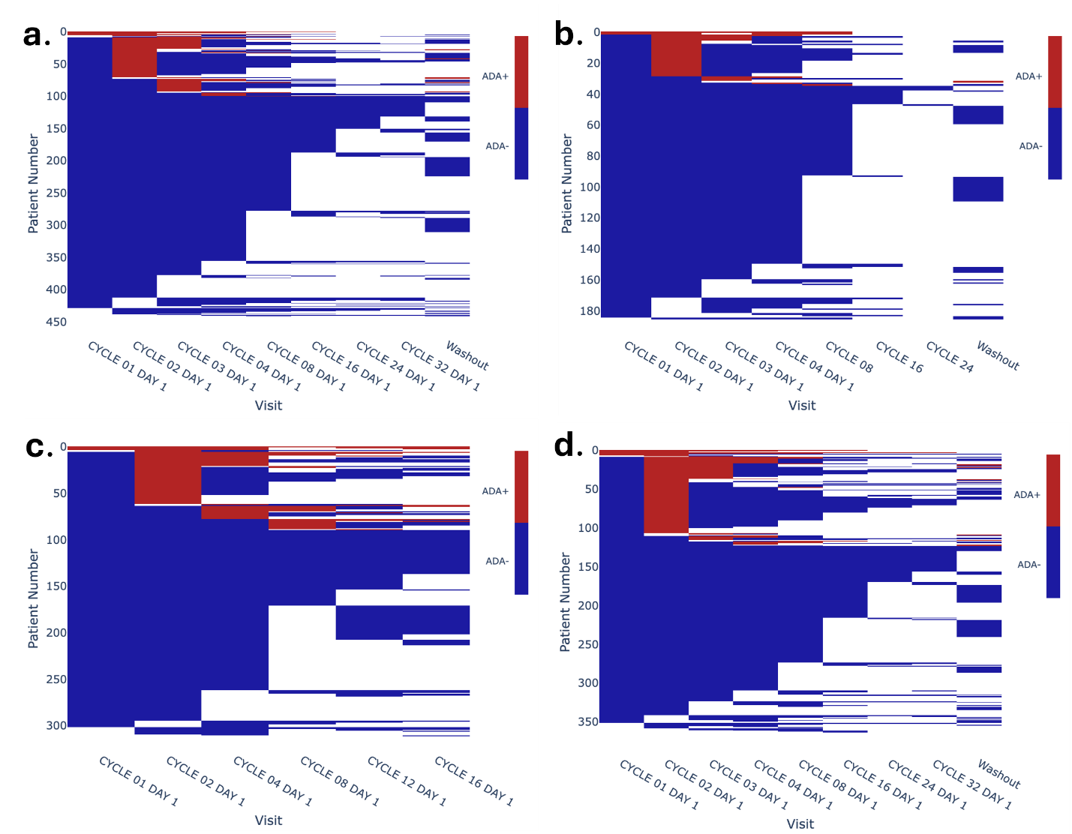

Supplemental Figure 3: OAK Study ADA heat map based on ADA sampling at C1D1, C3D1, C8D1, C16D1, C32D1, C24D1 and washout
Supplemental Figure 3 Legend: This heatmap shows a sampling scheme including C1D1, C3D1, C8D1, C16D1, C24D1, C32D1 and washout data for ADA evaluable patients in the OAK study (Case B2 in Table 1). The x-axis represents treatment cycles, and the y-axis represents patient data at each scheduled visit. Colored lines indicate ADA status: blue for negative, red for positive, and white for no sample. Patients are arranged by ADA onset times and data availability, with earlier onset times placed higher. To reduce complexity, data from unscheduled (25 visits), study discontinuation (356 visits) visits were excluded, leaving results from 546 patients with at least one post-baseline ADA sample, of which 159 (29.1%) were ADA positive.

