Liposomal Formulations of Anti-Alzheimer Drugs and siRNA for Nose-to-Brain Delivery: Design, Safety and Efficacy in Vitro
David Lee, Andrew M Shen, Olga B Garbuzenko, Tamara Minko
Supplemental Materials

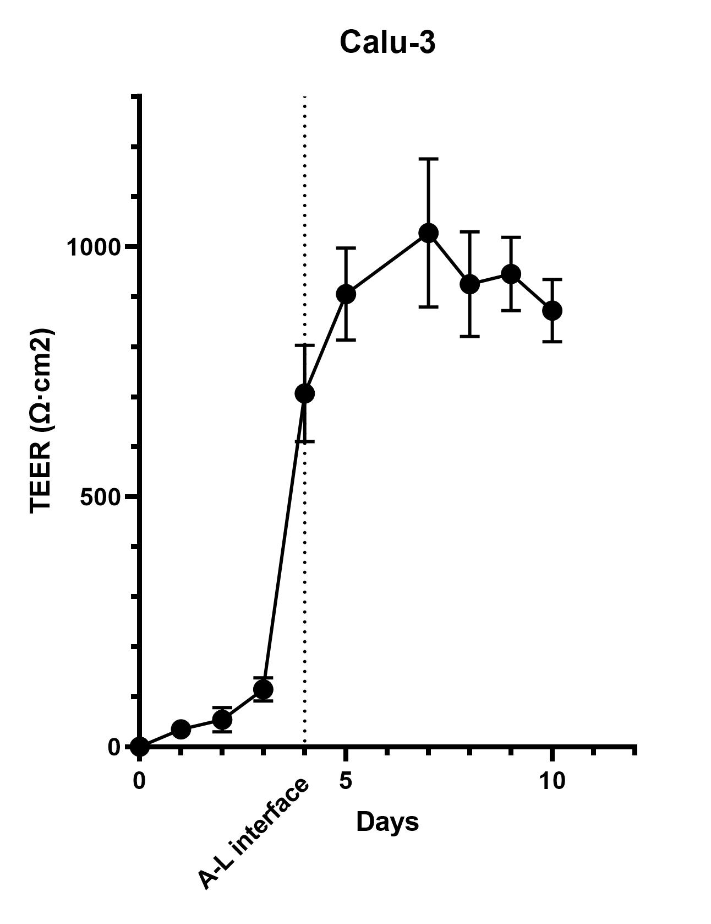
Figure S1. The TEER values of the Calu-3 cells in 0.4 µm pore PET membrane insert in 24mm Transwell using EVOM2. Once TEER values were above 500 Ω·cm², Calu-3 cells underwent air-liquid interface to simulate nasal epithelium environment. The TEER values were measured until day 10.

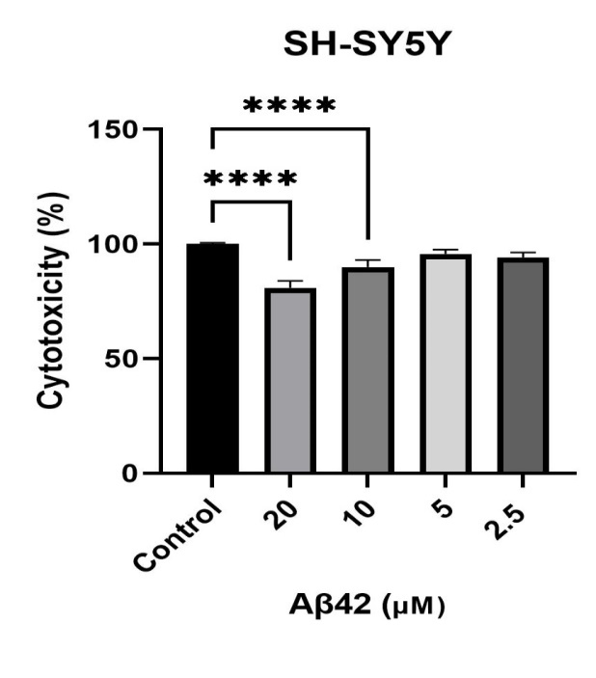
Figure S2. The cytotoxic effect Aβ42 in different concentration (****p<0.0001).
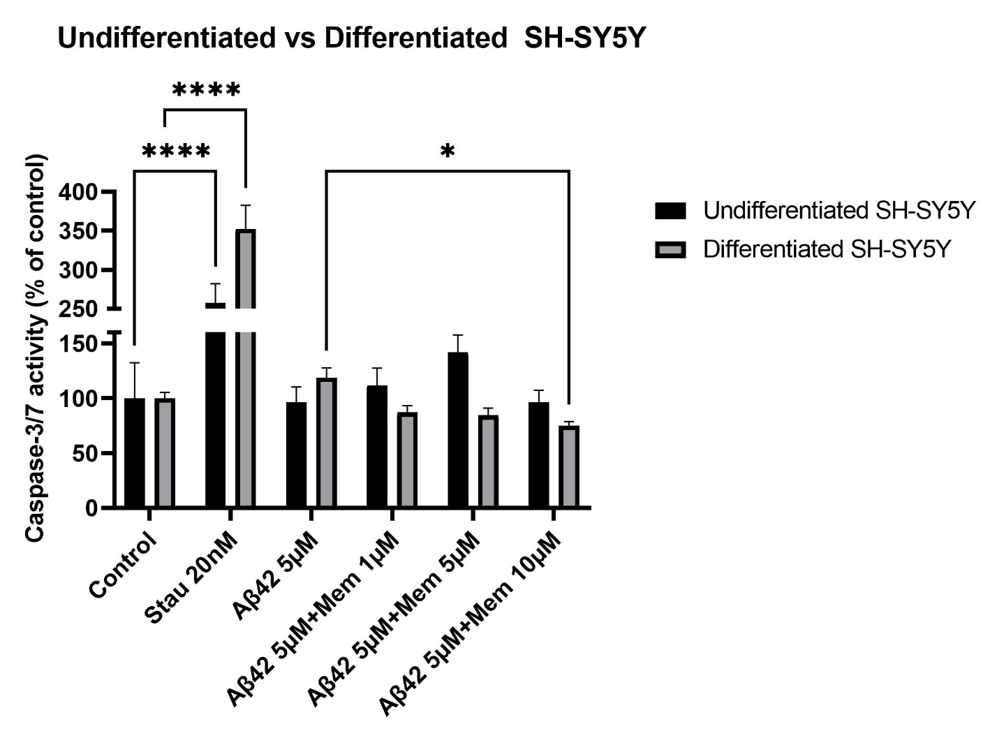

Figure S3. Caspase 3/7 activity of undifferentiated and differentiated SH-SY5Y neuroblastoma cells. Staurosporine 20 nM was used as positive control. The decreased activity of caspase due to free memantine was dose-dependent (****p<0.0001; *p<0.05).

