SUPPLEMENTARY MATERIALS
FOR

Recommendation for Clarifying FDA Policy in Evaluating “Sameness” of Higher Order Structure for Generic Peptide Therapeutics

Jessica A. Rogers-Crovak, Edward J. Delaney, David J. Detlefsen*
*Novatia, LLC Newtown, PA, USA.

Table SI. sample pH used for similarity studies of liraglutide, semaglutide and teriparatide
Drug Product | Study Cohort (Figure) | Sample | Measured pH
Liraglutide (Victoza®) | ± 0.4 pH range  (Figure 2) | 1 | 7.80
Liraglutide (Victoza®) | ± 0.4 pH range  (Figure 2) | 2 | 7.93
Liraglutide (Victoza®) | ± 0.4 pH range  (Figure 2) | 3 | 8.09
Liraglutide (Victoza®) | ± 0.4 pH range  (Figure 2) | 4 | 8.11
Liraglutide (Victoza®) | ± 0.4 pH range  (Figure 2) | 5 | 8.31
Liraglutide (Victoza®) | ± 0.4 pH range  (Figure 2) | 6 | 8.58
Liraglutide (Victoza®) | RLD – Lower pH Variability  (Figure 3B, 5, 6, 7, 8) | 1 | 8.11
Liraglutide (Victoza®) | RLD – Lower pH Variability  (Figure 3B, 5, 6, 7, 8) | 2 | 8.13
Liraglutide (Victoza®) | RLD – Lower pH Variability  (Figure 3B, 5, 6, 7, 8) | 3 | 8.14
Liraglutide (Victoza®) | RLD – Lower pH Variability  (Figure 3B, 5, 6, 7, 8) | 4 | 8.15
Liraglutide (Victoza®) | Generic – Higher pH Variability  (Figure 3A, 5) | 1 | 8.08
Liraglutide (Victoza®) | Generic – Higher pH Variability  (Figure 3A, 5) | 2 | 8.11
Liraglutide (Victoza®) | Generic – Higher pH Variability  (Figure 3A, 5) | 3 | 8.13
Liraglutide (Victoza®) | Generic – Higher pH Variability  (Figure 3A, 5) | 4 | 8.31
Liraglutide (Victoza®) | Generic – Lower pH Variability  (Figure 6) | 1 | 8.11
Liraglutide (Victoza®) | Generic – Lower pH Variability  (Figure 6) | 2 | 8.12
Liraglutide (Victoza®) | Generic – Lower pH Variability  (Figure 6) | 3 | 8.13
Liraglutide (Victoza®) | Generic – Lower pH Variability  (Figure 6) | 4 | 8.16
Liraglutide (Victoza®) | Generic – Lower Average pH  (Figure 7) | 1 | 7.93
Liraglutide (Victoza®) | Generic – Lower Average pH  (Figure 7) | 2 | 7.95
Liraglutide (Victoza®) | Generic – Lower Average pH  (Figure 7) | 3 | 7.95
Liraglutide (Victoza®) | Generic – Lower Average pH  (Figure 7) | 4 | 7.97
Liraglutide (Victoza®) | Generic – Higher Average pH  (Figure 8) | 1 | 8.31
Liraglutide (Victoza®) | Generic – Higher Average pH  (Figure 8) | 2 | 8.32
Liraglutide (Victoza®) | Generic – Higher Average pH  (Figure 8) | 3 | 8.32
Liraglutide (Victoza®) | Generic – Higher Average pH  (Figure 8) | 4 | 8.36
Semaglutide (Wegovy®) | ± 0.4 pH range  (Figure 9) | 1 | 6.95
Semaglutide (Wegovy®) | ± 0.4 pH range  (Figure 9) | 2 | 7.18
Semaglutide (Wegovy®) | ± 0.4 pH range  (Figure 9) | 3 | 7.36
Semaglutide (Wegovy®) | ± 0.4 pH range  (Figure 9) | 4 | 7.58
Semaglutide (Wegovy®) | ± 0.4 pH range  (Figure 9) | 5 | 7.83
Teriparatide (Forteo®) | ± 0.4 pH range  (Figure 10) | 1 | 3.64
Teriparatide (Forteo®) | ± 0.4 pH range  (Figure 10) | 2 | 3.78
Teriparatide (Forteo®) | ± 0.4 pH range  (Figure 10) | 3 | 3.97
Teriparatide (Forteo®) | ± 0.4 pH range  (Figure 10) | 4 | 4.21
Teriparatide (Forteo®) | ± 0.4 pH range  (Figure 10) | 5 | 4.37

Figure S1. Average pH and variability for all Cohorts compared: RLD – Lower pH Variability, red; Generic – Higher pH Variability, purple; Generic – Lower pH Variability, blue; Generic – Lower Average pH, teal; Generic – Higher Average pH, light blue

Figure S2. 1D 1H NMR spectrum of liraglutide at pH 8.13 including uniform binning and excluded excipient regions. Bins are shown as thin grey regions and excluded excipient regions are noted by white spectral regions with yellow boxes along the chemical shift axis.
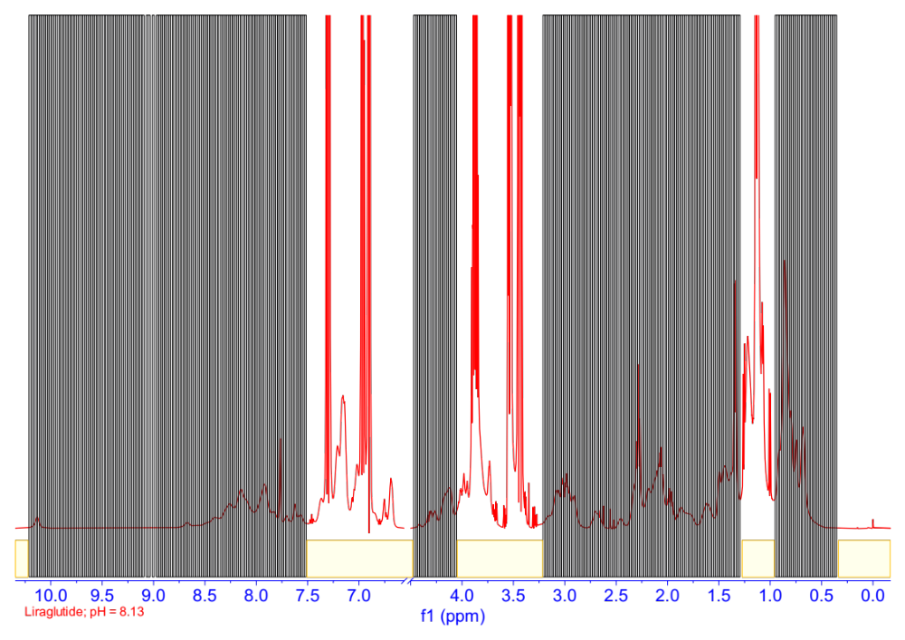
Figure S3. (A) PC1-PC2, (B) PC1-PC3 and (C) PC2-PC3 Scores Plots for the comparison of the cohorts RLD – Low Variability and Generic – High Variability. PCs 1-3 represent a total of 90.8% of the spectral variability with a D_{M} of 4.28 for the first 3 PCs.
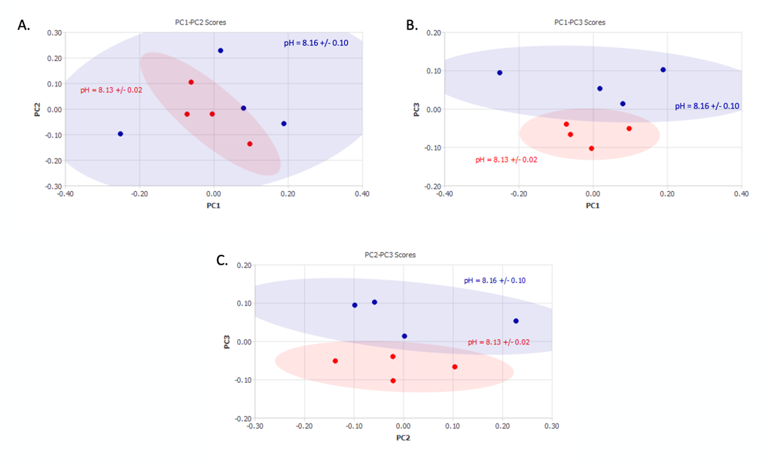

Figure S4. (A) PC1-PC2, (B) PC1-PC3 and (C) PC2-PC3 Scores Plots for the comparison of RLD – Low Variability and Generic – Low Variability. PC 1-3 represent a total of 84.2% of the spectral variability with a D_{M} of 1.02 for the first 3 PCs.
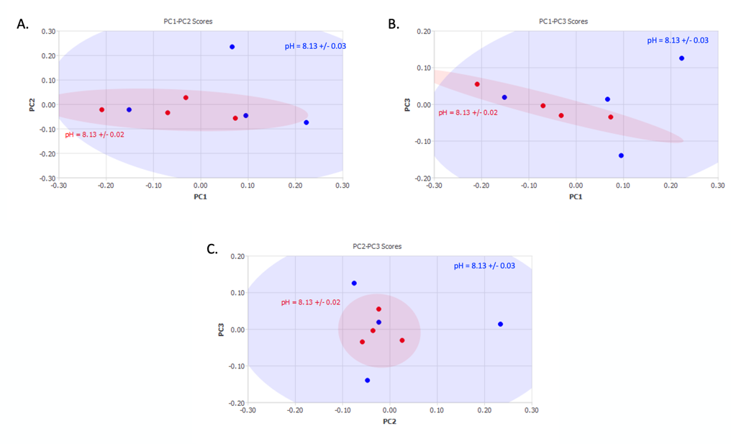

Figure S5. PC1-PC2 Scores Plot for the comparison of the cohorts RLD – Low Variability and Generic – Low Average pH. PC 1-3 represent a total of 92.7% of the spectral variability with a D_{M} of 11.04 for the first 3 PCs.
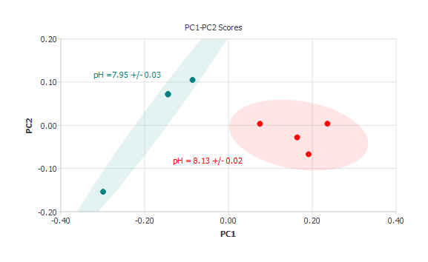

Figure S6. PC1-PC2 Scores Plots for the comparison of the cohorts RLD – Low Variability and Generic – High Average pH. PC 1-3 represent a total of 94.5% of the spectral variability with a D_{M} of 5.31 for the first 3 PCs.
