The drug titration paradox in the presence of intra-individual variation: can we estimate the true concentration-effect relationship?

Author: Sebastiaan C. Goulooze (1,3), Elke H.J. Krekels (2,3), Catherijne A.J. Knibbe (3,4), Martijn van Noort (1)
Institution: (1) LAP&P Consultants BV, Leiden, The Netherlands (2) Certara Inc, Princeton, NJ, USA
(3) Division of Systems Pharmacology and Pharmacy, Leiden Academic Centre for Drug Research, Leiden University, Leiden, the Netherlands (4) Department of Clinical Pharmacy, St. Antonius Hospital, Nieuwegein, The Netherlands.

Corresponding Author
Sebastiaan C. Goulooze
Email: b.goulooze@lapp.nl, s.c.goulooze@lacdr.leidenuniv.nl
Address: Archimedesweg 31, 2333 CM Leiden, The Netherlands
Phone: +31 71 524 3000

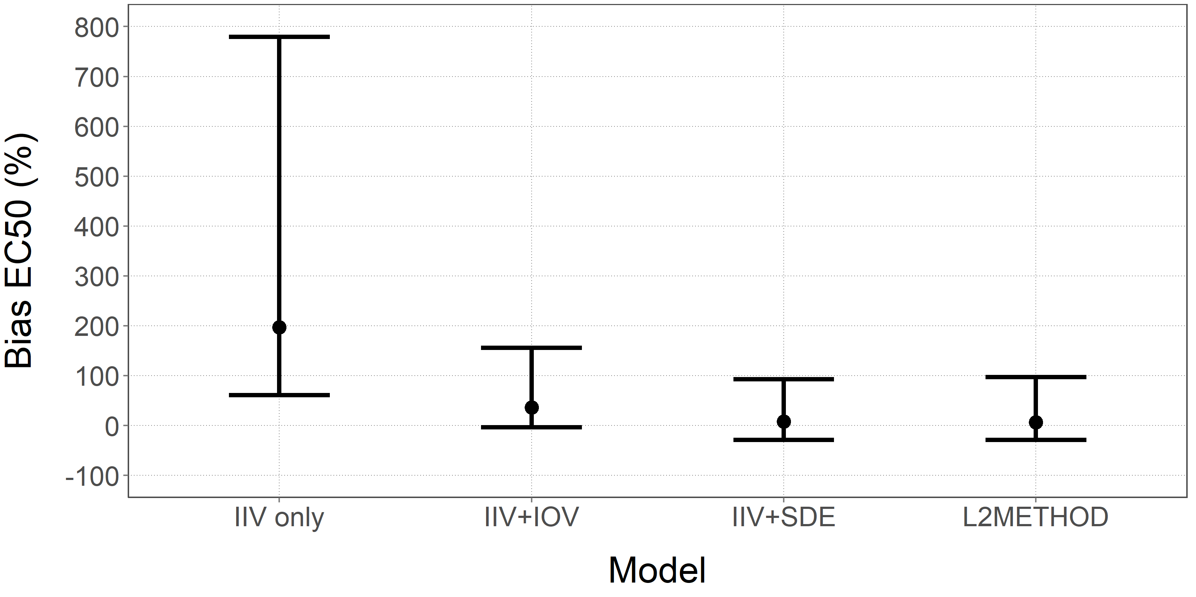
Median (point) and 90% interval (error bars) of the bias of the estimated EC₅₀ for each of the four PKPD modeling approaches. The bias is calculated separately for each model and simulated dataset by comparing the parameter estimate for the population value EC₅₀ against the true value (10 ng/ml) of the simulation model. Bias of 0% indicates the estimated value is equal to the true value.

