Supplementary Figures
Supplementary Figure 1. Schematic presentation of the anti-drug antibody (ADA) assays used in the study. a. ADA bridging assay. ADAs bind (“bridge”) two differently labeled drug molecules into ternary complexes, which are then captured on a streptavidin-coated plate (SA-MTP) via biotin-labeled drug molecules (Drug-Bi) and detected via the digoxigenin labeled drug molecule (Drug-Dig) using an anti-digoxigenin detection reagent (Anti-Dig–HRP; HRP: horseradish peroxidase). b. IgM-specific proteolytic cleavage destroys the pentameric structure of IgM ADAs and thus removes the bridging component, which results in signal inhibition in a treated sample. Since IgG ADAs are not affected, a reduced signal after IgM protease pretreatment indicates that ADAs of IgM isotype were present in the sample. Although proteolytic cleavage of IgM generates F(ab’)2 fragments potentially capable of bridging, the decreased valency of the F(ab’)2 fragments and the lack of IgM pentameric structure likely lead to their reduced ability to stably cross-link the labeled drugs and thus to a markedly reduced assay signal. c, d. IgM- and IgG-specific ADA assays. ADAs are captured onto a drug-coated plate (MaxiSorp MTP) and then detected using an anti-IgM antibody or FcγRI-digoxigenin (FcγRI-Dig).
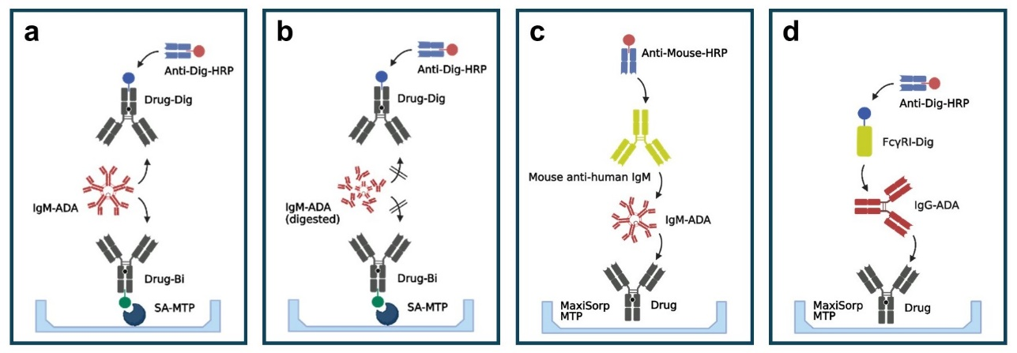
Supplementary Figure 2. Schematic presentation of the anti-AAV IgM- (a) and IgG-specific (b) immune complex (IC) assays used in the study. Anti-AAV antibodies bind to recombinant viral particles (AAV) in a preincubation step. Then, the formed ICs are captured onto a plate coated with an anti-AAV antibody (Anti-AAV-Bi/SA-MTP) and detected using anti-IgM or anti-IgG detection antibodies (AP: alkaline phosphatase). c. Potential mechanism of anti-AAV IgG assay interference by anti-AAV IgM antibodies. Large pentameric anti-AAV IgM bound to capsid particles create a steric barrier, which prevents anti-AAV IgG binding and thereby reduces assay signals. IgM digestion prevents the formation of this steric barrier, enabling anti-AAV IgG binding and thus increasing anti-AAV IgG signal.
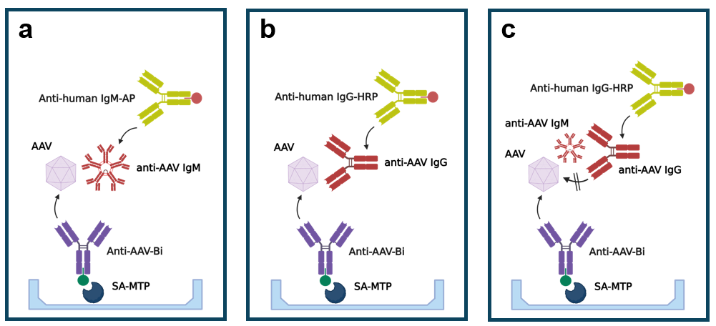

Supplementary Figure 3. Specificity of the IgM cleaving protease. Complete gel images for the experiments shown in Figure 1. “+” indicates incubation with the protease, “–“ indicates control (no protease added), “V” indicates vehicle (no substrate).
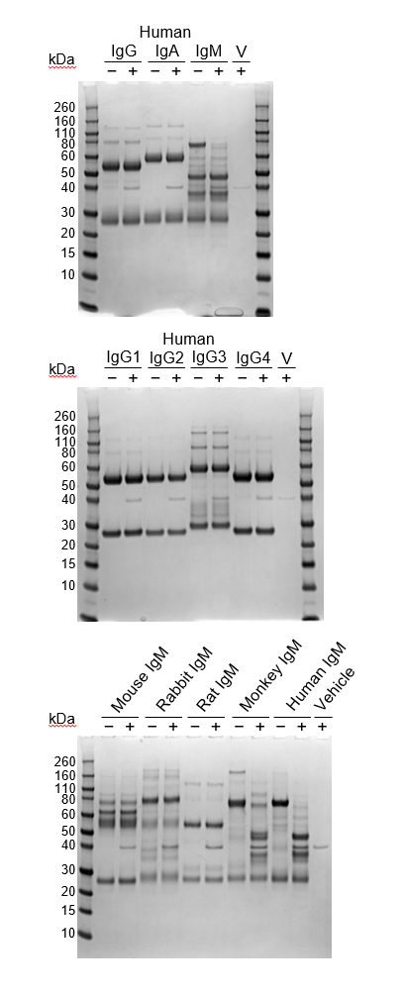
Supplementary Figure 4. Mechanisms of rheumatoid factor (RF) interference. Unwanted anti-drug antibody (ADA) assay signals in the presence of RF (mostly IgM) result from its binding to Fc domains of drug molecules (a, b) or drug molecules and circulating serum IgGs (c). IgM digestion, which disrupts all IgMs, including RF, prevents such binding and thereby suppresses unwanted assay signals. a. Interference in a bridging assay. b. Interference in an IgM assay. c. Interference in an IgG assay.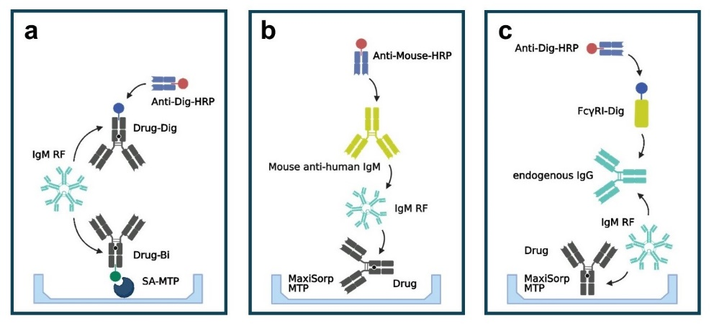
Supplementary Tables
Supplementary Table 1. Assay signals in samples from patients with rheumatoid arthritis. (Assays for ADAs against mAb Drug X)
Sample | Signal, AU
Sample | Bridging assay |  | IgM assay |  | IgG assay
Sample | Untreated | Treated | Untreated | Treated | Untreated | Treated
Donor 1 | 0.740 | 0.079 | 1.804 | 0.036 | 0.033 | 0.026
Donor 2 | 0.839 | 0.079 | 1.875 | 0.077 | 0.061 | 0.027
Donor 3 | 0.779 | 0.077 | 1.650 | 0.036 | 0.056 | 0.036
Donor 4 | 0.189 | 0.078 | 1.904 | 0.274 | 0.865 | 0.105
Donor 5 | 0.272 | 0.095 | 1.819 | 0.035 | 0.067 | 0.034
RA pool | 0.676 | 0.079 | 2.003 | 0.346 | 0.147 | 0.037
Healthy pool | 0.084 | 0.081 | 0.111 | 0.020 | 0.022 | 0.023
IgG | 1.063 | 1.059 | 0.018 | 0.018 | 1.278 | 1.284
ADA: anti-drug antibody; AU: absorbance units.
Sample analysis was performed in duplicates. Mean values of two measurements are shown.
Supplementary Table 2. Detection of pre-existing ADAs against mAb Drug Y in samples from healthy human donors.
Donor No. | Signal, AU
Donor No. | Bridging assay |  | IgM assay |  | IgG assay
Donor No. | Untreated | Treated | Untreated | Treated | Untreated | Treated
1 | 0.391 | 0.040 | 0.627 | 0.026 | 0.046 | 0.047
2 | 0.335 | 0.047 | 0.209 | 0.027 | 0.050 | 0.052
3 | 0.243 | 0.085 | 0.307 | 0.029 | 0.055 | 0.056
4 | 0.323 | 0.047 | 0.585 | 0.028 | 0.086 | 0.088
5 | 1.252 | 0.042 | 0.595 | 0.026 | 0.054 | 0.052
6 | 0.337 | 0.034 | 0.425 | 0.028 | 0.060 | 0.061
7 | 0.315 | 0.368 | 0.028 | 0.027 | 0.314 | 0.311
8 | 0.092 | 0.081 | 0.074 | 0.023 | 1.912 | 1.915
ADA: anti-drug antibody; AU: absorbance units.
Sample analysis was performed in duplicates. Mean values of two measurements are shown.
Supplementary Table 3. Detection of treatment-emergent anti-AAV2 antibodies in cynomolgus monkey samples.
Animal | Assay | Pretreatment | Time postdose, day
Animal | Assay | Pretreatment | 1 | 8 | 12 | 28 | 56 | 84
1 | IgM | Untreated | 0.232 | 1.237 | 2.126 | 2.079 | 0.818 | 0.283
1 | IgM | Treated | 0.027 | 0.036 | 0.037 | 0.039 | 0.036 | 0.032
1 | IgG | Untreated | 0.032 | 0.357 | 0.292 | 0.857 | 2.201 | 2.273
1 | IgG | Treated | 0.021 | 0.567 | 1.588 | 2.045 | 2.301 | 2.361
2 | IgM | Untreated | 0.092 | 0.397 | 1.007 | 1.451 | 0.493 | 0.196
2 | IgM | Treated | 0.033 | 0.035 | 0.032 | 0.036 | 0.037 | 0.034
2 | IgG | Untreated | 0.023 | 0.032 | 0.045 | 0.291 | 2.191 | 2.525
2 | IgG | Treated | 0.012 | 0.019 | 0.084 | 1.509 | 2.419 | 2.509
3 | IgM | Untreated | 0.065 | 0.508 | 0.823 | 0.605 | 0.185 | 0.111
3 | IgM | Treated | 0.036 | 0.033 | 0.038 | 0.038 | 0.029 | 0.030
3 | IgG | Untreated | 0.024 | 0.039 | 0.168 | 0.629 | 1.030 | 0.861
3 | IgG | Treated | 0.013 | 0.031 | 0.282 | 0.820 | 1.166 | 0.904
AAV2: adeno-associated virus of serotype 2.
Sample analysis was performed in duplicates. Mean values of two measurements are shown. Values are expressed in absorbance units.

