Machine learning predicts direct compression drug release profiles and Kinetic Parameters

Chrystalla Protopapaª, Angeliki Siamidiª, Amelia Adibe Eneli^{b}, Moe Elbadawi*^{b}, Marilena Vlachou*ª

ª Section of Pharmaceutical Technology, Department of Pharmacy, National and Kapodistrian University of Athens, 157 84 Athens, Greece
^{b} School of Biological and Behavioural Sciences, Faculty of Science and Engineering Queen Mary University of London Dept W, 81 Mile End Rd, London E1 4UJ

*Corresponding authors: m.elbadawi@qmul.ac.uk, vlachou@pharm.uoa.gr

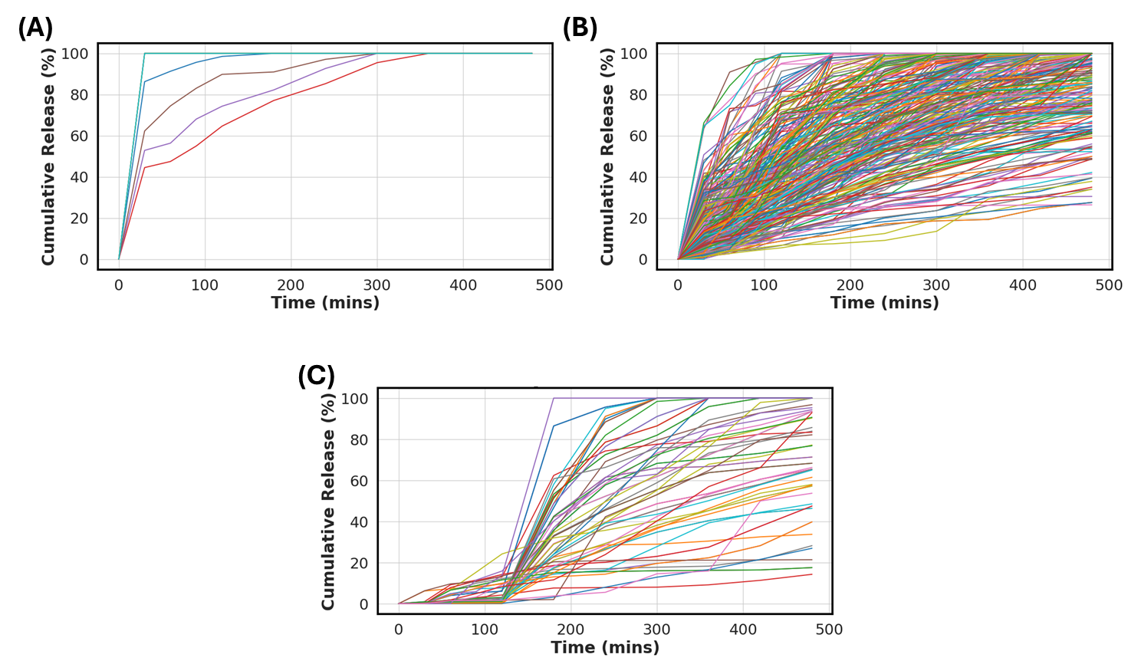
Figure S1. The release kinetic for all 377 formulations, grouped by the release type (A) Immediate, (B) Sustained and (C) Delayed release. Note, (A) contains 10 release profiles that are superimposed.
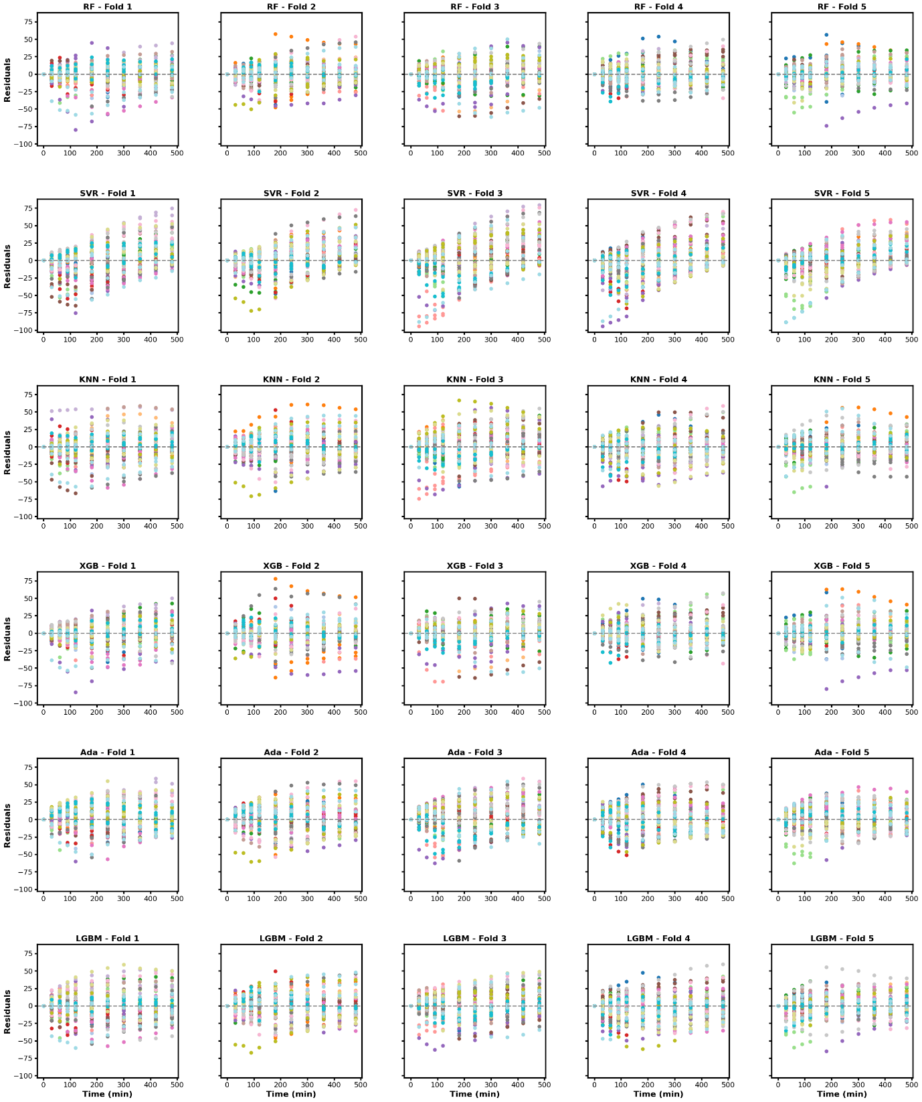

Figure S2. The residual plot for each of the six MLTs at each cross-validation fold

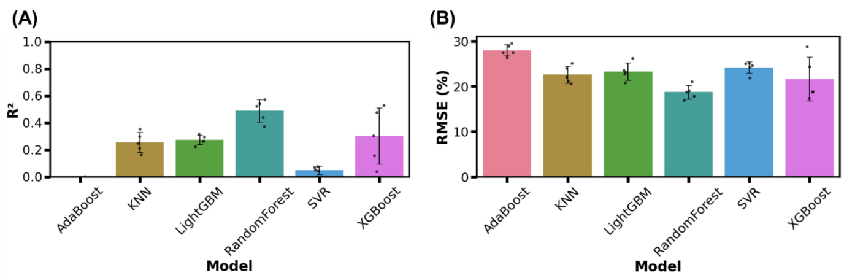

Figure S3.The (A) R² and (B) RMSE for predicting the Weibull Parameters (n=5). Note, Adaboost R² values were below 0 and hence are not visible in the figure.

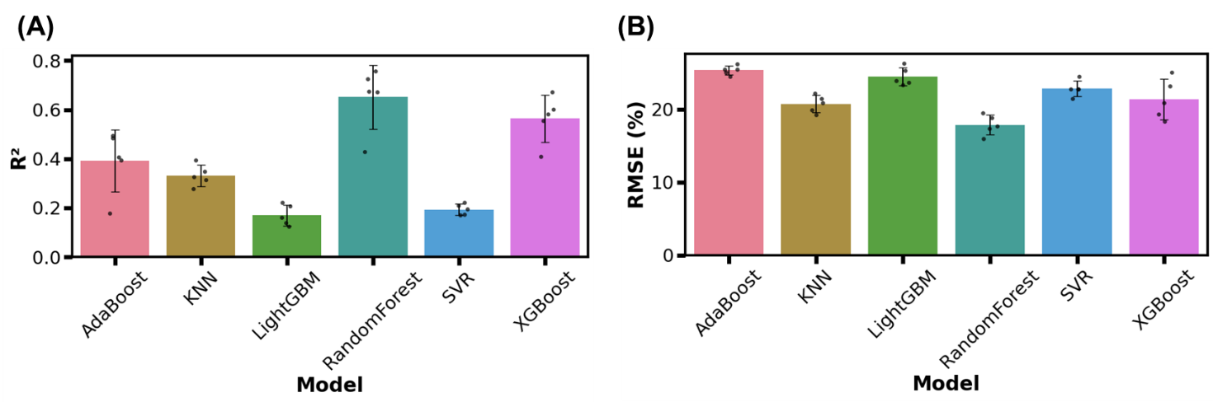
Figure S4. The (A) R2 and (B) RMSE for predicting the modified first-order kinetic Parameters (n=5).

API | Supplier
Melatonin | Tokyo Chemical Industry (Tokyo, Japan)
Ketoprofen | Sigma-Aldrich, St. Louis, Missouri, USA
SQ109 | Proprietary
Bromocriptine | Sigma-Aldrich, St. Louis, Missouri, USA
Amiodarone | Sigma-Aldrich, St. Louis, Missouri, USA
Propranolol | Sigma-Aldrich, St. Louis, Missouri, USA
Diclofenac sodium | Sigma-Aldrich, St. Louis, Missouri, USA
Acetaminophen | Sigma-Aldrich, St. Louis, Missouri, USA
N-acetylserotonin | MP Biomedicals (Santa Ana, California, USA).
Lobaplatin | Sigma-Aldrich, St. Louis, Missouri, USA
Isoniazid | Sigma-Aldrich, St. Louis, Missouri, USA
Mesalasine | Sigma-Aldrich, St. Louis, Missouri, USA
Caffeine | Sigma-Aldrich, St. Louis, Missouri, USA
Theobromine | Sigma-Aldrich, St. Louis, Missouri, USA
Theophyline | Sigma-Aldrich, St. Louis, Missouri, USA
Hydrocortisone | Sigma-Aldrich, St. Louis, Missouri, USA
Naltrexone | Tokyo Chemical Industry (Tokyo, Japan)
Bupropion | Tokyo Chemical Industry (Tokyo, Japan)
Furosemide | Sigma-Aldrich, St. Louis, Missouri, USA
Omeprazole | Tokyo Chemical Industry (Tokyo, Japan)
Experimental drug | Department of Pharmaceutical chemistry, National and Kapodistrian University of Athens, Athens, Greece

Table S1. The different APIs used to train the algorithms

Table S2. The excipients used in the formulations
Excipients | Supplier
Avicel PH101 | Sigma-Aldrich, St. Louis, Missouri, USA
Avicel PH102 | Sigma-Aldrich, St. Louis, Missouri, USA
Cabosil M-5 | Able Sales Company, Inc, Puerto Rico, USA
Carbopol 974P | Lubrizol Pharmaceuticals, Cleveland, Ohio, USA
Carrageenan Type I | Sigma-Aldrich, St. Louis, Missouri, USA
Cellulose acetate | Sigma-Aldrich, St. Louis, Missouri, USA
Cellulose acetate propionate ( 482-20) | Sigma-Aldrich, St. Louis, Missouri, USA
CENLY VH | Nisso Chemical Europe GmbH, Dusseldorf, Germany
Chitosan | Sigma-Aldrich, St. Louis, Missouri, USA
Chitosan HCl (CS-HCl) | Proprietary
Chitosan high MW | Sigma-Aldrich, St. Louis, Missouri, USA
Chitosan-OCNC | Proprietary
Dextran | Sigma-Aldrich, St. Louis, Missouri, USA
Ethylcellulose | Sigma-Aldrich, St. Louis, Missouri, USA
Eudragit E100 | Evonik, Essen, Germany
Eudragit L100 | Evonik, Essen, Germany
Eudragit L100-55 | Evonik, Essen, Germany
Eudragit RL100 | Evonik, Essen, Germany
Eudragit RS100 | Evonik, Essen, Germany
Eudragit S100 | Evonik, Essen, Germany
GLY-PCL | Proprietary
Guar Gum | Sigma-Aldrich, St. Louis, Missouri, USA
HPC 100.000 | Nisso Chemical Europe GmbH, Dusseldorf, Germany
HPC 80.000 | Nisso Chemical Europe GmbH, Dusseldorf, Germany
HPC H | Nisso Chemical Europe GmbH, Dusseldorf, Germany
HPC M | Nisso Chemical Europe GmbH, Dusseldorf, Germany
HPMC 100M | Ashland Inc. Wilmington, Delaware, USA
HPMC 4K | Ashland Inc. Wilmington, Delaware, USA
HPMCK15M | Ashland Inc. Wilmington, Delaware, USA
Lactose | Armor pharma, Maen Roch, France
Mg-Stearate | Riedel-De Haen (Hannover, Germany)
mPEG-PCL (1:1) | Proprietary
mPEG-PCL (1:3) | Proprietary
Neat PCL | Proprietary
Neat PLA | Proprietary
PE-PCL | Proprietary
Pectin | Sigma-Aldrich, St. Louis, Missouri, USA
PEO (7x10^6) | Sigma-Aldrich, St. Louis, Missouri, USA
PLA-GLycerol | Proprietary
PLA-Pentaerythritol | Proprietary
PLA-Sorbitol | Proprietary
PLA/PBAd [75/25] | Proprietary
PLA/PBAd [90/10] | Proprietary
PLA/PEAd [75/25] | Proprietary
PLA/PEAd [90/10] | Proprietary
Polyox 0.9x10^6 | Union Carbide, Antwerpen, Belgium
Polyox 4x10^6 | Union Carbide, Antwerpen, Belgium
Polyox 5x10^6 | Union Carbide, Antwerpen, Belgium
Polyox 7x10^6 | Union Carbide, Antwerpen, Belgium
PVP 10.000 | Sigma-Aldrich, St. Louis, Missouri, USA
PVP 29.000 | Sigma-Aldrich, St. Louis, Missouri, USA
PVP 55.000 | Sigma-Aldrich, St. Louis, Missouri, USA
Reta M | Meggle GmbH, Wasserburg am Inn, Germany
RetaLac | Meggle GmbH, Wasserburg am Inn, Germany
SLS | Sigma-Aldrich, St. Louis, Missouri, USA
Sod. Alginate (high viscosity) | Sigma-Aldrich, St. Louis, Missouri, USA
Sod. Alginate (medium viscosity) | Sigma-Aldrich, St. Louis, Missouri, USA
Sodium alginate (low viscosity) | Sigma-Aldrich, St. Louis, Missouri, USA
Starch | Sigma-Aldrich, St. Louis, Missouri, USA
Ulvan | Carbosynth Ltd., Berkshire, UK
Xanthan gum | Sigma-Aldrich, St. Louis, Missouri, USA

