Supplementary Information

Title: Optimization of in vitro CYP3A4 TDI assay conditions and use of derived parameters for clinical DDI risk assessment using static and dynamic models.

Authors and affiliations:
Alessandra Pugliano ^{a,b}, Aynur Ekiciler ª, Lena Preiss ª, Neil John Parrott ª, Pieter Annaert ^{b}, Kenichi Umehara ª.
ª Roche Pharmaceutical Research and Early Development, Roche Innovation Center Basel, Grenzacherstrasse 124, F. Hoffmann-La Roche Ltd, CH-4070 Basel, Switzerland.
^{b} Drug delivery and Disposition, Department of Pharmaceutical and Pharmacological Sciences, KU Leuven, ON2 Herestraat 49, 3000 Leuven, Belgium.

Additional Materials and Methods

LC-MS/MS method. The quantitation analysis for 1’-hydroxymidazolam was performed using a Sciex triple quad 6500 (Framingham, Massachusetts, US) equipped with an ion source operating in positive mode and multiple reaction monitoring (MRM). A Shimadzu (Kyoto, Japan) LC-30AD pump and SIL-30AC autosampler were programmed to inject 2 mL of sample into the Atlantis T3 C18 column (100 Å, 3 mm, 2.1x30 mm; Waters, Milford, Massachusetts, US) heated up to 60°C using a Shimadzu CTO-20A oven. Samples were eluted by applying a binary gradient of acetonitrile added with 0.1% (v/v) formic acid (mobile phase A) and a 10 mM ammonium formate solution in water (pH=2.5, mobile phase B) with a flow rate of 0.6 mL/min. Transition masses Q1 and Q3 for 1’-hydroxymidazolam and 1’-hydroxymidazolam-d4 were set at 342.1 - 324.1 and at 346 - 328, respectively, and with 35 V as collision energies (CE). Further information regarding the method performance are reported in Table SII. Data processing and peaks integration were performed via Analyst software (Sciex, version 1.7.2). The metabolite to internal standard peak area ratio was used for the evaluation of the remaining enzymatic activity.
CYP3A4 recovery predictions using dynamic modeling. Starting from the validated SimCYP PBPK models used for the in vivo DDI risk assessment, the clinical trial duration was extended up to 30 days to simulate the recovery of CYP3A4 both in liver and in gut, after the exposure to multiple oral dosing of fluoxetine, ethinyl estradiol, diltiazem, verapamil, erythromycin and saquinavir. Predictions were run both applying the original SimCYP input parameters, including TDI kinetic data (Tables S11-19), and implementing in vitro KI._{u} and k_{inact} from set B measured in this study (Table S4). In accordance with FDA Guidelines (2020) and the previous PBPK simulations, CYP3A4 k_{deg,h} = 0.0193 h⁻¹ and k_{deg,g} = 0.03 h⁻¹ were applied. To provide an estimation of clinically relevant enzymatic recovery times, applicable in clinical studies, CYP3A4 was considered as recovered from TDI when reaching back 80% of the initial activity, eventually corresponding to the presence of weak DDI.
Statistical analysis. To determine the overall bias and accuracy of the predictions, the average-fold error (AFE) and the absolute average-fold error (AAFE) were calculated using the equations reported below:

$AFE = {10}^{[Σ log10(AUCRpredicted/AUCRobserved)]/n}$ (10)
$AAFE = {10}^{[Σ ABS(log10(AUCRpredicted/AUCRobserved))]/n}$ (11)

where n stands for the number of observations. AFE measures the average under or overestimation of the predicted parameter, while AAFE measures the accuracy of the model in terms of closeness to the predicted data to the observed one.
Additional Results
Impact of pre-incubation time on in vitro TDI assay.
Extending the pre-incubation time to 40 minutes enhanced the sensitivity to TDI, particularly for borderline and weak in vivo TDI inhibitors. For instance, ethinyl estradiol showed an increased k_{obs} from 0.021 min⁻¹ (set A) to 0.043 min⁻¹ (set B), and the enhanced assay sensitivity allowed to fit KI and k_{inact} values with relatively high reliability leading to a k_{inact}/KI ratio of 0.002 min⁻¹ μM⁻¹ (Tables S3 and S4). Similarly, for amlodipine, extending the pre-incubation time provided a higher k_{inact}/KI ratio (0.009 min⁻¹ μM⁻¹; set B) relative to the baseline condition (0.004 min⁻¹ μM⁻¹; set A).
Impact of substrate concentrations on in vitro TDI assay.
Altering MDZ concentration during the incubation step, either increasing to 20 μM (set C, Figure 2) or decreasing to 1 μM (set D, Figure 2) generally resulted in reduced inhibitory efficiency compared to the data from set B, indicating lower k_{obs} and k_{inact} values and an increased KI value especially for weak and moderate in vivo TDI inhibitors, exemplified by reduction of the k_{inact}/KI ratios for verapamil, diltiazem and amlodipine (set C: MDZ at 20 μM, incubation 10 min, HLM 0.1 mg/mL, Table S5; set D: MDZ at 1 μM, incubation 10 min, HLM 0.1 mg/mL, Table S6). The assay was expected to have insufficient sensitivity for measuring MDZ metabolism in HLM at a low concentration of 1 μM. A similar outcome might occur at a higher concentration of 20 μM, which is about 10 times greater than the reported K_{m} for MDZ (DIDB).
Impact of substrate incubation time on in vitro TDI assay.
Reducing the MDZ incubation time, from 10 min to 5 min, decreased the assay’s sensitivity in assessing the residual enzymatic activity post exposure to precipitants, primarily resulting in decreased k_{obs}, k_{inact} and increased in KI (Table S7). Due to a significantly lower assay sensitivity after a shorter incubation time of MDZ at lower substrate concentrations (set F: MDZ at 1 μM, incubation 5 min, HLM 0.1 mg/mL), k_{obs}, k_{inact} and KI for 26 out of 32 precipitants in the dataset could not be resolved regardless of their in vivo TDI potential (Table S8).
Impact of HLM protein concentration on in vitro TDI assay.
When compared to the results from set B, lowering the HLM concentration from 0.1 mg/mL to 0.05 - 0.01 mg/mL (set G-H, respectively, Figure 2) did not significantly affect the k_{inact}/KI ratios for weak and moderate inhibitors such as amlodipine and imatinib (set B: 0.1 mg/mL, Table S4; set G: 0.05 mg/mL, Table S9; set H: 0.01 mg/mL, Table S10). An increase in the k_{inact}/KI ratio was observed for strong TDIs: telithromycin from 0.014 min⁻¹ μM⁻¹ (set B) to 0.020 min⁻¹ μM⁻¹ (set G) and telaprevir from 0.037 min⁻¹ μM⁻¹ (set B) to 0.089 min⁻¹ μM⁻¹ (set G).
Recovery time estimations for active CYP3A4 levels following TDI treatments.
We investigated the prediction of time to 80% CYP3A4 recovery following multiple oral administration of the six precipitants reaching steady-state based on our in vitro TDI data (Figure S7, Table S22). In the absence of corresponding observed in vivo CYP3A4 activity recovery data, we compared the model predictions using in vitro KI._{u} and k_{inact} measured under conditions from set B, with those based on the default SimCYP input parameters (Tables S11-19). The time required for the active CYP3A4 levels to recover following TDI treatments for moderate or strong in vivo TDI inhibitors such as verapamil and saquinavir were predicted to be 6.5 (liver) and 6.5 days (gut); and 6.8 (liver) and 7.4 days (gut), respectively. Due to the similarity of the in vitro KI._{u} and k_{inact} values to the SimCYP library data, no or only minor differences in predictions of the CYP3A4 recovery times for such moderate and strong TDI treatments were seen compared to the SimCYP models: e.g. 6.5 days (liver and gut) for verapamil; and 8.3 days (liver) and 7.7 days (gut) for saquinavir (Figure S7, Table S21). Consistent with the predicted weak in vivo DDI risk being below the bioequivalence limit (AUCR = 1.25), no or negligible recovery time for CYP3A4 activity was forecasted (0 days) in both liver and gut following ethinyl estradiol administration (Figure S7, Table S22). The SimCYP library did not assign ethinyl estradiol as the time-dependent inhibitor, and therefore the TDI input parameters were not available. Fluoxetine required a much longer time for CYP3A4 activity restoration in both liver and gut (17.8 and 18.8 days, respectively, Table S21). Of note, affected by the different KI._{u} and k_{inact} values, a variance in recovery outcomes was observed for erythromycin. For erythromycin, 1.2 days (liver) and 2 days (gut) using the in vitro TDI assays (set B); and 4.9 days (liver) and 3.0 days (gut) using the SimCYP library (Table S22). These discrepancies reflect the differences between the two models in estimating the in vivo DDI magnitude for the precipitant: predicted AUCR values of 6.59 (in vitro set B) and 1.38 (SimCYP) (Figure 5B). Similar recovery time disagreements were also observed for diltiazem (Figure S7, Table S22).
The variability in liver CYP3A4 turnover rates reported in literature (0.0077 h⁻¹ Yang et al. 2008; 0.0193 h⁻¹ Yeo et al. 2011; 0.014-0.017 h⁻¹ Chan et al. 2018), combined with the lack of comprehensive clinical data, challenges reliably predicting the time needed to recover the active enzyme amount. Nonetheless, concordance between predicted and observed AUCR might support a certain level of accuracy in estimating CYP3A4 recovery times following precipitants administration. Our current erythromycin (n. 26) PBPK model predicted a midazolam AUCR of 6.59, which is comparable to clinical observation of 4.99 (Table S22). It also estimated that 4.9 and 3.0 days are required for recovering 80% of baseline CYP3A4 activity in liver and gut, respectively (Figure S7). Although these estimates are notably longer than those obtained applying SimCYP original TDI data (1.2 days for liver, 2.0 days for gut), considering a broader recovery timeframe may be beneficial for patients undergoing co-medication strategies involving erythromycin.

Table S1: Precipitants input parameters for in vivo DDI risk assessment with mechanistic static modeling.
 | Drug | MW | C_{max} (ng/mL) |  | fu,_{p} | Rb |  | fa | ka (h⁻¹) | LogP | CYP3A4 K_{i,u} (μM) | References
 | Erlotinib | 429.9 ª | 1056.0 |  | 0.088 | 0.67 ^{b} |  | 0.99 ^{b} | 2.30 ^{c} | 3.30 | 25.48 | EMA/H/C/000618, Colclough et al. 2021, Kim et al. 2013
 | Terbinafine | 327.9 | 745.0 |  | 0.010 | 0.79 ^{b} |  | 0.70 | 0.75 | 5.78 ^{b} |  | FDA NDA 22-071, Ryder et al. 1992, Jensen et al. 1989, Gupta et al. 2003
 | Sorafenib | 637.0 | 2460.0 |  | 0.005 | 0.75 ª |  | 1.00 (default) | 0.94 ^{c} | 3.80 |  | FDA NDA 21-923, Wang et al. 2021
 | Fluoxetine | 309.3 ^{f} | 12.9 |  | 0.079 ^{f} | 1.30 ^{f} |  | 1.00 ^{f} | 0.69 ^{f} | 4.05 ^{f} | 5.19 | Moraes et al. 1999, Fahmi et al. 2008
 | Propranolol | 295.8 ª | 26.0 |  | 0.130 | 0.90 ^{d} |  | 0.90 | 1.05 ^{c} | 3.12 | 47.00 | Bianchetti et al.1976, Francis et al. 2021, Usansky et al. 2005, Mohsen-Nia et al. 2012, Tseng et al. 2021
 | Nitrendipine | 360.4 ª | 8.0 ª |  | 0.020 ^{e} | 0.98 |  | 0.22 | 1.15 ^{c} | 2.44 ª |  | Mikus et al. 1987
 | Citalopram | 405.4 | 142.5 |  | 0.200 e | 0.80 |  | 0.80 | 1.05 ^{c} | 1.57 |  | FDA NDA 21-046, Nolting et al. 2012,  Lundbeck Canada Inc. 2023
 | Ramelteon | 259.4 | 2.4 ª |  | 0.200 e | 0.25 ª |  | 0.84 | 3.20 ^{c} | 2.94 ^{b} |  | FDA NDA 21-782, Zammit et al. 2007
 | Paroxetine | 329.4 ^{f} | 36.4 |  | 0.060 e | 1.26 ^{f} |  | 0.95 ^{f} | 1.08 ^{f} | 3.55 ^{f} | 10.84 | Martin et al. 1997, Lee et al. 2012
 | Flumazenil | 303.3 | 12.0 |  | 0.590 | 0.50 |  | 0.00 (i.v) | 6.00 (i.v) | 1.55 ^{b} |  | FDA NDA 20-073, Murad et al. 2021
 | Quetiapine | 883.1 ª | 64.0 |  | 0.170 | 1.26 |  | 1.00 | 1.77 | 2.86 | 4.70 | Khazaal et al. 2013, Johnson et al. 2016, Nirogi et al. 2014
 | Midostaurin | 570.7 | 1170.0 |  | 0.000 | 0.55 |  | 0.85 | 1.50 | 5.50 ª |  | FDA NDA 207997, Gu et al. 2017
 | Disulfiram | 296.5 | 62.3 |  | 0.010 (default) | 0.75 ^{b} |  | 0.80 | 0.08 | 3.88 |  | FDA ANDA091619, Lanz et al 2023,  Hansch et al. 1995
 | Buspirone | 385.5 | 0.5 |  | 0.050 ^{d} | 0.81 ^{d} |  | 1.00 (default) | 2.30 ^{d} | 2.63 ^{d} |  | FDA NDA 202714, Buch et al. 1993
 | Raltegravir | 444.4 ^{f} | 2000.0 ª |  | 0.170 ^{f} | 0.62 ^{f} |  | 1.00 ^{f} | 0.40 ^{f} | 1.07 ^{f}
 | Drug | MW | C_{max} (ng/mL) |  | fu,_{p} | Rb |  | fa | ka (h⁻¹) | LogP | CYP3A4 K_{i,u} (μM) | References
 | Carfilzomib | 719.9 | 4232.0 ª |  | 0.020 e | 0.70 e |  | 0.00 (i.v) | 6.00 (i.v) | 3.25 ^{b} |  | FDA NDA 21190
 | Terfenadine | 471.6 ª | 1.6 ª |  | 0.030 | 1.00 ^{d} |  | 0.30 ^{d} | 2.80 ^{d} | 5.62 ^{d} |  | Wood et al. 2017
 | Ethinyl estradiol | 296.4 ª | 0.1 |  | 0.014 | 1.00 ^{f} |  | 0.96 ^{f} | 1.33 ^{f} | 3.81 ^{f} |  | Ezuruike et al. 2018, Obach et al. 2008
 | Simvastatin | 418.7 ª | 11.5ª  (calculated based on dose linearity) |  | 0.014 ^{d} | 0.57 ^{d} |  | 1.00  (default) | 1.43 ^{f} | 4.68 ^{f}
 | Azithromycin | 749.0 ª | 430.0 ª |  | 0.690 | 0.94 ^{b} |  | 0.38 | 0.11 | 8.40 ^{f} | 44.82 | Johnson et al. 2016, FDA ID 3263750,  Ito et al. 2003, Kosugi et al. 2014
 | Amlodipine | 408.9 ª | 1.3 |  | 0.005 e | 0.98 |  | 0.64 | 0.33 ^{c} | 2.96 | 2..99 | Williams et al. 1988, EMEA/H/C/00403, Caron et al. 2004, Nirogi et al. 2014
 | Nilotinib | 584.0 | 508.0 |  | 0.016 | 0.68 |  | 0.30 | 0.30 | 4.90 ª | 0.60 | FDA NDA 22-068, Tanaka et al. 2009,  Xia et al. 2012
 | Imatinib | 589.7 ª | 2600.0 ª |  | 0.050 e | 0.73 |  | 0.97 | 1.03 | 3.50 ª | 20.20 | Kretz et al. 2004, Leveque et al. 2005,  Petain et al. 2008, Tseng et al. 2021
 | Verapamil | 491.1 | 56.4 |  | 0.081 | 0.71 ^{f} |  | 0.61 | 1.20 | 3.97 | 8.00 | FDA NDA 20-943, Wood et al. 2017,  Sandström et al. 1999, Peters et al. 2012, Lee et al. 2012
 | Diltiazem | 451.0 | 70.0 |  | 0.220 | 0.96 ^{f} |  | 0.99 | 0.73 | 2.84 | 29.9 | FDA Ref ID 2867292, Friedman et al. 2011, Francis et al. 2021, Usansky et al. 2005, Murata et al. 1989, McConn et al. 2004
 | Erythromycin | 1018.4 | 751.0 |  | 0.160 | 0.85 ^{f} |  | 0.58 | 0.52 ^{f} | 2.50 ^{f} | 7.62 | FDA Ref ID 3416724, Carls et al. 2014, Ito et al. 1998, McConn et al. 2004
 | Nefazodone | 506.5 | 267.0 ª |  | 0.009 e | 0.85 |  | 1.00 ^{b} | 2.15 ^{c} | 4.30 ª | 0.46 | Wood et al. 2017, FDA NDA 20-628, Mao et al. 2012
 | Saquinavir | 670.9 |  | 948 | 0.028 ^{d} |  | 0.74 ^{d} | 0.3 | 0.03 ^{d} | 4.51 ª |  |  | FDA NDA 20-152, Greene et al. 1997, Pepin et al. 2021
Drug |  | MW | C_{max} (ng/mL) |  | fu,_{p} | Rb |  | fa | ka (h⁻¹) | LogP | CYP3A4 K_{i,u} (μM) | References
 | Telithromycin | 812.0 | 1900.0 |  | 0.300 e | 0.80 e |  | 0.92 | 0.95 ^{f} | 3.00 ª |  | FDA NDA 021144, Zhao et al. 2012
 | Itraconazole | 705.6 ª | 1100.0 ª |  | 0.002 | 0.58 ^{f} |  | 1.00 ^{f} | 1.50 | 5.66 ª | 0.01 | Obach et al. 2008, Peters et al. 2012, Kozakai et al. 2014
 | Telaprevir | 679.9 | 1741.0 |  | 0.410 ª | 0.65 ª |  | 1.00  (default) | 0.80 | 4.00 | 1.35 | FDA NDA 201917, Kimoto et al. 2019
 | Ritonavir | 721.0 ª | 890.0 |  | 0.015 | 0.60 ^{d} |  | 0.50 ^{f} | 0.45 ^{f} | 3.90 ^{f} | 0.03 | Aarnoutse et al. 2005, Francis et al. 2020, Fahmi et al. 2008

- Drug interaction database (DIDB) (Certara, New Jersey, US)
- Estimated using ADMET predictor 10.1 (Simulation Plus, Lancaster, CA)
- Calculated based on t_{max} = ln(k_{a}/k_{e})/(k_{a}-k_{e})
- Gertz et al. 2011
- Lombardo et al. 2018
- SimCYP compound file (Version 21 and 22; Certara, New Jersey, US): Fluoxetine, Azithromycin, Paroxetine, Raltegravir, Ethinyl estradiol, Simvastatin, Verapamil, Diltiazem, Erythromycin, Telithromycin, Itraconazole, Ritonavir.

Table S2: LC-MS/MS method performance results for the quantification of midazolam and 1’-hydroxymidazolam. For accuracy, acceptance criteria require a maximum relative error (RE%) equal to 20% for the low concentration quality control sample (QC), at lower limit of quantification (LLOQ), and equal to 15% for the high concentration QC at upper limit of quantification (ULOQ). For precision, acceptance criteria require a maximum coefficient of variation (CV%) equal to 20% for the low concentration QC, at LLOQ, and equal to 15% for the high concentration QC. For both compounds, acceptance criteria were met in terms of accuracy and precision.
Compound | Calibration range (μM) | Linearity correlation coefficient (R²) | LLOQ (μM) | ULOQ (μM) | Accuracy (%RE)  low QC / high QC | Precision (%CV)  low QC / high QC
Midazolam | 0.00164 – 1.0 | >0.995 | 0.0041 | 1.0 | 8.0/1.0 | 10.0/9.0
1’-OH-midazolam | 0.00164 – 1.0 | >0.995 | 0.0041 | 1.0 | 0.0/6.0 | 8.0/9.0

Table S3: Measured k_{obs}, KI, k_{inact} under the in vitro TDI conditions from set A: max. pre-incubation 30 min, HLM 0.1 mg/mL, MDZ 10 μM, incubation 10 min. Kinetic parameters were measured in replicates (n=3) for erythromycin, used as positive control for in vitro TDI, and the relative standard error (SE) values are reported in the table.

Set A: pre-incubation 30 min, HLM 0.1 mg/mL, MDZ 10 μM, incubation 10 min
Drug | Concentration  μM |  | k_{obs} (SE)  min⁻¹ |  | k_{inact} (SE)  min⁻¹ |  | KI (SE)  μM |  | k_{inact}/KI  min⁻¹ μM⁻¹
Erlotinib |  | 25 |  | 0.038 |  | N/A |  | N/A
Terbinafine |  | 25 |  | 0.000 |  | N/A |  | N/A
Sorafenib |  | 25 |  | P > 0.01 |  | - |  | -
Fluoxetine |  | 25 |  | P > 0.01 |  | - |  | -
Propranolol |  | 25 |  | P > 0.01 |  | - |  | -
Nitrendipine |  | 25 |  | P > 0.01 |  | - |  | -
Citalopram |  | 25 |  | P > 0.01 |  | - |  | -
Ramelteon |  | 25 |  | P > 0.01 |  | - |  | -
Paroxetine |  | 25 |  | P > 0.01 |  | - |  | -
Flumazenil |  | 25 |  | P > 0.01 |  | - |  | -
Quetiapine |  | 25 |  | P > 0.01 |  | - |  | -
Midostaurin |  | 25 |  | P > 0.01 |  | - |  | -
Disulfiram |  | 25 |  | P > 0.01 |  | - |  | -
Buspirone |  | 25 |  | 0.012 |  | N/A |  | N/A
Raltegravir |  | 25 |  | P > 0.01 |  | - |  | -
Carfilzomib |  | 25 |  | 0.031 |  | 0.034 |  | 1.81 |  | 0.019
Terfenadine |  | 25 |  | P > 0.01 |  | - |  | -
Ethinyl estradiol |  | 25 |  | 0.021 |  | N/A |  | N/A
Simvastatin |  | 25 |  | P > 0.01 |  | - |  | -
Azithromycin |  | 25 |  | P > 0.01 |  | - |  | -
Amlodipine |  | 25 |  | 0.022 |  | 0.024 |  | 6.01 |  | 0.004
Nilotinib |  | 12.5 |  | 0.037 |  | 0.054 |  | 7.25 |  | 0.007
Imatinib |  | 25 |  | 0.031 |  | 0.045 |  | 12.88 |  | 0.004
Verapamil |  | 25 |  | 0.057 |  | 0.070 |  | 4.67 |  | 0.015
Diltiazem |  | 25 |  | 0.037 |  | 0.039 |  | 2.33 |  | 0.017
Erythromycin |  | 25 |  | 0.053 (0.008) |  | 0.079 (0.016) |  | 11.16 (1.46) |  | 0.007
Nefazodone |  | 25 |  | 0.079 |  | 0.086 |  | 4.99 |  | 0.017
Saquinavir |  | 25 |  | 0.016 |  | N/A |  | N/A
Telithromycin |  | 25 |  | 0.048 |  | 0.044 |  | 1.79 |  | 0.025
Itraconazole |  | 1.56 |  | 0.021 |  | N/A |  | N/A
Telaprevir |  | 25 |  | 0.050 |  | 0.055 |  | 0.83 |  | 0.066
Ritonavir |  | 0.78 |  | 0.061 |  | 0.019 |  | N/A
N/A not assessed due to poor fitting (95% CI undefined).
Table S4: Measured k_{obs}, KI, k_{inact} under the in vitro TDI conditions from set B: max. pre-incubation 40 min, HLM 0.1 mg/mL, MDZ 10 μM, incubation 10 min. Kinetic parameters were measured in replicates (n=3) for all the test drugs in the dataset, and the relative standard error (SE) values are reported in the table.

Set B: max. pre-incubation 40 min, HLM 0.1 mg/mL, MDZ 10 μM, incubation 10 min
Drug | Concentration  μM | k_{obs} (SE)  min⁻¹ | k_{inact} (SE)  min⁻¹ | KI (SE)  μM | k_{inact}/KI  min⁻¹ μM⁻¹
Erlotinib | 25 | 0.044 (0.001) | N/A | N/A
Terbinafine | 25 | P > 0.01 | - | -
Sorafenib | 25 | P > 0.01 | - | -
Fluoxetine | 25 | 0.012 (0.004) | 0.012 (0.004) | 6.62 (0.10) | 0.002
Propranolol | 25 | P > 0.01 | - | -
Nitrendipine | 25 | P > 0.01 | - | -
Citalopram | 25 | P > 0.01 | - | -
Ramelteon | 25 | P > 0.01 | - | -
Paroxetine | 25 | P > 0.01 | - | -
Flumazenil | 25 | P > 0.01 | - | -
Quetiapine | 25 | P > 0.01 | - | -
Midostaurin | 25 | P > 0.01 | - | -
Disulfiram | 25 | P > 0.01 | - | -
Buspirone | 25 | 0.016 (0.003) | 0.038 (0.010) | 34.81 (0.22) | 0.001
Raltegravir | 25 | P > 0.01 | - | -
Carfilzomib | 25 | 0.057 (0.010) | 0.064 (0.014) | 4.15 (0.22) | 0.015
Terfenadine | 25 | P > 0.01 | - | -
Ethinyl estradiol | 25 | 0.043 (0.006) | 0.127 (0.023) | 51.36 (10.61) | 0.002
Simvastatin | 25 | P > 0.01 | - | -
Azithromycin | 25 | P > 0.01 | - | -
Amlodipine | 25 | 0.012 (0.003) | 0.014 (0.004) | 1.53 (0.11) | 0.009
Nilotinib | 12.5 | 0.032 (0.003) | 0.039 (0.000) | 3.83 (0.10) | 0.010
Imatinib | 25 | 0.033 (0.005) | 0.045 (0.010) | 8.40 (2.66) | 0.005
Verapamil | 25 | 0.063 (0.009) | 0.067 (0.011) | 1.96 (0.31) | 0.034
Diltiazem | 25 | 0.029 (0.004) | 0.028 (0.003) | 0.36 (0.10) | 0.077
Erythromycin | 25 | 0.052 (0.006) | 0.057 (0.006) | 5.46 (1.11) | 0.010
Nefazodone | 25 | 0.086 (0.009) | 0.105 (0.013) | 6.87 (1.18) | 0.015
Saquinavir | 25 | 0.048 (0.007) | 0.078 (0.011) | 15.73 (5.18) | 0.005
Telithromycin | 25 | 0.040 (0.004) | 0.047 (0.005) | 3.43 (0.53) | 0.014
Itraconazole | 1.56 | P > 0.01 | - | -
Telaprevir | 25 | 0.047 (0.008) | 0.051 (0.008) | 1.39 (0.15) | 0.037
Ritonavir | 0.78 | P > 0.01 | - | -
N/A not assessed due to poor fitting (95% CI undefined).
Table S5: Measured k_{obs}, KI, k_{inact} under the in vitro TDI conditions from set C: max. pre-incubation 40 min, HLM 0.1 mg/mL, MDZ 20 μM, incubation 10 min. Kinetic parameters were measured in replicates (n=3) for erythromycin, used as positive control for in vitro TDI, and the relative standard error (SE) values are reported in the table.

Set C: pre-incubation 40 min, HLM 0.1 mg/mL, MDZ 20 μM, incubation 10 min
Drug | Concentration  μM | k_{obs} (SE)  min⁻¹ | k_{inact} (SE)  min⁻¹ | KI (SE)  μM | k_{inact}/KI  min⁻¹ μM⁻¹
Erlotinib | 25 | 0.046 | 0.092 | 34.78 | 0.003
Terbinafine | 25 | P > 0.01 | - | -
Sorafenib | 25 | P > 0.01 | - | -
Fluoxetine | 25 | P > 0.01 | - | -
Propranolol | 25 | P > 0.01 | - | -
Nitrendipine | 25 | P > 0.01 | - | -
Citalopram | 25 | P > 0.01 | - | -
Ramelteon | 25 | P > 0.01 | - | -
Paroxetine | 25 | 0.008 | N/A | N/A
Flumazenil | 25 | 0.015 | N/A | N/A
Quetiapine | 25 | P > 0.01 | - | -
Midostaurin | 25 | 0.005 | N/A | N/A
Disulfiram | 25 | P > 0.01 | - | -
Buspirone | 25 | 0.006 | N/A | N/A
Raltegravir | 25 | 0.007 | N/A | N/A
Carfilzomib | 25 | 0.041 | 0.047 | 4.53 | 0.010
Terfenadine | 25 | P > 0.01 | - | -
Ethinyl estradiol | 25 | 0.022 | N/A | N/A
Simvastatin | 25 | P > 0.01 | - | -
Azithromycin | 25 | P > 0.01 | - | -
Amlodipine | 25 | P > 0.01 | - | -
Nilotinib | 12.5 | 0.023 | 0.035 | 8.83 | 0.004
Imatinib | 25 | 0.026 | N/A | N/A
Verapamil | 25 | 0.044 | 0.049 | 3.13 | 0.016
Diltiazem | 25 | 0.016 | 0.019 | 1.19 | 0.016
Erythromycin | 25 | 0.038 (0.005) | 0.040 (0.006) | 3.80 (1.09) | 0.011
Nefazodone | 25 | 0.067 | 0.092 | 8.00 | 0.012
Saquinavir | 25 | 0.033 | N/A | N/A
Telithromycin | 25 | 0.040 | 0.045 | 2.45 | 0.018
Itraconazole | 1.56 | P > 0.01 | - | -
Telaprevir | 25 | 0.032 | 0.032 | 1.59 | 0.020
Ritonavir | 0.78 | 0.035 | N/A | N/A
N/A not assessed due to poor fitting (95% CI undefined).
Table S6: Measured k_{obs}, KI, k_{inact} under the in vitro TDI conditions from set D: max. pre-incubation 40 min, HLM 0.1 mg/mL, MDZ 1 μM, incubation 10 min. Kinetic parameters were measured in replicates (n=3) for erythromycin, used as positive control for in vitro TDI, and the relative standard error (SE) values are reported in the table.

Set D: pre-incubation 40 min, HLM 0.1 mg/mL, MDZ 1 μM, incubation 10 min
Drug | Concentration  μM | k_{obs} (SE)  min⁻¹ | k_{inact} (SE)  min⁻¹ | KI (SE)  μM | k_{inact}/KI  min⁻¹ μM⁻¹
Erlotinib | 25 | 0.039 | 0.078 | 35.96 | 0.002
Terbinafine | 25 | 0.007 | N/A | N/A
Sorafenib | 25 | P > 0.01 | - | -
Fluoxetine | 25 | P > 0.01 | - | -
Propranolol | 25 | P > 0.01 | - | -
Nitrendipine | 25 | P > 0.01 | - | -
Citalopram | 25 | P > 0.01 | - | -
Ramelteon | 25 | P > 0.01 | - | -
Paroxetine | 25 | P > 0.01 | - | -
Flumazenil | 25 | P > 0.01 | - | -
Quetiapine | 25 | P > 0.01 | - | -
Midostaurin | 25 | P > 0.01 | - | -
Disulfiram | 25 | P > 0.01 | - | -
Buspirone | 25 | P > 0.01 | - | -
Raltegravir | 25 | P > 0.01 | - | -
Carfilzomib | 25 | 0.026 | 0.029 | 3.80 | 0.008
Terfenadine | 25 | P > 0.01 | - | -
Ethinyl estradiol | 25 | 0.028 | N/A | N/A
Simvastatin | 25 | P > 0.01 | - | -
Azithromycin | 25 | P > 0.01 | - | -
Amlodipine | 25 | 0.021 | 0.022 | 2.16 | 0.010
Nilotinib | 12.5 | 0.021 | 0.027 | 3.14 | 0.009
Imatinib | 25 | 0.026 | N/A | N/A
Verapamil | 25 | 0.054 | 0.059 | 2.94 | 0.020
Diltiazem | 25 | 0.025 | 0.026 | 1.12 | 0.023
Erythromycin | 25 | 0.040 (0.006) | 0.040 (0.006) | 3.51 (0.57) | 0.011
Nefazodone | 25 | N/A | 0.069 | 3.79 | 0.018
Saquinavir | 25 | 0.008 | N/A | N/A
Telithromycin | 25 | 0.033 | 0.036 | 2.14 | 0.017
Itraconazole | 1.56 | P > 0.01 | - | -
Telaprevir | 25 | 0.034 | 0.036 | 1.46 | 0.025
Ritonavir | 0.78 | 0.027 | N/A | N/A
N/A not assessed due to poor fitting (95% CI undefined).
Table S7: Measured k_{obs}, KI, k_{inact} under the in vitro TDI conditions from set E: max. pre-incubation 40 min, HLM 0.1 mg/mL, MDZ 10 μM, incubation 5 min. Kinetic parameters were measured in replicates (n=3) for erythromycin, used as positive control for in vitro TDI, and the relative standard error (SE) values are reported in the table.

Set E: pre-incubation 40 min, HLM 0.1 mg/mL, MDZ 10 μM, incubation 5 min
Drug | Concentration  μM | k_{obs} (SE)  min⁻¹ | k_{inact} (SE)  min⁻¹ | KI (SE)  μM | k_{inact}/KI  min⁻¹ μM⁻¹
Erlotinib | 25 | 0.029 | 0.099 | 66.50 | 0.001
Terbinafine | 25 | P > 0.01 | - | -
Sorafenib | 25 | P > 0.01 | - | -
Fluoxetine | 25 | 0.006 | N/A | N/A
Propranolol | 25 | 0.007 | N/A | N/A
Nitrendipine | 25 | 0.004 | N/A | N/A
Citalopram | 25 | P > 0.01 | - | -
Ramelteon | 25 | P > 0.01 | - | -
Paroxetine | 25 | 0.004 | N/A | N/A
Flumazenil | 25 | P > 0.01 | - | -
Quetiapine | 25 | P > 0.01 | - | -
Midostaurin | 25 | 0.017 | 0.020 | 4.06 | 0.005
Disulfiram | 25 | P > 0.01 | - | -
Buspirone | 25 | 0.010 | N/A | N/A
Raltegravir | 25 | P > 0.01 | - | -
Carfilzomib | 25 | N/A | 0.042 | 4.09 | 0.010
Terfenadine | 25 | P > 0.01 | - | -
Ethinyl estradiol | 25 | 0.035 | N/A | N/A
Simvastatin | 25 | P > 0.01 | - | -
Azithromycin | 25 | P > 0.01 | - | -
Amlodipine | 25 | 0.019 | 0.031 | 6.31 | 0.005
Nilotinib | 12.5 | 0.027 | 0.033 | 5.90 | 0.006
Imatinib | 25 | 0.020 | 0.038 | 17.27 | 0.002
Verapamil | 25 | 0.049 | 0.055 | 2.93 | 0.019
Diltiazem | 25 | 0.031 | 0.030 | 1.08 | 0.028
Erythromycin | 25 | 0.036 (0.000) | 0.037 (0.000) | 0.72 (0.063) | 0.051
Nefazodone | 25 | 0.064 | 0.083 | 6.80 | 0.012
Saquinavir | 25 | 0.023 | 0.052 | 19.81 | 0.003
Telithromycin | 25 | 0.036 | 0.042 | 2.67 | 0.014
Itraconazole | 1.56 | 0.011 | N/A | N/A
Telaprevir | 25 | 0.028 | 0.031 | 1.22 | 0.025
Ritonavir | 0.78 | P > 0.01 | - | -
N/A not assessed due to poor fitting (95% CI undefined).
Table S8: Measured k_{obs}, KI, k_{inact} under the in vitro TDI conditions from set F: max. pre-incubation 40 min, HLM 0.1 mg/mL, MDZ 1 μM, incubation 5 min. Kinetic parameters were measured in replicates (n=3) for erythromycin, used as positive control for in vitro TDI, and the relative standard error (SE) values are reported in the table.

Set F: pre-incubation 40 min, HLM 0.1 mg/mL, MDZ 1 μM, incubation 5 min
Drug | Concentration  μM | k_{obs} (SE)  min⁻¹ | k_{inact} (SE)  min⁻¹ | KI (SE)  μM | k_{inact}/KI  min⁻¹ μM⁻¹
Erlotinib | 25 | 0.029 | N/A | N/A
Terbinafine | 25 | P > 0.01 | - | -
Sorafenib | 25 | P > 0.01 | - | -
Fluoxetine | 25 | P > 0.01 | - | -
Propranolol | 25 | P > 0.01 | - | -
Nitrendipine | 25 | P > 0.01 | - | -
Citalopram | 25 | P > 0.01 | - | -
Ramelteon | 25 | P > 0.01 | - | -
Paroxetine | 25 | P > 0.01 | - | -
Flumazenil | 25 | P > 0.01 | - | -
Quetiapine | 25 | P > 0.01 | - | -
Midostaurin | 25 | P > 0.01 | - | -
Disulfiram | 25 | P > 0.01 | - | -
Buspirone | 25 | P > 0.01 | - | -
Raltegravir | 25 | P > 0.01 | - | -
Carfilzomib | 25 | P > 0.01 | - | -
Terfenadine | 25 | P > 0.01 | - | -
Ethinyl estradiol | 25 | 0.037 | N/A | N/A
Simvastatin | 25 | P > 0.01 | - | -
Azithromycin | 25 | P > 0.01 | - | -
Amlodipine | 25 | 0.020 | 0.023 | 5.27 | 0.004
Nilotinib | 12.5 | 0.031 | N/A | N/A
Imatinib | 25 | P > 0.01 | - | -
Verapamil | 25 | 0.049 | 0.052 | 1.35 | 0.039
Diltiazem | 25 | P > 0.01 | - | -
Erythromycin | 25 | 0.037 (0.005) | 0.036 (0.001) | 0.59 (0.03) | 0.061
Nefazodone | 25 | P > 0.01 | - | -
Saquinavir | 25 | 0.032 | N/A | N/A
Telithromycin | 25 | 0.029 | 0.032 | 2.16 | 0.015
Itraconazole | 1.56 | P > 0.01 | - | -
Telaprevir | 25 | 0.031 | 0.031 | 1.24 | 0.025
Ritonavir | 0.78 | 0.031 | N/A | N/A
N/A not assessed due to poor fitting (95% CI undefined)

Table S9: Measured k_{obs}, KI, k_{inact} under the in vitro TDI conditions from set G: max. pre-incubation 40 min, HLM 0.05 mg/mL, MDZ 10 μM, incubation 10 min. Kinetic parameters were measured in replicates (n=3) for erythromycin, used as positive control for in vitro TDI, and the relative standard error (SE) values are reported in the table.
Set G: pre-incubation 40 min, HLM 0.05 mg/mL, MDZ 10 μM, incubation 10 min
Drug | Concentration  μM | k_{obs} (SE)  min⁻¹ | k_{inact} (SE)  min⁻¹ | KI (SE)  μM | k_{inact}/KI  min⁻¹ μM⁻¹
Erlotinib | 25 | 0.046 | 0.052 | 11.45 | 0.005
Terbinafine | 25 | P > 0.01 | - | -
Sorafenib | 25 | P > 0.01 | - | -
Fluoxetine | 25 | 0.003 | 0.005 | 7.96 | 0.001
Propranolol | 25 | P > 0.01 | - | -
Nitrendipine | 25 | 0.011 | 0.019 | 27.53 | 0.001
Citalopram | 25 | P > 0.01 | - | -
Ramelteon | 25 | P > 0.01 | - | -
Paroxetine | 25 | P > 0.01 | - | -
Flumazenil | 25 | P > 0.01 | - | -
Quetiapine | 25 | P > 0.01 | - | -
Midostaurin | 25 | 0.012 | 0.014 | 2.42 | 0.006
Disulfiram | 25 | 0.017 | 0.061 | 64.34 | 0.001
Buspirone | 25 | 0.010 | N/A | N/A
Raltegravir | 25 | 0.003 | N/A | N/A
Carfilzomib | 25 | P > 0.01 | - | -
Terfenadine | 25 | P > 0.01 | - | -
Ethinyl estradiol | 25 | 0.044 | 0.068 | 15.65 | 0.004
Simvastatin | 25 | P > 0.01 | - | -
Azithromycin | 25 | P > 0.01 | - | -
Amlodipine | 25 | 0.016 | 0.020 | 3.64 | 0.005
Nilotinib | 12.5 | N/A | 0.020 | 1.24 | 0.016
Imatinib | 25 | 0.021 | 0.029 | 10.03 | 0.003
Verapamil | 25 | 0.042 | 0.046 | 1.32 | 0.035
Diltiazem | 25 | 0.012 | N/A | N/A
Erythromycin | 25 | 0.035 (0.002) | 0.035 (0.002) | 0.92 (0.26) | 0.038
Nefazodone | 25 | P > 0.01 | - | -
Saquinavir | 25 | P > 0.01 | - | -
Telithromycin | 25 | 0.031 | 0.033 | 1.61 | 0.020
Itraconazole | 1.56 | 0.010 | N/A | N/A
Telaprevir | 25 | 0.032 | 0.034 | 0.38 | 0.089
Ritonavir | 0.78 | 0.029 | N/A | N/A
N/A not assessed due to poor fitting (95% CI undefined).

Table S10: Measured k_{obs}, KI, k_{inact} under the in vitro TDI conditions from set H: max. pre-incubation 40 min, HLM 0.01 mg/mL, MDZ 10 μM, incubation 10 min. Kinetic parameters were measured in replicates (n=3) for erythromycin, used as positive control for in vitro TDI, and the relative standard error (SE) values are reported in the table.
Set H: pre-incubation 40 min, HLM 0.01 mg/mL, MDZ 10 μM, incubation 10 min
Drug | Concentration  μM | k_{obs} (SE)  min⁻¹ | k_{inact} (SE)  min⁻¹ | KI (SE)  μM | k_{inact}/KI  min⁻¹ μM⁻¹
Erlotinib | 25 | 0.041 | 0.046 | 10.25 | 0.004
Terbinafine | 25 | P > 0.01 | - | -
Sorafenib | 25 | 0.002 | N/A | N/A
Fluoxetine | 25 | P > 0.01 | - | -
Propranolol | 25 | 0.011 | N/A | N/A
Nitrendipine | 25 | 0.018 | 0.017 | 2.58 | 0.007
Citalopram | 25 | P > 0.01 | - | -
Ramelteon | 25 | P > 0.01 | - | -
Paroxetine | 25 | P > 0.01 | - | -
Flumazenil | 25 | P > 0.01 | - | -
Quetiapine | 25 | P > 0.01 | - | -
Midostaurin | 25 | 0.007 | N/A | N/A
Disulfiram | 25 | P > 0.01 | - | -
Buspirone | 25 | 0.017 | 0.030 | 18.01 | 0.002
Raltegravir | 25 | 0.000 | N/A | N/A
Carfilzomib | 25 | 0.034 | 0.038 | 0.45 | 0.084
Terfenadine | 25 | P > 0.01 | - | -
Ethinyl estradiol | 25 | 0.050 | 0.062 | 6.92 | 0.009
Simvastatin | 25 | 0.005 | N/A | N/A
Azithromycin | 25 | P > 0.01 | - | -
Amlodipine | 25 | 0.017 | 0.019 | 0.82 | 0.023
Nilotinib | 12.5 | 0.014 | N/A | N/A
Imatinib | 25 | 0.023 | 0.030 | 10.87 | 0.003
Verapamil | 25 | 0.030 | 0.034 | 1.31 | 0.026
Diltiazem | 25 | 0.011 | 0.017 | 8.53 | 0.002
Erythromycin | 25 | 0.037 (0.003) | 0.040 (0.002) | 1.34 (0.05) | 0.030
Nefazodone | 25 | 0.044 | N/A | N/A
Saquinavir | 25 | 0.046 | 0.053 | 1.27 | 0.042
Telithromycin | 25 | 0.017 | 0.018 | 2.29 | 0.008
Itraconazole | 1.56 | 0.012 | N/A | N/A
Telaprevir | 25 | 0.029 | N/A | N/A
Ritonavir | 0.78 | 0.026 | N/A | N/A
N/A not assessed due to poor fitting (95% CI undefined).

Fig. S1 Plots of the natural logarithm of the remaining enzymatic activity over pre-incubation times are reported for verapamil under different in vitro conditions: A) pre-incubation max. 30 mins, MDZ 10 μM, incubation 10 mins, HLM 0.1 mg/mL; B) pre-incubation max. 40 mins, MDZ 10 μM, incubation 10 mins, HLM 0.1 mg/mL; C) pre-incubation max. 40 mins, MDZ 20 μM, incubation 10 mins, HLM 0.1 mg/mL; D) pre-incubation max. 40 mins, MDZ 1 μM, incubation 10 mins, HLM 0.1 mg/mL. Linear regression was used to estimate the slope representing -k_{obs}. Additionally, k_{obs} versus inhibitor concentrations and fitting to retrieve KI and k_{inact} under in vitro conditions A-D are also reported.
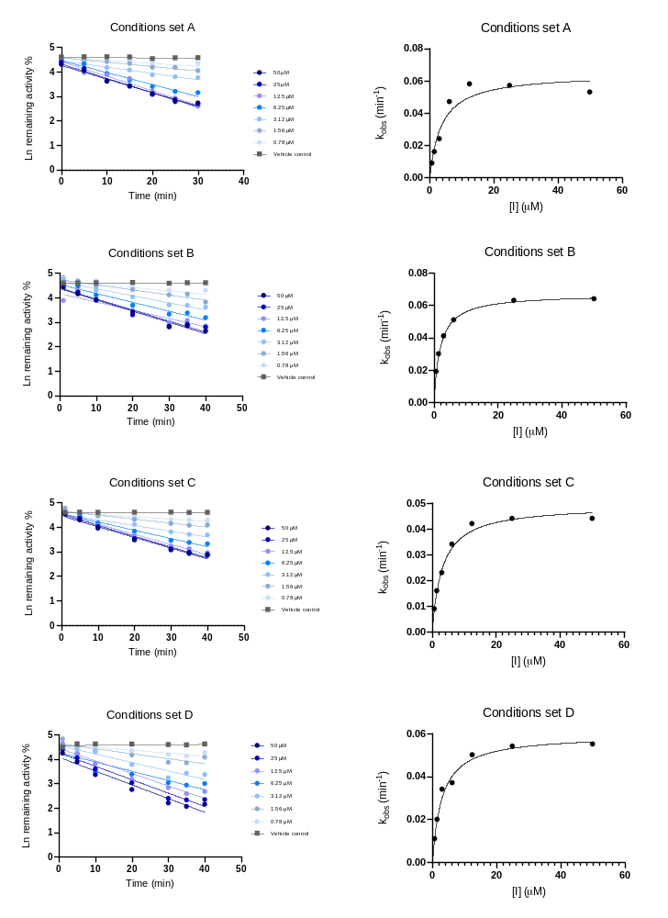
Fig. S2 Plots of the natural logarithm of the remaining enzymatic activity over pre-incubation times are reported for verapamil under different in vitro conditions: E) pre-incubation max. 40 mins, MDZ 10 μM, incubation 5 mins, HLM 0.1 mg/mL; F) pre-incubation max. 40 mins, MDZ 1 μM, incubation 5 mins, HLM 0.1 mg/mL; G) pre-incubation max. 40 mins, MDZ 10 μM, incubation 10 mins, HLM 0.05 mg/mL; H) pre-incubation max. 40 mins, MDZ 10 μM, incubation 10 mins, HLM 0.01 mg/mL. Linear regression was used to estimate the slope representing -k_{obs}. Additionally, k_{obs} versus inhibitor concentrations and fitting to retrieve KI and k_{inact} under in vitro conditions E-H are also reported.
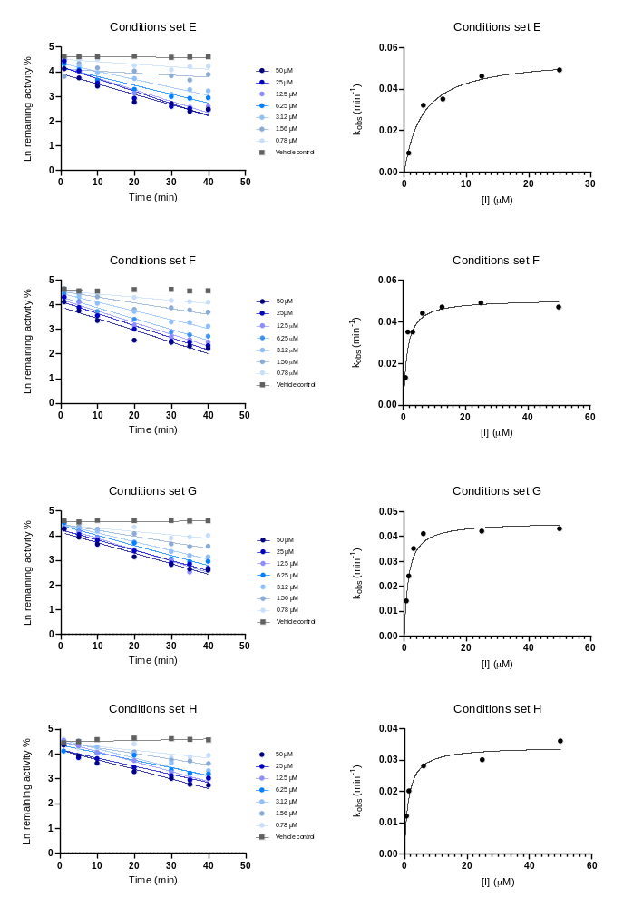
Fig. S3 Plots of the natural logarithm of the remaining enzymatic activity over pre-incubation times are reported for the positive control erythromycin under different in vitro conditions: A) pre-incubation max. 30 mins, MDZ 10 μM, incubation 10 mins, HLM 0.1 mg/mL; B) pre-incubation max. 40 mins, MDZ 10 μM, incubation 10 mins, HLM 0.1 mg/mL; C) pre-incubation max. 40 mins, MDZ 20 μM, incubation 10 mins, HLM 0.1 mg/mL; D) pre-incubation max. 40 mins, MDZ 1 μM, incubation 10 mins, HLM 0.1 mg/mL. Linear regression was used to estimate the slope representing -k_{obs}. Additionally, k_{obs} versus inhibitor concentrations and fitting to retrieve KI and k_{inact} under in vitro conditions A-D are also reported.
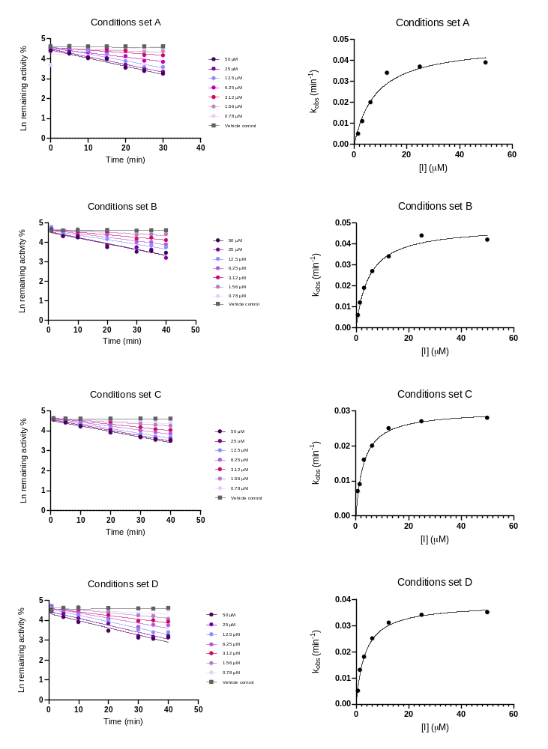
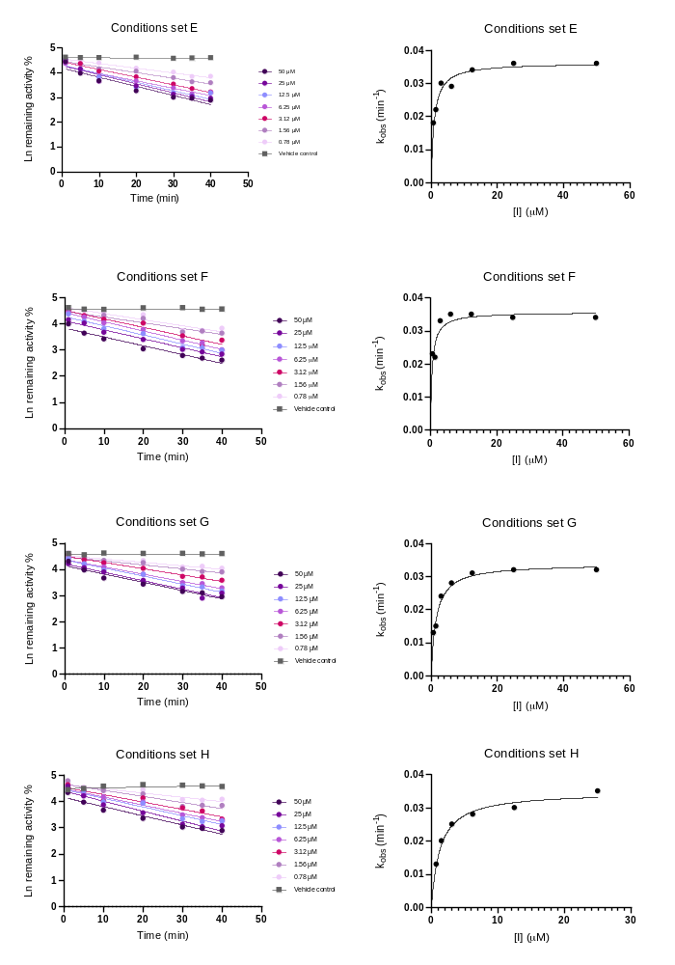Fig. S4 Plots of the natural logarithm of the remaining enzymatic activity over pre-incubation times are reported for the positive control erythromycin under different in vitro conditions: E) pre-incubation max. 40 mins, MDZ 10 μM, incubation 5 mins, HLM 0.1 mg/mL; F) pre-incubation max. 40 mins, MDZ 1 μM, incubation 5 mins, HLM 0.1 mg/mL; G) pre-incubation max. 40 mins, MDZ 10 μM, incubation 10 mins, HLM 0.05 mg/mL; H) pre-incubation max. 40 mins, MDZ 10 μM, incubation 10 mins, HLM 0.01 mg/mL. Linear regression was used to estimate the slope representing -k_{obs}. Additionally, k_{obs} versus inhibitor concentrations and fitting to retrieve KI and k_{inact} under in vitro conditions E-H are also reported.
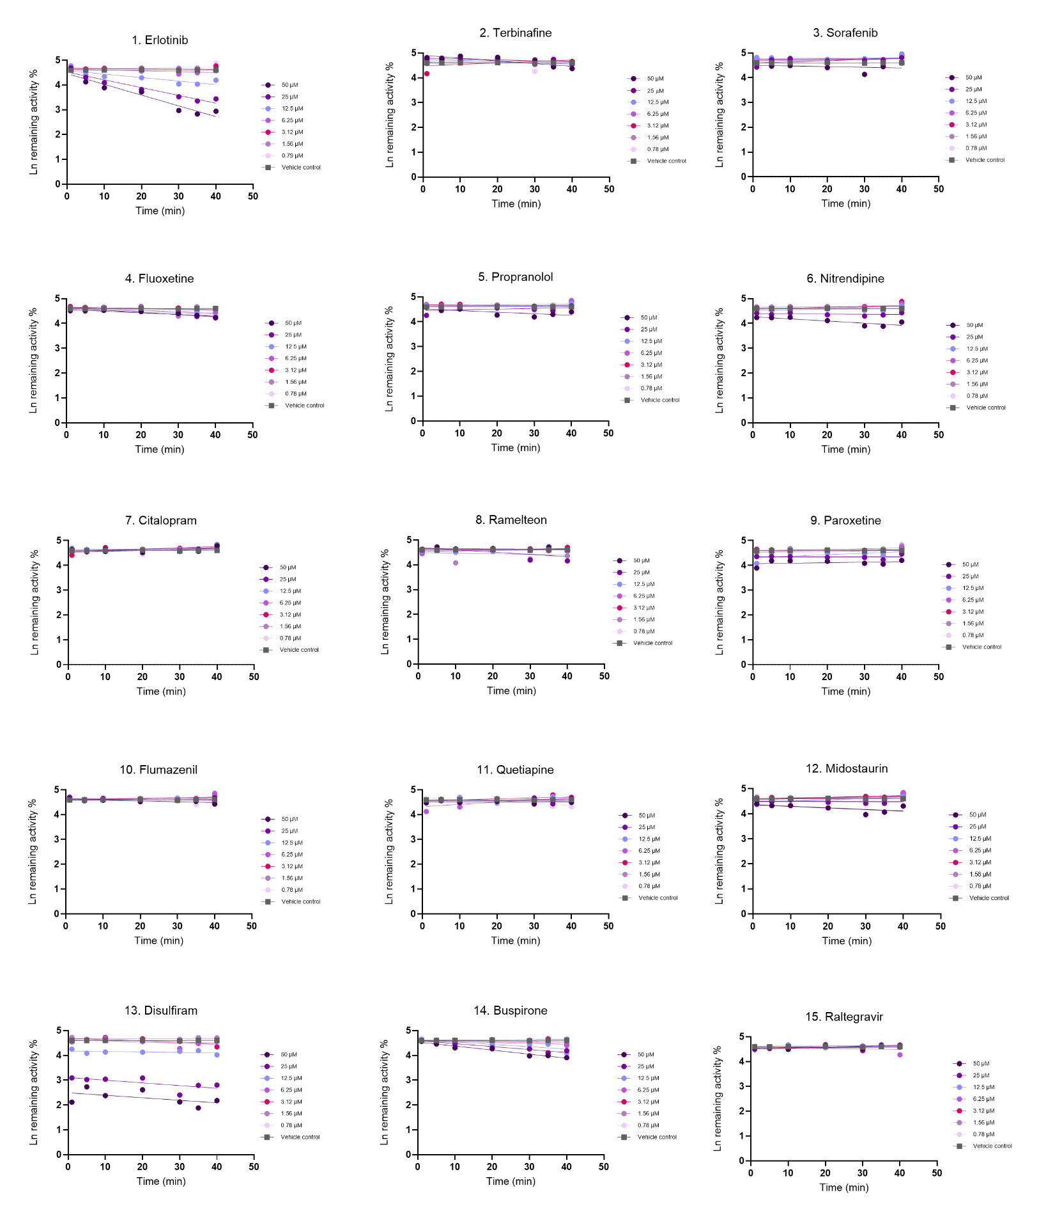
Fig. S5 Plots of the natural logarithm of the remaining enzymatic activity over pre-incubation times are reported for drugs 1-15 in the dataset (Table I) under in vitro conditions from set B: pre-incubation max. 40 mins, MDZ 10 μM, incubation 10 mins, HLM 0.1 mg/mL.

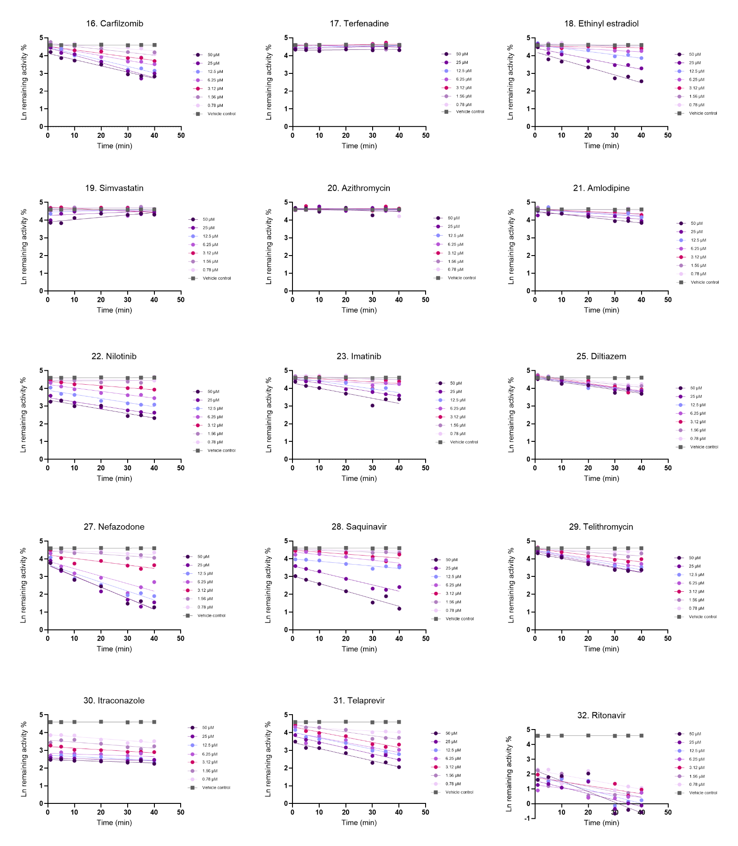
Fig. S6 Plots of the natural logarithm of the remaining enzymatic activity over pre-incubation times are reported for drugs 16-32 in the dataset (Table I) under in vitro conditions from set B: pre-incubation max. 40 mins, MDZ 10 μM, incubation 10 mins, HLM 0.1 mg/mL.

Table S11: Precipitants in silico and in vitro measured fraction unbound in human liver microsomes (HLM). In vitro fu,_{mic} were used to correct TDI KI for mechanistic static (MSM) and physiologically based pharmacokinetic (PBPK) modeling predictions. Exceptionally, in silico fu,_{mic} were used for erlotinib, sorafenib, midostaurin, disulfiram, carfilzomib, simvastatin and erythromycin due to in vitro measurement limitations (recovery < 50% or 50-80%).
Fraction unbound in microsomes (fu,_{mic})
 | HLM 1 mg/mL |  | HLM 0.5 mg/mL |  | HLM 0.1 mg/mL |  | Notes
Drug | in silico ¹ | in vitro ± SD ² | in silico ¹ | in vitro ³ | in silico ¹ | in vitro ³ | Notes
Erlotinib | 0.560 | 0.403 ± 0.009 | 0.720 | 0.574 | 0.930 | 0.871 | Recovery 50-80%
Terbinafine | 0.040 | 0.005 ± 0.001 | 0.090 | 0.009 | 0.320 | 0.043
Sorafenib | 0.400 | 0.006 ± 0.001 | 0.570 | 0.011 | 0.870 | 0.052 | Recovery 50-80%
Fluoxetine | 0.320 | 0.057 ± 0.001 | 0.480 | 0.107 | 0.820 | 0.375
Propranolol | 0.620 | 0.306 ± 0.038 | 0.760 | 0.469 | 0.940 | 0.815
Nitrendipine | 0.800 | 0.154 ± 0.014 | 0.890 | 0.266 | 0.980 | 0.645
Citalopram | 0.930 | 0.381 ± 0.030 | 0.960 | 0.551 | 0.990 | 0.860
Ramelteon | 0.590 | 0.773 ± 0.070 | 0.740 | 0.872 | 0.930 | 0.971
Paroxetine | 0.480 | 0.828 ± 0.003 | 0.650 | 0.906 | 0.900 | 0.980
Flumazenil | 0.930 | 0.772 ± 0.117 | 0.960 | 0.872 | 0.990 | 0.971
Quetiapine | 0.700 | 0.285 ± 0.048 | 0.820 | 0.443 | 0.960 | 0.799
Midostaurin | 0.060 | 0.003 ± 0.001 | 0.120 | 0.006 | 0.400 | 0.029 | Recovery 50-80%
Disulfiram | 0.370 |  | 0.540 |  | 0.850 |  | Recovery < 50%
Buspirone | 0.760 | 0.506 ± 0.029 | 0.860 | 0.672 | 0.970 | 0.911
Raltegravir | 0.950 | 0.838 ± 0.026 | 0.980 | 0.912 | 1.000 | 0.981
Carfilzomib | 0.580 |  | 0.730 |  | 0.930 |  | Recovery < 50%
Terfenadine | 0.050 | 0.006 ± 0.000 | 0.100 | 0.012 | 0.370 | 0.057
Ethinyl estradiol | 0.360 | 0.335 ± 0.013 | 0.530 |  | 0.850
Simvastatin | 0.190 | 0.026 ± 0.002 | 0.310 | 0.051 | 0.690 | 0.212 | Recovery 50-80%
Azithromycin | 0.330 | 0.410 ± 0.029 | 0.490 | 0.639 | 0.830 | 0.898
Amlodipine | 0.670 | 0.036 ± 0.004 | 0.800 | 0.069 | 0.950 | 0.269
Nilotinib | 0.130 | 0.015 ± 0.001 | 0.230 | 0.030 | 0.600 | 0.133
Imatinib | 0.490 | 0.231 ± 0.032 | 0.660 | 0.375 | 0.910 | 0.750
Verapamil | 0.340 | 0.302 ± 0.015 | 0.510 | 0.464 | 0.840 | 0.812
Diltiazem | 0.700 | 0.389 ± 0.004 | 0.830 | 0.560 | 0.960 | 0.864
Erythromycin | 0.790 |  | 0.880 |  | 0.970 |  | Recovery < 50%
Nefazodone | 0.250 | 0.082 ± 0.003 | 0.400 | 0.152 | 0.770 | 0.473
Saquinavir | 0.200 | 0.072 ± 0.004 | 0.340 | 0.135 | 0.720 | 0.438
Telithromycin | 0.660 | 0.558 ± 0.043 | 0.790 | 0.716 | 0.950 | 0.927
 | HLM 1 mg/mL |  | HLM 0.5 mg/mL |  | HLM 0.1 mg/mL |  | Notes
Drug | in silico ¹ | in vitro ± SD ² | in silico ¹ | in vitro ³ | in silico ¹ | in vitro ³
Itraconazole | 0.050 | 0.016 ± 0.002 | 0.520 | 0.031 | 0.350 | 0.139
Telaprevir | 0.320 | 0.508 ± 0.051 | 0.480 | 0.674 | 0.820 | 0.912
Ritonavir | 0.360 | 0.210 ± 0.009 | 0.480 | 0.346 | 0.850 | 0.726

¹ Calculated following Turner and Rostami-Hodjegan method.
² Measured via equilibrium dialysis using HLM instead of plasma and as previously described by Keemink et al. (2023).
³ Retrieved by dilution method (Austin et al. 2002)
Table S12: Fluoxetine input parameters used in SimCYP Model for in vivo DDI predictions.
Parameters | Value | Reference
Molecular weight (g/mol) | 309.33 | Pubchem
LogP | 4.05 | Pubchem
Compound type | Monoprotic base
pKa | 9.8 | Pubchem
B/P | 1.3 | SimCYP data archive
fu_{,p} | 0.079 | Aronoff et al. (1984),  Schenker et al. (1988)
Absorption: First-order model
fa | 1 | default
ka (1/h) | 0.69 | Aronoff et al. (1984),  Hamelin et al. (1996)
fu,_{gut} | 0.079 | assumed equal to fu,_{p}
Q,_{gut} (L/h) | 18.129 | predicted
Distribution: Minimal PBPK
V_{ss} (L/kg) | 10.42 | Aronoff et al. (1984),  Schenker et al. (1988)
Elimination
CYP2C9 CL_{int} (μL/min/mg protein) | 13.31 | In vitro CL_{int} apportioned from  Margolis et al. (2000) and Ring et al. (2001)
CYP2D6 CL_{int} (μL/min/mg protein) | 52.65 | optimized
CYP3A4 CL_{int} (μL/min/mg protein) | 2.56 | In vitro CL_{int} apportioned from  Margolis et al. (2000) and Ring et al. (2001)
Interaction CYP2C19
Ki (μM) | 9.39 | Lutz et al. (2013)
KI (μM) | 2.69 | Lutz et al. (2013)
k_{inact} (1/h) | 2.16 | Lutz et al. (2013)
Interaction CYP2D6
Ki (μM) | 0.012 | Nielsen et al. (1996)
Interaction CYP3A4
Ki (μM) | 31.42 | Lutz et al. (2013)
KI (μM) | 6.9 | Mayhew, Jones, and Hall (2000)  Albaugh et al. (2012)
k_{inact} (1/h) | 0.66 | Mayhew, Jones, and Hall (2000)  Albaugh et al. (2012)

Table S13: Norfluoxetine input parameters used in SimCYP Model for in vivo DDI predictions.
Parameters | Value | Reference
Molecular weight (g/mol) | 295.3 | Pubchem
LogP | 3.8 | Pubchem
Compound type | Monoprotic base
pKa | 9.77 | Pubchem
B/P | 1 | SimCYP data archive
fu_{,p} | 0.165 | Lutz et al. (2013)
Absorption: First-order model
fu,_{gut} | 1 | assumed
Q,_{gut} (L/h) | 18.129 | predicted
Distribution: Minimal PBPK
V_{ss} (L/kg) | 6.99 | Predicted method 3
Interaction CYP2C19
Ki (μM) | 2.99 | Lutz et al. (2013), Stresser et al. (2009)
KI (μM) | 6 | Optimised, Vlase et al. (2010)
k_{inact} (1/h) | 3.27 | Lutz et al. (2013)
Interaction CYP2D6
Ki (μM) | 0.012 | optimized
Interaction CYP3A4
Ki (μM) | 3.64 | Lutz et al. (2013)
KI (μM) | 16 | Lutz et al. (2013)
k_{inact} (1/h) | 0.66 | Lutz et al. (2013)
Table S14: Diltiazem input parameters used in SimCYP Model for in vivo DDI predictions.
Parameters | Value | Reference
Molecular weight (g/mol) | 414.5 | Pubchem
LogP | 2.8 | SimCYP data archive
Compound type | Monoprotic base
pKa | 8.06 | Pubchem
B/P | 0.963 | SimCYP data archive
fu_{,p} | 0.25 | Meta-analysis including Boyd et al. (1989)
Absorption: First-order model
fa | 1 | default
ka (1/h) | 6 | Höglund et al. (1989)
fu,_{gut} | 1 | assumed
Q,_{gut} (L/h) | 15.509 | predicted
Distribution: Minimal PBPK
V_{ss} (L/kg) | 3.09 | Kölle et al. (1983), Hermann et al. (1983), Ochs et al. (1984)
Elimination
CYP1A2 CL_{int} (μL/min/mg protein) | 2.4 | Zhao et al. (2007)
Interaction CYP3A4
Ki (μM) | 36.1 | Zhang et al. (2009)
KI (μM) | 4.75 | Yeo et al. (2011)
k_{inact} (1/h) | 0.702 | Yeo et al. (2011)
Interaction CYP3A5
Ki (μM) | 36.1 | Zhang et al. (2009)
KI (μM) | 4.75 | Yeo et al. (2011)
k_{inact} (1/h) | 0.702 | Yeo et al. (2011)

Table S15: Desmethyldiltiazem input parameters used in SimCYP Model for in vivo DDI predictions.
Parameters | Value | Reference
Molecular weight (g/mol) | 400 | Pubchem
LogP | 2.01 | SimCYP data archive
Compound type | Monoprotic base
pKa | 8.06 | Assumed same as parent
B/P | 1 | assumed
fu_{,p} | 0.323 | Boyd et al. (1989)
Absorption:
fu,_{gut} | 0.323 | assumed equal to fu,_{p}
Distribution: Minimal PBPK
V_{ss} (L/kg) | 4.0053 | Predicted method 2
Elimination
CYP3A4 CL_{int} (μL/min/mg protein) | 30.85 | Back calculated from Zhao et al.  (2007)
Interaction CYP3A4
Ki (μM) | 2.43 | Meta-analysis including Zhang et al.  (2009)
KI (μM) | 1.74 | Yeo et al. (2011)
k_{inact} (1/h) | 1.09 | Yeo et al. (2011)

Table S16: Verapamil input parameters used in SimCYP Model for in vivo DDI predictions.
Parameters | Value | Reference
Molecular weight (g/mol) | 454.6 | Pubchem
LogP | 4.46 | Meta-analysis including:  Hansch et al. (1995), Sangster (2013), ChemAxon
Compound type | Monoprotic base
pKa | 8.78 | Meta-analysis including:  Sangster (1994), Avdeef (2012)
B/P | 0.709 | Robinson et al. (1996)  Obach (1999)
fu_{,p} | 0.09 | Meta-analysis including: Keefe et al. (1981), Giacomini et al. (1984)
Absorption: ADAM
fu,_{gut} | 1 | assumed
P_{eff,man} (10⁻⁴cm/s) | 12.453 | predicted
Distribution: Full PBPK
V_{ss} (L/kg) | 5.3662 | Predicted method 2 (Rodger and Rowland method)
Elimination: Norverapamil pathway
CYP2C8  V_{max} (pmol/min/pmol)  K_{m} (μM) | 221.2  140.5 | A retrograde approach was used to calculate CL_{int} for CYP3A4/5and CYP2C8 using in vivo CL_{iv} from meta-analysis including Schomerus et al. (1976); McAllister et al. (1982) then converted to Vmax using reported Km (Tracy et al., 1999)
CYP3A4  V_{max} (pmol/min/pmol)  K_{m} (μM) | 154.3  122
CYP3A5  V_{max} (pmol/min/pmol)  K_{m} (μM) | 169.3  87.5
Interaction CYP3A4
KI (μM) | 2.21 | Rowland Yeo et al. (2011)
k_{inact} (1/h) | 2 | Rowland Yeo et al. (2011)
Interaction CYP3A5
KI (μM) | 3.99 | Ma et al. (2000), Wang et al. (2004), Obach et al. (2007)
k_{inact} (1/h) | 1.84 | Ma et al. (2000), Wang et al. (2004), Obach et al. (2007)
Interaction ABCB1 (P-gp)
Ki (μM) | 0.16 | Bentz et al. (2013)  Kishimoto et al. (2016)

Table S17: Norverapamil input parameters used in SimCYP Model for in vivo DDI predictions.
Parameters | Value | Reference
Molecular weight (g/mol) | 440.57 | Pubchem
LogP | 4.66 | ChemAxon
Compound type | Monoprotic base
pKa | 10.29 | ChemAxon
B/P | 0.675 | Robinson et al. (1996)
fu | 0.083 | Yong et al. (1980)  Robinson et al. (1996)
Absorption: ADAM
fu,_{gut} | 1 | assumed
P_{eff,man} (10⁻⁴cm/s) | 12.453 | predicted
Distribution: minimal PBPK
V_{ss} (L/kg) | 4.139 | Predicted method 1
Q (L/h) | 18 | Fitted to single oral dose PK profile Mattila et al. (1985)
V_{SAC} (L/kg) | 2 | Fitted to single oral dose PK profile Mattila et al. (1985)
Elimination:
CYP2C8  V_{max} (pmol/min/pmol)  K_{m} (μM) | 38.5  68 | A retrograde approach was used to calculate CL_{int} for CYP3A4/5and CYP2C8 then converted to Vmax using reported Km (Tracy et al., 1999)
CYP3A4  V_{max} (pmol/min/pmol)  K_{m} (μM) | 46  90
CYP3A5  V_{max} (pmol/min/pmol)  K_{m} (μM) | 18.8  19.5
Interaction CYP3A4
KI (μM) | 10.3 | Wang et al. (2005)
k_{inact} (1/h) | 6
Interaction CYP3A5
KI (μM) | 4.53 | Wang et al. (2005)
k_{inact} (1/h) | 4.2 | Wang et al. (2005)
Interaction ABCB1 (P-gp)
Ki (μM) | 0.04 | The IC50 value reported  by Pauli-Magnus et al. (2000) was scaled by the ratio between Verapamil IC50  Organ Gut in this study and P-gp Ki input value in the SV-Verapamil model KI (¹M) 0.04 (Bentz et al. (2013); Kishimoto et al. (2016))

Table S18: Erythromycin input parameters used in SimCYP Model for in vivo DDI predictions.
Parameters | Value | Reference
Molecular weight (g/mol) | 733.9 | Dollery (1999)
LogP | 2.5 | Lewis (2000)
Compound type | Monoprotic base
pKa | 8.8 | Dollery (1999)
B/P | 0.854 | Pfizer analysis
fu_{,p} | 0.31 | Dette et al. (1982)
Absorption: First-order model
fa | 0.6 | optimized
ka (1/h) | 0.52 | optimized
fu,_{gut} | 1
Q,_{gut} (L/h) | 1.7471 | predicted
Permeability assay | Caco-2 | Richter et al. (2009)
Apical pH : Basolateral pH | 7.4 : 7.4 | Richter et al. (2009)
Activity | Passive&active | Richter et al. (2009)
Caco-2 (10⁻⁶cm/s) | 1.7 | Richter et al. (2009)
Reference | multiple
Scalar | 0.28957 | Calculated in SimCYP
Distribution: Minimal PBPK
V_{ss} (L/kg) | 0.75 | Austin et al. (1980),  Barre et al. (1987)
Elimination
CYP3A4  V_{max} (pmol/min/pmol)  K_{m} (μM) | 1.45  14.7 | Huang et al. (2004)
CYP3A5  V_{max} (pmol/min/pmol)  K_{m} (μM) | 1.25  30.7 | Huang et al. (2004)
Interaction CYP3A4
Ki (μM) | 32.8 | Literature meta analysis
KI (μM) | 17.64 | Literature meta analysis
k_{inact} (1/h) | 0.8 | Optimised using study from Olkkola et al. (1993)
Interaction CYP3A4
KI (μM) | 7.14 | McConn et al. (2004)
k_{inact} (1/h) | 0.66 | McConn et al. (2004)

Table S19: Ethinyl estradiol input parameters used in SimCYP Model for in vivo DDI predictions.
Parameters | Value | Reference
Molecular weight (g/mol) | 296.4 | Pubchem
LogP | 3.81 | Hansch et al. (1995); Faassen et al.  (2003), Predicted (ACD)
Compound type | Neutral | Teleki et al. (2020)
B/P | 1 | Assumed
fu_{,p} | 0.015 | Kuhnz et al. (1990), Pacifici et al. (1989)
Absorption: First-order model
fa | 0.97386 | predicted
ka (1/h) | 1.3269 | predicted
fu,_{gut} | 1
P_{eff,man} (10⁻⁴ cm/s) | 1.7901 | predicted
Permeability assay | Caco-2
Apical pH : Basolateral pH | 7.4 : 7.4
Activity | Passive&active
P_{app} (10⁻⁶cm/s) | 7.21 | Faassen et al. (2003)
Reference | Verapamil
Reference value (10⁻⁶cm/s) | 15.58
Scalar | 1.4763 | Faassen et al. (2003)
Distribution: Minimal PBPK
V_{ss} (L/kg) | 4.06 | Back et al. (1979), Kuhnz et al. (1996)
Elimination
CYP2C9 – Pathway 1  CLint (μL/min/mg protein) | 0.51 | Estimated from in-vitro fm,Wang et al.  (2004)
CYP3A4 – Pathway1  CLint (μL/min/mg protein) | 0.5 | Optimised,Wiesinger et al. (2015)
CYP2C8 – Pathway 1
CLint (μL/min/mg protein) | 0.13 | Estimated from in-vitro fm,Wang et al.  (2004)
CYP1A2 – Pathway 1
CLint (μL/min/mg protein) | 0.51 | Estimated from in-vitro fm,Wang et al.  (2004)
UGT1A1 – Pathway 2
V_{max} (pmol/min/pmol)  K_{m} (μM) | 408.5  19.22 | Shiraga et al. (2004)

Table S20: Saquinavir soft gel capsule input parameters used in SimCYP Model for in vivo DDI predictions.
Parameters | Value | Reference
Molecular weight (g/mol) | 670.86 | Saquinavir label FDA
LogP | 3.66 | Predicted
Compound type | Base
pKa | 8.47 | predicted
B/P | 0.648 | EMA
fu_{,p} | 0.025 | Perry et al. 1998
Absorption: First-order model
fa | 0.3 | optimized
ka (1/h) | 0.5 | optimized
fu,_{gut} | 0.33 | optimized
fg | 0.67 | DDI with grapefruit
Q_{gut} (L/h) | 18.2 | Predicted with Mechp_{eff} model
Distribution: Minimal PBPK
V_{ss} (L/kg) | 1.49 | Kupferschmidt et al. 1998
Elimination
CL_{iv} (L/h) | 43.3 | Kupferschmidt et al. 1998
CYP3A4  CLint (μL/min/mg protein) | 1309 | estimated using 1000 mg saquinavir/100 mg  ritonavir BID from Boffito et al., 2005 (HIV patients)
HLM CLint (μL/min/mg protein) | 68.9
CLr (L/h) | 0.77 | Fröhlich et al. 2004
Interaction CYP3A4
KI (μM) | 2.99 | in vitro value from Ernest et al., 2005, Zimmerlin et al., 2011, Fahmi et al., 2008, Mao et al., 2012
k_{inact} (1/h) | 2.0 | optimized value, 3.2-fold reduction of averaged Kinact value from Ernest et al., 2005, Zimmerlin et al., 2011, Fahmi et al., 2008, Mao et al., 2012

Perpetrator drug | N. of subjects | Proportion of females | Age range (years) | Substrate dose – Midazolam (mg) | Perpetrator dose (mg) | Reference
Fluoxetine | 40 | 0.58 | 18-50 | 10 | 60 | Lam et al. 2003
Diltiazem | 9 | 1.00 | 19-28 | 15 | 60 | Backman et al. 1994
Diltiazem | 14 | 0.36 | 22-53 | 2 | 60 | Friedman et al. 2011
Verapamil | 9 | 1.00 | 19-28 | 15 | 80 | Backman et al. 1994
Erythromycin | 8 | 0.44 | 18-60 | 0.003 | 1000 | Carls et al. 2014
Ethinylestradiol | 9 | 1.00 | 20-25 | 7.5 | 0.035 | Palovaara et al. 2000
Saquinavir | 12 | 0.50 | 21-32 | 7.5 | 1200 | Palkama et al. 1999
Table S21: Clinical studies design details in terms of number of subjects, proportion of females, age range, dosing of victim and perpetrator which were applied in the PBPK models for fluoxetine, diltiazem, verapamil, erythromycin, ethinyl estradiol and saquinavir.

Fig. S7 Predicted recovery time required to restore 80% of the baseline CYP3A4 activity in liver and gut after exposure to six precipitants. Predictions were run with verified SimCYP models up to 30 days and applying k_{deg,h} = 0.0193 and k_{deg,g} = 0.03 (Rowland-Yeo et al. 2011). In vitro KI,_{u} and k_{inact} measured under the incubation conditions optimized in this study (set B: pre-incubation max 40 min, MDZ 10 μM, HLM 0.1 mg/mL, incubation 10 min) (hatched orange circles and hatched yellow squares for liver and gut predictions, respectively) and taken from SimCYP library (teal circles and cerulean squares for liver and gut predictions, respectively) were implemented into the models. Recovery times are expressed in terms of days.
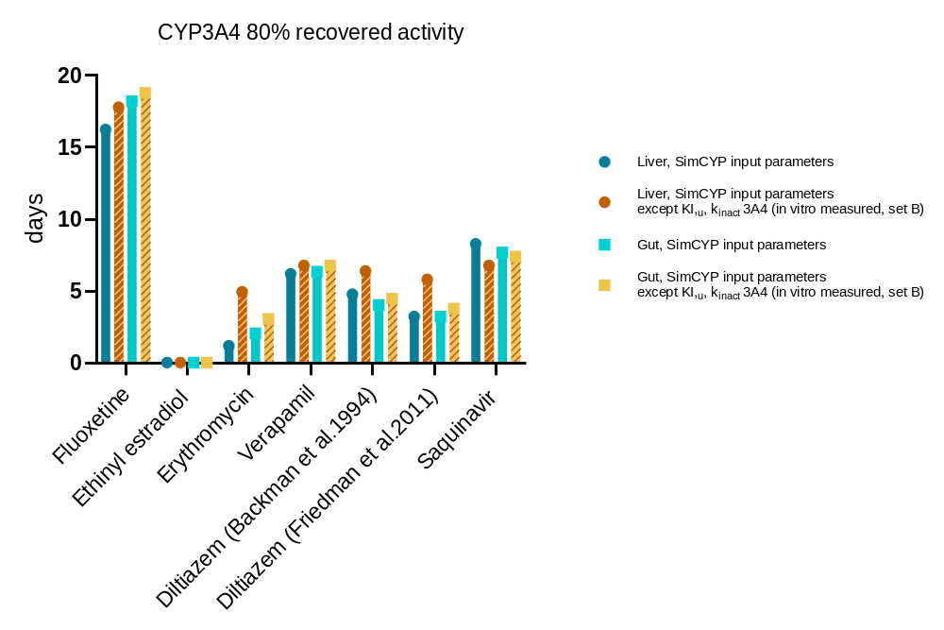

Table S22: Dynamic simulations results of the CYP3A4 recovery in liver and gut after the exposure to six different perpetrators. Predictions were run through validated PBPK models from SimCYP, using the original set of input data and by substituting the TDI kinetic data with those measured in this study under the in vitro conditions represented by set B (pre-incubation max. 40 mins, MDZ 10 μM, incubation 10 mins, HLM 0.1 mg/mL). Moreover, the following CYP3A4 turnover values were applied: k_{deg},_{h} = 0.0193, k_{deg},_{g} = 0.03 (Rowland-Yeo et al. 2011). A restored enzymatic activity equal to 80% was considered as clinically relevant and the corresponding required recovery times are reported below in terms of days. In addition, details regarding input KI,_{u} and k_{inact}, predicted inhibition in liver and gut, and predicted and observed AUCR values are also stated below.

Drug |  | SimCYP input parameters | SimCYP input parameters,  except CYP3A4 KI,_{u}, k_{inact} in vitro measured (set B) | Predicted recovery difference (days)
Fluoxetine | k_{inact} (h⁻¹) | 0.66 | 0.72
Fluoxetine | KI,_{u} (μM) | 6.90 | 5.43
Fluoxetine | Inhibition %
Fluoxetine | Liver | 31 | 35
Fluoxetine | Gut | 43 | 46
Fluoxetine | CYP3A4 recovery (days)
Fluoxetine | Liver | 16.2 | 17.8 | 1.5
Fluoxetine | Gut | 18.2 | 18.8 | 0.6
Fluoxetine | AUCR predicted | 1.59 | 1.7
Fluoxetine | AUCR in vivo | 0.87
Ethinyl Estradiol | k_{inact} (h⁻¹) | - | 7.62
Ethinyl Estradiol | KI,_{u} (μM) | - | 43.66
Ethinyl Estradiol | Inhibition %
Ethinyl Estradiol | Liver | 0 | 0
Ethinyl Estradiol | Gut | 0 | 0
Ethinyl Estradiol | CYP3A4 recovery (days)
Ethinyl Estradiol | Liver | 0.0 | 0.1 | 0
Ethinyl Estradiol | Gut | 0.0 | 0.1 | 0
Ethinyl Estradiol | AUCR predicted | 1.00 | 1.00
Ethinyl Estradiol | AUCR in vivo | 1.20
Erythromycin | k_{inact} (h⁻¹) | 0.80 | 3.42
Erythromycin | KI,_{u} (μM) | 17.64 | 5.30
Erythromycin | Inhibition %
Erythromycin | Liver | 24 | 95
Erythromycin | Gut | 55 | 98
Erythromycin | CYP3A4 recovery (days)
Erythromycin | Liver | 1.2 | 4.9 | 3.7
Erythromycin | Gut | 2.0 | 3.0 | 1.0
Erythromycin | AUCR predicted | 1.38 | 6.59
Erythromycin | AUCR in vivo | 4.99
Drug |  | SimCYP input parameters | SimCYP input parameters,  except CYP3A4 KI,_{u}, k_{inact} in vitro measured (set B) | Predicted recovery difference (days)
Verapamil | k_{inact} (h⁻¹) | 2.00 | 4.02
Verapamil | KI,_{u} (μM) | 2.21 | 1.65
Verapamil | Inhibition %
Verapamil | Liver | 61 | 75
Verapamil | Gut | 96 | 98
Verapamil | CYP3A4 recovery (days)
Verapamil | Liver | 6.2 | 6.8 | 0.6
Verapamil | Gut | 6.3 | 6.8 | 0.5
Verapamil | AUCR predicted | 3.00 | 4.22
Verapamil | AUCR in vivo | 2.92
Diltiazem  (Backman et al. 1994) | k_{inact} (h⁻¹) | 0.70 | 1.68
Diltiazem  (Backman et al. 1994) | KI,_{u} (μM) | 4.75 | 0.35
Diltiazem  (Backman et al. 1994) | Inhibition %
Diltiazem  (Backman et al. 1994) | Liver | 45 | 89
Diltiazem  (Backman et al. 1994) | Gut | 65 | 92
Diltiazem  (Backman et al. 1994) | CYP3A4 recovery (days)
Diltiazem  (Backman et al. 1994) | Liver | 4.8 | 6.4 | 1.6
Diltiazem  (Backman et al. 1994) | Gut | 4.0 | 4.5 | 0.5
Diltiazem  (Backman et al. 1994) | AUCR predicted | 2.01 | 6.5
Diltiazem  (Backman et al. 1994) | AUCR in vivo | 3.75
Diltiazem  (Friedman et al. 2011) | k_{inact} (h⁻¹) | 0.70 | 1.68
Diltiazem  (Friedman et al. 2011) | KI,_{u} (μM) | 4.75 | 0.35
Diltiazem  (Friedman et al. 2011) | Inhibition %
Diltiazem  (Friedman et al. 2011) | Liver | 32 | 83
Diltiazem  (Friedman et al. 2011) | Gut | 55 | 91
Diltiazem  (Friedman et al. 2011) | CYP3A4 recovery (days)
Diltiazem  (Friedman et al. 2011) | Liver | 3.2 | 5.8 | 2.6
Diltiazem  (Friedman et al. 2011) | Gut | 3.2 | 3.7 | 0.5
Diltiazem  (Friedman et al. 2011) | AUCR predicted | 1.68 | 5.3
Diltiazem  (Friedman et al. 2011) | AUCR in vivo | 4.06
Saquinavir V21 | k_{inact} (h⁻¹) | 2.00 | 4.80
Saquinavir V21 | KI,_{u} (μM) | 2.99 | 11.33
Saquinavir V21 | Inhibition %
Saquinavir V21 | Liver | 49 | 33
Saquinavir V21 | Gut | 91 | 87
Saquinavir V21 | CYP3A4 recovery (days)
Saquinavir V21 | Liver | 8.3 | 6.8 | -1.5
Saquinavir V21 | Gut | 7.7 | 7.4 | -0.3
Saquinavir V21 | AUCR predicted | 1.96 | 1.73
Saquinavir V21 | AUCR in vivo | 5.18

References

- Aarnoutse RE, Kleinnijenhuis J, Koopmans PP, Touw DJ, Wieling J, Hekster YA, and Burger DM (2005) Effect of low‐dose ritonavir (100 mg twice daily) on the activity of cytochrome P450 2D6 in healthy volunteers. Clin Pharmacol Ther 78:664–674.
- Albaugh DR, Fullenwider CL, Fisher MB, and Hutzler JM (2012) Time-Dependent Inhibition and Estimation of CYP3A Clinical Pharmacokinetic Drug-Drug Interactions Using Plated Human Cell Systems. Drug Metab Dispos 40:1336–1344.
- Aronoff GR, Bergstrom RF, Pottratz ST, Sloan RS, Wolen RL, and Lemberger L (1984) Fluoxetine kinetics and protein binding in normal and impaired renal function. Clin Pharmacol Ther 36:138–144.
- Austin K, Mather L, Philpot C, and McDonald P (1980) Intersubject and dose‐related variability after intravenous administration of erythromycin. Br J Clin Pharmacol 10:273–279.
- Austin RP, Barton P, Cockroft SL, Wenlock MC, Riley RJ.(2002) The influence of nonspecific microsomal binding on apparent intrinsic clearance, and its prediction from physicochemical properties. Drug Metab Dispos. 30:1497-503.
- Avdeef A (2023) Absorption and Drug Devel: solubility, permeability, and charge state, in Wiley, doi: 10.1002/9781118286067.
- Back DJ, Breckenridge AM, Crawford FE, MacIver M, Orme ML, Rowe PH, and Watts MJ (1979) An investigation of the pharmacokinetics of ethynylestradiol in women using radioimmunoassay. Contraception 20:263–273.
- Backman J, Olkkola K, Aranko K, Himberg J, and Neuvonen P (1994) Dose of midazolam should be reduced during diltiazem and verapamil treatments. Br J Clin Pharmacol 37:221–225.
- Barre J, Mallat A, Rosenbaum J, Deforges L, Houin G, Dhumeaux D, and Tillement J (1987) Pharmacokinetics of erythromycin in patients with severe cirrhosis. Respective influence of decreased serum binding and impaired liver metabolic capacity. Br J Clin Pharmacol 23:753–757.
- Bentz J, O’Connor MP, Bednarczyk D, Coleman J, Lee C, Palm J, Pak YA, Perloff ES, Reyner E, Balimane P, Brännström M, Chu X, Funk C, Guo A, Hanna I, Herédi-Szabó K, Hillgren K, Li L, Hollnack-Pusch E, Jamei M, Lin X, Mason AK, Neuhoff S, Patel A, Podila L, Plise E, Rajaraman G, Salphati L, Sands E, Taub ME, Taur J-S, Weitz D, Wortelboer HM, Xia CQ, Xiao G, Yabut J, Yamagata T, Zhang L, and Ellens H (2013) Variability in P-Glycoprotein Inhibitory Potency (IC50) Using Various in Vitro Experimental Systems: Implications for Universal Digoxin Drug-Drug Interaction Risk Assessment Decision Criteria. Drug Metab Dispos 41:1347–1366.
- Bergstrom RF, Lemberger L, Farid NA, and Wolen RL (1988) Clinical pharmacology and pharmacokinetics of fluoxetine: a review. Br J psychiatry Suppl 47–50.
- Bianchetti G, Graziani G, Brancaccio D, Morganti A, Leonetti G, Manfrin M, Sega R, Gomeni R, Ponticelli C, and Morselli PL (1976) Pharmacokinetics and Effects of Propranolol in Terminal Uraemic Patients and in Patients Undergoing Regular Dialysis Treatment. Clin Pharmacokinet 1:373–384.
- Boffito M, Back D, Stainsby‐Tron M, Hill A, Perri GD, Moyle G, Nelson M, Tomkins J, Gazzard B, and Pozniak A (2005) Pharmacokinetics of saquinavir hard gel/ritonavir (1000/100 mg twice daily) when administered with tenofovir diproxil fumarate in HIV‐1‐infected subjects. Br J Clin Pharmacol 59:38–42.
- Boyd RA, Chin SK, Don‐Pedro O, Verotta D, Sheiner LB, Williams RL, and Giacomini KM (1989) The pharmacokinetics and pharmacodynamics of diltiazem and its metabolites in healthy adults after a single oral dose. Clin Pharmacol Ther 46:408–419.
- Buch AB, Harken DRV, Seidehamel RJ, and Barbhaiya RH (1993) A Study of Pharmacokinetic Interaction Between Buspirone and Alprazolam at Steady State. J Clin Pharmacol 33:1104–1109.
- Carls A, Jedamzik J, Witt L, Hohmann N, Burhenne J, and Mikus G (2014) Effect of topical erythromycin on cytochrome P450 3A4. Br J Clin Pharmacol 78:1433–1440.
- Caron G, Ermondi G, Damiano A, Novaroli L, Tsinman O, Ruell JA, and Avdeef A (2004) Ionization, lipophilicity, and molecular modeling to investigate permeability and other biological properties of amlodipine. Bioorg Med Chem 12:6107–6118.
- Chan CYS, Roberts O, Rajoli RKR, Liptrott NJ, Siccardi M, Almond L, and Owen A (2018) Derivation of CYP3A4 and CYP2B6 degradation rate constants in primary human hepatocytes: A siRNA-silencing-based approach. Drug Metab Pharmacokinet 33:179–187.
- Colclough N, Chen K, Johnström P, Strittmatter N, Yan Y, Wrigley GL, Schou M, Goodwin R, Varnäs K, Adua SJ, Zhao M, Nguyen DX, Maglennon G, Barton P, Atkinson J, Zhang L, Janefeldt A, Wilson J, Smith A, Takano A, Arakawa R, Kondrashov M, Malmquist J, Revunov E, Vazquez-Romero A, Moein MM, Windhorst AD, Karp NA, Finlay MRV, Ward RA, Yates JWT, Smith PD, Farde L, Cheng Z, and Cross DAE (2021) Preclinical Comparison of the Blood–brain barrier Permeability of Osimertinib with Other EGFR TKIs. Clin Cancer Res 27:189–201.
- Dette GA, Knothe H, and Herrmann G (1982) Erythromycin binding to human serum. Biochem Pharmacol 31:1081–1087.
- Dollery CT (1999), Therapeutic drugs, second edition in Churchill Livingstone, London, UK.
- Ernest CS, Hall SD, and Jones DR (2005) Mechanism-Based Inactivation of CYP3A by HIV Protease Inhibitors. J Pharmacol Exp Ther 312:583–591.
- EMA (2017), Assessment report: Tarceva (erlotinib), Procedure No. EMEA/H/C/000618/II/005, EMA London, UK.
- EMA (2016), Product information: Valsartan Mylan (amlodipine), Procedure No. EMEA/H/C/00403, EMA London, UK.
- EMA (2018), Product information: Invirase (saquinavir), Procedure No. EMEA/H/C/000113, EMA London, UK.
- Ezuruike U, Humphries H, Dickins M, Neuhoff S, Gardner I, and Yeo KR (2018) Risk–Benefit Assessment of Ethinylestradiol Using a Physiologically Based Pharmacokinetic Modeling Approach. Clin Pharmacol Ther 104:1229–1239.
- Faassen F, Vogel G, Spanings H, and Vromans H (2003) Caco-2 permeability, P-glycoprotein transport ratios and brain penetration of heterocyclic drugs. Int J Pharm 263:113–122.
- Fahmi OA, Maurer TS, Kish M, Cardenas E, Boldt S, and Nettleton D (2008) A Combined Model for Predicting CYP3A4 Clinical Net Drug-Drug Interaction Based on CYP3A4 Inhibition, Inactivation, and Induction Determined in Vitro. Drug Metab Dispos 36:1698–1708.
- FDA (2007), Chemistry review: Lamisil (terbinafine hydrochloride), FDA application number: NDA 22-071, FDA Silver Springs, MD.
- FDA (2005), Drug Approval package: Nexavar (sorafenib), FDA application number: NDA 21-923, FDA Silver Springs, MD.
- FDA (1999), Drug Approval package: Celexa (citalopram), FDA application number: NDA 21-046, FDA Silver Springs, MD.
- FDA (2005), Drug label: Rozerem (ramelteon), FDA application number: NDA 21-782, FDA Silver Springs, MD.
- FDA (2007), Drug label: Romazicom (flumazenil), FDA application number: NDA 20-073/S-016, FDA Silver Springs, MD.
- FDA (2016), Clinical pharmacology review application: Rydapt (midostaurin), FDA application number: NDA 207997, FDA Silver Springs, MD.
- FDA (2009), Bioequivalence review application: Disulfiram, FDA application number: FDA ANDA091619, FDA Silver Springs, MD.
- FDA (2012), Drug Approval package: Kyprolis (carfilzomib), FDA application number: NDA 202714, FDA Silver Springs, MD.
- FDA (2000), Chemistry review: BuSpar (buspirone hydrochloride), FDA application number: NDA 21-190, FDA Silver Springs, MD.
- FDA (2013), Drug label: Zithromax (azithromycin), FDA reference number: ID 3263750, FDA Silver Springs, MD.
- FDA (2007), Pharmacology review application: Tasigna (nilotinib), FDA application number: NDA 22-068, FDA Silver Springs, MD.
- FDA (2002), Drug Approval package: Verelan PM (verapamil hydrochloride), FDA application number: NDA 20-943, FDA Silver Springs, MD.
- FDA (2010), Drug label: Tiazac (diltiazem hydrochloride), FDA reference number: ID 2867292, FDA Silver Springs, MD.
- FDA (2010), Drug label: erythromycin, FDA reference number: ID 3416724, FDA Silver Springs, MD.
- FDA (2012), Clinical pharmacology review application: Invirase (saquinavir), FDA application number: NDA 20-628, FDA Silver Springs, MD.
- FDA (2002), Drug Approval package: Serzone (nefazodone hydrochloride), FDA application number: NDA 20-152, FDA Silver Springs, MD.
- FDA (2004), Drug Approval package: Ketek (telithromycin), FDA application number: NDA 021144, FDA Silver Springs, MD.
- FDA (2011), Drug Approval package: Incivek (telaprevir), FDA application number: NDA 201917, FDA Silver Springs, MD.
- Francis LJ, Houston B, and Hallifax D (2020) Impact of plasma protein binding in drug clearance prediction: a database analysis of published studies and implications for in vitro in vivo extrapolation. Drug Metab Dispos 49:188-201.
- Friedman EJ, Fraser IP, Wang Y, Bergman AJ, Li C, Larson PJ, Chodakewitz J, Wagner JA, and Stoch SA (2011) Effect of Different Durations and Formulations of Diltiazem on the Single‐Dose Pharmacokinetics of Midazolam: How Long Do We Go? J Clin Pharmacol 51:1561–1570.
- Fröhlich M, Hoffmann MM, Burhenne J, Mikus G, Weiss J, and Haefeli WE (2004) Association of the CYP3A5 A6986G (CYP3A5*3) polymorphism with saquinavir pharmacokinetics. Br J Clin Pharmacol 58:443–444.
- Gertz M, Houston JB, and Galetin A (2011) Physiologically Based Pharmacokinetic Modeling of Intestinal First-Pass Metabolism of CYP3A Substrates with High Intestinal Extraction. Drug Metab Dispos 39:1633–1642.
- Giacomini KM, Massoud N, Wong FM, and Giacomini JC (1984) Decreased Binding of Verapamil to Plasma Proteins in Patients with Liver Disease. J Cardiovasc Pharmacol 6:924–928.
Greene DS, and Barbhaiya RH (1997) Clinical Pharmacokinetics of Nefazodone. Clin Pharmacokinet 33:260–275.
- Gu H, Dutreix C, Rebello S, Ouatas T, Wang L, Chun DY, Einolf HJ, and He H (2017) Simultaneous physiologically-based pharmacokinetic (PBPK) modeling of parent and active metabolites to investigate complex CYP3A4 drug-drug interaction potential: a case example of midostaurin. Drug Metab Dispos 46:109-121.
- Gupta AK, Cooper EA, and Lynde CW (2003) The efficacy and safety of terbinafine in children. Dermatol Clin 21:511–520.
- Hamelin BA, Turgeon J, Vallée F, Bélanger P, Paquet F, and LeBel M (1996) The disposition of fluoxetine but not sertraline is altered in poor metabolizers of debrisoquin. Clin Pharmacol Ther 60:512–521.
- Hashimoto T, Narikawa S, Huang X-L, Minematsu T, Usui T, Kamimura H, and Endou H (2004) Simultaneous expression of guinea pig UDP-glucuronosyltransferase 2B21 (UGT2B21) and 2B22 in COS-7 cells enhances UGT2B21-catalyzed chloramphenicol glucuronidation. Drug Metab Dispos 32:1057–1060.
- Höglund P, and Nilsson LG (1989) Pharmacokinetics of Diltiazem and Its Metabolites After Single and Multiple Dosing in Healthy Volunteers. Ther Drug Monit 11:558–566.
- Huang W, Lin YS, McConn DJ, Calamia JC, Totah RA, Isoherranen N, Glodowski M, and Thummel KE (2004) Evidence of significant contribution from CYP3A5 to hepatic drug metabolism. Drug Metab Dispos 32:1434–1445.
- Ito K, Ogihara K, Kanamitsu S, and Itoh T (2003) Prediction of the in vivo interaction between midazolam and macrolides based on in vitro studies using human liver microsomes. Drug Metab Dispos 31:945–954.
- Jensen JC (1989) Clinical pharmacokinetics of terbinafine (Lamisil). Clin Exp Dermatol 14:110–113.
- Johnson TN, Jamei M, and Rowland-Yeo K (2016) How Does In Vivo Biliary Elimination of Drugs Change with Age? Evidence from In Vitro and Clinical Data Using a Systems Pharmacology Approach. Drug Metab Dispos 44:1090–1098.
- Keefe DL, Yee Y, and Kates RE (1981) Verapamil protein binding in patients and in normal subjects. Clin Pharmacol Ther 29:21–26.
- Keemink J, Cantrill C, Riboulet W, Jurmanović S, Pavlovski I, Bissantz C. (2023) Estimating Unbound Drug Concentrations in Simulated Human Lung Fluid: Relevance to Lung Antibiotic PKPD. Mol Pharm. 20:3578-3588.
- Khazaal Y, Preisig M, Chatton A, Kaufmann N, Bilancioni R, and Eap CB (2013) Use of High Doses of Quetiapine in Bipolar Disorder Episodes are not Linked to High Activity of Cytochrome P4503A4 and/or Cytochrome P4502D6. Psychiatr Q 84:329–335.
- Kim M-J, Lee J-W, Oh K-S, Choi C-S, Kim KH, Han WS, Yoon C-N, Chung ES, Kim D-H, and Shin J-G (2013) The Tyrosine Kinase Inhibitor Nilotinib Selectively Inhibits CYP2C8 Activities in Human Liver Microsomes. Drug Metab Pharmacokinet 28:462.
- Kimoto E, Vourvahis M, Scialis RJ, Eng H, Rodrigues AD, and Varma MVS (2019) Mechanistic Evaluation of the Complex Drug-Drug Interactions of Maraviroc: Contribution of Cytochrome P450 3A, P-Glycoprotein and Organic Anion Transporting Polypeptide 1B1. Drug Metab Dispos 47:493–503.
- Kishimoto W, Ishiguro N, Ludwig-Schwellinger E, Ebner T, Maeda K, and Sugiyama Y (2016) Usefulness of A Model-Based Approach for Estimating In Vitro P-Glycoprotein Inhibition Potency in a Transcellular Transport Assay. J Pharm Sci 105:891–896.
- Kölle EU, Ochs HR, and Vollmer KO (1983) Pharmacokinetic model of diltiazem. Arzneim-Forsch 33:972–7.
- Kosugi Y, Hirabayashi H, Igari T, Fujioka Y, Okuda T, and Moriwaki T (2014) Risk assessment of drug–drug interactions using hepatocytes suspended in serum during the drug discovery process. Xenobiotica 44:336–344.
- Kozakai K, Yamada Y, Oshikata M, Kawase T, Suzuki E, Haramaki Y, and Taniguchi H (2014) Cocktail-substrate Approach-based High-throughput Assay for Evaluation of Direct and Time-dependent Inhibition of Multiple Cytochrome P450 Isoforms. Drug Metab Pharmacokinet 29:198.
- Kretz O, Weiss HM, Schumacher MM, and Gross G (2004) In vitro blood distribution and plasma protein binding of the tyrosine kinase inhibitor imatinib and its active metabolite, CGP74588, in rat, mouse, dog, monkey, healthy humans and patients with acute lymphatic leukaemia. Br J Clin Pharmacol 58:212–216.
- Kuhnz W, Hümpel M, Biere H, and Gross D (1996) Influence of repeated oral doses of ethinyloestradiol on the metabolic disposition of [13C2]-ethinyloestradiol in young women. Eur J Clin Pharmacol 50:231–235.
- Kuhnz W, Pfeffer M, and Al-Yacoub G (1990) Protein binding of the contraceptive steroids gestodene, 3-keto-desogestrel and ethinylestradiol in human serum. J Steroid Biochem 35:313–318.
- Kupferschmidt HHT, Fattinger KE, Ha HR, Follath F, and Krähenbühl S (1998) Grapefruit juice enhances the bioavailability of the HIV protease inhibitor saquinavir in man. Br J Clin Pharmacol 45:355–359.
- Lam YWF, Alfaro CL, Ereshefsky L, and Miller M (2003) Pharmacokinetic and Pharmacodynamic Interactions of Oral Midazolam with Ketoconazole, Fluoxetine, Fluvoxamine, and Nefazodone. J Clin Pharmacol 43:1274–1282.
- Lanz J, Biniaz-Harris N, Kuvaldina M, Jain S, Lewis K, and Fallon BA (2023) Disulfiram: Mechanisms, Applications, and Challenges. Antibiotics 12:524.
- Lee CA, Jones JP, Katayama J, Kaspera R, Jiang Y, Freiwald S, Smith E, Walker GS, and Totah RA (2012) Identifying a Selective Substrate and Inhibitor Pair for the Evaluation of CYP2J2 Activity. Drug Metab Dispos 40:943–951.
- Levêque D, and Maloisel F (2005) Clinical pharmacokinetics of imatinib mesylate. In vivo, 19:77–84.
- Lewis DFV (2000) Structural characteristics of human P450s involved in drug metabolism: QSARs and lipophilicity profiles. Toxicology 144:197–203.
- Lombardo F, Berellini G, and Obach RS (2018) Trend analysis of a database of intravenous pharmacokinetic parameters in humans for 1352 drug compounds. Drug Metab Dispos 46:1466-1477.
- Lundbeck Canada (2023), Product monograph: citalopram, https://www.lundbeck.com/content/dam/lundbeck-com/americas/canada/products/files/celexa_product_monograph_english.pdf
- Lutz JD, VandenBrink BM, Babu KN, Nelson WL, Kunze KL, and Isoherranen N (2013) Stereoselective Inhibition of CYP2C19 and CYP3A4 by Fluoxetine and Its Metabolite: Implications for Risk Assessment of Multiple Time-Dependent Inhibitor Systems. Drug Metab Dispos 41:2056–2065.
- Ma B, Prueksaritanont T, and Lin JH (2000) Drug interactions with calcium channel blockers: possible involvement of metabolite-intermediate complexation with CYP3A. Drug Metab Dispos: Biol fate Chem 28:125–30.
- Mao J, Mohutsky MA, Harrelson JP, Wrighton SA, and Hall SD (2012) Predictions of Cytochrome P450-Mediated Drug-Drug Interactions Using Cryopreserved Human Hepatocytes: Comparison of Plasma and Protein-Free Media Incubation Conditions. Drug Metab Dispos 40:706–716.
- Margolis JM, O’Donnell JP, Mankowski DC, Ekins S, and Obach RS (2000) (R)-, (S)-, and racemic fluoxetine N-demethylation by human cytochrome P450 enzymes. Drug Metab Dispos: Biol fate Chem 28:1187–91.
- Martin DE, Zussman BD, Everitt DE, Benincosa LJ, Etheredge RC, and Jorkasky DK (1997) Paroxetine Does Not Affect the Cardiac Safety and Pharmacokinetics of Terfenadine in Healthy Adult Men. J Clin Psychopharmacol 17:451-459.
- Martin YC (1996) Exploring QSAR: Hydrophobic, Electronic, and Steric Constants C. Hansch, A. Leo, and D. Hoekman. American Chemical Society, Washington, DC.
- Mayhew BS, Jones DR, and Hall SD (2000) An in vitro model for predicting in vivo inhibition of cytochrome P450 3A4 by metabolic intermediate complex formation. Drug Metab Dispos: Biol fate Chem 28:1031–7.
- McAllister RG, and Kirsten EB (1982) The Pharmacology of verapamil. IV. Kinetic and dynamic effects after single intravenous and oral doses. Clin Pharmacol Ther 31:418–426.
- Mikus G, Fischer C, Heuer B, Langen C, and Eichelbaum M (1987) Application of stable isotope methodology to study the pharmacokinetics, bioavailability and metabolism of nitrendipine after i.v. and p.o. administration. Br J Clin Pharmacol 24:561–569.
- Mohsen-Nia M, Ebrahimabadi AH, and Niknahad B (2012) Partition coefficient n-octanol/water of propranolol and atenolol at different temperatures: Experimental and theoretical studies. J Chem Thermodyn 54:393–397.
- Moraes MO, Lerner FE, Corso G, Bezerra FAF, Moraes MEA, and Nucci GD (1999) Fluoxetine Bioequivalence Study: Quantification of Fluoxetine and Norfluoxetine by Liquid Chromatography Coupled to Mass Spectrometry. J Clin Pharmacol 39:1053–1061.
- Murad N, Pasikanti KK, Madej BD, Minnich A, McComas JM, Crouch S, Polli JW, and Weber AD (2020) Predicting Volume of Distribution in Humans: Performance of in silico Methods for A Large Set of Structurally Diverse Clinical Compounds. Drug Metab Dispos 49:169-178.
- Murata K, Yamahara H, Kobayashi M, Noda K, and Smejima M (1989) Pharmacokinetics of an oral sustained‐release diltiazem preparation. J Pharm Sci 78:960–963.
- Nielsen KK, Flinois JP, Beaune P, and Brøsen K (1996) The biotransformation of clomipramine in vitro, identification of the cytochrome P450s responsible for the separate metabolic pathways. J Pharmacol Exp Ther 277:1659–64.
- Nirogi R, Kandikere V, Palacharla RC, Bhyrapuneni G, Kanamarlapudi VB, Ponnamaneni RK, and Manoharan AK (2014) Identification of a suitable and selective inhibitor towards aldehyde oxidase catalyzed reactions. Xenobiotica 44:197–204.
- Nolting A, and Abramowitz W (2000) Lack of Interaction Between Citalopram and the CYP3A4 Substrate Triazolam. Pharmacother: J Hum Pharmacol Drug Ther 20:750–755.
- Obach RS (1999) Prediction of human clearance of twenty-nine drugs from hepatic microsomal intrinsic clearance data: An examination of in vitro half-life approach and nonspecific binding to microsomes. Drug Metab Dispos: Biol fate Chem 27:1350–9.
- Obach RS, Lombardo F, and Waters NJ (2008) Trend Analysis of a Database of Intravenous Pharmacokinetic Parameters in Humans for 670 Drug Compounds. Drug Metab Dispos 36:1385–1405.
- Obach RS, Walsky RL, and Venkatakrishnan K (2007) Mechanism-Based Inactivation of Human Cytochrome P450 Enzymes and the Prediction of Drug-Drug Interactions. Drug Metab Dispos 35:246–255.
- Ochs HR, and Knüchel M (1984) Pharmacokinetics and absolute bioavailability of diltiazem in humans. Klin Wochenschr 62:303–306.
- Olkkola KT, Aranko K, Luurila H, Hiller A, Saarnivaara L, Himberg J, and Neuvonen PJ (1993) A potentially hazardous interaction between erythromycin and midazolam. Clin Pharmacol Ther 53:298–305.
- Pacifici GM, Viani A, Rizzo G, and Carrai M (1989) Plasma protein binding of ethinyloestradiol: effect of disease and interaction with drugs. Int J Clin Pharmacol, Ther, Toxicol 27:362–5.
- Palkama VJ, Ahonen J, Neuvonen PJ, and Olkkola KT (1999) Effect of saquinavir on the pharmacokinetics and pharmacodynamics of oral and intravenous midazolam. Clin Pharmacol Ther 66:33–39.
- Palovaara S, Kivistö KT, Tapanainen P, Manninen P, Neuvonen PJ, and Laine K (2000) Effect of an oral contraceptive preparation containing ethinylestradiol and gestodene on CYP3A4 activity as measured by midazolam 1′‐hydroxylation. Br J Clin Pharmacol 50:333–337.
- Pepin XJH, Huckle JE, Alluri RV, Basu S, Dodd S, Parrott N, and Riedmaier AE (2021) Understanding Mechanisms of Food Effect and Developing Reliable PBPK Models Using a Middle-out Approach. AAPS J 23:12.
- Perry CM, and Noble S (1998) Saquinavir Soft-Gel Capsule Formulation. Drugs 55:461–486.
- Petain A, Kattygnarath D, Azard J, Chatelut E, Delbaldo C, Geoerger B, Barrois M, Séronie-Vivien S, LeCesne A, Vassal G, and consortium O behalf of the IT with C with CE (2008) Population Pharmacokinetics and Pharmacogenetics of Imatinib in Children and Adults. Clin Cancer Res 14:7102–7109.
- Peters SA, Schroeder PE, Giri N, and Dolgos H (2012) Evaluation of the Use of Static and Dynamic Models to Predict Drug-Drug Interaction and Its Associated Variability: Impact on Drug Discovery and Early Development. Drug Metab Dispos 40:1495–1507.
- Richter O von, Glavinas H, Krajcsi P, Liehner S, Siewert B, and Zech K (2009) A novel screening strategy to identify ABCB1 substrates and inhibitors. Naunyn-Schmiedeberg’s Arch Pharmacol 379:11–26.
- Robinson MA, and Mehvar R (1996) Enantioselective distribution of verapamil and norverapamil into human and rat erythrocytes: the role of plasma protein binding. Biopharm Drug Dispos 17:577–587.
- Ryder NS (1992) Terbinafine: Mode of action and properties of the squalene epoxidase inhibition. Br J Dermatol 126:2–7.
- Sandström R, Knutson TW, Knutson L, Jansson B, and Lennernäs H (1999) The effect of ketoconazole on the jejunal permeability and CYP3A metabolism of (R/S)‐verapamil in humans. Br J Clin Pharmacol 48:180–189.
- Schomerus M, Spiegelhalder B, Stieren B, and Eichelbaum M (1976) Physiological disposition of verapamil in man1. Cardiovasc Res 10:605–612.
- Shiraga T, Niwa T, Ohno Y, and Kagayama A (2004) Interindividual Variability in 2-Hydroxylation, 3-Sulfation, and 3-Glucuronidation of Ethynylestradiol in Human Liver. Biol Pharm Bull 27:1900.
- Stresser DM, Mason AK, Perloff ES, Ho T, Crespi CL, Dandeneau AA, Morgan L, and Dehal SS (2009) Differential Time- and NADPH-Dependent Inhibition of CYP2C19 by Enantiomers of Fluoxetine. Drug Metab Dispos 37:695–698.
- Tanaka C, Yin OQP, Sethuraman V, Smith T, Wang X, Grouss K, Kantarjian H, Giles F, Ottmann OG, Galitz L, and Schran H (2010) Clinical Pharmacokinetics of the BCR–ABL Tyrosine Kinase Inhibitor Nilotinib. Clin Pharmacol Ther 87:197–203.
- Teleki A, Nylander O, and Bergström CAS (2020) Intrinsic Dissolution Rate Profiling of Poorly Water-Soluble Compounds in Biorelevant Dissolution Media. Pharmaceutics 12:493.
- Tracy TS, Korzekwa KR, Gonzalez FJ, and Wainer IW (1999) Cytochrome P450 isoforms involved in metabolism of the enantiomers of verapamil and norverapamil. Br J Clin Pharmacol 47:545–552.
- Tseng E, Eng H, Lin J, Cerny MA, Tess DA, Goosen TC, and Obach RS (2021) Static and Dynamic Projections of Drug-Drug Interactions Caused by Cytochrome P450 3A Time-Dependent Inhibitors Measured in Human Liver Microsomes and Hepatocytes. Drug Metab Dispos 49:947-960.
- Turner DB, Rostami-Hodjegan A, Tucker GT, Yeo KR. Prediction of Non-Specific Hepatic Microsomal Binding from Readily Available Physicochemical Properties. Drug Metab Rev. 2006;38 (S1).
- Usansky HH, and Sinko PJ (2005) Estimating Human Drug Oral Absorption Kinetics from Caco-2 Permeability Using an Absorption-Disposition Model: Model Development and Evaluation and Derivation of Analytical Solutions for ka and Fa. J Pharmacol Exp Ther 314:391–399.
- Wang B, Sanchez RI, Franklin RB, Evans DC, and Huskey S-EW (2004) The involvement of CYP3A4 and CYP2C9 In the metabolism of 17α-ethinylestradiol. Drug Metab Dispos 32:1209–1212.
- Wang Y-H, Jones DR, and Hall SD (2004) Prediction of cytochrome P450 3A inhibition by verapamil enantiomers and their metabolites. Drug Metab Dispos 32:259–266.
- Wang Z, Xiang X, Liu S, Tang Z, Sun H, Parvez M, Ghim J-L, Shin J-G, and Cai W (2021) A physiologically based pharmacokinetic/pharmacodynamic modeling approach for drug-drug interaction evaluation of warfarin enantiomers with sorafenib. Drug Metab Pharmacokinet 39:100362.
- Wiesinger H, Berse M, Klein S, Gschwend S, Höchel J, Zollmann FS, and Schütt B (2015) Pharmacokinetic interaction between the CYP3A4 inhibitor ketoconazole and the hormone drospirenone in combination with ethinylestradiol or estradiol. Br J Clin Pharmacol 80:1399–1410.
- Williams DM, and Cubeddu LX (1988) Amlodipine Pharmacokinetics in Healthy Volunteers. J Clin Pharmacol 28:990–994.
- Wood FL, Houston JB, and Hallifax D (2017) Clearance prediction methodology needs fundamental improvement: trends common to rat and human hepatocytes/microsomes and implications for experimental methodology. Drug Metab Dispos 45:1178-1188.
- Xia B, Heimbach T, He H, and Lin T (2012) Nilotinib preclinical pharmacokinetics and practical application toward clinical projections of oral absorption and systemic availability. Biopharm Drug Dispos 33:536–549.
- Yang J, Liao M, Shou M, Jamei M, Yeo K, Tucker G, and Rostami-Hodjegan A (2008) Cytochrome P450 Turnover: Regulation of Synthesis and Degradation, Methods for Determining Rates, and Implications for the Prediction of Drug Interactions. Curr Drug Metab 9:384–393.
- Yeo KR, Walsky RL, Jamei M, Rostami-Hodjegan A, and Tucker GT (2011) Prediction of time-dependent CYP3A4 drug–drug interactions by physiologically based pharmacokinetic modelling: Impact of inactivation parameters and enzyme turnover. Eur J Pharm Sci 43:160–173.
- Zammit GK (2007) Ramelteon: a novel hypnotic indicated for the treatment of insomnia. Psychiatry (Edgmont (Pa : Townsh)) 4:36–42.
- Zhang X, Jones DR, and Hall SD (2009) Prediction of the Effect of Erythromycin, Diltiazem, and Their Metabolites, Alone and in Combination, on CYP3A4 Inhibition. Drug Metab Dispos 37:150–160.
Zhao P, Lee CA, and Kunze KL (2007) Sequential Metabolism Is Responsible for Diltiazem-Induced Time-Dependent Loss of CYP3A. Drug Metab Dispos 35:704–712.
- Zhao P, Vieira M de LT, Grillo JA, Song P, Wu T, Zheng JH, Arya V, Berglund EG, Atkinson AJ, Sugiyama Y, Pang KS, Reynolds KS, Abernethy DR, Zhang L, Lesko LJ, and Huang S (2012) Evaluation of Exposure Change of Nonrenally Eliminated Drugs in Patients With Chronic Kidney Disease Using Physiologically Based Pharmacokinetic Modeling and Simulation. J Clin Pharmacol 52:91S-108S.
- Zimmerlin A, Trunzer M, and Faller B (2011) CYP3A Time-Dependent Inhibition Risk Assessment Validated with 400 Reference Drugs. Drug Metab Dispos 39:1039–1046.

