Supplementary Figures for
Impacts of Antibody Structure and Mixtures on
Receptor Signaling for Antibody Dependent Cellular Cytotoxicity

Jiakun Guan^{1,}*, Tiexin Wang^{1,4,}*, Peter Tessier^{1,2,3,4,}’, Greg M. Thurber^{1,2,5,}’

¹ Department of Chemical Engineering, University of Michigan, Ann Arbor, MI 48109
² Department of Biomedical Engineering, University of Michigan, Ann Arbor, MI 48109
³ Department of Pharmaceutical Sciences, University of Michigan, Ann Arbor, MI 48109
⁴ Biointerfaces Institute, University of Michigan, Ann Arbor, MI 48109
⁵ Rogel Cancer Center, University of Michigan, Ann Arbor, MI 48109

* - Denotes equal contribution of authors
‘ – Corresponding Authors

Figures S1 – S10

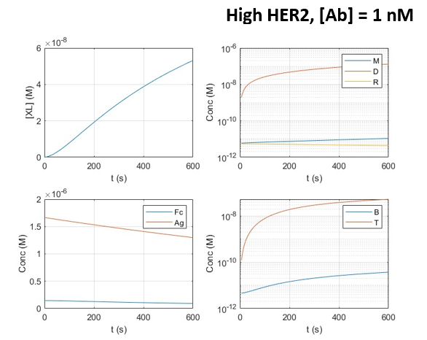
Figure S1. Temporal Changes in Antibodies Species
Concentration of individual species changes over time at high expression.

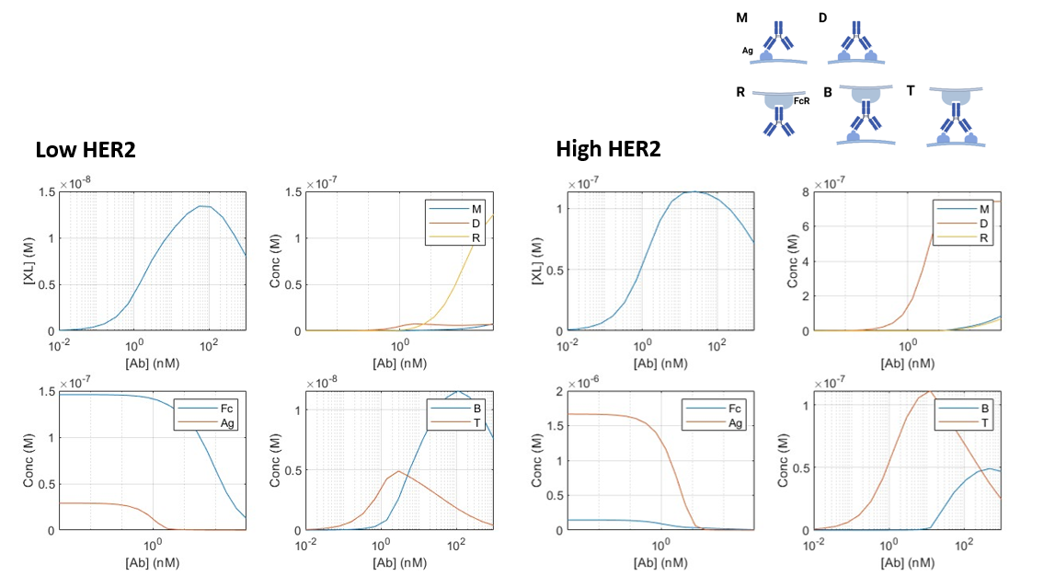
Figure S2. Individual Species Concentrations as a Function of Antibody Concentration
The concentration profiles of individual species (varying antibody bound states) changes over antibody concentration at high and low expression.

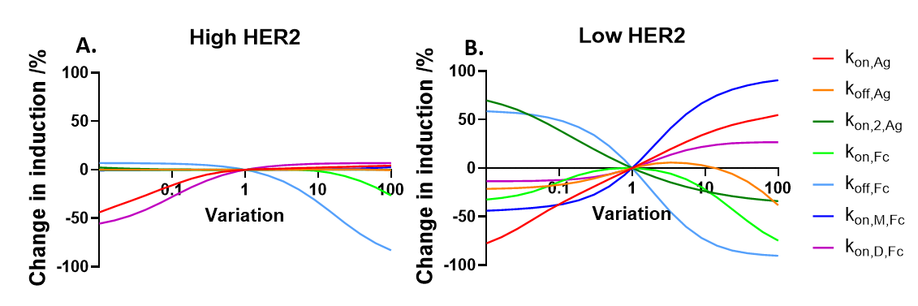

Figure S3. Kinetic Model Sensitivity Analysis
Sensitivity analysis of parameters in the model at high (A) and low (B) antigen expression. Values are varied from WT trastuzumab and the results show the change of induction at an antibody concentration of 10nM.

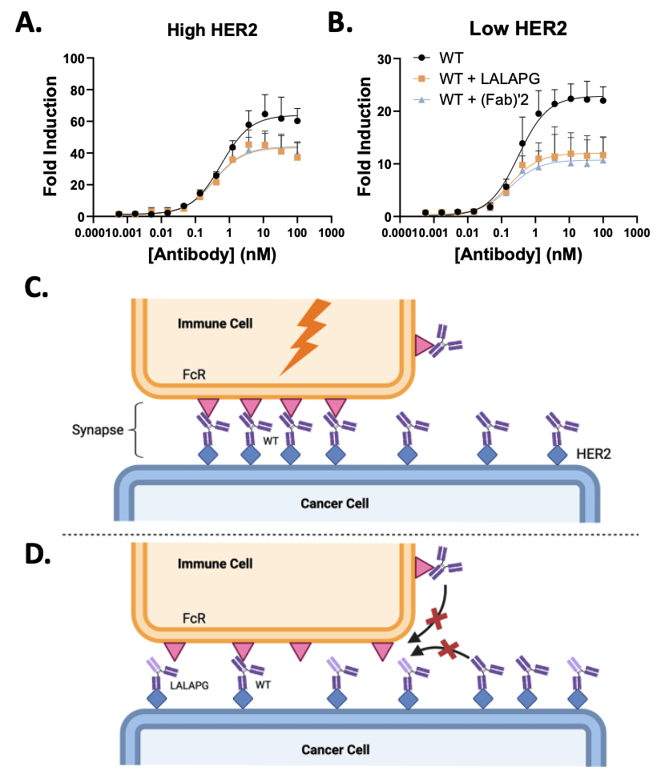

Figure S4. Blocking Trastuzumab Signal Induction with LALAPG or Fab’2 Antibodies
A and B. Comparison between the LALAPG variant and F(ab’)2 shows the Fc domain of LALAPG is inactive. The Fc region of LALAPG has no impact on the blocking given the identical results with the F(ab’)2. C. A conceptual model of the synapse shows efficient clustering of Fc receptors by WT antibodies. D. However, the LALAPG variant efficiently blocks the binding of WT antibodies within the confined area of the synapse. Even when the number of WT antibodies bound to HER2 is in excess of the total number of Fc receptors, limited receptor diffusion could prevent these bound WT antibodies from accessing FcR within the synapse.

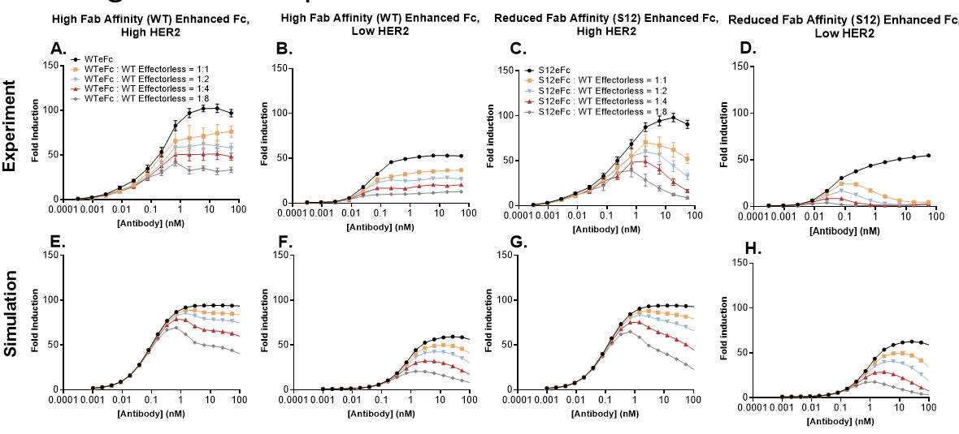

Figure S5. Model Validation with enhanced Fc antibody Mixtures with wt Fab LALAPG antibodies
Reporter cell induction with the co-administration of Fc enhanced antibodies and the Fc inactivated mutant LALAPG at high (A and C) and low expression (B and D) cell lines, compared with corresponding simulations (E-H).

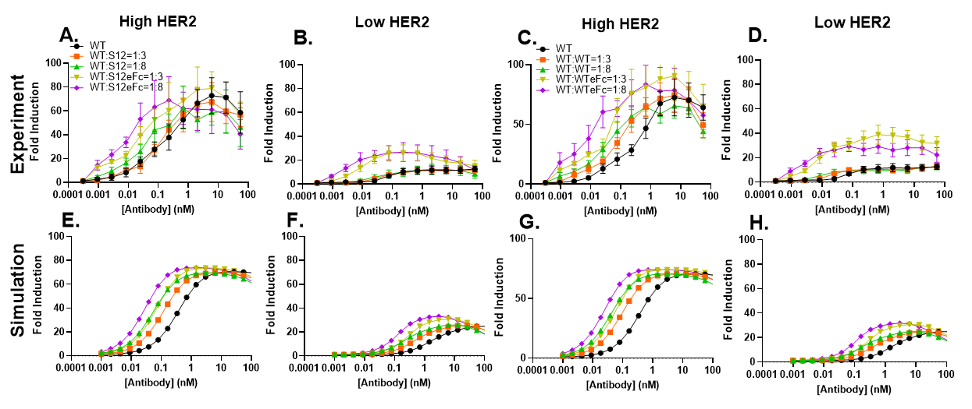

Figure S6. Model Validation with Varying Fab and Fc Domain Affinity Antibody Mixtures.
Reporter cell induction with the co-administration of Fc enhanced antibodies and the WT or S12 antibodies at high (A and C) and low expression (B and D) cell lines, compared with corresponding simulations (E-H).

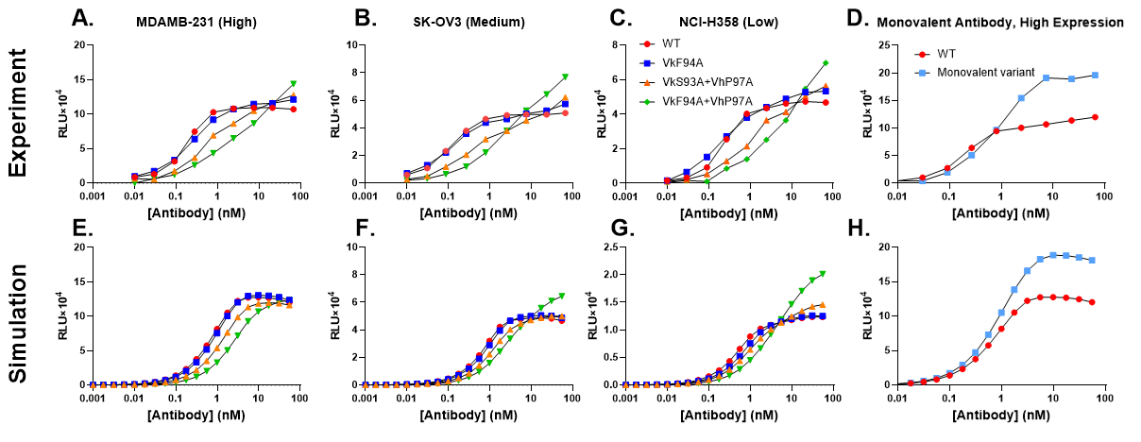
Figure S7. Model Validation with EGFR antibody
Reporter cell induction with anti-EGFR antibody GA201 and its three low-affinity mutants at high (A and E), medium (B and F) and low (C and G) EGFR expression cell lines reported in Mazor et al. 2016, PLoS One, compared with corresponding simulations (E-G). The simulations successfully replicate the trends of low-affinity variants with improved signaling at saturating concentrations. D and H. Reporter cell induction with the monovalent WT mutant, compared with corresponding simulations.

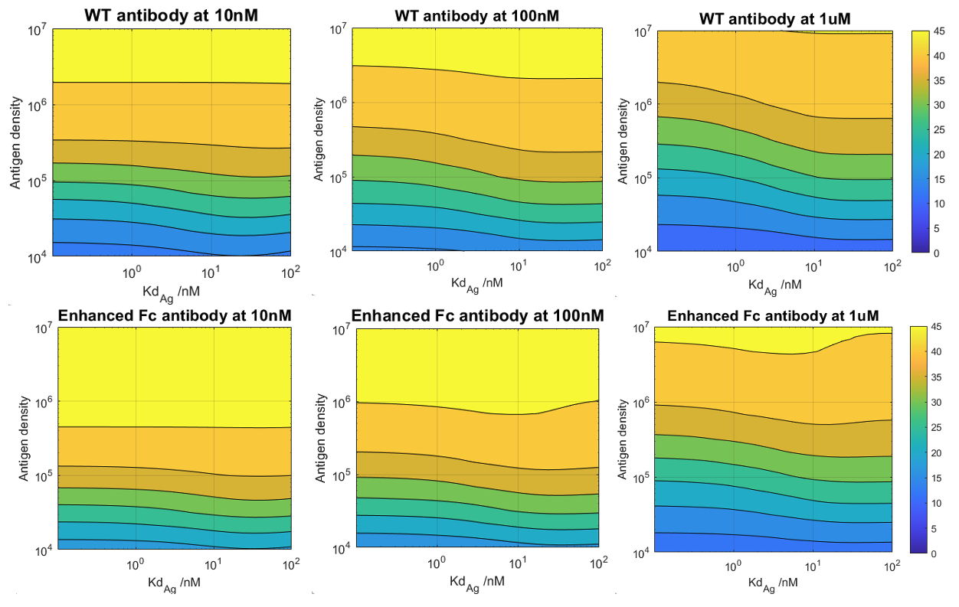
Figure S8. Simulated fold induction across antigen density and affinity
Simulation results with the WT antibody or enhanced Fc mutants at 10nM, 100nM, or 1 μM within a range of antigen density from 10K to 10M and a range of Fab affinity from 0.1nM to 100nM, representing the typical antibody concentrations and antigen expression levels in a clinical setting.

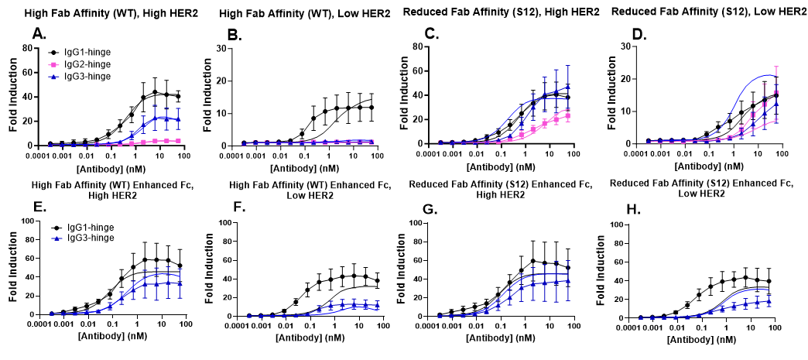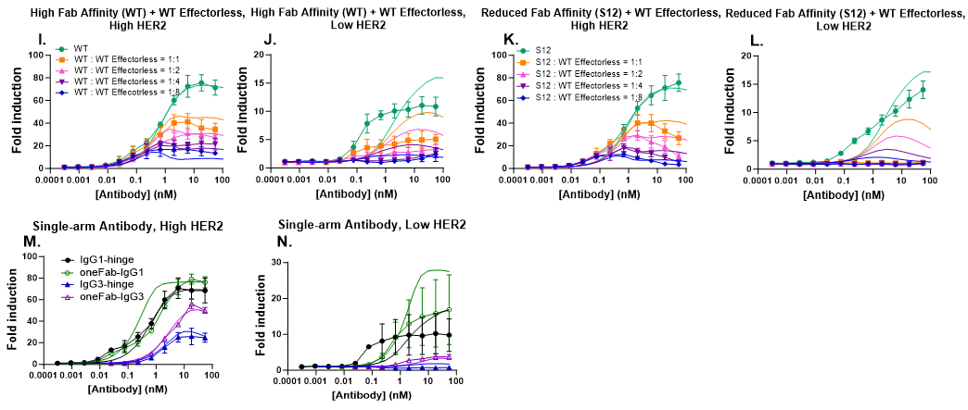
Figure S9. Data in Figure 2-5 with simulation outcomes (curves without symbols) overlay on experimental data

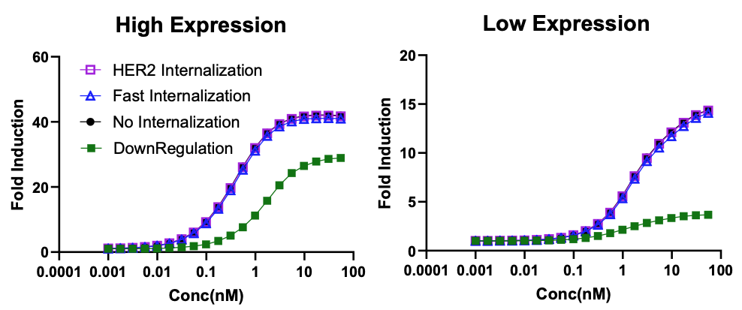
Figure S10. The impact of internalization
Simulation results with or without internalization showing modest impact of internalization rates. The HER2 internalization rate is 3.3×10⁻⁵ s⁻¹, and fast internalization rate is 1.9×10⁻⁴ s⁻¹.

