Supplementary Material

Whole-Body Pharmacokinetics of Ionizable Lipid, mRNA, and the Expressed Antibody following Intravenous Administration of mRNA-Loaded Lipid Nanoparticles
Shrusti Tiwari¹, Mokshada Kumar¹, Shengjia Wu^{1,*}, Rutuja Kulkarni¹ and Dhaval K. Shah^{1,*}
¹Department of Pharmaceutical Sciences, School of Pharmacy and Pharmaceutical Sciences, The State University of New York at Buffalo, Buffalo, NY

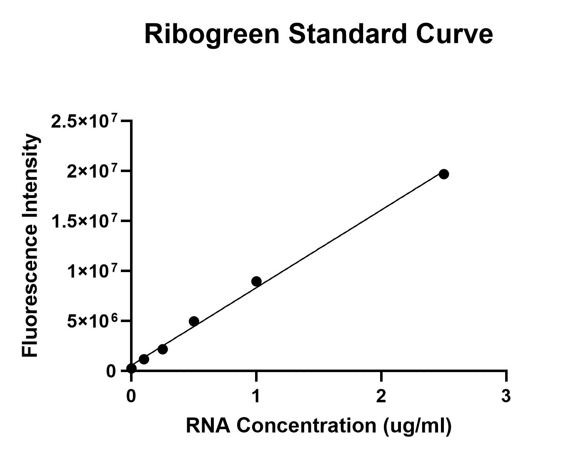

Fig S1. Standard curve for RNA quantification using the RiboGreen assay. RNA standards ranging from 0.1 to 2.5 µg/mL, with blank controls were used to generate the fluorescence calibration curve. The regression equation was y = 7.0 × 10⁶ x + 316,451 with an R² of 0.9996, indicating excellent linearity. This standard curve was used to quantify mRNA encapsulated in LNP formulations.

F-CTCACCGTCCTTGACACGAT
R-CTGGGGCTCTGAGTCATCTG

Fig S2. Primer sequences used for quantitative RT-PCR (qPCR) analysis. Forward and reverse primers were designed to specifically amplify the mRNA encoding trastuzumab.

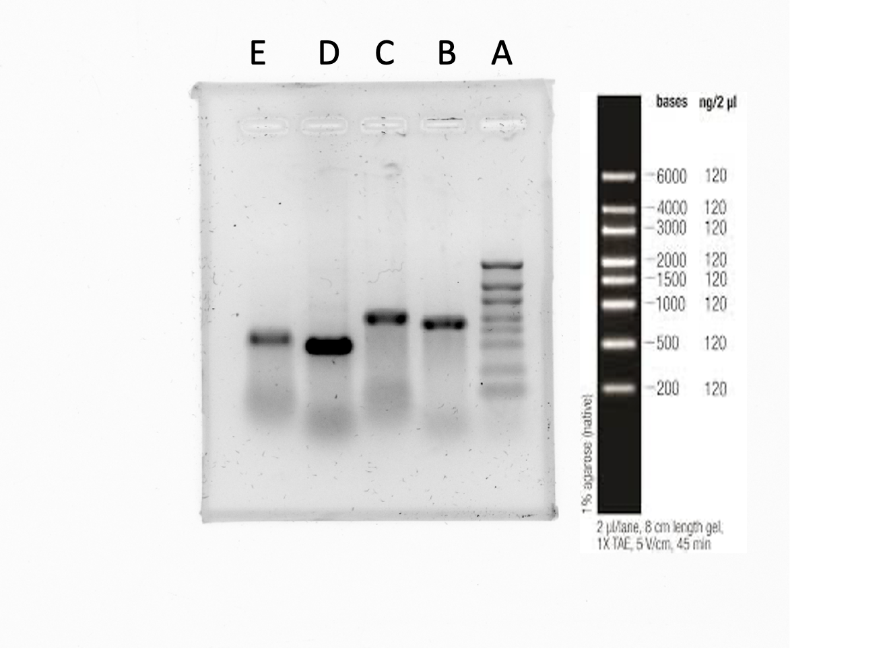

Fig S3. Gel electrophoresis confirmation of mRNA integrity and poly(A) tail addition. Lane A: Molecular weight ladder; Lane B: Heavy chain mRNA (1673 bp); Lane C: Poly(A)-tailed heavy chain mRNA; Lane D: Light chain mRNA (965 bp); Lane E: Poly(A)-tailed light chain mRNA. The poly(A) tailing results in a size shift, verifying successful enzymatic polyadenylation of the transcripts.

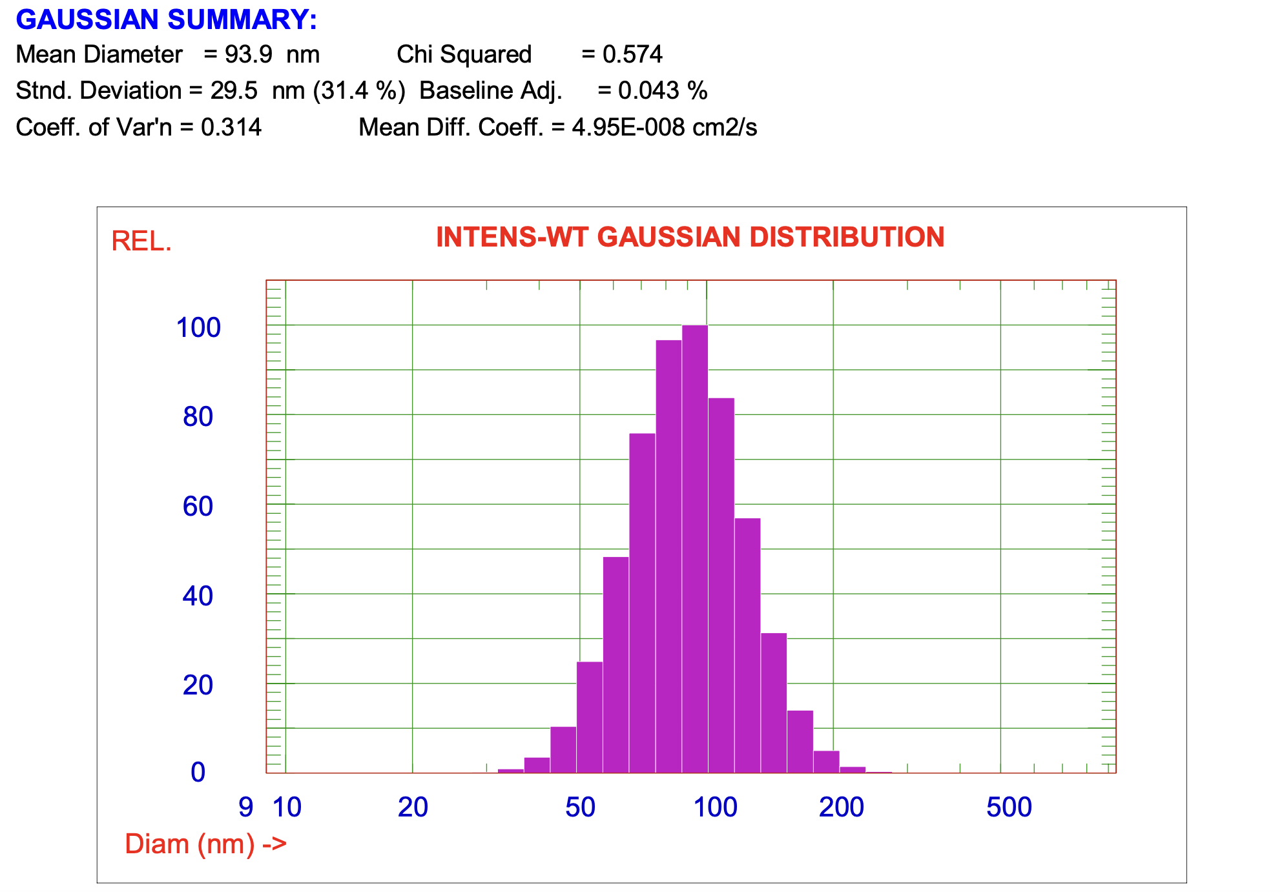
Fig S4. Particle size and polydispersity index (PDI) analysis of mRNA-loaded LNPs. Dynamic light scattering revealed a mean particle size of 93.9 nm with a PDI of 0.0987, indicating uniform and homogeneous formulation.

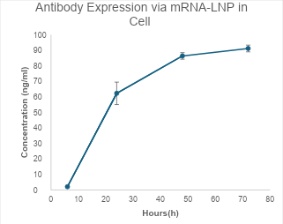
Fig S5. In vitro expression kinetics of trastuzumab following mRNA-LNP incubation with HEK293T cells. Culture media was collected at 6, 24, 48, and 72 hours post-transfection and analyzed by ELISA. A time-dependent increase in trastuzumab protein concentration was observed, indicating efficient cellular uptake of mRNA-LNPs and sustained protein translation over time. Data represent mean ± SD from triplicate wells.

A. Calibration curve for ALC-0315 quantification
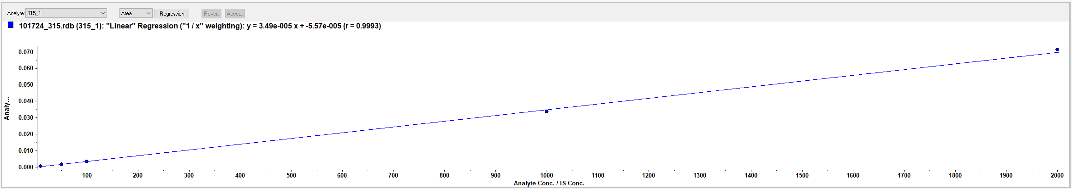
B. Plasma Standard (1–2000 ng/mL)
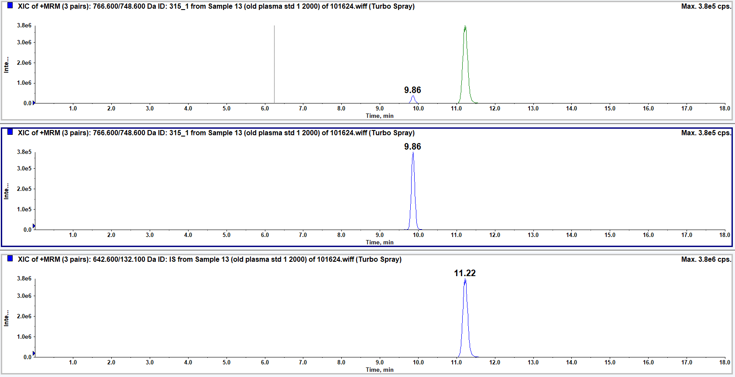
C. Lung Tissue Sample (6 hr post-dose)

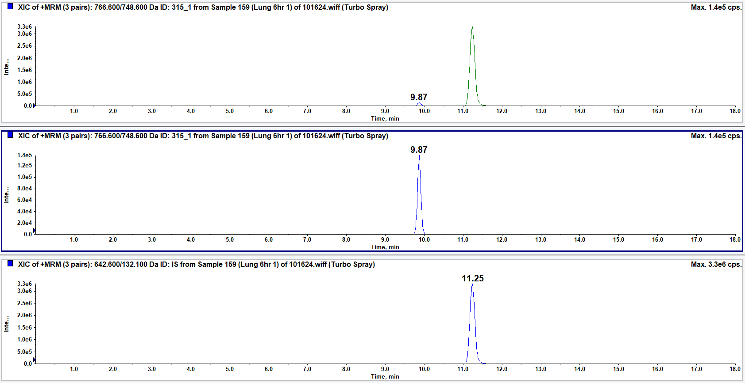

Fig S6. A. Calibration curve for ALC-0315 quantification using LC-MS. The curve demonstrates excellent linearity across the range of 1–2000 ng/mL (R² = 0.9986), enabling accurate and sensitive quantification in plasma and tissue samples. B. MRM chromatograms from a plasma calibration standard (1–2000 ng/mL) showing ALC-0315 (transition 766.6/748.6, retention time 9.86 min, green; expanded view 2) and internal standard DLin-MC3-DMA (transition 642.6/132.1, retention time 11.22 min, blue; expanded view 3). (C) MRM chromatograms from a representative lung tissue sample (6 hr post-dose) showing ALC-0315 (retention time 9.87 min) and internal standard (retention time 11.25 min). The near-identical retention times between plasma standard and lung tissue (Δ = 0.01 min) confirm specific detection of intact ALC-0315, with no additional peaks indicative of hydrolysis product interference. LC conditions: Waters XSelect® CSH C18 column (3.5 µm, 2.1 × 100 mm), 70°C; mobile phase A: water/MeOH/ACN (15:30:55) + 10 mM ammonium acetate; mobile phase B: ACN/MeOH (60:40) + 10 mM ammonium acetate; flow rate 0.2 mL/min.

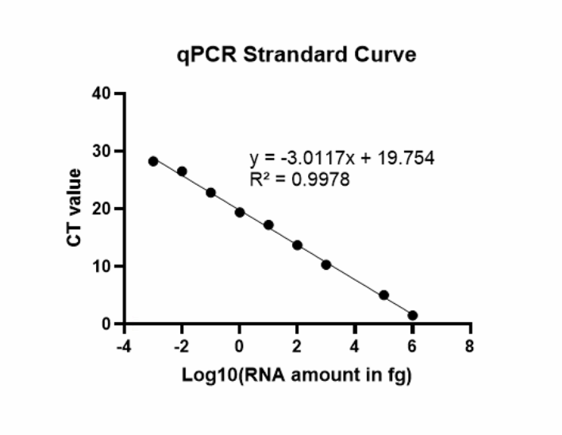
Fig S7. RT-qPCR standard curve for RNA quantification. The graph shows the linear relationship between the CT value and the logarithm (base 10) of RNA amount (in femtograms). The standard curve follows the equation y = -3.0117x + 19.754 with an R² of 0.9978, indicating excellent amplification efficiency and reliability of the assay across a wide dynamic range of RNA concentrations.

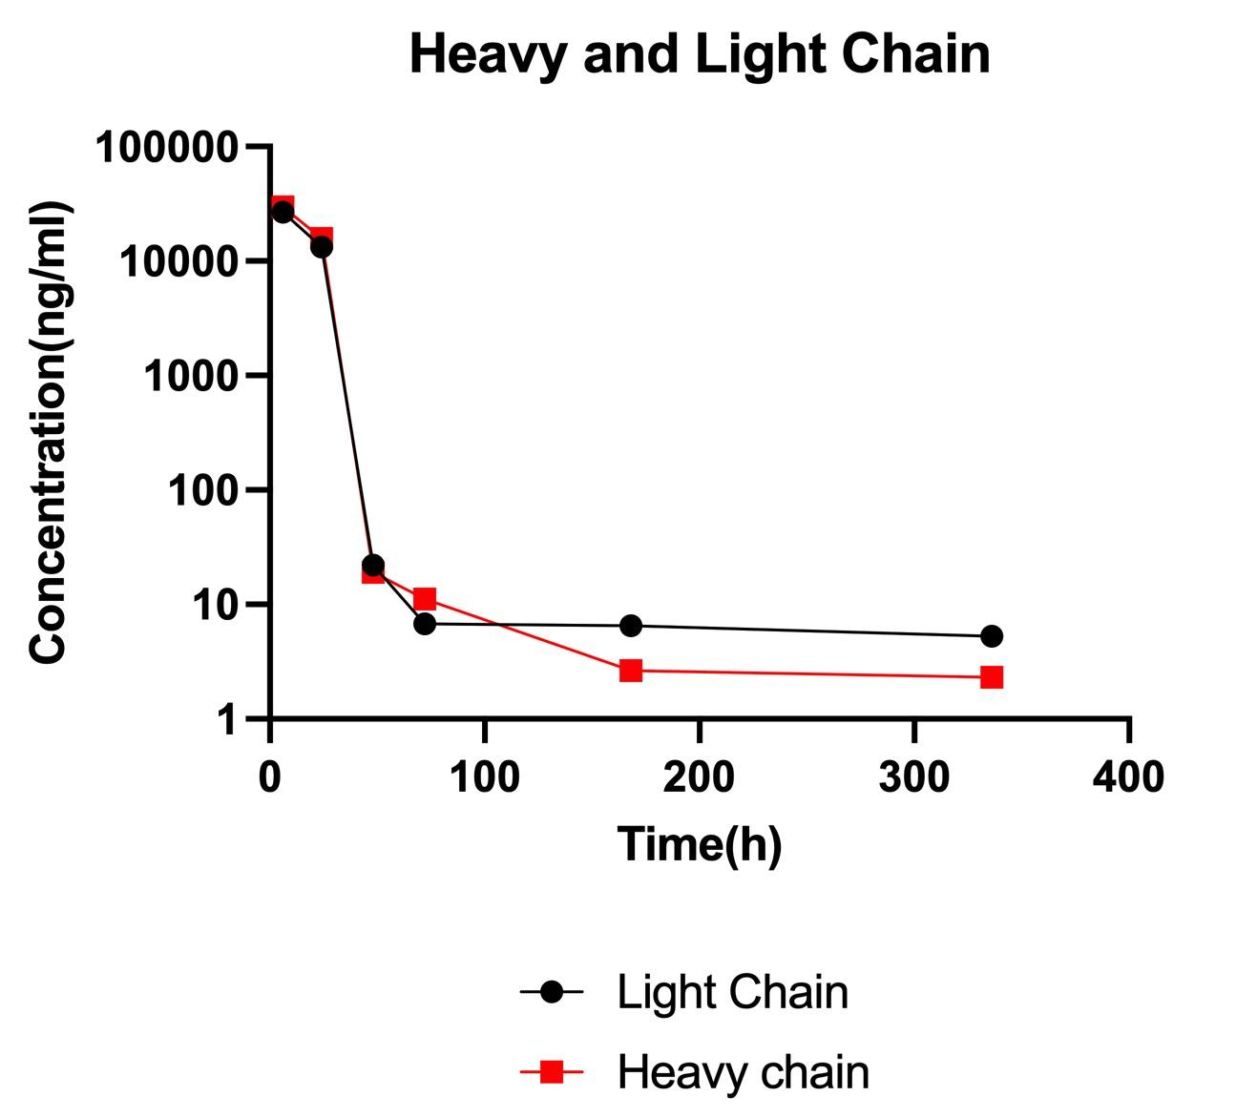
Fig S8. Blood concentration-time profiles of mRNA-expressed heavy and light chains of trastuzumab. Following administration of mRNA-LNP encoding trastuzumab, both light chain (black circles) and heavy chain (red squares) concentrations were quantified in blood over time. A rapid decline in expression was observed within the first 24 hours, followed by sustained low levels up to 336 hours. Data are shown on a logarithmic scale.

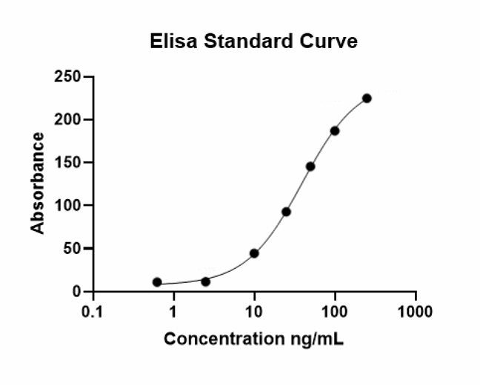

Fig S9. Standard curve for ELISA used to quantify antibody concentrations. A sigmoidal standard curve was generated using known concentrations of antibody (ng/mL) versus absorbance measured at 405 nm. Data were fitted using a 4-parameter logistic (4PL) regression model. This curve was used to interpolate unknown sample concentrations within the assay’s dynamic range.

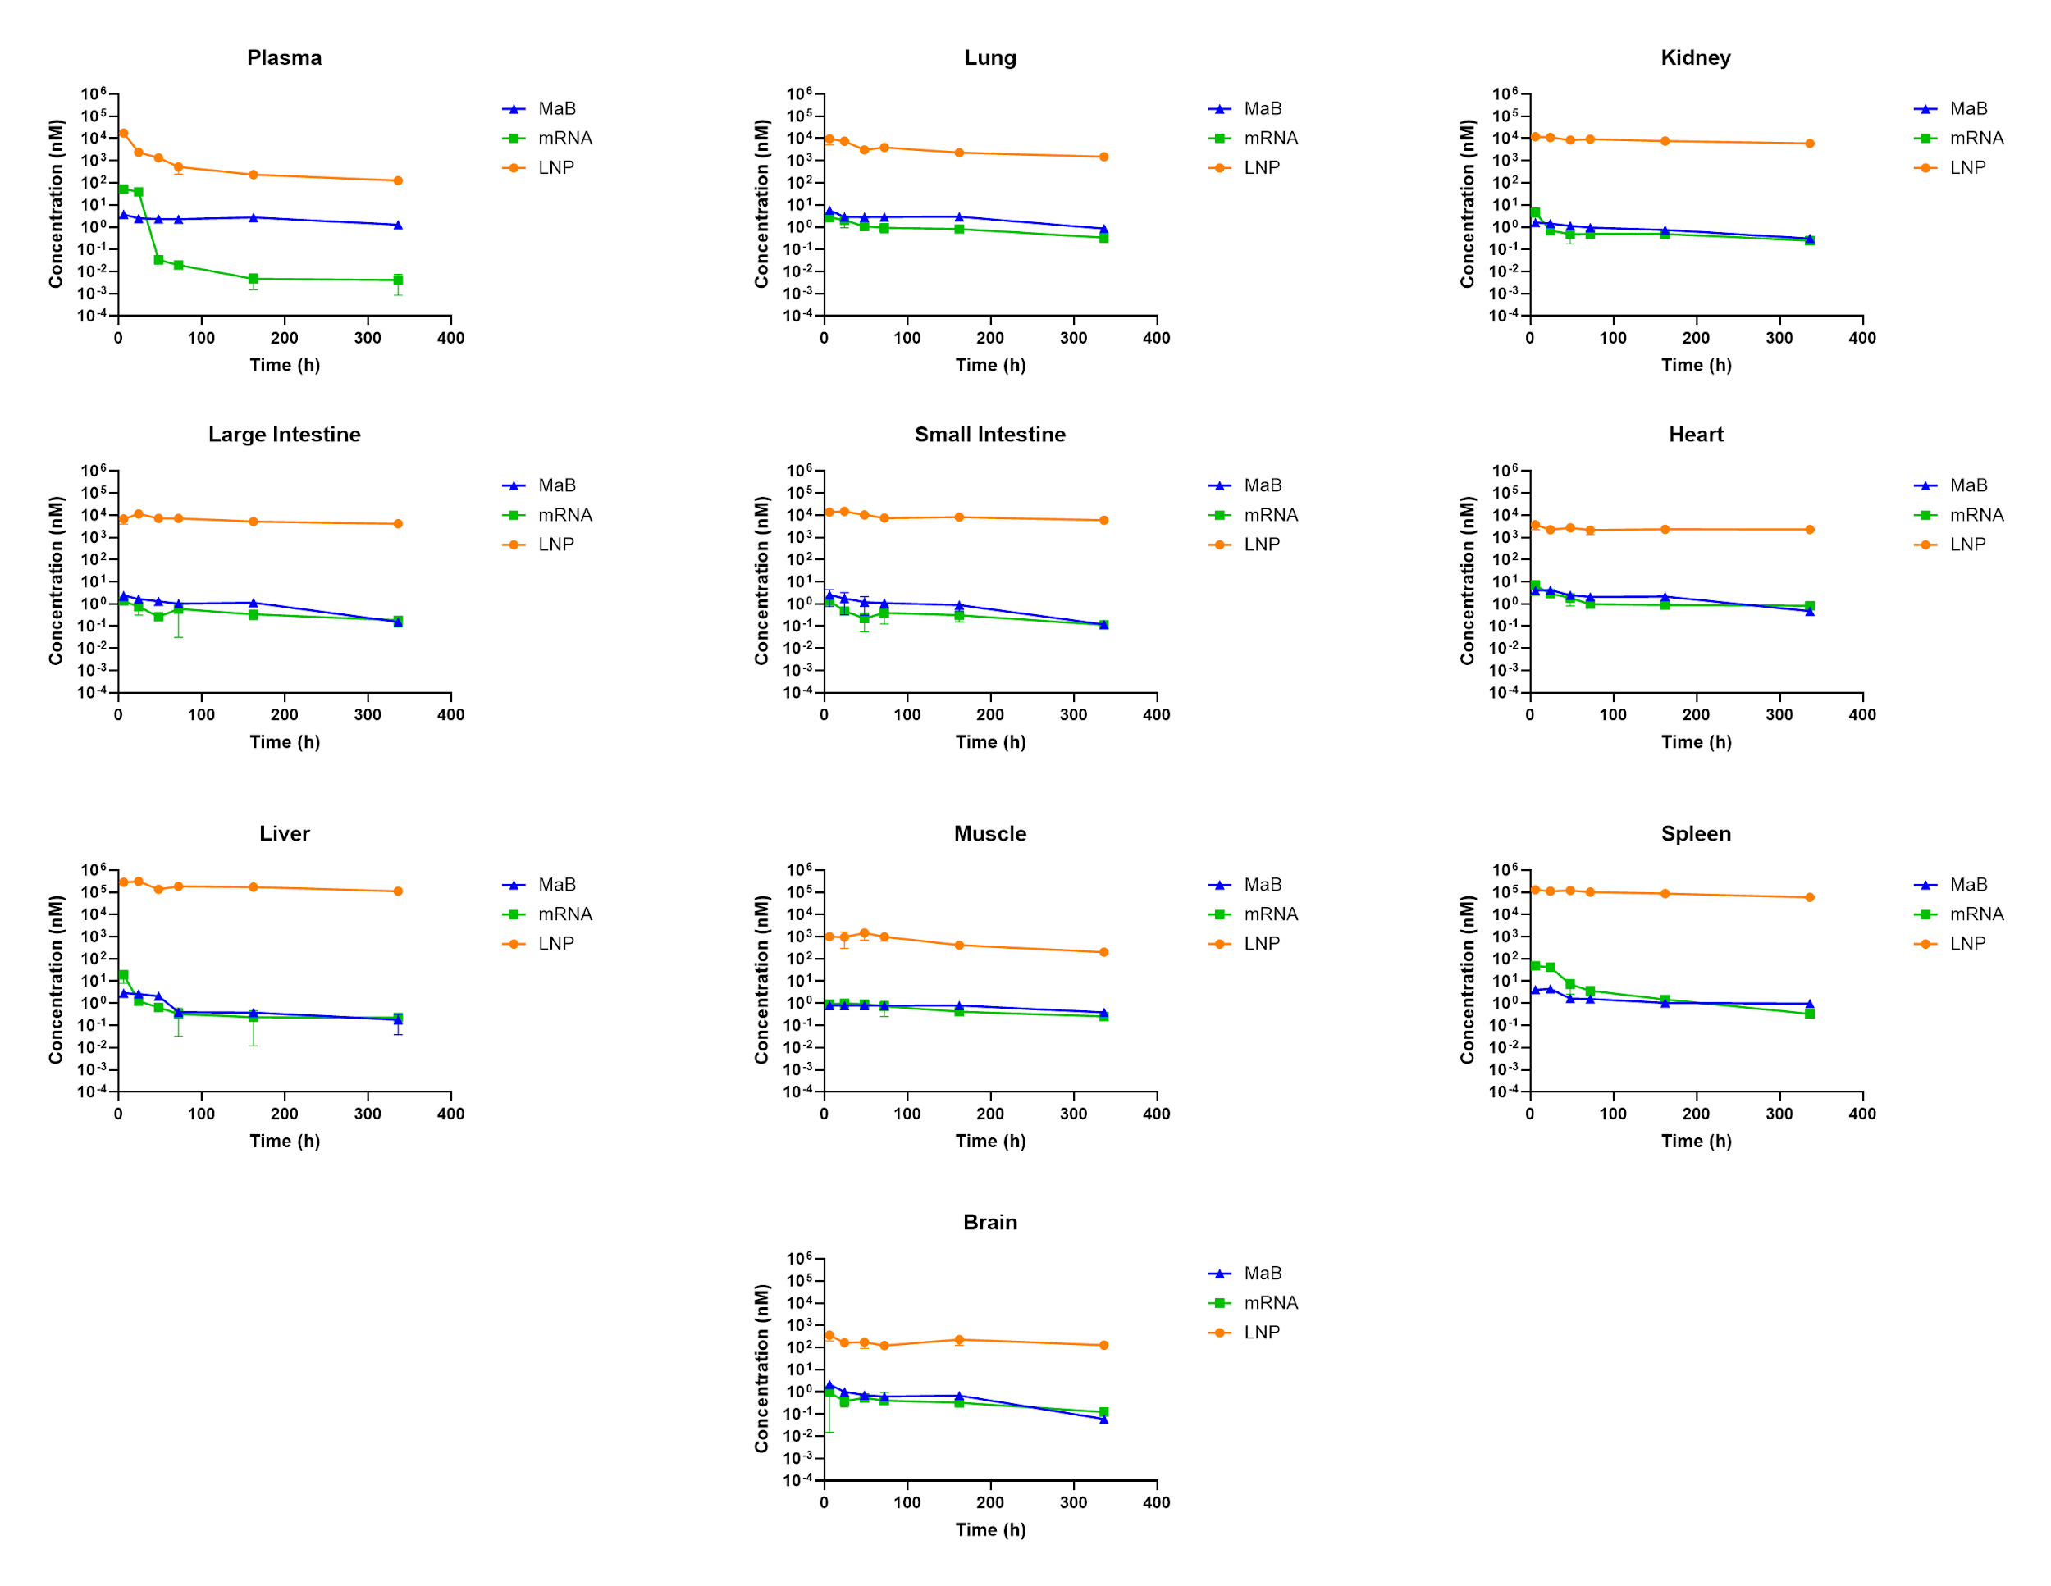
Fig S10. Biodistribution of LNP, mRNA, and monoclonal antibody across tissues superimposed over each other. Data represent mean ± SD from n=3 animals per time point. Log scale was used for the y-axis to visualize dynamic range across tissues.

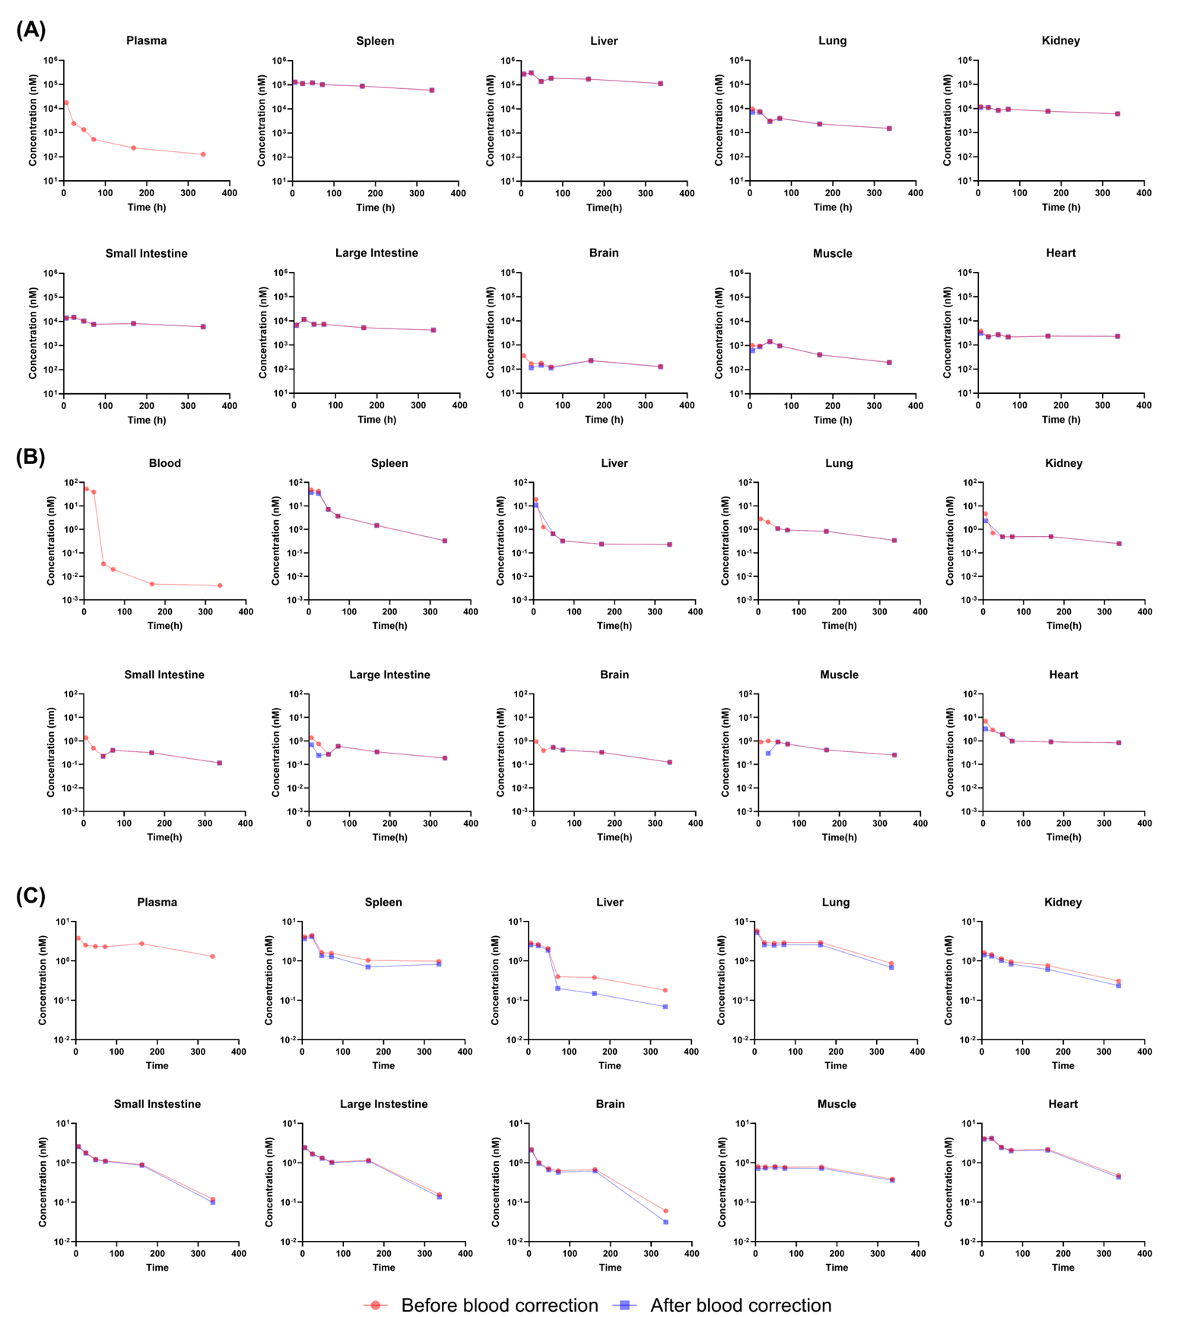
Fig S11. Biodistribution of ALC-0315 (A), mRNA (B), and antibody (C) across tissues before and after residual blood correction. The measured tissue data before residual blood correction are shown in red, and the data after correction are shown in blue.

