Supplemental information

In vivo predictive dissolution test using biorelevant bicarbonate buffer for high-dose free acid drug

Yuki Tarumi, Kiyohiko Sugano*

Molecular Pharmaceutics Lab., College of Pharmaceutical Sciences, Ritsumeikan University, 1-1-1, Noji-higashi, Kusatsu, Shiga 525-8577, Japan

* Corresponding author. Tel.: +81-77-561-2773; E-mail address: suganok@fc.ritsumei.ac.jp (K. Sugano).

- Charge fraction

In the case of 3-protonic acid (H₃A) (e.g., phosphoric acid (H₃PO₄)), the fraction of tri-anionic species (f₋₃) is calculated as,
$$f_{-3}=\frac{\left[A^{3-}\right]}{\left[H_{3}A\right]+\left[H_{2}A^{-}\right]+\left[HA^{2-}\right]+\left[A^{3-}\right]}=\frac{1}{\frac{\left[H_{3}A\right]}{\left[A^{3-}\right]}+\frac{\left[H_{2}A^{-}\right]}{\left[A^{3-}\right]}+\frac{\left[HA^{2-}\right]}{\left[A^{3-}\right]}+\frac{\left[A^{3-}\right]}{\left[A^{3-}\right]}}=\frac{1}{\frac{\left[H_{3}A\right]}{\left[H_{2}A^{-}\right]}\frac{\left[H_{2}A^{-}\right]}{\left[HA^{2-}\right]}\frac{\left[HA^{2-}\right]}{\left[A^{3-}\right]}+\frac{\left[H_{2}A^{-}\right]}{\left[HA^{2-}\right]}\frac{\left[HA^{2-}\right]}{\left[A^{3-}\right]}+\frac{\left[HA^{2-}\right]}{\left[A^{3-}\right]}+1}=\frac{1}{\frac{\left[H^{+}\right]}{K_{a1}}\frac{\left[H^{+}\right]}{K_{a2}}\frac{\left[H^{+}\right]}{K_{a3}}+\frac{\left[H^{+}\right]}{K_{a2}}\frac{\left[H^{+}\right]}{K_{a3}}+\frac{\left[H^{+}\right]}{K_{a3}}+1}=\frac{{\left[H^{+}\right]}^{0}K_{a1}K_{a2}K_{a3}}{{\left[H^{+}\right]}^{3}+{\left[H^{+}\right]}^{2}K_{a1}+{\left[H^{+}\right]}^{1}K_{a1}K_{a2}+{\left[H^{+}\right]}^{0}K_{a1}K_{a2}K_{a3}}$$ | (S1)

Similarly, the fraction of di- and mono, and zero-anionic species (f₋₂, f₋₁, and f₀, respectively) is calculated as,
$$f_{-2}=\frac{{\left[H^{+}\right]}^{1}K_{a1}K_{a2}}{{\left[H^{+}\right]}^{3}+{\left[H^{+}\right]}^{2}K_{a1}+{\left[H^{+}\right]}^{1}K_{a1}K_{a2}+{\left[H^{+}\right]}^{0}K_{a1}K_{a2}K_{a3}}$$ | (S2)
$$f_{-1}=\frac{{\left[H^{+}\right]}^{2}K_{a1}}{{\left[H^{+}\right]}^{3}+{\left[H^{+}\right]}^{2}K_{a1}+{\left[H^{+}\right]}^{1}K_{a1}K_{a2}+{\left[H^{+}\right]}^{0}K_{a1}K_{a2}K_{a3}}$$ | (S3)
$$f_{0}=\frac{{\left[H^{+}\right]}^{3}}{{\left[H^{+}\right]}^{3}+{\left[H^{+}\right]}^{2}K_{a1}+{\left[H^{+}\right]}^{1}K_{a1}K_{a2}+{\left[H^{+}\right]}^{0}K_{a1}K_{a2}K_{a3}}$$ | (S4)
In a general form, the fraction of each molecule (charge = z) for an n-protonated acid can be calculated as [1]
$$f_{z}=\frac{{\left[H^{+}\right]}^{n-l}\prod_{i=1}^{l}{K_{a,i}}}{\sum_{j=0}^{n}{\left({\left[H^{+}\right]}^{n-j}\prod_{i=1}^{j}{K_{a,i}}\right)}}$$ | (S5)
where l = z_{max}-z. This equation can be used for any ionizable molecules (multivalent acids, multivalent bases, and multivalent zwitterions). For example, z_{max} = 0, +1, +2, and +3 for AAA, AAB, ABB, and BBB type molecules, respectively (A = acid, B = base).

- Data

Table S1 Standard curves for solubility measurement
Drug | Media | Concentration range (µg/mL) | r²
Naproxen | pH-adjusted NaCl solutions (I = 0.14 M) | 0.84 – 53.7 | 0.9999
Naproxen | Blank FaSSIF | 0.84 – 53.7 | 0.9999
Naproxen | FaSSIF | 0.84 – 53.7 | 0.9994
Valsartan | pH-adjusted NaCl solutions (I = 0.14 M) | 0.86 – 55.2 | 1.0000

Table S2 Standard curves for dissolution test of valsartan
Dose/ FV (mg/mL) | Media | Concentration range (µg/mL) | r²
0.36 (320 mg/ 900 mL) | BCB | 0.86 – 55.2 | 0.9999
 | PPB | 0.86 – 55.2 | 0.9999
 | USP | 0.86 – 55.2 | 0.9999
0.40 (20 mg/ 50 mL) | BCB | 0.86 – 55.2 | 1.0000
 | PPB | 0.86 – 55.2 | 0.9999
0.80 (40 mg/ 50 mL) | BCB | 0.86 – 55.2 | 1.0000
 | PPB | 0.86 – 55.2 | 0.9999
1.6 (80 mg/ 50 mL) | BCB | 0.86 – 55.2 | 1.0000
 | BCB-FaSSIF | 0.86 – 55.2 | 0.9999
 | PPB | 0.86 – 55.2 | 1.0000
 | PPB-FaSSIF | 0.86 – 55.2 | 0.9999
3.2 (160 mg/ 50 mL) | BCB | 0.86 – 55.2 | 1.0000
 | BCB-FaSSIF | 0.86 – 55.2 | 0.9999
 | PPB | 0.86 – 55.2 | 0.9999
 | PPB-FaSSIF | 0.86 – 55.2 | 1.0000
 | USP | 0.86 – 55.2 | 0.9999

Table S3 Standard curves for dissolution test of naproxen
Dose/ FV (mg/mL) | Media | Concentration range (µg/mL) | r²
1.1 (1000 mg/900 mL) | BCB | 0.84 – 53.7 | 1.0000
 | PPB | 0.84 – 53.7 | 0.9998
 | USP | 0.84 – 53.7 | 0.9999
2.5 (125 mg/50 mL) | BCB | 0.84 – 53.7 | 0.9999
 | PPB | 0.84 – 53.7 | 0.9999
 | USP | 0.84 – 53.7 | 0.9999
5.0 (250 mg/50 mL) | BCB | 0.84 – 53.7 | 0.9999
 | PPB | 0.84 – 53.7 | 0.9999
 | USP | 0.84 – 53.7 | 0.9999
10 (500 mg/50 mL) | BCB | 0.84 – 53.7 | 1.0000
 | PPB | 0.84 – 53.7 | 0.9999
 | USP | 0.84 – 53.7 | 0.9999
20 (1000 mg/50 mL) | BCB | 0.84 – 53.7 | 0.9996
 | PPB | 0.84 – 53.7 | 0.9999
 | USP | 0.84 – 53.7 | 0.9999
30 (1500 mg/50 mL) | BCB | 0.84 – 53.7 | 0.9996
 | BCB-FaSSIF | 0.84 – 53.7 | 0.9998
 | PPB | 0.84 – 53.7 | 0.9999
 | PPB-FaSSIF | 0.84 – 53.7 | 0.9997
 | USP | 0.84 – 53.7 | 0.9999
40 (2000 mg/50 mL) | BCB | 0.84 – 53.7 | 0.9996
 | BCB-FaSSIF | 0.84 – 53.7 | 0.9995
 | PPB | 0.84 – 53.7 | 0.9998
 | PPB-FaSSIF | 0.84 – 53.7 | 0.9998
 | USP | 0.84 – 53.7 | 0.9999

Table S4 Clinical pharmacokinetic parameters of valsartan following a single oral dose in the fasting stateª
Dose (mg) | C_{max} (µg/mL) | AUC₀₋₄₈ (µg・ｈ/mL)
20 | 0.86 ± 0.53 | 5.2 ± 3.1
40 | 1.37 ± 0.53 | 8.9 ± 4.0
80 | 2.83 ± 0.92 | 18.0 ± 5.8
160 | 5.26 ± 2.30 | 33.9 ± 18.9
320 | 7.54 ± 3.10 | 55.5 ± 27.5
a Adapted from the literature [2].

Table S5 Clinical pharmacokinetic parameters of naproxen following a single oral dose in the fasting stateª
Dose (mg) | C_{max} (µg/mL) | AUC₀₋₄₈ (µg・ｈ/mL)
250 | 35 | 560.5
500 | 64 | 942.24
1000 | 110 | 1402
2000 | 155 | 2187
3000 | 169 | 2614
4000 | 210 | 2796
a Adapted from the literature[3,4].

Table S6 Equilibrium solubility of valsartan at each pH
Final pHª | S_{pH} (mg/mL) ^{a, b, c}
1.02 ± 0.01 | 0.094 ± 0.002
2.02 ± 0.00 | 0.101± 0.002
3.00 ± 0.01 | 0.111 ± 0.004
3.47 ± 0.01 | 0.167 ± 0.009
3.95 ± 0.00 | 0.411 ± 0.001
4.98 ± 0.01 | 7.28 ± 0.051
5.50 ± 0.02 | >12.0
a Mean ± S.D., N = 3
b I = 0.14 M, 37 °C.
c The residual solid was amorphous valsartan free acid in all cases.
d Completely dissolved.

Table S7 Equilibrium solubility of naproxen at each pH
Final pHª | S_{pH} (mg/mL)^{a,b,c}
1.03 ± 0.01 | 0.024 ± 0.000
2.02 ± 0.01 | 0.028± 0.000
3.06 ± 0.00 | 0.030 ± 0.000
3.99 ± 0.01 | 0.045 ± 0.003
5.00 ± 0.01 | 0.211 ± 0.011
5.91 ± 0.01 | 1.08 ± 0.009
6.85 ± 0.02 | > 12.0 ^{d}
a Mean ± S.D., N = 3
b I = 0.14 M, 37 °C.
c The residual solid was crystalline naproxen free acid in all cases.
d Completely dissolved.

Table S8 Dissolution rate constant of valsartan
Dose/ FV (mg/mL) | Medium | k_{diss} (/h) | Dn
0.4 | BCB | 4.051 | 14.18
0.4 | PPB | 3.898 | 13.64
0.4 | USP | 4.233 | 14.82
0.8 | BCB | 6.859 | 24.01
0.8 | PPB | 6.572 | 23.00
0.8 | USP | 7.377 | 25.82
1.6 | BCB | 13.100 | 45.85
1.6 | PPB | 8.911 | 31.19
1.6 | USP | 14.015 | 49.05
1.6 | BCB-FaSSIF | 12.966 | 45.38
1.6 | PPB-FaSSIF | 10.296 | 36.03
3.2 | BCB | 19.889 | 69.61
3.2 | PPB | 12.754 | 44.64
3.2 | USP | 21.731 | 76.06
3.2 | BCB-FaSSIF | 20.317 | 71.11
3.2 | PPB-FaSSIF | 12.997 | 45.49

Table S9
Table S8 Dissolution rate constant of naproxen
Dose/ FV (mg/mL) | Medium | k_{diss} (/h) | Dn
2.5 | BCB | 6.54 | 22.9
2.5 | PPB | 6.67 | 23.3
2.5 | USP | 16.53 | 57.8
5 | BCB | 8.74 | 30.6
5 | PPB | 7.01 | 24.5
5 | USP | 20.79 | 72.7
10 | BCB | 10.23 | 35.8
10 | PPB | 6.87 | 24.0
10 | USP | 22.25 | 77.9
20 | BCB | 9.96 | 34.9
20 | PPB | 6.69 | 23.4
20 | USP | 22.05 | 77.2
30 | BCB | 10.54 | 36.9
30 | PPB | 6.43 | 22.5
30 | USP | 21.69 | 75.9
30 | BCB-FaSSIF | 12.44 | 43.5
30 | PPB-FaSSIF | 7.84 | 27.4
40 | BCB | 10.17 | 35.6
40 | PPB | 7.02 | 24.6
40 | USP | 21.21 | 74.2
40 | BCB-FaSSIF | 13.52 | 47.3
40 | PPB-FaSSIF | 8.06 | 28.2

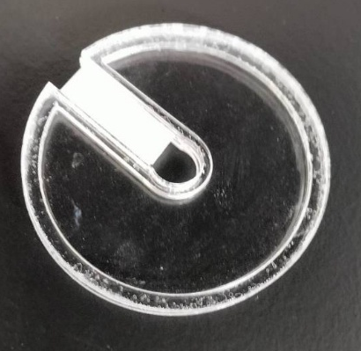

Figure S1 Floating lid for the mini vessel. The floating lid was made of a 2 mm-thick acrylic plate. Diameter: 49.5 mm, diameter of central hole: 8.0 mm, slit width: 7.4 mm. The floating lid was made of two plates and a central frame to form a cavity. Styrofoam was used to fill the slit.

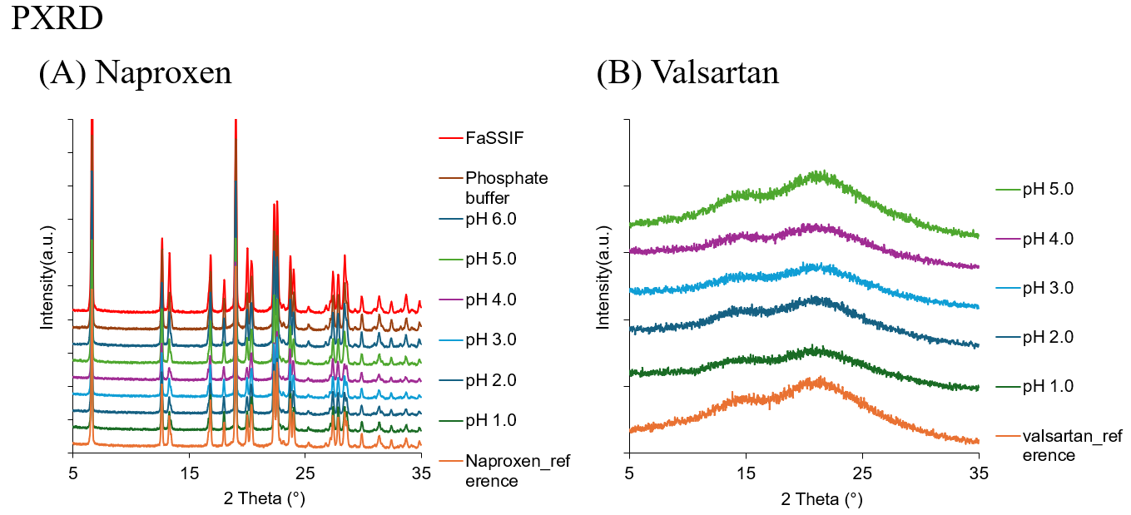
Figure S2 PXRD patterns of the residual solid in the solubility measurement. (A) Naproxen, and (B) Valsartan.

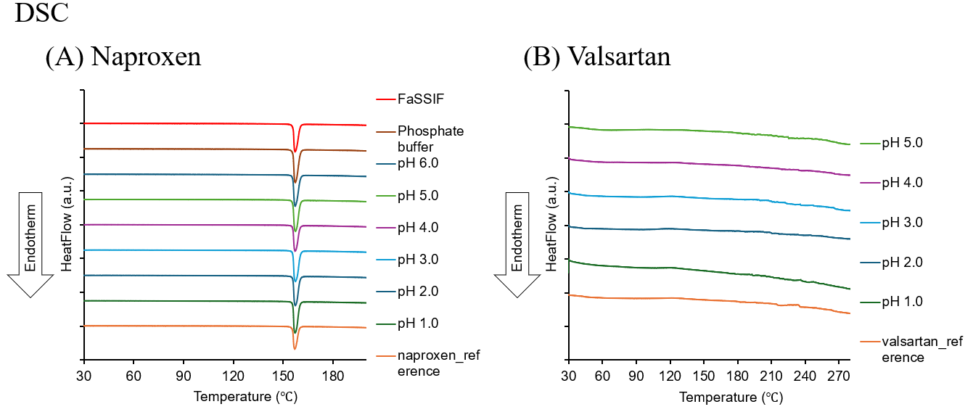
Figure S3 DSC curves of the residual solid in the solubility measurement. (A) Naproxen, and (B) Valsartan.

References
1. Kalka H. Polyprotic acids and beyond—an algebraic approach. Chemistry. MDPI; 2021;3:454–508.
2. Novartis AG. Valsartan Drug Product Information. [cited 2025 Dec 31]; https://www.pro.novartis.com/jp-ja/sites/pro_novartis_com_jp/files/2024-11/if_dio_202305.pdf. Accessed 31 Dec 2025
3. Davies NM, Anderson KE. Clinical Pharmacokinetics of Naproxen. Clin-Pharmacokinet. 1997;32:268–93. https://doi.org/10.2165/00003088-199732040-00002
4. Niazi SK, Alam SM, Ahmad SI. Dose Dependent Pharmacokinetics of Naproxen in Man. Biopharmaceutics & Drug Disposition. 1996;17:355–61. https://doi.org/10.1002/(SICI)1099-081X(199605)17:4%253C355::AID-BDD960%253E3.0.CO;2-N

